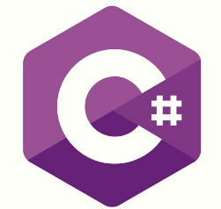

# Introduction

## What is C#?

* C# is pronounced, "C-Sharp".
* It is an object-oriented programming language created by Microsoft that runs on the .NET Framework.
* C# has roots from the C family, and the language is close to other popular languages like C++ and Java.
* The first version was released in year 2002. The latest version, C# 12, was released in November 2023.

## C# use for what?

C# is used for:

* Mobile applications
* Desktop applications
* Web applications
* Web services
* Web sites
* Games
* VR
* Database applications
* And much, much more!

## Why use C#?

* It is one of the most popular programming languages in the world
* It is easy to learn and simple to use
* It has huge community support
* C# is an object-oriented language which gives a clear structure to programs and allows code to be reused, lowering development costs
* As C# is close to C, C++ and Java, it makes it easy for programmers to switch to C# or vice versa

## Before can start the C#

* Install the vs code
* Install .net

## Syntax code

## Comments

* Single-line comments start with two forward slashes (//).
* Multi-line comments start with /* and ends with */.

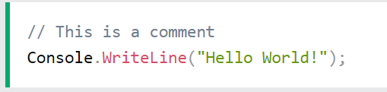

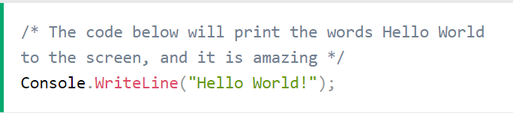

## Data Types

* int - stores integers (whole numbers), without decimals, such as 123 or -123
* double - stores floating point numbers, with decimals, such as 19.99 or -19.99
* char - stores single characters, such as 'a' or 'B'. Char values are surrounded by single quotes
* string - stores text, such as "Hello World". String values are surrounded by double quotes
* bool - stores values with two states: true or false
  + 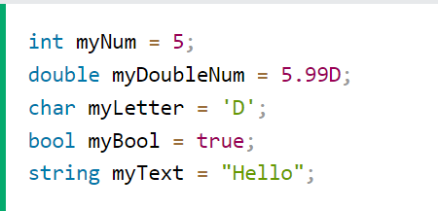
  + 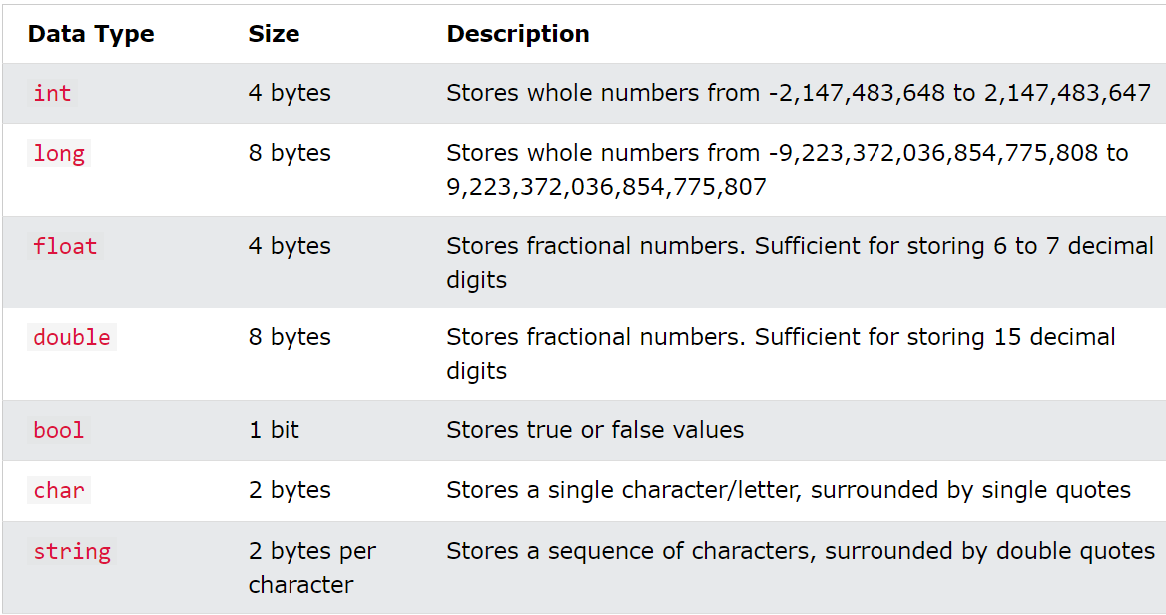

## Type Casting

## Type Conversion Methods

It is also possible to convert data types explicitly by using built-in methods, such as Convert.ToBoolean, Convert.ToDouble, Convert.ToString, Convert.ToInt32 (int) and Convert.ToInt64 (long):

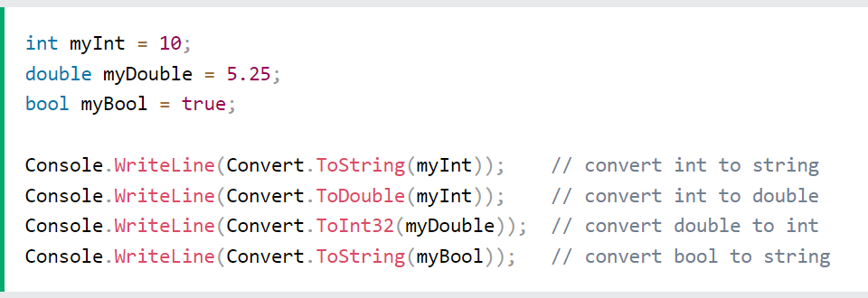

## Get the user input

You have already learned that Console.WriteLine() is used to output (print) values. Now we will use Console.ReadLine() to get user input.

## C# Operators

Operators are used to perform operations on variables and values.

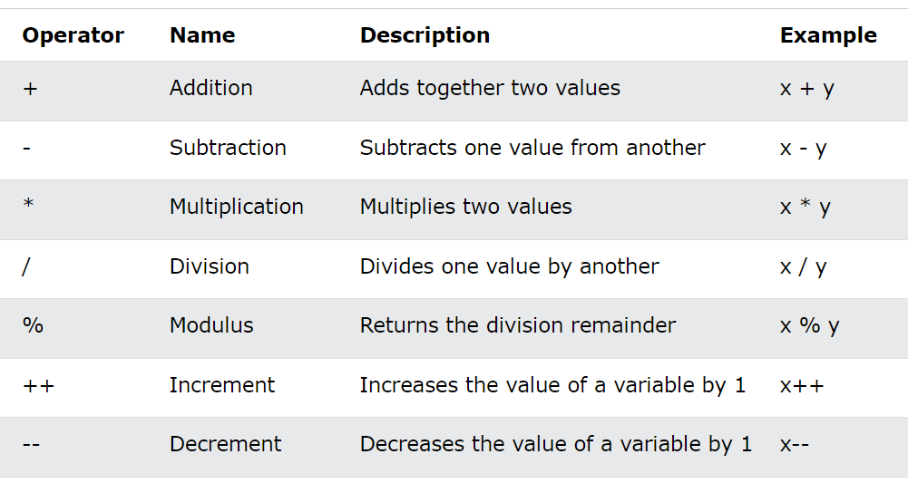

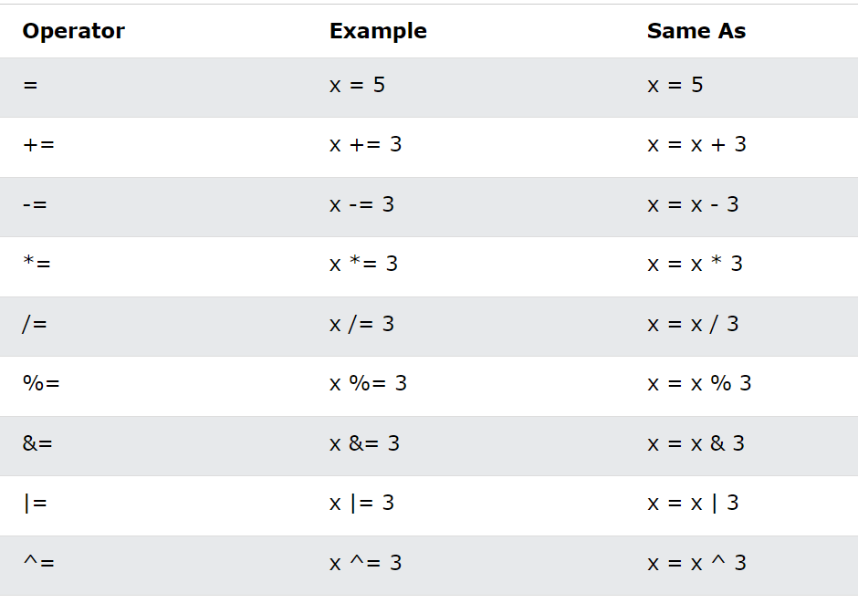

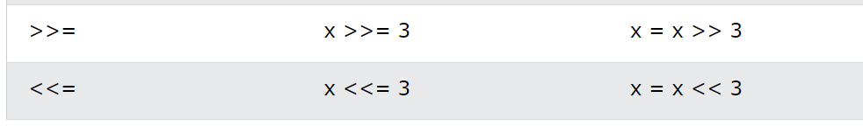

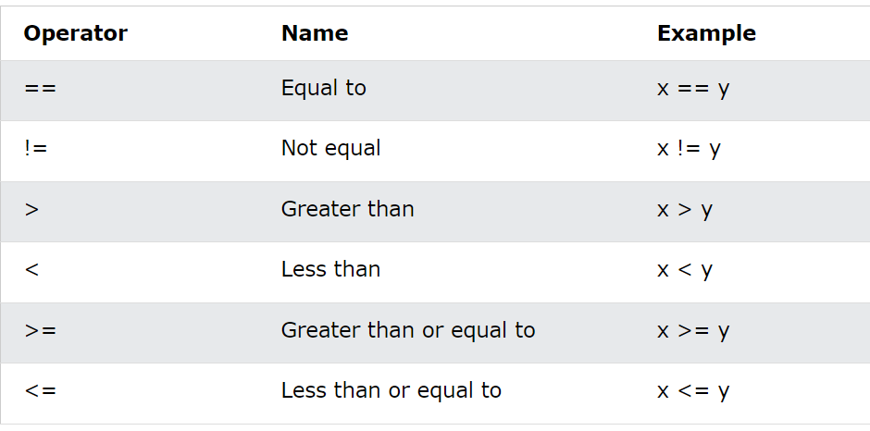

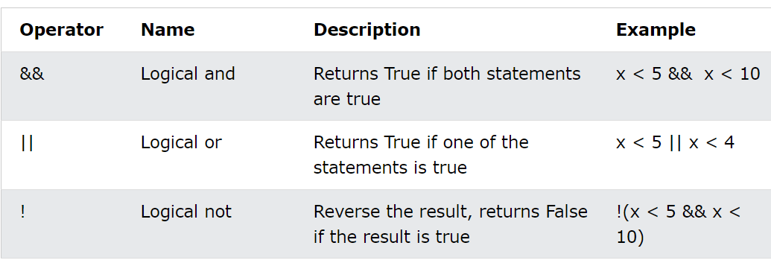

## String

### String

* A string variable contains a collection of characters surrounded by double quotes
  + 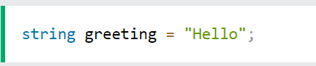
  + 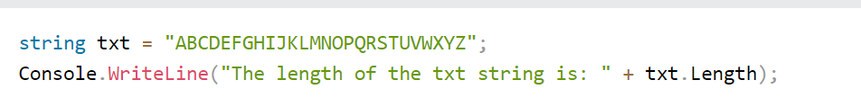
  + 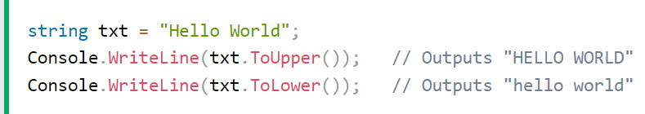

### Concatenation

* The + operator can be used between strings to combine them. This is called concatenation
  + 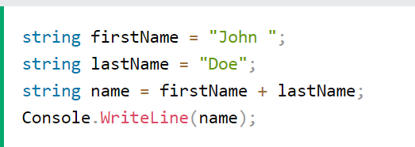
  + 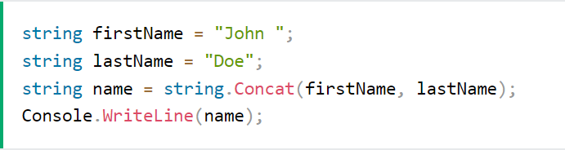

### Interpolation

* string concatenation, is string interpolation, which substitutes values of variables into placeholders in a string.
  + 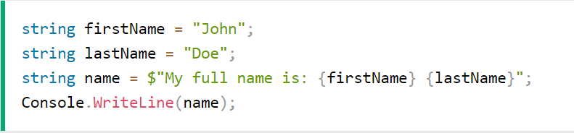

### Access string

* You can access the characters in a string by referring to its index number inside square brackets []
  + 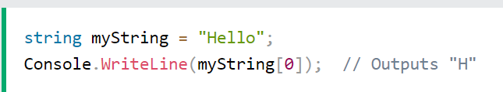

### Special characters

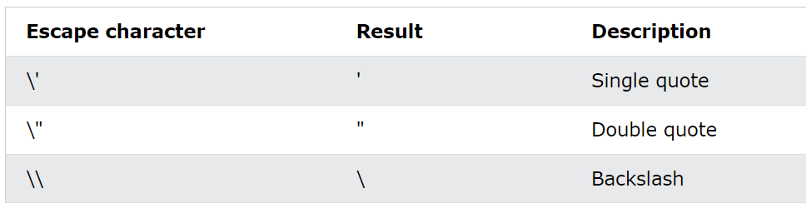

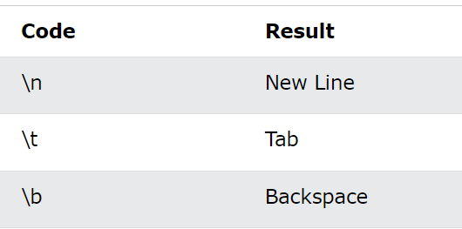

## Array

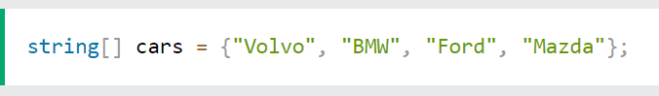

## Conditions

* Use if to specify a block of code to be executed, if a specified condition is true
* Use else to specify a block of code to be executed, if the same condition is false
* Use else if to specify a new condition to test, if the first condition is false
* Use switch to specify many alternative blocks of code to be executed

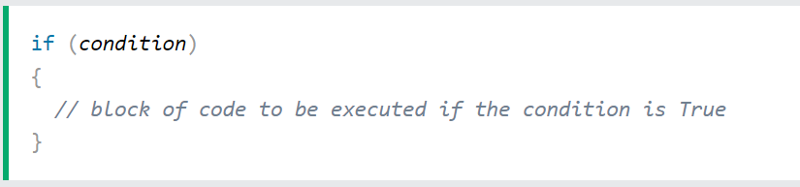

## Loop

### While loop

* The while loop loops through a block of code as long as a specified condition is True
  + 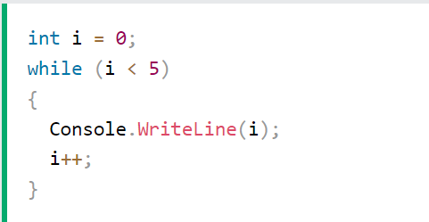

### For loop

* When you know exactly how many times you want to loop through a block of code, use the for loop instead of a while loop
  + 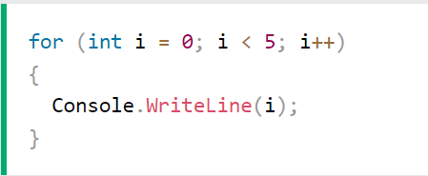

### Foreach loop

* There is also a foreach loop, which is used exclusively to loop through elements in an **array**
  + 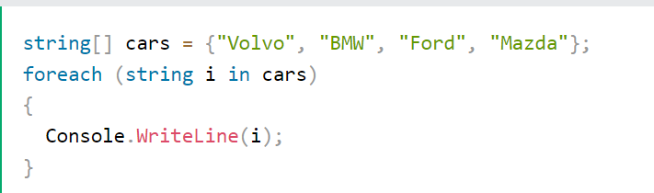

# Methods

## Methods

* A **method** is a block of code which only runs when it is called.
  + 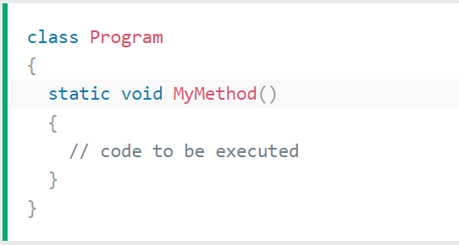
  + MyMethod() is the name of the method
  + static means that the method belongs to the Program class and not an object of the Program class. You will learn more about objects and how to access methods through objects later in this tutorial.
  + void means that this method does not have a return value. You will learn more about return values later in this chapter

# C# OOP