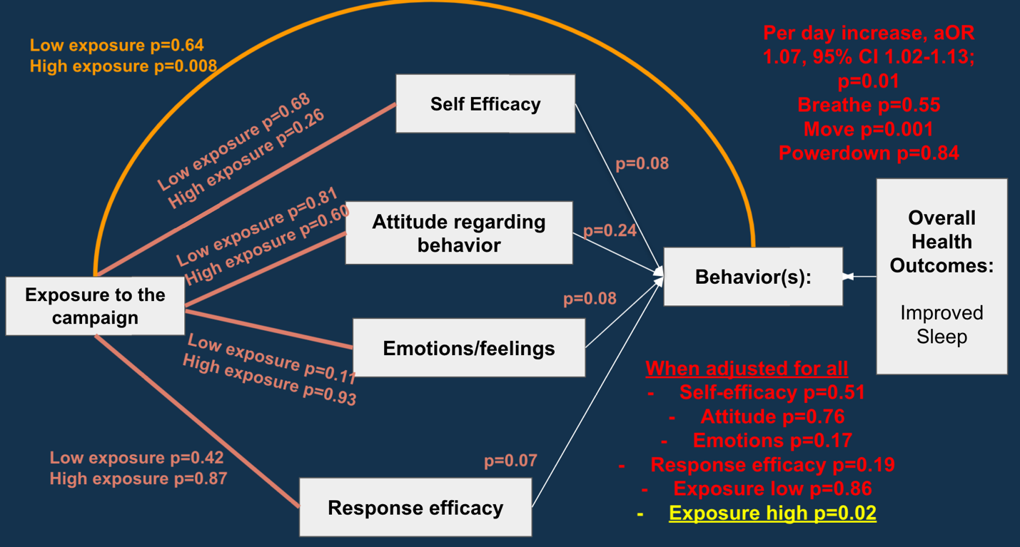

**Exposure to campaign**

Correctly identifying images associated with the campaign (**maximum 4 points**)

Engaging with the campaign (Did you engage with the campaign “Yes”) (**maximum 1 point**)

Did you participate in any of the following #MoveMore, #PowerDown, #Breathe (**maximum 3 points**)

Did you participate in any of the following associated with the campaign: Instagram, text message, word of mouth discussion with others (**maximum 3 points**)

Categorization based on percentiles:

**No exposure:** 0 points (<75%ile)

**Low exposure:** < 5 points (75%ile to 90%ile)

**High exposure:** ≥ 5 points (>90%ile)

**Self-efficacy**

* Please tell us how confident you feel practicing the following behaviors in order to get better sleep: I can maintain healthy sleep habits.
* Please tell us how confident you feel practicing the following behaviors in order to get better sleep: I can cut out screen use 1 hour before bed.
* Please tell us how confident you feel practicing the following behaviors in order to get better sleep: I can exercise for 30 minutes total each day.
* Please tell us how confident you feel practicing the following behaviors in order to get better sleep: I can participate in a breathing exercise during the day or before bed.

Options: Not at all confident, somewhat confident, extremely confident

Maximum 4 points

**Attitude regarding behavior**

* Please rate your agreement with the following statements: Getting a good night’s sleep is important to me.
* Please rate your agreement with the following statements: Having a regular sleep routine improves mental clarity/sharpness.

Options: Strongly disagree, somewhat disagree, neither agree nor disagree somewhat agree, strongly agree

If respond “strongly agree” – 1 point (maximum 2 points)

**Emotions/feelings**

* Please rate your agreement with the following statements: I feel positive about the quality of my sleep.

Options: Strongly disagree, somewhat disagree, neither agree nor disagree somewhat agree, strongly agree

If respond “strongly agree” – 1 point (maximum 1 point)

**Response efficacy**

* Please rate your agreement with the following statements: I think cutting out screen use 1 hour before bed leads to better sleep.
* Please rate your agreement with the following statements: I think exercising regularly leads to better sleep.
* Please rate your agreement with the following statements: I think participating in breathing exercises during the day or before bed leads to better sleep.

Options: Strongly disagree, somewhat disagree, neither agree nor disagree somewhat agree, strongly agree

If responded “strongly agree” – 1 point (maximum 3 points)

**Behavior**

* Points for each day that participants reported moving at least 30 minutes in the last 14 days
* Points for each day that participants reported using a breathing exercise  in the last 14 days
* Points for each day that participants reported powering down devices at least 1 hour before bedtime in the last 14 days

Maximum 14 points per behavior (total 48 points maximum)

**Overall health outcome: improved sleep**

* Are you happy with your sleep quality overall currently? (options yes or no)
* Please rate your sleep quality from the following options: In the last two weeks? (on average) (options poor, fair, good, excellent)

If responds happy with sleep quality or rating sleep quality as excellent – 1 otherwise 0 (binary outcome)

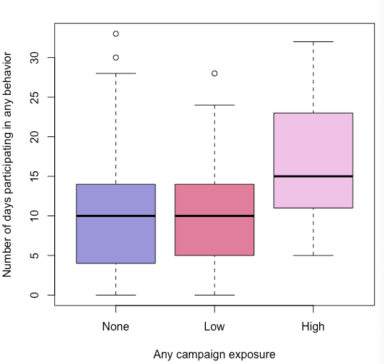

Any campaign exposure defined as:

- recognizing at least one of the four images from the campaign

- responding having engaged with the campaign

- participating in at least one of the #MoveMore, #Powerdown #Breathe

- having participated in the instagram campaign, text message campaign, or discussing the campaign with others

None = 0 points

Low < 5 points

High ≥ points

Overall p=0.012 Kruskal-Wallis rank sum test

For nomenclature below Dependent variable ~ Independent variable 1 + independent variable 2 etc…

**Evaluated associations between campaign exposure and 1. self-efficacy, 2. attitude, 3. emotions, and 4. response efficacy**

*Linear regression*

**Model:**

Self-efficacy ~ Exposure level + sex + hours of sleep per workday + role at Bloomberg (full time, part time)

Low exposure (ref: no exposure) p=0.68

High exposure (ref: no exposure) p=0.26

*Linear regression*

**Model:**

Attitude ~ Exposure level + sex + hours of sleep per workday + age

Low exposure (ref: no exposure) p=0.81

High exposure (ref: no exposure) p=0.60

*Logistic regression*

**Model:**

Emotions/feelings (binary) ~ Exposure level + sex + hours of sleep per workday + age

Low exposure (ref: no exposure) p=0.11

High exposure (ref: no exposure) p=0.93

*Linear regression*

**Model:**

Response efficacy ~ Exposure level + sex + hours of sleep per workday + role at Bloomberg (full time, part time)

Low exposure (ref: no exposure) p=0.42

High exposure (ref: no exposure) p=0.87

**Evaluated association between 1. self-efficacy, 2. attitude, 3. emotions, and 4 response efficacy and 5. campaign exposure itself in participating in the behavior**

*Linear regression*

**Model:**

Behavior (cumulative points) ~ Self-efficacy + sex + hours of sleep per workday + role at Bloomberg (full time, part time)

Self-efficacy p=0.08

*Linear regression*

**Model:**

Behavior (cumulative points ~ Attitude + age + sex + hours of sleep per workday

Attitude p=0.24

*Linear regression*

**Model:**

Behavior (cumulative points) ~ Emotions/feelings + age + sex + hours of sleep per workday

Emotions/feelings p=0.08

*Linear regression*

Behavior (cumulative points) ~ response efficacy + sex + hours of sleep per workday + role at Bloomberg (full time, part time)

response efficacy p=0.08

*Linear regression*

Behavior (cumulative points) ~ campaign+ age + sex

Low exposure p=0.59

High exposure estimate 5.6693 (positive), p=0.007

**Evaluating association between self-efficacy, attitude, emotions, response efficacy, and campaign exposure and participating in behavior (inputting all variables in the model to see which one remains)**

*Linear regression*

**Model:**

Behavior (cumulative points) ~ Campaign exposure + Response efficacy (independent variable) + self-efficacy (independent variable) + attitude (independent variable) + emotions (independent variable) + sex + hours of sleep on a regular workday + role at Bloomberg (full-time, part time)

* Campaign exposure low p=0.86
* Campaign exposure high estimate 4.68 (positive association) p=0.02*
* Self-efficacy p=0.51
* Attitude p=0.76
* Emotions p=0.17
* Response efficacy p=0.19

**Evaluating the association between cumulative behavior and overall health outcomes (good sleep quality)**

*Logistic regression*

**Model:**

Good sleep (cumulative points) ~ Behavior (cumulative points) + sex + hours of sleep on a regular workday + role at Bloomberg (full-time, part time) + age

Behavior cumulative points OR 1.07, 95% CI 1.02-1.13; p=0.014*

Average sleep on a weekday OR 3.41, 95% CI 2.16-5.83; p<0.001**

*Linear regression*

**Model:**

Behavior (cumulative points) ~ Cumulative points from breathing variable + Cumulative points from moving + Cumulative points from powering down + age + sex + hours of sleep on a regular workday + role at Bloomberg (full-time, part time)

Breathe OR 1.03, 95% CI 0.94-1.13; p=0.55

Power down OR 0.99, 95% CI 0.88-1.11; p=0.84

Moving OR 1.28, 95% CI 1.11-1.49; p=0.001*

Average sleep on a weekday OR 4.02, 95% CI 2.43-7.27; p<0.001**