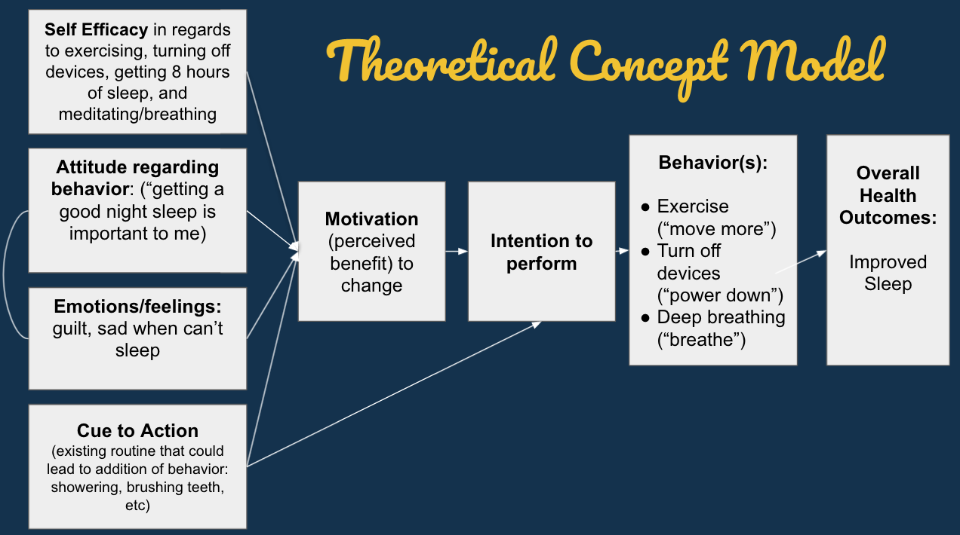

**Variables and definitions:**

**Self-efficacy**

1. **Please tell us how confident you feel practicing the following behaviors in order to get better sleep: I can maintain healthy sleep habits.**

Not at all confident, somewhat confident, extremely confident

1. **Please tell us how confident you feel practicing the following behaviors in order to get better sleep: I can cut out screen use 1 hour before bed.**

Not at all confident, somewhat confident, extremely confident

1. **Please tell us how confident you feel practicing the following behaviors in order to get better sleep: I can exercise for 30 minutes total each day.**

Not at all confident, somewhat confident, extremely confident

1. **Please tell us how confident you feel practicing the following behaviors in order to get better sleep: I can participate in a breathing exercise during the day or before bed.**

Not at all confident, somewhat confident, extremely confident

*Coding for self-efficacy*

sleephygiene <- sleephygiene %>% mutate(

SELF_EFFICACY = case_when(

Q59_canmaintainhealthysleephabits == "Extremely confident" ~ 1,

Q59_canparticipateinbreathing == "Extremely confident" ~ 1,

Q59_cancutoutscreen == "Extremely confident" ~ 1,

Q59_canexercise == "Extremeley confident" ~ 1,

is.na(Q59_canmaintainhealthysleephabits) ~ NA_real_,

is.na(Q59_canparticipateinbreathing) ~ NA_real_,

is.na(Q59_cancutoutscreen) ~ NA_real_,

is.na(Q59_canexercise) ~ NA_real_,

TRUE ~ 0

)

)

**Attitude**

1. **Please rate your agreement with the following statements: Getting a good night’s sleep is important to me.**

Strongly disagree, somewhat disagree, neither agree nor disagree somewhat agree, strongly agree

1. **Please rate your agreement with the following statements: Having a regular sleep routine improves mental clarity/sharpness.**

Strongly disagree, somewhat disagree, neither agree nor disagree somewhat agree, strongly agree

Coding for attitude

sleephygiene <- sleephygiene %>% mutate(

ATTITUDE = case_when(

Q44_goodnightsleepisimportant == "Strongly agree" ~ 1,

is.na(Q44_goodnightsleepisimportant) ~ NA_real_,

Q44_mentalclarity == "Strongly agree" ~ 1,

is.na(Q44_mentalclarity) ~ NA_real_,

TRUE ~ 0

)

)

**Emotions**

1. **Please rate your agreement with the following statements: I feel positive about the quality of my sleep.**

Strongly disagree, somewhat disagree, neither agree nor disagree somewhat agree, strongly agree

*Coding for emotions*

sleephygiene <- sleephygiene %>% mutate(

EMOTIONS = case_when(

Q44_feelpositive == "Strongly agree" ~ 1,

is.na(Q44_feelpositive) ~ NA_real_,

TRUE ~ 0

)

)

**Cue to action – no good question to evaluate**

**Motivation**

1. **Please rate your agreement with the following statements: I think cutting out screen use 1 hour before bed leads to better sleep.**

Strongly disagree, somewhat disagree, neither agree nor disagree somewhat agree, strongly agree

1. **Please rate your agreement with the following statements: I think exercising regularly leads to better sleep.**

Strongly disagree, somewhat disagree, neither agree nor disagree somewhat agree, strongly agree

1. **Please rate your agreement with the following statements: I think participating in breathing exercises during the day or before bed leads to better sleep.**

Strongly disagree, somewhat disagree, neither agree nor disagree somewhat agree, strongly agree

*Coding for motivation*

mutate(MOTIVATION = case_when(

Q44_cuttingoutscreenleadstobettersleep == "Strongly agree" ~ 1,

Q44_exercisingleadstobettersleep == "Strongly agree" ~ 1,

Q44_breathingexercisesleadstobettersleep == "Strongly agree" ~ 1,

is.na(Q44_cuttingoutscreenleadstobettersleep) ~ NA_real_,

is.na(Q44_exercisingleadstobettersleep) ~ NA_real_,

is.na(Q44_breathingexercisesleadstobettersleep) ~ NA_real_,

TRUE ~ 0

))

**Intention to perform**

1. **Please rate your agreement with the following statements: In the next two weeks, I will stop using screens 1 hour before bed for better sleep.**

Strongly disagree, somewhat disagree, neither agree nor disagree somewhat agree, strongly agree

1. **Please rate your agreement with the following statements: In the next two weeks, I will exercise for at least 30 minutes total each day for better sleep.**

Strongly disagree, somewhat disagree, neither agree nor disagree somewhat agree, strongly agree

1. **Please rate your agreement with the following statements: In the next two weeks, I will do a daily breathing exercise for better sleep.**

Strongly disagree, somewhat disagree, neither agree nor disagree somewhat agree, strongly agree

*Coding for intention*

sleephygiene <- sleephygiene %>% mutate(

INTENTION = case_when(

Q44_iwillstopscreens == "Strongly agree" ~ 1,

is.na(Q44_iwillstopscreens) ~ NA_real_,

Q44_iwillbreathe == "Strongly agree" ~ 1,

is.na(Q44_iwillbreathe) ~ NA_real_,

Q44_iwillexercise == "Strongly agree" ~ 1,

is.na(Q44_iwillexercise) ~ NA_real_,

TRUE ~ 0

)

)

**Behaviors**

1. **Please rate your agreement with the following statements: In the next two weeks, I will do a daily breathing exercise for better sleep.**

Does response (days of doing activites)

*UPPER 75%ile exposure*

sleephygiene <- sleephygiene %>% mutate(

UPPERPERCENTILEexposure = case_when(

pointscombinedperdays >= 15 ~ 1,

is.na(pointscombinedperdays) ~ NA_real_,

TRUE ~ 0

)

)

*Two categories (low to mid exposure vs. high exposure) – to evaluate dose response*

mutate(

UPPERPERCENTILEexposure_categories = case_when(

pointscombinedperdays >= 15 ~ 2,

pointscombinedperdays < 15 ~ 1,

is.na(pointscombinedperdays) ~ NA_real_,

TRUE ~ 0

)

)

**Overall health outcomes: improved sleep**

1. **Are you happy with your sleep quality overall currently?**

Yes or no

1. **Please rate your sleep quality from the following options: In the last two weeks? (on average)**

Poor, fair, good, excellent

*Coding for outcome*

mutate(happywithsleepqualitycombined = case_when(

Q90_areyouhappywithyoursleepquality_awareofcampaign == "Yes" ~ 1,

Q90_areyouhappywithyoursleepquality_awareofcampaign == "No" ~ 0,

Q91_areyouhappywithyoursleepquality_notawareofcampaign == "Yes" ~ 1,

Q91_areyouhappywithyoursleepquality_notawareofcampaign == "No" ~ 0,

Q89_ratesleepquality_notawareofcampaign == "Good" ~ 1,

Q89_ratesleepquality_notawareofcampaign == "Excellent" ~ 1,

Q89_ratesleepquality_notawareofcampaign == "Poor" ~ 0,

Q89_ratesleepquality_notawareofcampaign == "Fair" ~ 0,

))



**Self-efficacy related to motivation**

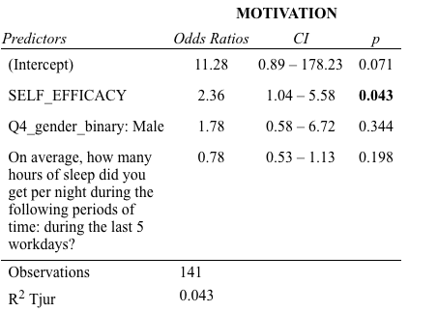

**Attitude related to motivation**

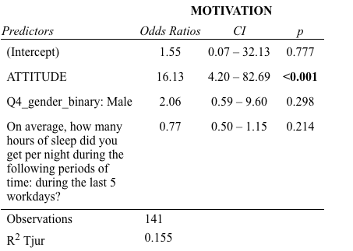

**Emotions/feelings related to motivation**

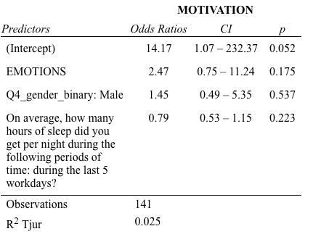

**Motivation related to intention**

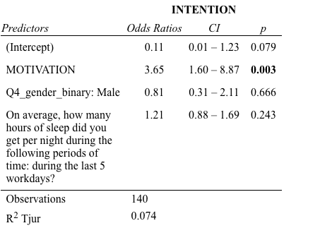

**Intention related to high exposure (defined as >75%ile of days performing activities [15 days cumulative])**

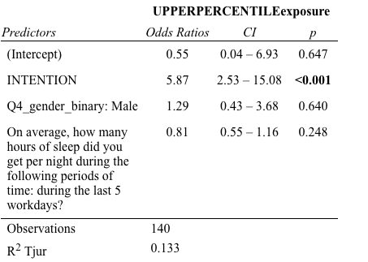

**High exposure (defined as >75%ile of days performing activities [15 days cumulative]) vs. mid to low exposure < 15 days related to being happy with sleep**

