**1050 Programming Logic**

Lab 6 (14 points total)

Name: **Angela Dennis**

***Paste your code and screenshots of the console as below.***

1. Use a while loop and if statement to write a program that prints the next 20 leap years (2 points).

int year;

Console.Write("Enter year (yyyy): ");

year = Convert.ToInt32(Console.ReadLine());

int leap = year;

while (year <= (leap + 20))

{

year++;

if (year % 400 == 0)

Console.WriteLine("Year {0} is Leap", year);

else if (year % 100 == 0)

Console.WriteLine("Year {0} is not a Leap Year", year);

else if (year % 4 == 0)

Console.WriteLine("Year {0} is a Leap Year", year);

else

Console.WriteLine("Year {0} is not a Leap Year", year);

}

Console.Write("\nPress any key to exit...");

Console.ReadKey(true);

}

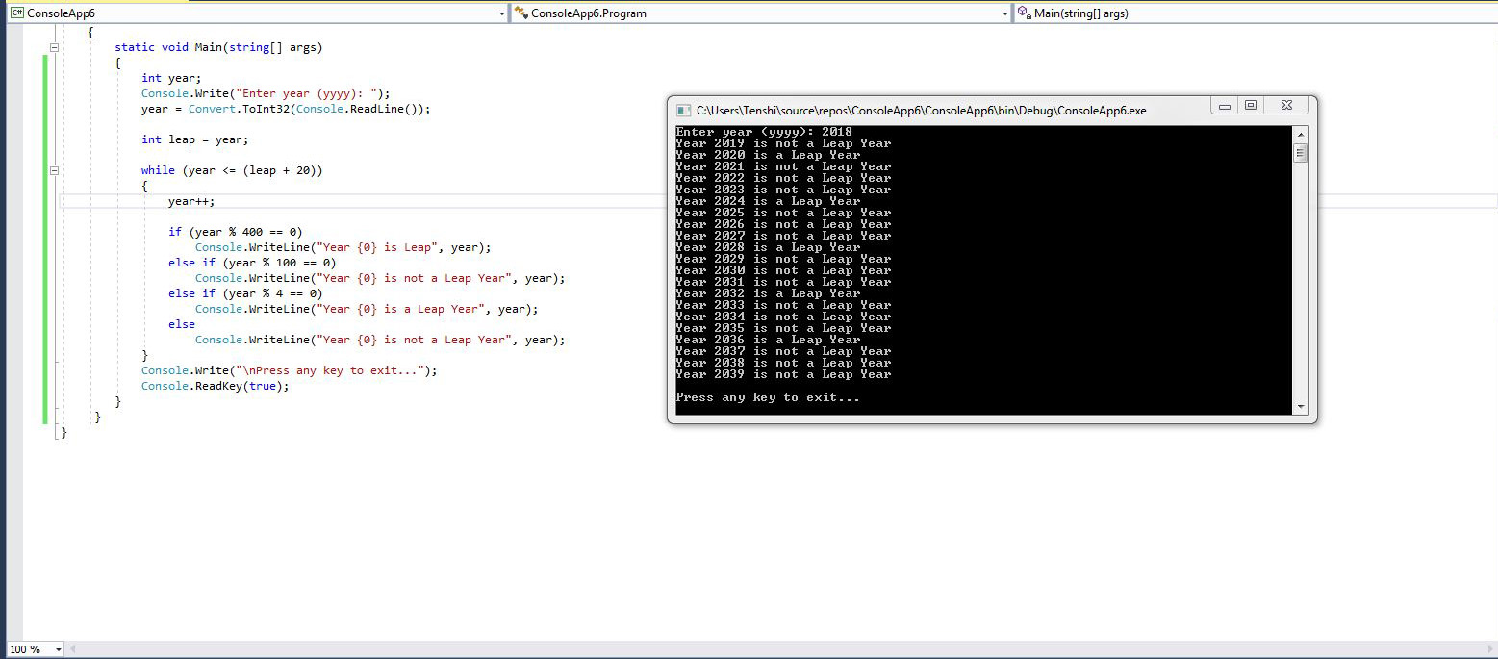

1. Write a guessing game where the user has to guess a secret number. After every guess the program tells the user whether their number was too large or too small. At the end the number of tries needed should be printed. To keep it simple, input the number at the beginning of the game. (6 points)

Console.WriteLine("Let's play a game! How many times did the Cleveland Cavaliers win in a row in 2017?\n" +

"You have to guess the number in 6 tries.");

int x = 13;

bool rightAnswer = false;

for (int i = 1; i <= 6; i++)//i=increment(counter)

{

Console.Write("\nNumber of guesses is at " + i + ". Enter your number: ");

int n1 = Convert.ToInt32(Console.ReadLine());

if (n1 == x)

{

Console.WriteLine("\nYes, you answered right! They tied the franchise record when they managed that!");

rightAnswer = true;

break;

}

bool highAnswer = false;

bool lowAnswer = false;

if (x > n1)

highAnswer = true;

if (n1 > 13)

{

if (highAnswer == false)

Console.WriteLine("Your guess is too high, go lower!");

}

if (x < n1)

lowAnswer = true;

if (n1 < 13)

{

if (lowAnswer == false)

Console.WriteLine("Your guess is too low, go higher");

}

}

{

if (rightAnswer == false)

Console.WriteLine("\nAww too bad, you're out of tries. The correct number is: " + x + " times! Go Cavs!");

}

Console.Write("\nPress any key to exit...");

Console.ReadKey(true);

}

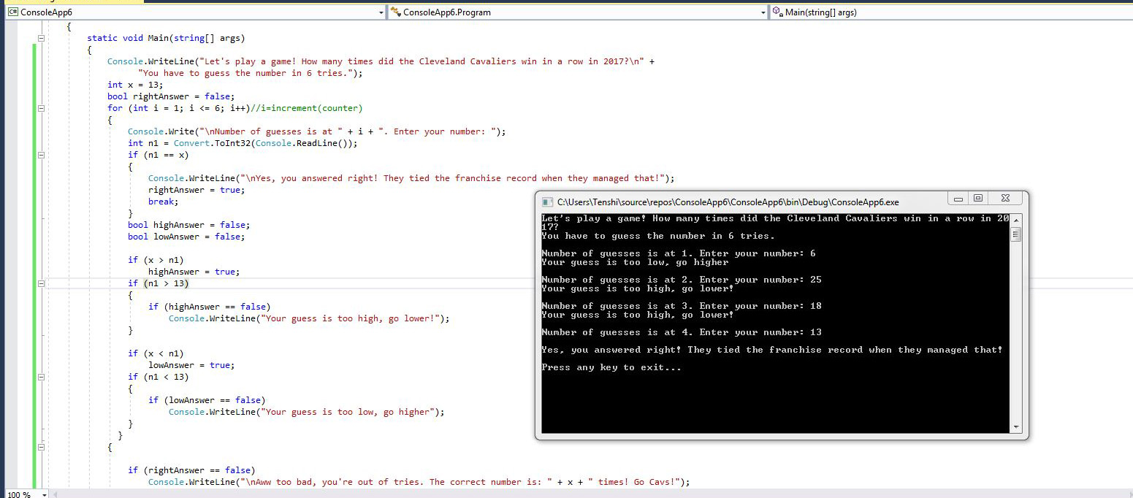

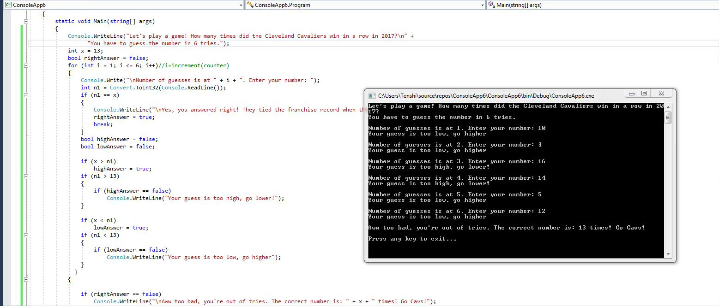

1. Create a while loop. The while loop will continue to run until the user inputs a value of “E”. During the loop, accept two other inputs: grocery item and cost. Keep a running total of the cost. Also, add the item to a string. When the loop is complete, display the items and the total cost. (6 points)

Example:

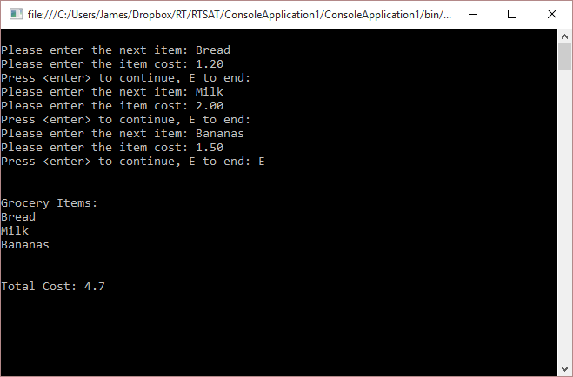

Example Code for keeping track of grocery items:

Console.Write("Please enter the next item: "); // this would go before the while loop

item = Console.ReadLine(); // this would go in the while loop

allItems += item + "\n";

Console.WriteLine("A while loop for keeping track of grocery items:\n");

string item;

double cost;

List<string> items = new List<string>();

List<double> costs = new List<double>();

string E = "";

while (true)

{

Console.Write("Please enter the next item: ");

item = Console.ReadLine();

items.Add(item);

Console.Write("Please Enter the cost of the item: $");

cost = Convert.ToDouble(Console.ReadLine());

costs.Add(cost);

Console.Write("Press <ENTER> to continue, E to end: \n");

E = Console.ReadLine();

if (E == "E")

{

Console.WriteLine("\nGrocery Items: ");

for (int i = 0; i <= items.Count() - 1; i++)

{

Console.WriteLine(items[i].ToString());

}

Console.Write("\nTotal Cost: $");

double sum = costs.Sum();

Console.WriteLine(sum);

Console.WriteLine();

break;

}

}

Console.Write("\nPress any key to exit...");

Console.ReadKey(true);

}

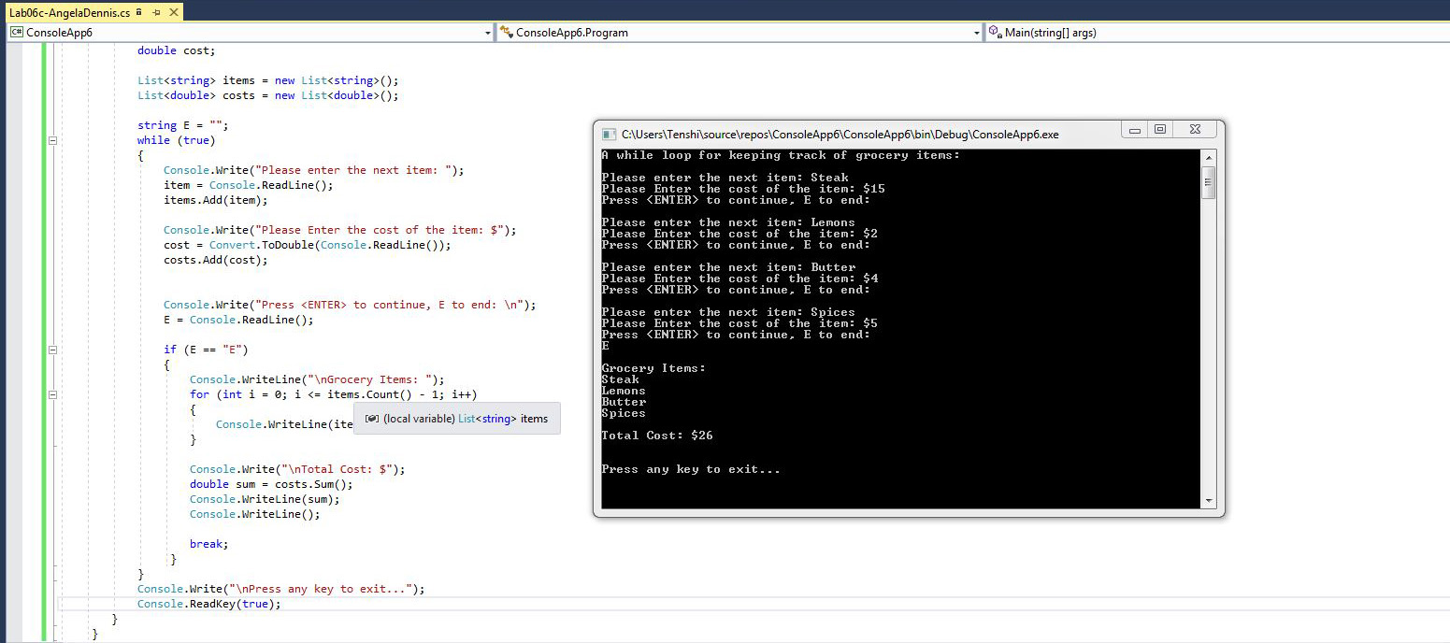

**Deliverables:**

When Complete, please push to GitHub and submit the URL to your repository in Blackboard.