**1050 Programming Logic**

**NAME: Angela Dennis**Lab 07 (25 points total)

1. Create a project called Lab07.

2. Create a class called MyMath. Implement the following properties and methods:

|  |
| --- |
| **MyMath** |
| double result  double operand1  double operand2 |
| public void Multiply (double operand1, double operand2)  public void Divide (double operand1, operand2)  public void Subtract (double operand1, double operand2)  public void Add (double operand1, operand2)  public double GetResult() |

namespace Lab07

{

class MyMath

{

public double result { get; set; }

public double operand1 { get; set; }

public double operand2 { get; set; }

public void Multiply(double operand1, double operand2)

{

result = operand1 * operand2;

}

public void Divide(double operand1, double operand2)

{

result = operand1 / operand2;

}

public void Subtract(double operand1, double operand2)

{

result = operand1 - operand2;

}

public void Add(double operand1, double operand2)

{

result = operand1 + operand2;

}

public double GetResult { get; set; }

}

}

3. Create an object or type MyMath in Program.cs and call each of your methods to test them. Output the value of GetResult each time.

namespace Lab07

{

class Lab07_AngelaDennis

{

static void Main(string[] args)

{

MyMath Result = new MyMath();

Console.Write("Enter first amount: ");

int operand1 = Convert.ToInt32(Console.ReadLine());

Console.Write("Enter second amount: ");

int operand2 = Convert.ToInt32(Console.ReadLine());

Result.Multiply(operand1, operand2);

Console.WriteLine("If we multiply that number we get " +Result.result);

Result.Divide(operand1, operand2);

Console.WriteLine("If we divide that number we get " + Result.result);

Result.Add(operand1, operand2);

Console.WriteLine("If we add that number we get " + Result.result);

Result.Subtract(operand1, operand2);

Console.WriteLine("If we subtract that number we get " + Result.result);

Console.Write("\nPress any key to exit...");

Console.ReadKey(true);

}

}

}

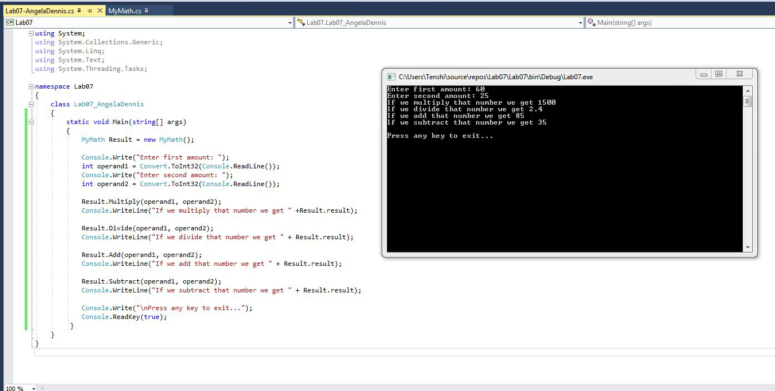

Once complete, push your project to github and submit the URL to your repository in Blackboard.