**Water Polo – A parent’s guide Jan 2025**

Welcome to Tiverton Water Polo Club! Our club has Mini, U11, U13’s, U15’s, U17, and Seniors cohorts. The club’s vision is to have U13’s, U15’s & Senior teams compete in the Devon League by 2028. There are also opportunities to attend county and regional training sessions.

Suitable for ages 5+, children develop water confidence, learn ball skills, teamwork, make new friends and have loads of fun! As they progress, children will move up to our junior teams and onwards!

**Water Polo Training/Matches at Tiverton.**

**When do we train?**

We train on Saturday afternoon at Exe Valley Leisure Centre:

* 2.30-2.55pm (& 2.00-2.25pm in due course) – Minis in the learner pool.
* 2-2.30pm – U11s shallow end of the main pool.
* 2-3pm – U13s, U15s in the main pool.
* 3-4pm – U17, Seniors in the main pool.

**When do we play matches?**

Home matches are either played during our training session or the club will hire the pool specifically for the event. This might mean a change of training time for some groups. We will play in the Devon League (running from January to October) with teams from Barnstaple, Taunton, Exeter, Paignton, Newton Abbot and Devonport (Plymouth). Up to the age of 18, Water Polo is a mixed sport where boys and girls play together.

* U11 – friendlies with a few tournaments at various clubs.
* U13 – tournaments organised by different clubs.
* U15 – home and away league matches.
* Senior (mixed inc U17s) – friendly home and away matches.
* Men’s (inc U17s) – friendly and league matches home and away.

We use WhatsApp as our main form of communication for training/match availability and selection. There are two WhatsApp Groups, one for Juniors and one for Seniors.

**Further training and development opportunities**

Devon County run trials and training from around September. Please contact:

[beckybellett@yahoo.co.uk](mailto:beckybellett@yahoo.co.uk)

The next step would be training with the South-West RTC (Regional Training Centre). Training is roughly held once a month at Millfield School on a Saturday afternoon costing £15 per session. If you are interested, then please contact:

Boys – [southwestboysacademy@gmail.com](mailto:_southwestboysacademy@gmail.com)

Girls – [southwest.wp.girls@gmail.com](mailto:southwest.wp.girls@gmail.com)

The next level is the Regional Talent Centre in Bristol where training is approximately 7 sessions per year on Sundays. This will cost £40 per month. You will be invited to trial for this through the RTC. The contact for the talent centre is Sue Webb:

[sweb07@outlook.com](mailto:sweb07@outlook.com)

**A Water Polo session**

An hour Water Polo session is roughly be split up as follows:

* 10 Min Swimming.
* 20-30 Skills.
* 20-30 Mini game.

**Playing Water Polo – The Basics!**

* A team is made up of 7 players in the water, with a maximum of 13 players in total. There are rolling subs, so players can get in and out at any time, although this usually only happens when a goal has been scored.
* It is a contact sport, with referees very vigilant on foul play. However, they are only human...
* To identify your teammates, everyone wears a cap, one team wear blue hats and one team in white hats. These hats have ear protectors and have numbers on the side so that you can tell your teammates who you are marking.

**Rules**

The full rules of water polo are long and complicated. This guide covers the main rules of the game as played at club level.

**U11**

* Played in the shallow end so players can stand but are not allowed to walk or jump off the bottom of the pool.
* Players may catch the ball with two hands but must throw the ball with one hand.
* 2 metres area will be marked away from each goal. No players apart from the goalkeeper will be allowed inside 2m.
* Apart from goalkeeper, you cannot block a pass/shot with 2 hands.
* Minor Fouls (a free throw where the defenders must move 1m away):
* Throwing the ball with 2 hands.
* Taking the ball under the water.
* Walking with the ball.
* Hitting the ball with closed fist.
* Swimming on or over other players.
* Players cannot wait within 2m but may dribble the ball into the 2m zone.
* Major (exclusion) Fouls (player sent out for 20seconds):
* Holding another player and preventing them moving.
* Swimming over another player.
* Splashing, sinking or pushing another player.
* Kicking or striking another player.

**U13/U15/U17/Seniors**

Players must pass, catch and shoot with only 1 hand. Goalkeepers may use 2 hands.

* Taking the ball under water when being marked by another player is a turnover (ball given to opposition).
* Players may not touch the bottom of the pool or hang on the wall. If they can touch the bottom of the pool, they must not push up off it.
* Games consist of 4 quarters and typically last 45 minutes to 1 hour in total.
* You must shoot within 30 seconds of your team having the ball.
* Minor fouls occur frequently and result in a free pass. There is no limit for players to give away minor fouls.
* If a player receives 3 major fouls (being sent out), that player may not return to the game.

**Minor Fouls**

If you do one of these minor fouls below, the referee will blow his whistle and signal with his arm the team which has the free throw (the defending team must retreat 1metre):

* Standing, walking or jumping off the bottom when playing (okay for the keeper to do this within his 6m area).
* Use two hands to hold or play the ball (okay for the keeper to do this within his 6m area).
* Punching the ball with a clenched fist (okay for the keeper to do this within his 6m area).
* Pushing an opponent who is not holding the ball.
* Taking the ball under water when being marked.
* Holding onto the wall/goalpost or pushing off from it during play.
* Be within 2m of the opponents’ goal ahead of the ball.
* Delay taking a free throw (Roughly 3 seconds).

You must take a free throw immediately. If you don’t pass the ball, you must either put it on the water or toss it up in the air to show that you’re putting it into play. Not waving it about!

If you are taking a free throw within 6m, you cannot shoot at goal yourself. You can swim with the ball, but not shoot it.

**Exclusion Fouls**

If you do one of these, the referee will whistle loudly, point to you and signal you out. You must swim back to your corner and get out without interfering with play. Your opponent gets a free throw, and you have to stay out for 20 seconds of play or until they score a goal. If your team regains possession, the referee can signal you (or a substitute) to get in immediately. If you commit three exclusion and/or penalty fouls during the game, you cannot play any more:

* Hold, sink, pull back or impede an opponent who is not holding the ball.
* Intentionally kick or strike an opponent or splash water in their face.
* Interfere with the taking of a free throw (you must visibly move back 1m before putting a hand up).
* Attempt to block a pass or shot with two hands outside the 6m area.
* Improper re-entry after an exclusion (diving or jumping into the pool or pushing off the wall).
* Misconduct (you will be “wrapped” and cannot play any more).

**Penalty Fouls**

These result in the other team being awarded a penalty. You stay in the pool if you were playing at the time, unless it’s your third personal foul.

* A foul within 6m that prevents a probable goal. This includes holding, sinking, pulling back or impeding; attempting to block a pass or shot with two hands; punching the ball; tackling the shooter from behind when he’s facing the keeper, even if he is holding the ball.
* A defender within 6m kicking or striking an opponent.
* An excluded player intentionally interfering with play or not proceeding to the exclusion area (e.g. throwing the ball away).
* Illegal entry (rejoining after your third exclusion foul or becoming an 8th player in the pool) or incorrect rolling substitution procedure and touching touching the goal line ropes.
* Brutality (you will be “wrapped” and your team have to play man down for 4 minutes).

**Other Rules**

If the keeper deflects a shot out of play, the attacking team are awarded a corner throw. But if any other defender does this, the defending team are awarded a goal throw. If a defender commits an ordinary foul outside his 5m area, the attacking team can take an immediate direct shot at goal. Goalkeepers – stay awake!

**Pitch Markings**

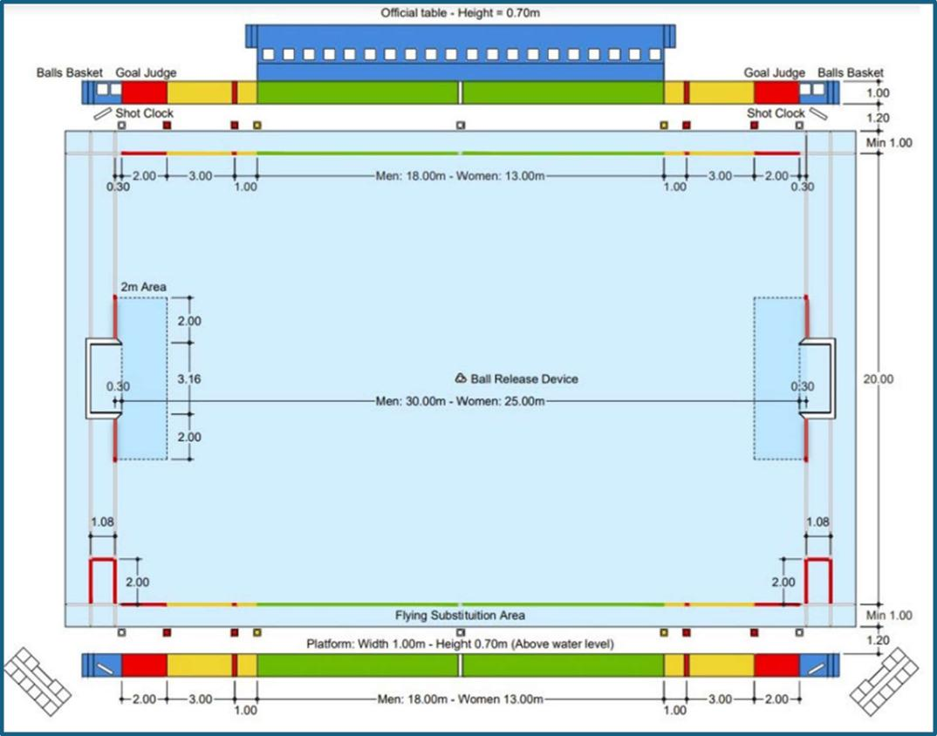

**Key Skills**

The following section are the key skills that players need to learn. Beside them are the age groups that are roughly linked to that skill and where it is **introduced**.

* Head Up Front Crawl (U11/U13).
* Water Polo Backstroke (U11/U13/U15).
* Eggbeater (U13+)
* Passing and Receiving (U11/U13/U15).
* Shooting Position (U11/U13/U15).
* Defending (U13/U15/U17).

**Head Up Front Crawl (U11/U13)** **Water Polo Backstroke (U11/U13/U15)**

**Eggbeater (U13/U15) (one of the hardest things to master!)**

**Passing and Receiving (U11/U13/U15)**

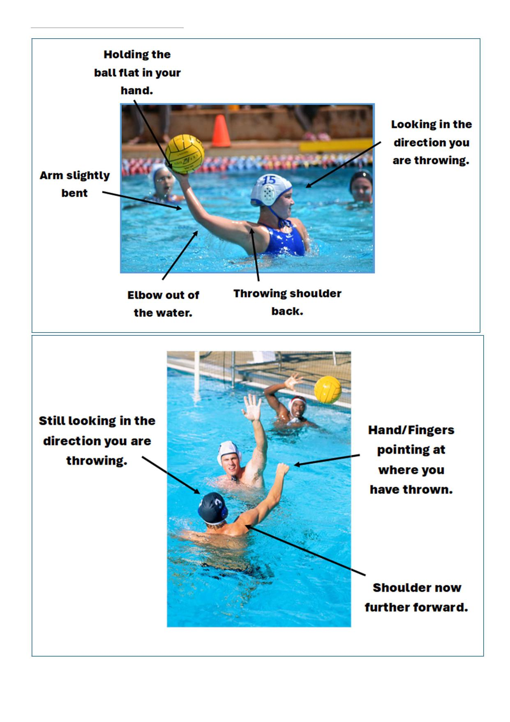

**Shooting Position (U11/U13/U15)**

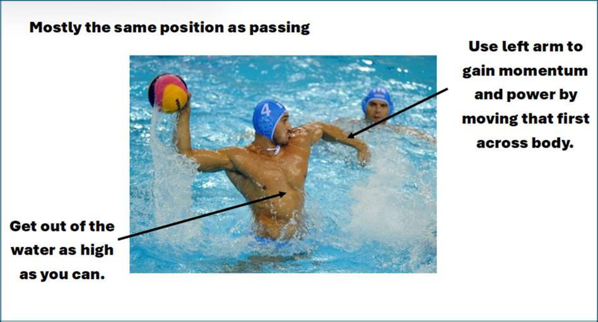

**Defending (U13/U15/U17)**

If you are marking someone who has not got the ball, the basic rule is “hand on, hips up, head on a swivel”

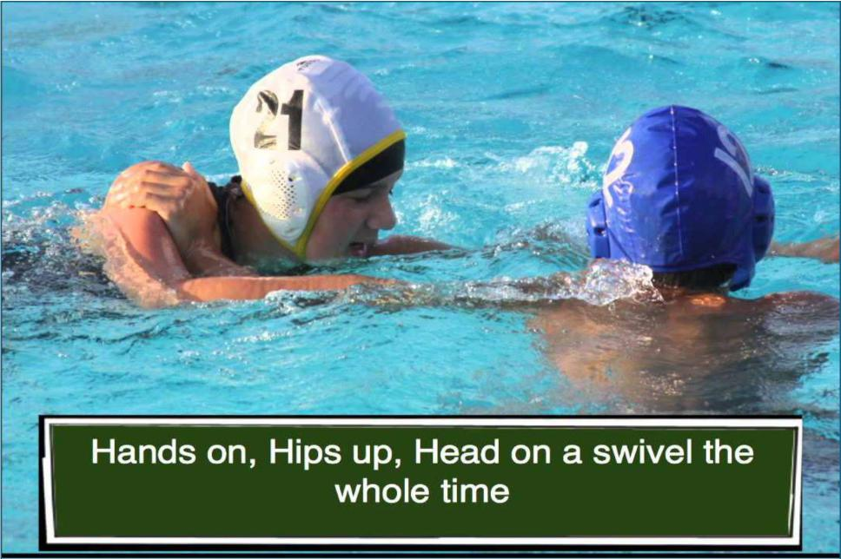

* **Hands on** – so you know where they are at all times, even when not looking at them, you are close enough to possibly compete for the ball if it is passed to them.
* **Hips up** – this is so you can jump in front of the player as the ball is going to them. Also, it is quicker to counterattack with you already in the swimming position, ie horizontal!
* **Head on a swivel** – watch the ball. Is it being passed to the player you are marking? Can you intercept it? Also, has someone else from your team won the ball so you can counterattack?

If the player you are marking has the ball...Put pressure on them by going towards them:

* Breaststroke or eggbeater kick (getting yourself out of the water and moving towards them).

* Mirror block with the hand opposite the hand they are holding the ball. This creates a block if they decide to pass or shoot.

* Scull or do front crawl arm action with the other hand with the aim of getting to them as quickly as possible without stopping the block.
* Once you are there, you could continue to push them backwards by continuing to swim front crawl. You cannot go over them, but you can push them all the way back....the further they are from the goal, the less likely they are going to shoot (and score!).

