CLOUD GALLERY

- SYSTEM ARCHITECTURE DIAGRAM

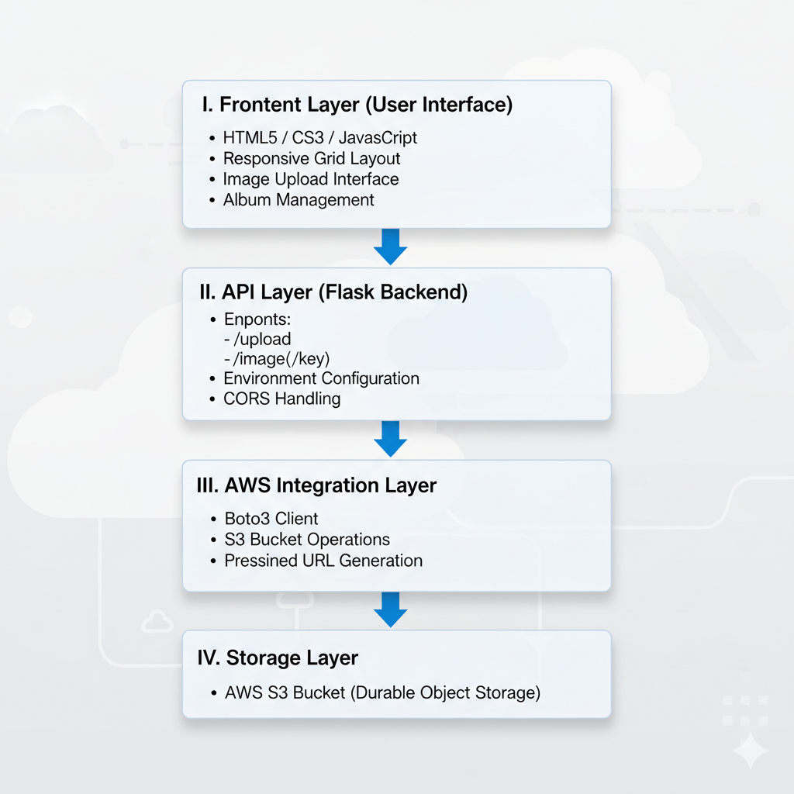

OUTPUTS

- AWS S3 BUCKET FOR STORAGE
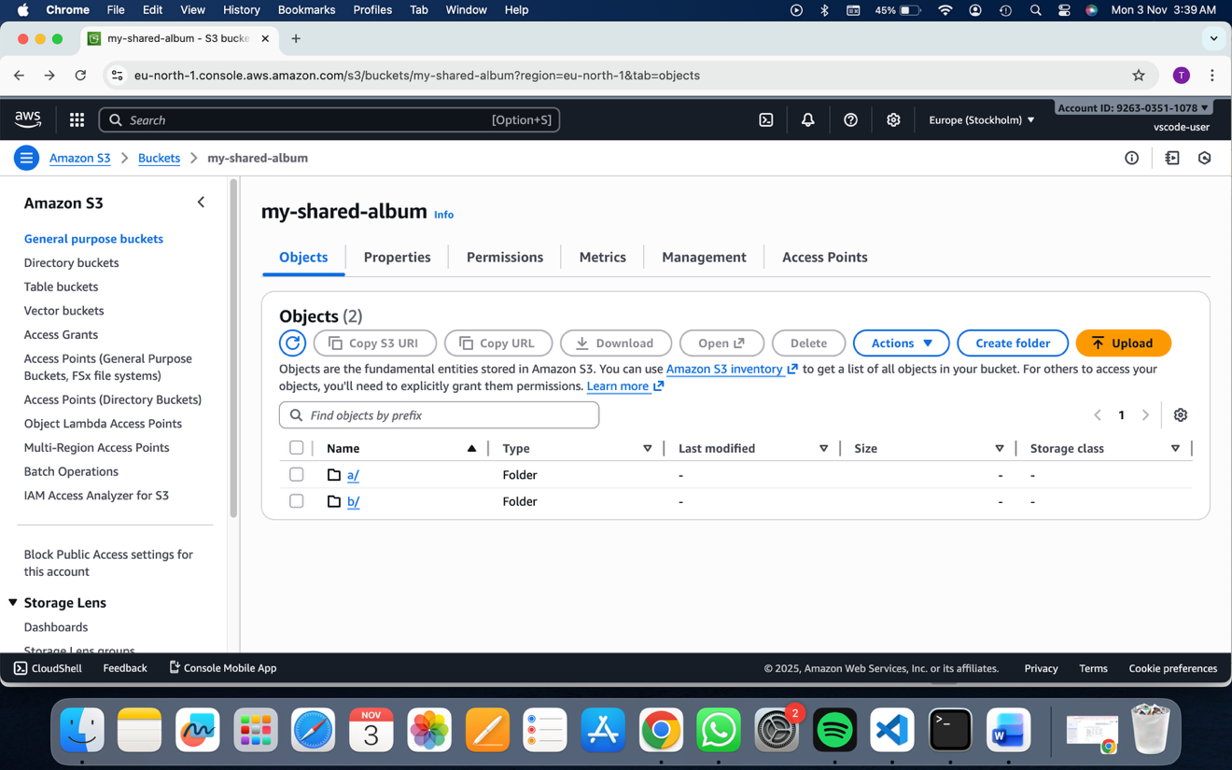

- USER INTERACTION
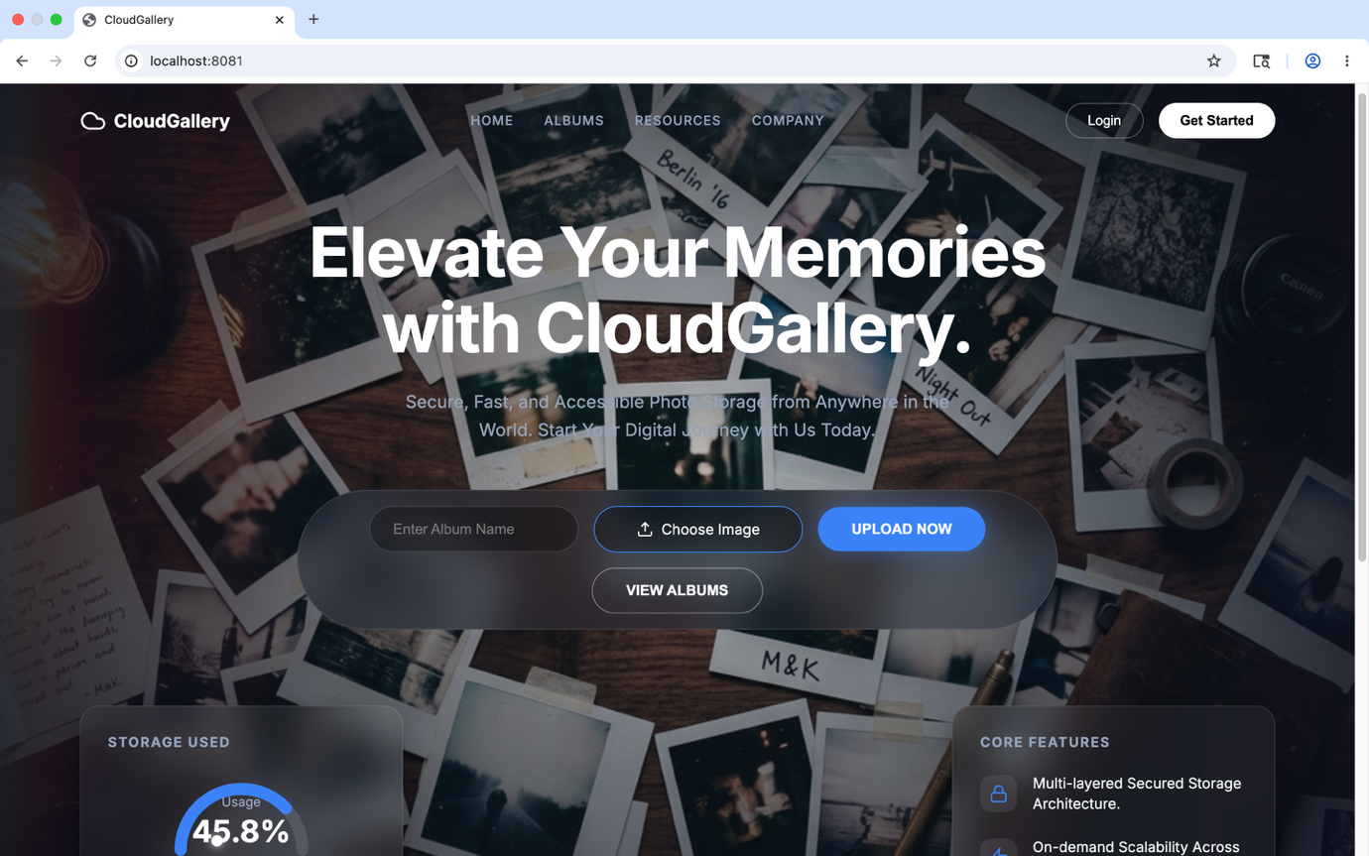
- VARIOUS IMAGE FORMATS AND SIZES
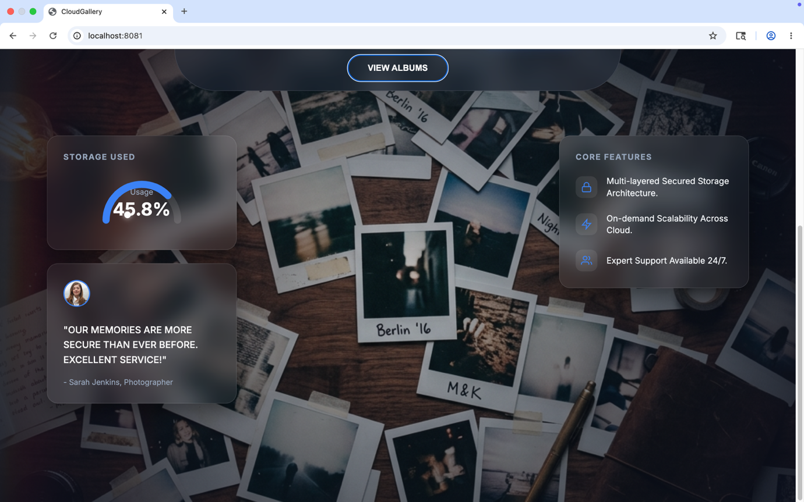

PROMETHEUS AND GRAFANA MONITORING

- Request count created
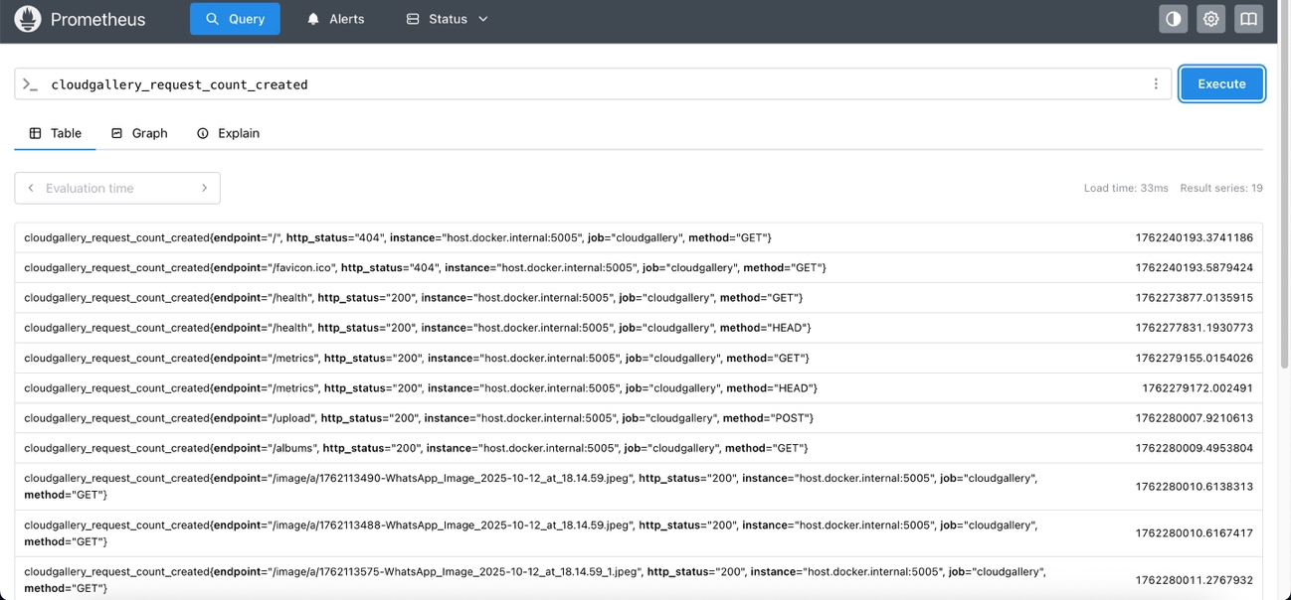

- Total request count
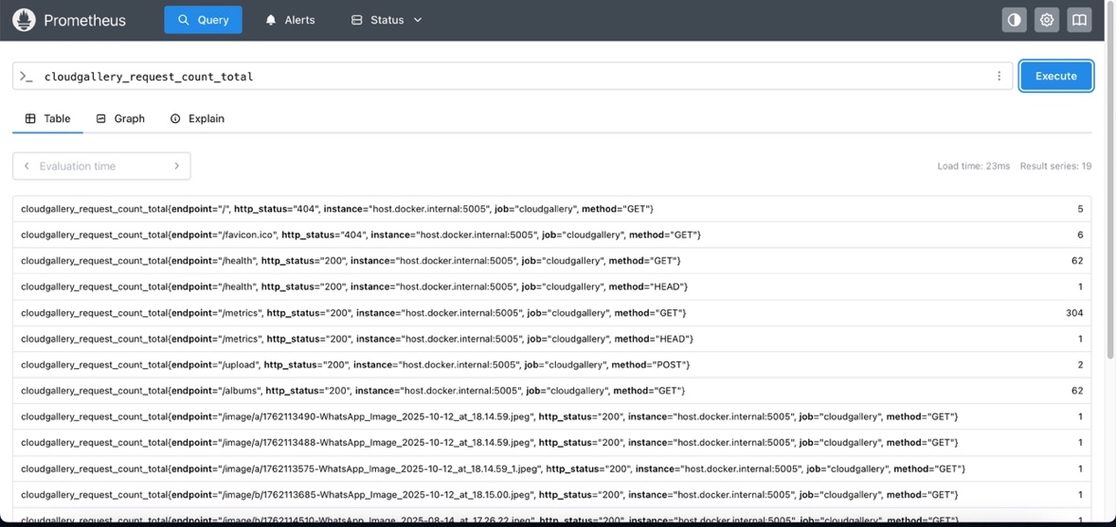

- Status – Target Health
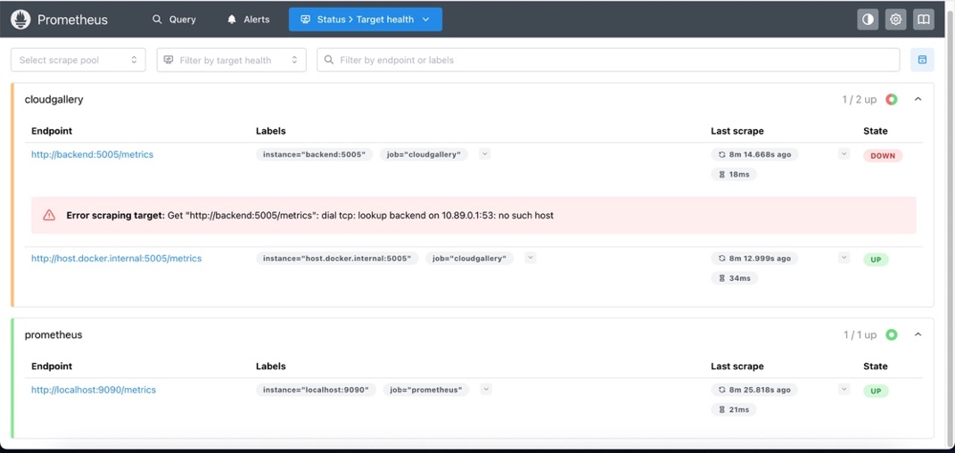

- Process Resident Memory
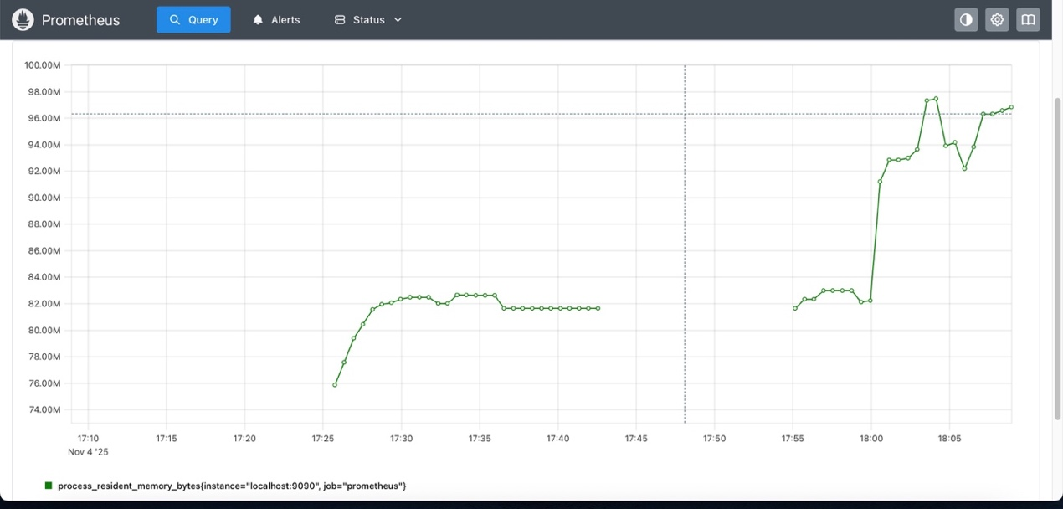
- Average Request Latency
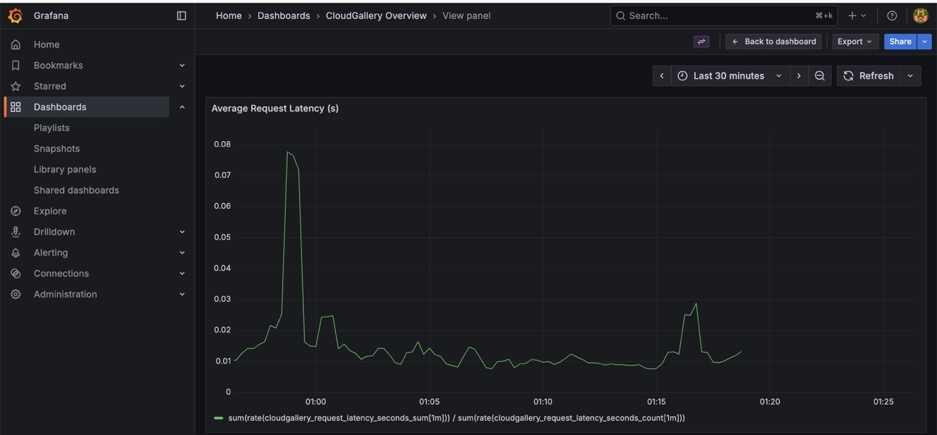

- Backend Memory
