CUSTOMER BEHAVIOUR ANALYSIS QUERIES
PROBLEM STATEMENT

1. WHAT IS THE TOTAL REVENUE GENERATED BY MALE VS FEMALE CUSTOMERS?
SELECT gender,
SUM(purchase_amount) AS revenue
FROM customer_shopping
GROUP BY gender;

OUTPUT:
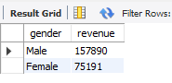
2. WHICH CUSTOMERS USED A DISCOUNT BUT STILL SPENT MORE THAN THE AVERAGE AMOUNT?
SELECT customer_id,
purchase_amount
FROM customer_shopping
WHERE discount_applied = 'Yes'
AND purchase_amount >= (
SELECT AVG(purchase_amount)
FROM customer_shopping
);
OUTPUT:
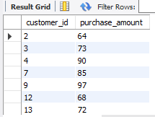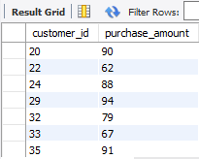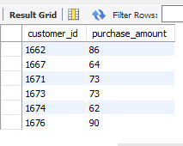
3. WHICH ARE THE TOP 5 PRODUCTS WITH THE HIGHEST AVERAGE REVIEW RATINGS?
SELECT item_purchased,
ROUND(AVG(review_rating),2) AS Average_Product_Rating
FROM customer_shopping
GROUP BY item_purchased
ORDER BY AVG(review_rating) DESC
LIMIT 5;

OUTPUT:
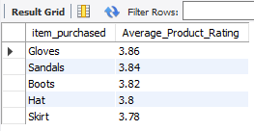
4. COMPARE THE AVERAGE PURCHASE AMOUNTS BETWEEN STANDARD AND EXPRESS SHIPPING?
SELECT shipping_type,
ROUND(AVG(purchase_amount),2) AS avg_purchase_amount
FROM customer_shopping
WHERE shipping_type IN ('Standard','Express')
GROUP BY shipping_type;
OUTPUT:
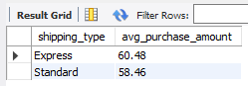
5. DO SUBSCRIBE CUSTOMER SPEND MORE?
SELECT subscription_status,
COUNT(customer_id) AS total_customers,
ROUND(AVG(purchase_amount),2) AS avg_spend,
ROUND(SUM(purchase_amount),2) AS total_revenue
FROM customer_shopping
GROUP BY subscription_status
ORDER BY total_revenue DESC;
OUTPUT:
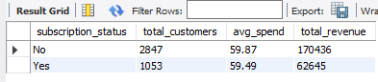
6. WHICH 5 PRODUCTS HAVE HIGHEST PERCENTAGE OF PURCHASE WITH DISCOUNTS APPLIED?
SELECT item_purchased,
ROUND(
100.0 * SUM(
CASE
WHEN discount_applied = 'Yes' THEN 1
ELSE 0
END
) / COUNT(*),
2) AS discount_rate
FROM customer_shopping
GROUP BY item_purchased
ORDER BY discount_rate DESC
LIMIT 5;

OUTPUT:
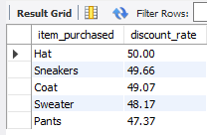
7.SEGMENT CUSTOMERS INTO NEW, RETURNING AND LOYAL.
WITH customer_type AS (
SELECT customer_id,
previous_purchases,
CASE
WHEN previous_purchases = 1 THEN 'New'
WHEN previous_purchases BETWEEN 2 AND 10 THEN 'Returning'
ELSE 'Loyal'
END AS customer_segment
FROM customer_shopping
)
SELECT customer_segment,
COUNT(*) AS Number_of_Customers
FROM customer_type
GROUP BY customer_segment;

OUTPUT:
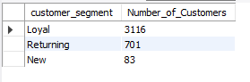
8.WHAT ARE TOP 3 MOST PURCHASED PRODUCTS WITHIN EACH CATEGORY?
WITH item_counts AS (
SELECT category,
item_purchased,
COUNT(customer_id) AS total_orders,
ROW_NUMBER() OVER (
PARTITION BY category
ORDER BY COUNT(customer_id) DESC
) AS item_rank
FROM customer_shopping
GROUP BY category, item_purchased
)
SELECT item_rank,
category,
item_purchased,
total_orders
FROM item_counts
WHERE item_rank <= 3;
OUTPUT:
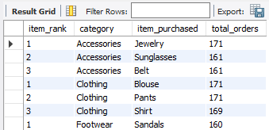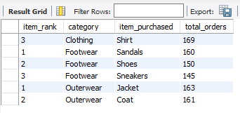

9.ARE CUSTOMERS WHO ARE REPEAT BUYERS ALSO LIKELY TO SUBSCRIBE?
SELECT subscription_status,
COUNT(customer_id) AS repeat_buyers
FROM customer_shopping
WHERE previous_purchases > 5
GROUP BY subscription_status;

OUTPUT:
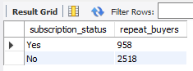

10. WHAT IS THE REVENUE CONTRIBUTION OF EACH AGE GROUP?
SELECT age_group,
SUM(purchase_amount) AS total_revenue
FROM customer_shopping
GROUP BY age_group
ORDER BY total_revenue DESC;
OUTPUT:
