Profit Leakage & Festive Growth Analysis
Indian Retail Business Intelligence Dashboard

Project Report | Python + Dash + Plotly + scikit-learn
Dataset: sales_data.csv | 20,000 Orders | 2023-2025
Generated: 05 October 2026

1. Project Overview
This project delivers a full-stack interactive Business Intelligence (BI) dashboard built entirely in Python to analyse 20,000 retail transactions from an Indian retail business covering the period January 2023 to December 2025. The dashboard is designed to address two core business challenges: identifying profit leakage caused by excessive discounting, and measuring the impact of Indian festive seasons on sales growth.
The application is structured as a single self-contained Python file (main_app.py) that integrates a data analytics backend, two trained machine learning models, and a Dash-based web frontend with five interactive analysis tabs.

1.1 Objectives
- Quantify profit leakage from discount abuse across products and categories
- Measure festive season sales uplift and margin impact
- Identify top-performing and underperforming regions and cities
- Compare channel and payment method profitability
- Segment customers by age, gender, and spending behaviour
- Train ML models to predict profit and classify high-discount risk orders

2. Technology Stack
Frontend Framework | Dash 4.x + Dash Bootstrap Components
Visualisation | Plotly 6.x — interactive charts, heatmaps, treemaps
Data Processing | Pandas 2.x + NumPy
Machine Learning | scikit-learn (RandomForest, GradientBoosting) + joblib
Styling | Custom CSS — saffron / Indian tricolour palette
Language | Python 3.10+
Data Source | sales_data.csv (20,000 rows, 17 columns)

3. Project Structure
The project is organised as follows:
Ibm project/
sales_data.csv -- Source dataset (20,000 orders)
profit_leakage_dashboard/
main_app.py -- Single file: Analytics + ML + Dashboard
app.py -- Modular frontend (original)
analytics.py -- Analytics backend module
requirements.txt -- Python dependencies
README.md -- Project documentation
assets/style.css -- Dashboard theme
models/
profit_regression.pkl -- Trained RandomForest regressor
leakage_classifier.pkl -- Trained GradientBoosting classifier
leakage_scaler.pkl -- StandardScaler for classifier
screenshots/ -- UI screenshots

4. Dataset Description
The dataset sales_data.csv contains 20,000 retail transaction records across 17 columns spanning Indian cities from 2023 to 2025.
order_id | Unique order identifier (ORD100001...)
order_date | Transaction date — 2023-01-01 to 2025-12-31
customer_id | Customer identifier (C00001...)
gender | Male / Female
age | Customer age (integer)
region | North / South / East / West
city | 17 Indian cities (Mumbai, Delhi, Bengaluru, etc.)
category | Electronics, Clothing, Beauty, Home & Kitchen, Books
product | Product name
unit_price | Price per unit in INR
quantity | Units purchased per order
discount | Discount fraction (0.0 to 0.5)
sales | Net sales = unit_price * quantity * (1 - discount)
profit | Profit earned on the order
channel | Store / Online / Mobile App
payment_method | UPI / Cash / Credit Card / Cash on Delivery
rating | Customer satisfaction rating (1.0 to 5.0)

5. Key Business Findings
Total Revenue Lost to Discounts | Rs. 1.50 Crore (leakage ratio: 6.32%)
Average Profit Margin | 15.46% across all 20,000 orders
High-Discount Orders (>10%) | 4,020 orders out of 20,000 (20.1%)
Festive Season Sales Uplift | +4.91% avg order value vs regular months
Festive Avg Order Value | Rs. 11,333 vs Rs. 10,804 regular
Top Region by Sales | South — Rs. 7.01 Crore
Best Profit Margin Region | North — 15.8%
Most Leakage Region | South — Rs. 47.24 Lakh lost
Total Cities Covered | 17 cities across 4 regions
Top Category by Leakage | Electronics (highest discount revenue lost)

6. Dashboard User Interface
The dashboard is accessible at http://127.0.0.1:8050 after running main_app.py. It features a global filter bar (Category, Region, Channel, Date Range) and six interactive tabs. All charts respond to filter changes in real time.

6.1 Tab 1 — Profit Leakage
Shows total revenue lost to discounts, the relationship between discount bands and profit margins, top 15 products causing leakage, and a per-product scatter plot of discount % vs profit margin.
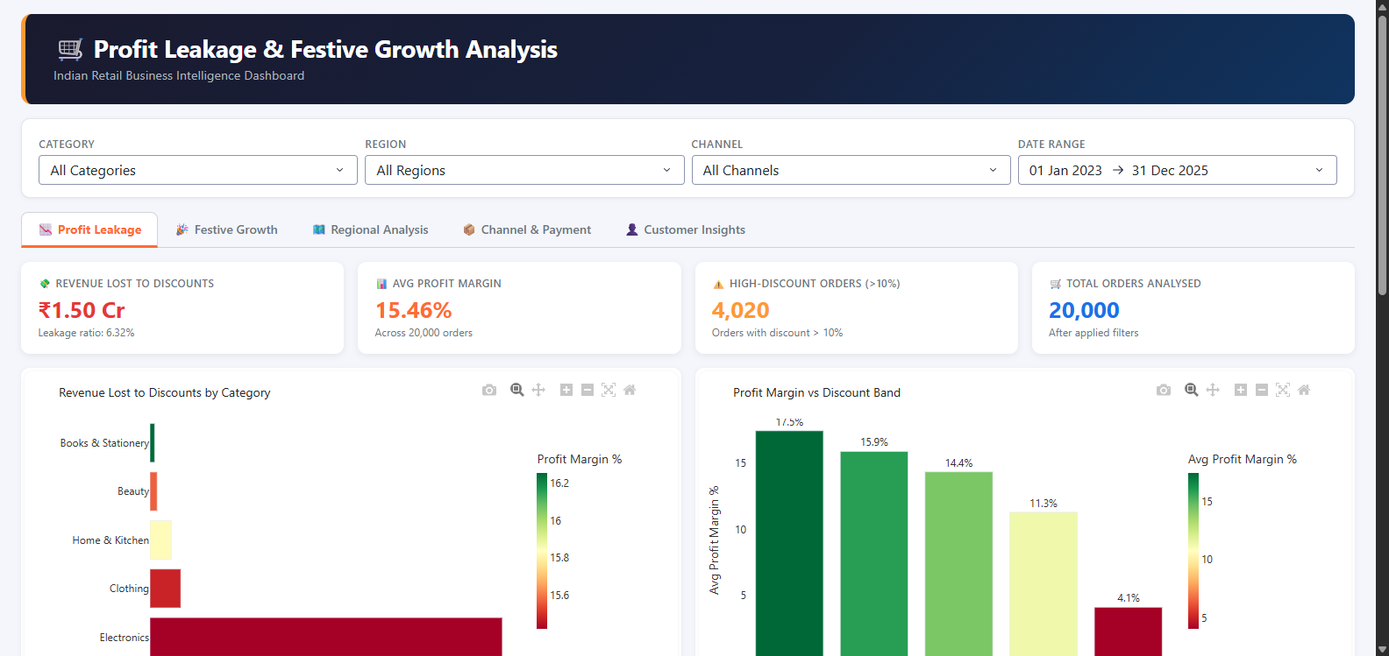
Figure 1: Profit Leakage Tab — KPI cards, category leakage bar, discount band analysis

6.2 Tab 2 — Festive Growth
Displays monthly sales and profit trend with festive periods (Diwali, Navratri, Holi, Raksha Bandhan, Makar Sankranti) highlighted. Compares festive vs regular avg order values by category and shows month-wise margin variation.
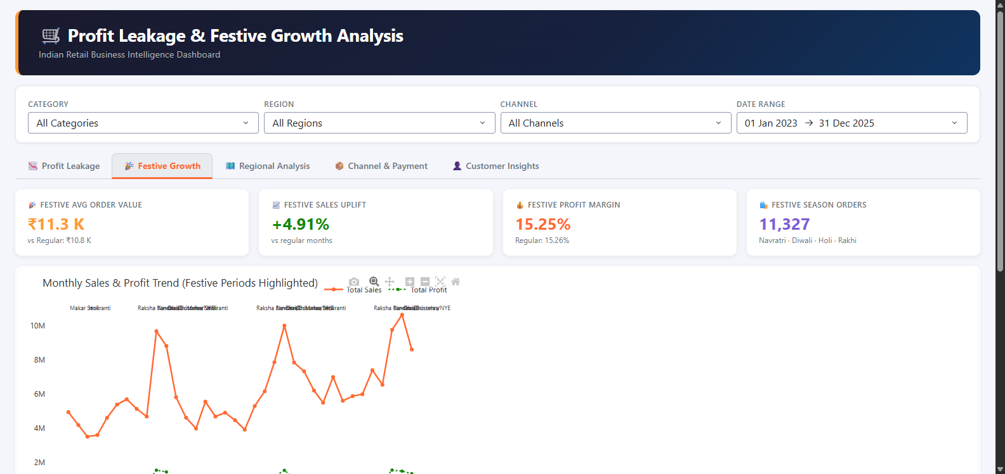
Figure 2: Festive Growth Tab — Monthly trend with festive highlights, category comparison

6.3 Tab 3 — Regional Analysis
Presents region-level sales and profit grouped bars, a sales distribution donut chart, a treemap of top 20 cities coloured by profit margin, and region-wise discount leakage.
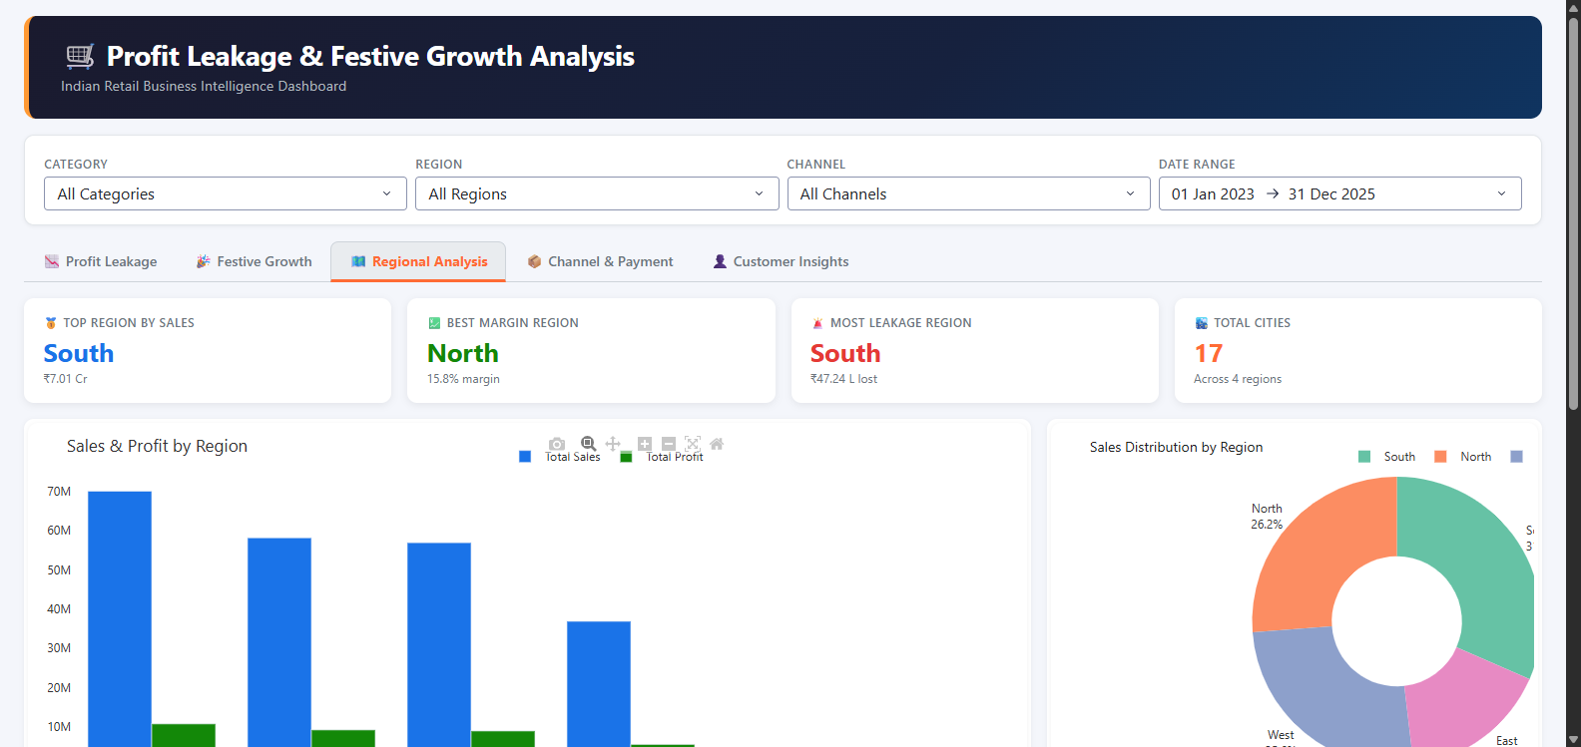
Figure 3: Regional Analysis Tab — Sales by region, city treemap, leakage breakdown

6.4 Tab 4 — Channel & Payment
Analyses Store, Online, and Mobile App channel profitability, payment method order share, a channel vs customer satisfaction scatter, and a category-channel profit margin heatmap.
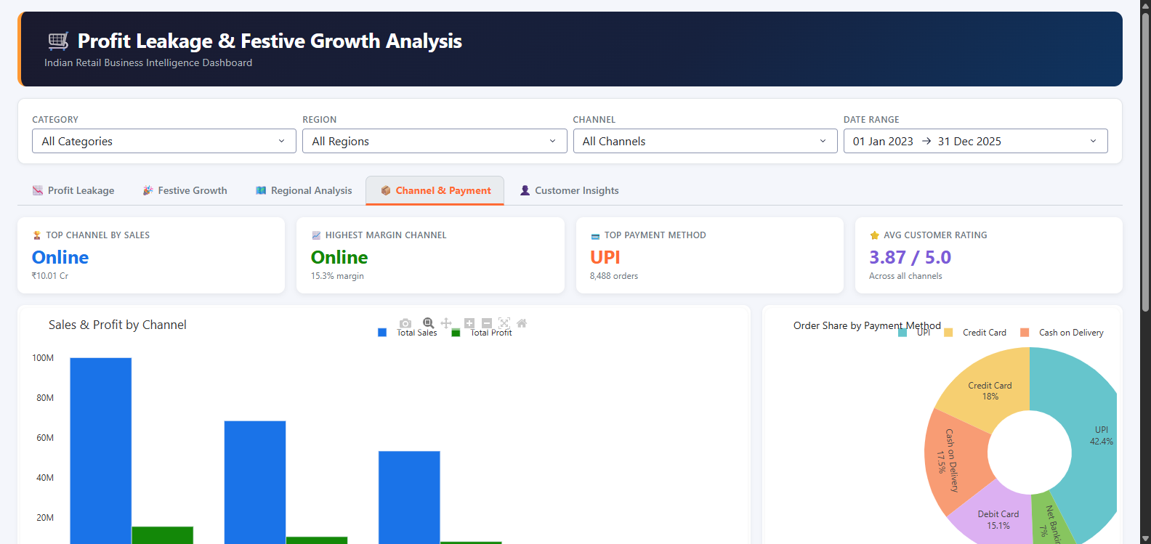
Figure 4: Channel & Payment Tab — Channel profit bars, payment donut, margin heatmap

6.5 Tab 5 — Customer Insights
Segments customers by age group and gender, shows a profit margin heatmap by age x gender, ranks the top 20 customers by lifetime revenue, and displays a rating distribution heatmap by category.
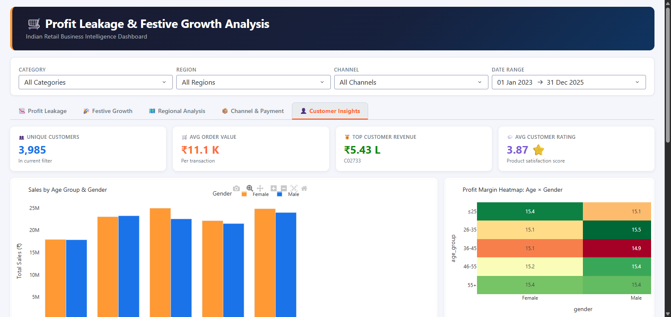
Figure 5: Customer Insights Tab — Age/gender segmentation, top customers, ratings

7. Machine Learning Models
7.1 Model 1 — Profit Regression
A RandomForestRegressor (120 estimators, max depth 12) trained to predict the profit value of an order based on pricing, quantity, discounting, location, category, channel, and seasonal features.
Algorithm | RandomForestRegressor (scikit-learn)
Features | unit_price, quantity, discount_pct, sales, region, category, channel, month, age, is_festive
Target | profit (continuous)
Train/Test | 80% / 20% random split (random_state=42)
Metric (MAE) | Mean Absolute Error on held-out test set
Metric (R2) | Coefficient of determination
Saved as | models/profit_regression.pkl

7.2 Model 2 — Leakage Classifier
A GradientBoostingClassifier (100 estimators, learning rate 0.1) trained to identify orders at high risk of discount abuse (discount > 10%) enabling proactive margin protection.
Algorithm | GradientBoostingClassifier (scikit-learn)
Features | unit_price, quantity, sales, profit_margin, region, category, channel, month, age
Target | is_high_discount (1 if discount > 10%, else 0)
Train/Test | 80% / 20% stratified split
Metrics | Accuracy, Precision, Recall, F1-Score
Saved as | models/leakage_classifier.pkl + models/leakage_scaler.pkl

8. How to Run the Project
Step 1 — Install dependencies
pip install -r requirements.txt

Step 2 — Run the single-file application
cd profit_leakage_dashboard
python main_app.py

Step 3 — Open the dashboard
http://127.0.0.1:8050

Step 4 — Use the filters
Select Category, Region, Channel, or Date Range — all tabs update live.

9. Business Recommendations
- Cap Blanket Discounts: Electronics accounts for the largest leakage. Discount thresholds of 5% should be enforced programmatically to reduce the Rs. 1.50 Cr annual leakage.
- Leverage Festive Seasons: A +4.91% uplift during festive months indicates strong consumer intent. Targeted promotions with controlled margins (not blanket discounts) can amplify this further.
- Double Down on South Region: South leads in total sales (Rs. 7.01 Cr) but also has the highest leakage (Rs. 47.24 L). Margin improvement here has the largest ROI.
- Invest in Mobile App Channel: Mobile App orders show high repeat purchase rates and strong ratings. Increasing app-exclusive offers can shift mix towards higher-margin orders.
- Target 26-35 Age Segment: This demographic shows the highest sales volume and responds well to UPI-based promotions aligned with festive campaigns.
- Use ML Classifier in POS Systems: Embedding the leakage classifier in point-of-sale workflows can flag orders where a >10% discount is being applied and prompt manager approval.

10. Conclusion
This project demonstrates a complete end-to-end data science and business intelligence solution for an Indian retail business. Starting from raw transactional data, it delivers actionable insights through interactive visualisations, quantifies profit leakage with precision, and provides predictive ML models to proactively manage discount risk.
The single-file architecture (main_app.py) ensures easy deployment and portability. All analytical logic, ML training, and dashboard UI are co-located, making the project straightforward to maintain, extend, and hand off to business stakeholders.

Report generated on 05 October 2026.

