Link Shortener: presenter's reading guide
Oct 11, 2026

What the project is
Link Shortener turns a long web address into a short one. When someone opens the short address, the service sends them on to the long address and counts the visit.
It is a Java 17 Spring Boot REST service. It is built with Maven and runs from IntelliJ IDEA. Three things make up what you will show: the REST API, the test page at /urlshortner, and the short links that redirect.

Requirements
The service must do the following. Each requirement has an identifier, so it can be traced to code and to a test.
ID | Requirement
REQ-01 | Create a short link from a web address that starts with http or https
REQ-02 | Give a random 7-character code when no name is chosen
REQ-03 | Let the owner choose a name, such as my-docs
REQ-04 | Let a link expire after a lifetime of 1 second to 1 year
REQ-05 | Redirect a visitor from the short address to the long one
REQ-06 | Count every visit to an active link
REQ-07 | Show statistics: total clicks and the time of the last click
REQ-08 | Disable a link so that it no longer redirects
The brief left some points open. These are the decisions made:
- Visits to expired or disabled links are refused with 410 and are not counted.
- Reserved names are refused: api, admin, health, login, metrics, root, static, urlshortner and v1.
- Addresses that point inside a private network, such as localhost, are refused.
- Only http and https addresses are allowed, with no user name or password.

Design and architecture
The code is split into three layers. Each layer has one job and calls only the layer below it.
- API layer (package api). It receives HTTP requests and sends replies. It holds no rules.
- Service layer (package service). It holds the rules: check the address, set the expiry, count the visits, disable a link.
- Repository layer (package repository). It stores links. The service depends on an interface, so a database can replace the in-memory store later without changing the rules.
The model package holds one class, ShortLink, which is one link with its click counter.
Four design choices matter most:
- No duplicate names. A new code or name is stored only if it is free, in one step. Two requests can never take the same name.
- Thread-safe counting. Clicks are counted with a thread-safe counter, so many visitors can be counted at once.
- Testable time. Expiry reads the time from a clock object, so tests can move time forward.
- Spring Boot wiring. Spring creates the objects and connects them, so no class creates another one directly.

Architecture diagram
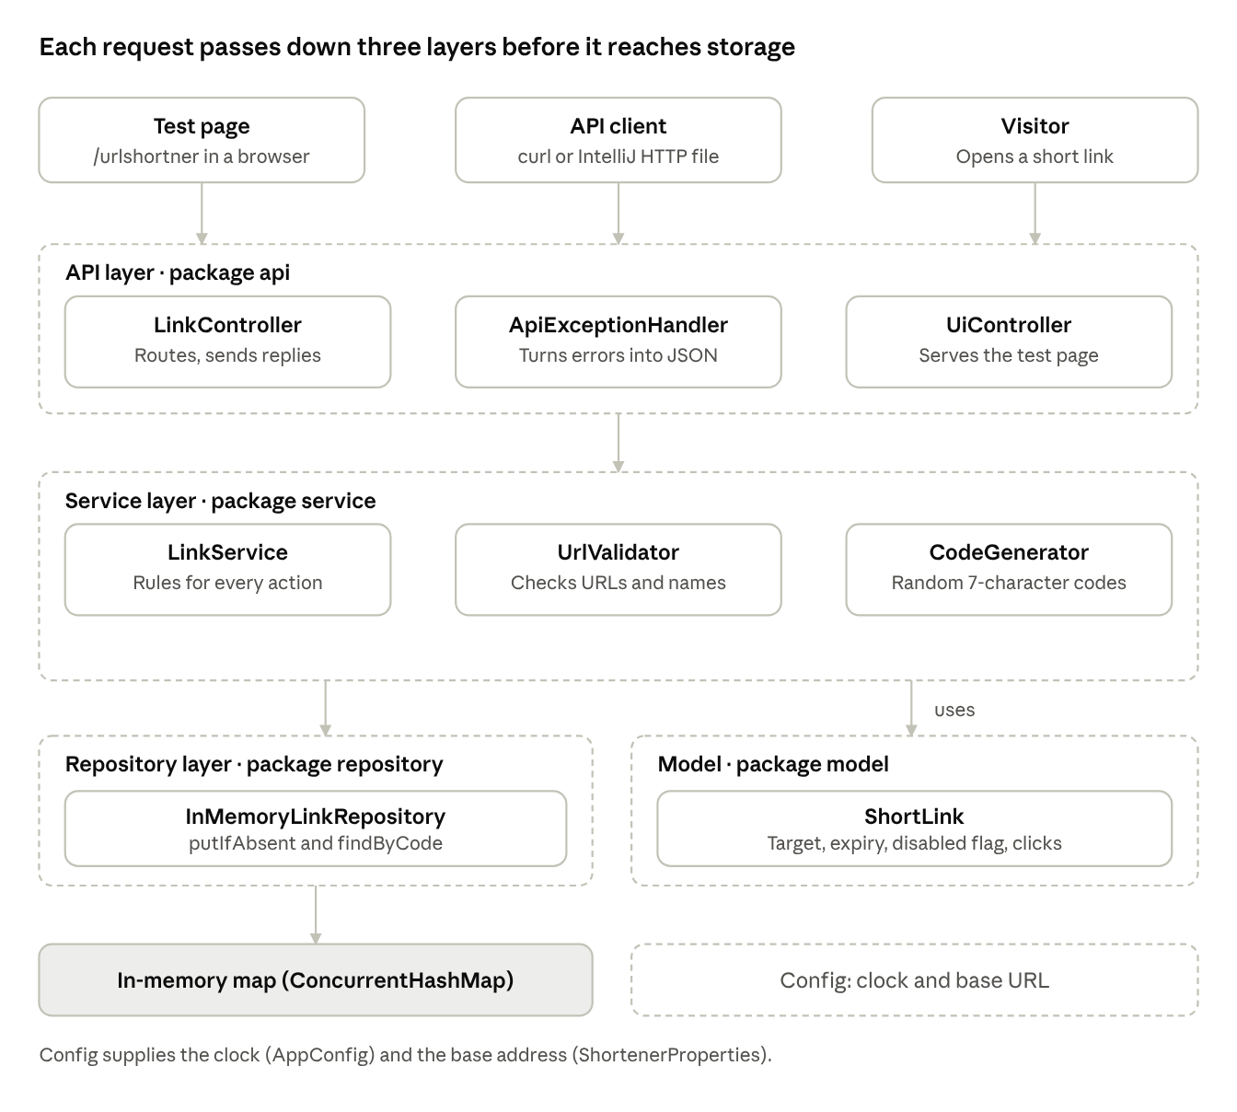
architecture · three layers and storage
A request enters at the top. The API layer reads it and calls the service. The service applies the rules and stores links through the repository. Arrows show which layer calls which.

Opening a link
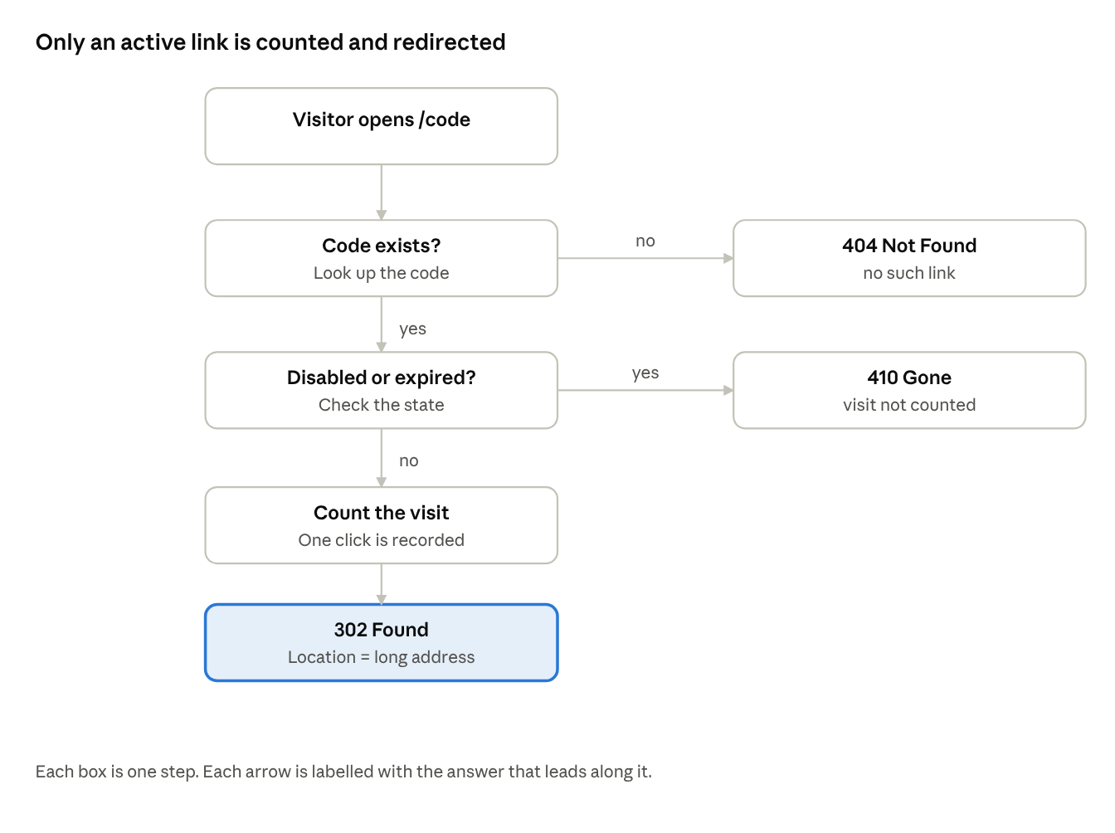
opening a link · three answers, three replies
The service checks the code first, then the state of the link. Only an existing, active link is counted and redirected.

Main files
Start with LinkController to see the routes, then LinkService for the rules.
File | What it does
LinkShortenerApplication.java | Starts the application
api/LinkController.java | All routes: health, create, get, stats, disable, and the redirect
api/ApiExceptionHandler.java | Turns any error into the standard JSON reply
api/UiController.java | Serves the test page at /urlshortner
api/dto/*.java | The shapes of the request and the replies
service/LinkService.java | The rules: create, follow and count, disable, expiry
service/UrlValidator.java | Checks web addresses and custom names
service/CodeGenerator.java | Makes random 7-character codes
service/ApiException.java | An error with an HTTP status
model/ShortLink.java | One link: target, expiry, disabled flag, click count
repository/LinkRepository.java | The storage interface
repository/InMemoryLinkRepository.java | Stores links in memory
config/AppConfig.java | Provides the clock
config/ShortenerProperties.java | Reads the base address from the settings
resources/application.yml | Settings: port and base address
resources/static/urlshortner.html | The test page
src/test/java/... | The tests

The test page: every UI component
The test page is one HTML file. It opens at http://localhost:8080/urlshortner. It calls the same REST API as any other client, so it adds no rules of its own.

Header
The header has the title Link Shortener - test page and a health indicator on the right. The page checks GET /api/v1/health when it loads.
State | Dot colour | Text
Service answers UP | Green | service is up
Service answers something else | Red | service returned <status>
Service cannot be reached | Red | service not reachable

Card 1: Create a short link
Component | What it is for | Required
Long address | The web address to shorten, such as https://docs.oracle.com/en/java/ | Yes
Custom name | A name for the short address, such as my-docs. Use 3 to 32 letters, digits or hyphens | No
Lifetime in seconds | How long the link works, from 1 to 31536000 | No
Create link button | Sends the request to create the link
Result line under the button | Green: Created, with the short address. Red: the error message from the service

Card 2: Open, check or disable a link
Component | What it does
Code or custom name field | Holds the code to work on. It is filled in automatically after a create
Show stats button | Reads the statistics and shows Clicks: a number, with the time of the last click
Open link button | Opens the short address in a new tab. That visit is counted
Disable button | Disables the link. Opening it afterwards gives 410 Gone
Result line under the buttons | Confirms what happened, or shows the error

Card 3: Replies from the API
This box shows the HTTP status and the JSON body of the last request. Use it to show the exact reply the service sent.

Card 4: Links created in this page
Each link created on this page appears as a small button, called a chip. Click a chip to load its code into Card 2. Hover over it to see the long address. The list is kept only while the page is open. Reloading the page clears it.

Live walkthrough of the test page
Run these steps in order. Each step says what to do and what the page should show.
- Check the health indicator. It should be green and say service is up.
- Create a named link. Enter https://docs.oracle.com/en/java/ and the custom name my-docs. Click Create link. The result line shows Created with http://localhost:8080/my-docs.
- Open the link. The code my-docs is filled in. Click Open link. The Oracle page opens in a new tab, and the visit is counted.
- Show the count. Click Show stats. It should read Clicks: 1 with the time of the visit.
- Try a duplicate name. Create my-docs again. The result line shows: alias is already in use.
- Try a local address. Create a link to http://localhost:9000/x. The result line shows: url host is not allowed.
- Disable the link. Click Disable. Then click Open link. The new tab shows an error, and the Replies box shows 410 Gone.
- Try expiry. Create a link named short-lived with the lifetime 2. Wait 3 seconds, then open it. It returns 410.
- Click a chip. Use a chip in Card 4 to load a code into Card 2 again.

Flows

Creating a link (POST /api/v1/links)
- The request arrives at LinkController, which passes it to LinkService.
- The service checks the address with UrlValidator.
- If a lifetime was given, the service checks it, from 1 to 31536000 seconds, and sets the expiry time.
- If a custom name was given, the service checks it and stores it only if it is free. Otherwise the reply is 409.
- If no name was given, the service makes a random code. If the code is taken, it tries again, up to five times.
- The reply is 201 Created, with a Location header and the new link.

Opening a link (GET /{code})
- A visitor opens the short address. The controller passes the code to the service.
- If the code does not exist, the reply is 404.
- If the link is disabled or past its expiry, the reply is 410 Gone. The visit is not counted.
- Otherwise the service counts the visit.
- The reply is 302 Found, with the long address in the Location header. The Cache-Control header is no-store, so browsers keep sending visits to the server.

Errors and what they mean
Every error has the same JSON shape: error, message and status. Example: {"error": "Conflict", "message": "alias is already in use", "status": 409}.
Situation | Status | Message
Address missing, empty or invalid | 400 | url is required, or url is not a valid web address
Scheme is not http or https | 400 | only http and https addresses are allowed
Localhost or a private network | 400 | url host is not allowed
Custom name not 3 to 32 letters, digits or hyphens | 400 | alias must be 3 to 32 letters, digits or hyphens
Lifetime outside 1 to 31536000 | 400 | ttlSeconds must be between 1 and 31536000
Custom name already used | 409 | alias is already in use
Custom name is reserved | 409 | alias is reserved
Code does not exist | 404 | no such link
Link disabled or expired | 410 | link has been disabled or has expired

Testing status
- The rule checks were run in development: 41 of 41 passed.
- The project has 22 JUnit tests. They were written but could not be run in the development environment, because the libraries could not be downloaded. Run mvn test on your machine before the demo. It should report no failures.
- The test page was checked for valid JavaScript only. Open it once in IntelliJ before the demo.

Limits and next steps
Limit today | Next step
Links are lost when the application restarts | Store links in a database behind the repository interface
Anyone who can reach port 8080 can create or disable links | Add login for the management routes
No limit on how many requests one client can send | Add a per-client rate limit as a filter
The test page resets its list of links on reload | Read the list from the server instead

