**Life course evolution of Glucose-insulin metabolism in thin young rural Indians**

**Abstract:**

**Background & Objective:**

An impaired insulin sensitivity coupled with a defective beta cell function is considered as a pathophysiological factor responsible for development of glucose intolerance. It is considered that in normal individuals, a decrease in insulin sensitivity is compensated by increased insulin secretion by beta cells while in individuals with high risk this compensatory mechanism is affected. In this work we present the relationship between insulin sensitivity and insulin secretion in normal glucose tolerant (NGT) and prediabetes individuals at 6,12 and 18 years of their life-course. We also track the evolution of NGT and Pre-diabetes individuals along the insulin sensitivity and secretion axis.

**Material & Methods:**

As a part of Pune Maternal Nutrition Study (PMNS), Insulin Sensitivity (HOMA-S) and insulin secretion (HOMA-β) among other clinical characteristics were estimated for 637 individuals at 6,12 and 18 years. Subjects were classified as normal glucose tolerance (NGT) or prediabetes according to their OGTT results at 18 year (ADA criteria). To determine the relationship between HOMA-B and HOMA-S we estimated HOMA-B as a nonlinear function of HOMA-S. The relationship was visualized separately for NGT and prediabetes individuals at 6,12 and 18 years each. Their temporal movement over years and rate of change of HOMA-S and HOMA-B was estimated using a linear mixed effect model.

**Result**

Out of 637 individuals, 455 were classified as NGT and 182 as prediabetes. A nonlinear hyperbolic relationship between insulin sensitivity and beta cell function was found , in agreement with other studies. However, we additionally demonstrate a lower level of HOMA-beta (secretion) for all levels of HOMA-sensitivity in prediabetes individuals as compared to normal controls at 18 years of age (mean difference …, sd …). The same trend was observed at 6 and 12 years as well, indicating an early life dysregulation of glucose-insulin metabolism.

**Conclusion:**

We provide evidence for early life dysregulation in glucose insulin metabolism leading to pre-diabetes at 18 years of age. Prediabetic individuals started with lower beta cell function and lower insulin sensitivity from early age. The relationship between HOMA-S and HOMA-B is nonlinear with. Diabetes prevention should start from early life.

**Introduction:**

Glucose-insulin metabolism is primarily governed by two physiological mechanisms namely insulin sensitivity (or insulin resistance) and insulin secretion. Insulin sensitivity is the ability of the human body to utilize insulin efficiently for metabolism of glucose. While insulin secretion is the mechanism by which pancreatic beta cells increase the secretion of insulin to act on the glucose. Under normal physiological conditions a decrease in insulin sensitivity (high insulin resistance) is compensated by an increase in insulin secretion by pancreatic beta cells and this relationship between insulin sensitivity and secretion was first demonstrated by Bergman et al [ref]. He demonstrated that insulin sensitivity and secretion follows a rectangular hyperbolic relationship wherein a decrease in insulin sensitivity is accompanied by an increase in insulin secretion thereby at any point of time their product remains constant. This constant is known as disposition index which is also defined as beta cell function adjusted for insulin sensitivity. He further demonstrated that a combined defect in insulin sensitivity and insulin secretion gives rise to diabetes phenotypes. This observation was further confirmed by various studies. Though the relative contribution of insulin sensitivity and secretion is not entirely understood it has been observed that insulin secretory defect is more prominent in undernourished while insensitivity is more prominent in Obese [ref]. The study by Bergman et al and various other groups demonstrated that insulin sensitivity and secretion follow a hyperbolic relationship , however this relationship is shifted towards the left in case of diseased/diabetic phenotype individuals implying that for same value of insulin sensitivity , beta cell function is reduced considerably in diabetic individuals. It is not known how these two mechanisms behave over a longer period of time. In this regard, Pune Maternal Nutrition Study (PMNS) provides us a unique opportunity to study evolution of insulin sensitivity and secretion in a longitudinal study setup. We have utilized the hyperbolic relationship described by Bergman to study the evolution of insulin sensitivity and secretion with respect to glucose metabolism.

**Determinants of HOMA-S and HOMA-BMethod:**

**Overview of the PMNS cohort**

The PMNS (Fig. 1 and Supplementary Fig. 1) was established in 1993 in six rural villages near Pune, India to prospectively study associations of maternal nutritional status with fetal growth and later diabetes risk in the offspring. Married, non-pregnant women were followed up and those who became pregnant (F0 generation) were recruited into the study if a singleton pregnancy of <21 weeks’ gestation was confirmed by ultrasound. .

Their children (F1 generation) were followed up at birth, 6, 12 and 18 years of age. Participants arrived at the Diabetes Unit the evening before the day of blood sampling, had a standard dinner, and fasted overnight. In the morning, a fasting blood sample was collected. At 6 years, an oral glucose tolerance test (OGTT) was performed, using 1.75g/kg of anhydrous glucose, followed by further samples at 30 and 120 minutes. At 12 years, only a fasting sample was collected. At 18 years a full OGTT (75g anhydrous glucose) was repeated. Glucose was measured by the glucose oxidase/peroxidase method, and specific insulin by ELISA. Insulin sensitivity (HOMA-S) and beta cell function (HOMA-β) were calculated using data from the fasting samples and the iHOMA2 website. [https://www.phc.ox.ac.uk/research/technology-outputs/ihoma2 , last accessed August 2019].

The study was approved by village leaders and the KEM Hospital Research Centre Ethics Committee. Parents gave written consent; children under 18 years of age gave written assent and written consent after reaching 18 years.

**Glucose tolerance classification:**

Using American Diabetes Association criteria participants (F1 generation) were classified as normal glucose tolerance (NGT) if their Fasting Plasma Glucose < 100 mg/dL, 2-h Plasma Glucose < 140 mg/dL) and prediabetes if Fasting Plasma Glucose : 100 - 125 mg/dL and/or 2-h Plasma Glucose: 140 mg/dL - 199 mg/dL) at 18 years of age.

**Statistical Analysis :**

**Relationship between Insulin sensitivity and secretion (beta cell function) in NGT and Prediabetes:**

The relationship between insulin sensitivity and insulin secretion was plotted for the cohort at 6,12 and 18 years of age.. LOESS models were fitted to obtain the mean curves of HOMA-B as a function of HOMA-S in NGT and Prediabetes group at 6, 12 and 18 years. Between the prediabetes and NGT groups, the difference in HOMA-beta at the mean value of HOMA sensitivity along with their confidence intervals was visualized.

**Trajectory of insulin sensitivity and secretion in NGT and Prediabetes over the years**

The temporal evolution of the aforementioned hyperbolic relationship from childhood to young adult age in the NGT and Prediabetes groups was plotted[Figure]. Additionally, the trajectory of this ‘disposition index’ was also visualized as the median values for each group serially over time [figure]

**Relationship between HOMA- B and HOMA-S with age**

The rates of change of HOMA-B and HOMA-S with age in NGT and prediabetes groups were modeled using a linear mixed effect modeling approach to account for variations arising due to repeated measures.

**Determinants of insulin sensitivity and secretion ratio**

To determine the factors affecting insulin sensitivity and insulin secretion, we modeled the ratio of insulin secretion and insulin sensitivity at 18 years of age. We built two different models using an elastic net algorithm of the glmnet library in R . In model 1 we used maternal features collected during the 28th week of pregnancy, father’s feature and at birth anthropometric measurements of participants as predictors. We termed it as a Birth model. In the second model, we also included the changes in different features from 0 to 6 years and 6 to 12 years as predictors in addition to the birth model. We termed the second model as a delta model. Important variables from the models were selected and R-square of the models are reported.

All the above analysis was performed on male and female combined data, male and female data separately.

**Results:**

Description of cohort:

Out of 620 individuals who participated in this study, 443 individuals were classified as Normal Glucose Tolerance (NGT) and 177 individuals were classified as Pre-diabetes according to their OGTT results at 18 years. A total of 336 were male and 284 were female. Out of 336 male, 127 were prediabetes and 209 were NGT and out of 284 females, 50 were prediabetes and 234 were NGT.

At 18 years, participants with glucose intolerance had lower insulin secretion (lower insulinogenic and disposition indices) and lower insulin sensitivity (lower HOMA-S and Matsuda index) than NGT participants. Glucose intolerant men, but not women were more adipose (higher BMI, fat% and waist circumference). Men and women with glucose intolerance at 18 years had higher glucose concentrations and lower disposition index at 6 and 12 years than the NGT group; men also had lower insulin sensitivity at age 6 years.

**Relationship between insulin sensitivity and secretion in NGT vs Prediabetes:**

We observed that a hyperbolic relationship exists between insulin sensitivity and insulin secretion in both NGT and Prediabetes individuals at 6,12 and 18 year each. Hyperbolic curve for the prediabetes group was found to be shifted towards the origin (left and downwards) as compared to their NGT counterpart. The downward shift of the Prediabetes curve suggests that Prediabetes individuals showed a decreased beta cell function compared to NGT individuals for the same value of insulin sensitivity. The separation between the NGT and Prediabetes curve was most prominent at 18 years (**see figure**), and a similar trend was observed at 12 and 6 years of age as well, indicating an early life dysregulation of glucose-insulin metabolism. However, the separation (intercept of NGT vs Prediabetes) was statistically significant both at 6 and 12 years[give stats].

With Increasing age (from 6 to 12 to 18 years) , insulin sensitivity was found to be decreasing in both NGT and Pre-diabetes individuals. Both NGT and Prediabetes were found to have high insulin sensitivity at 6 and 12 years of age while at 18 years there was a considerable decrease in sensitivity for both the group.(summary table).

To compensate for the loss of insulin sensitivity, the beta cell function of both the groups increased over the time. However an increase in Prediabetes groups was lower compared to NGT groups suggesting that in individuals with high risk beta cell function is altered.

**Evolution of insulin sensitivity/secretion in NGT vs Pre-diabetes.**

From childhood to young adult age there is a progressive decrease of HOMA-S and a progressive increase in HOMA-B. [calculate the change in percentage from 6 -12,12-18,6-18 HOMA-S and HOMA-B].The decrease in HOMA-S was higher and rise in HOMA-B was lower in prediabetes compared to that in NGT. This trajectory is better appreciated in a log transformed plot which shows that Prediabetes individuals at 6 years of their lifespan start with lower insulin sensitivity and beta cell function compared to their NGT counterpart and they continue to follow Over the years NGT and Prediabetes follow different trajectories which defines their insulin sensitivity and insulin secretion. The Prediabetes group was found to follow a trajectory corresponding to lower HOMA-B and HOMA-S compared to NGT group.]

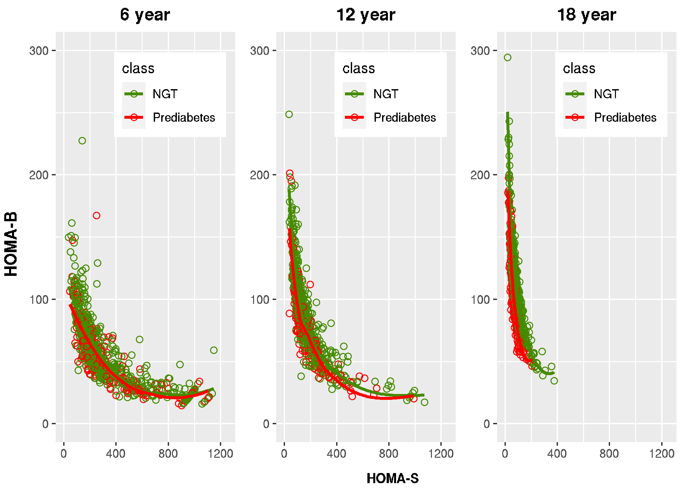

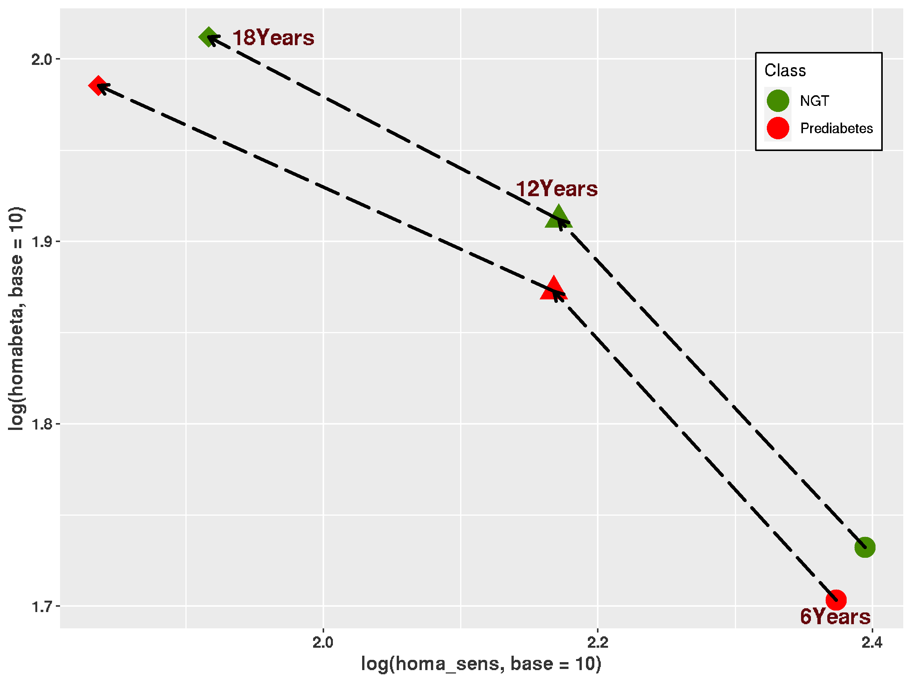

**Rate of Change of HOMA-Beta/Sensitivity from 6 to 12 to 18:**

It was found that insulin sensitivity decreased from 6 to 18 years while insulin secretion was found to increase with progression of age. Moreover, we also observed that the rate of change of insulin sensitivity/secretion differed in NGT and pre-diabetes individuals. Results from linear mixed effect models reveal that with age insulin sensitivity decreases more rapidly in prediabetes (23 units in NGT vs 39 units in Prediabetes ). Similarly the rate of increase of insulin secretion was found to be more in NGT compared to Prediabetes ( 4 units vs 2 units). Summary of the result is provided in supplementary table x

**Determinants of insulin sensitivity and secretion ratio:**

We obtained X and Y number of features important in the birth model and delta model respectively. At birth anthropometric features of newborn (midarm circumference , length of the foot