AP450-PRC-ECAT04 TSD of HSE Evaluation ODATA

09.04.2026

Created by: Dhanashri Kunte
Revision History

Version No. | Date | Author | Revision Description
0.1 | 09. 04.2026 | Dhanashri Kunte | Initial Draft

Authorisers for sign off

Role | Name | Date Signed Off in SharePoint

Distribution - in addition to Authorisers

Name | Role

Contents
1. Document Information 5
1.1 General Data 5
1.2 Related Documents 5
2. Development Overview 6
2.1 Requirements Summary 6
2.2 Assumptions 6
2.3 Dependencies/Constraints 6
2.4 Objects or Transaction Affected 6
2.5 Standards 6
2.6 Security, Integrity and controls 7
2.7 Error Handling / Messages 7
3. Detailed Technical Specifications 7
3.1 Technical Flow Diagram 7
3.2 Technical Flow Description 8
3.3 Selection Screen Details 8
3.4 Security and Authorization 9
3.5 Processing and Operational Considerations 9
3.5.1 Dependencies 9
3.5.2 Re-Use Details 9
3.5.3 Multi-site Details 9
3.5.4 Other 10
4. Technical Requirements 10
4.1 Database Tables 10
4.2 External Programs 10
4.3 Development Information 10
4.3.1 Development Class 10
4.3.2 Message Class 10
4.3.3 Program ID 10
4.3.4 Program Type 10
4.3.5 Module 10
4.4 Transport Number(s) 10
4.5 Detailed Design 10
4.5.1 SAP Objects 10
4.5.2 Request Mechanism/Trigger 11
4.5.3 Pseudocode 11
4.5.3.1 Custom Table Development 11
4.5.3.2 User Exit 11
4.5.3.3 Field Exit 12
4.5.3.4 Technical Design Constraints 12
4.5.3.5 Programmers Notes 12
5. Testing Requirements 13
5.1 Key Unit / Assembly Test Conditions 13
6. Outstanding Issues 14
7. Appendix 14
7.1 Glossary of Terms 14
7.2 Additional Supporting / Reference Documentation 14

1. Document Information

General Data

Information | Detail
Extension ID | Odata/Report/Workflow
Extension Description | TSD of HSE Evaluation Process
Process Area | PRC
Project | SPM
Job Name | NA
Functional Designer | Ranjit Shekdar
Technical Designer | Dhanashri Kunte
Developer | Dhanashri Kunte and Suraj Bhalerao (Fiori)
Tools used:
  Data Services
  Information Steward | Other
  NA

Related Documents

Document | Location
FD

Development Overview

Requirements Summary

This OData is created to display data on Fiori Portal as per bifurcation as -
- HSE Admin Process
- HSE Evaluation Process

There are filters also to display data as per filter value.

Assumptions

Dependencies/Constraints

Objects or Transaction Affected
SM36, SM37

Standards
As per ADNOC development guidelines

Security, Integrity and controls
N/A

Error Handling / Messages
N/A

Detailed Technical Specifications

Technical Flow Diagram

Create submit header
Fill header & item data on screen
Save Button
Edit Button
Submit Button
Save as the draft as submit
Enable header & item fields to modify the data
Final submit cannot modified data once submit
Opens the HSE application entry screen
Craete evaluation
Enter Contract id period

Description of flow diagram:

- The Hse application when loaded will first show all the HSE evaluations that have been carried out so far, and these can be viewed based on the access permissions. Once the user selected the “create evaluation” button a new screen is shown where the users can enter details like contract id, period for which the evaluation is being done and the Site and click submit, this will open the HSE application entry screen.
- The Hse application when loaded will first show all the workgroups under the contract where HSE is applicable.

Fiori Technical Flow Description

Admin
- The OData service used for this application is ‘ZMM_HSE_ADMIN_SRV’ from the manifest.json.

- When the user opens the application, it shows all the available Templates created by all the users in the system whose binding is done in the Responsive (sap.m) Table. Entity used here is ‘AdminDataSet’ and method id GET call.
- If any changes is there user will do accordingly after that User will click on “Save” button and ‘HeaderSet’ will be called with method id CREATE call.

Evaluation
- The OData service used for this application is ‘ZMM_HSE_EVAL_SRV’ from the manifest.json.

- When the user opens the application, it shows all the available Templates created by all the users in the system whose binding is done in the Responsive (sap.m) Table. Entity used here is ‘HeaderDetailsSet’ and method id GET call.

- This table list also has following filter options with its associated entity sets; these views are created in Fragment for reusability.
- HSE Evaluator ID - (HseEvalIdShelpSet)
- Contract ID- (ContractIdShelpSet)
- Status - (StatusSHelpSet)

- This process leads to a POST call in the backend on ‘HeaderSet’. In the payload, the filled information by user is passed in Header and Item format.

- Once the request is successfully created, it redirects the user to detail page of the just created Template, wherein the user can update further information if required.

- Here there are mainly 4 action buttons, i.e. ‘Save’, ‘Cancel’,‘Submit and Action’ in which ‘Add/View attchment’. The purpose of the ‘Save’ button is to save the updated information and create a new version for every change made.

- Before submitting while coming to details page Read method is called with ‘HSEWorkgroupListSet’.

- For the ‘Save' method, a POST call is made to ‘EvalHeaderSet’ with the updated information as payload.

Selection Screen Details
Admin
Custom Screen for Initial List of ZSP_CTRT_EVAL created

Controls Used:

- M controls
- Page
- V Box
- Button
- Breadcrumbs
- Table

Evaluation
Custom Screen for Initial List of ZSP_CTRT_END created

Controls Used:

- M controls
- Page
- V Box
- Label
- Input with F4 Value help request
- Button
- Table
- Breadcrumbs

- Comp controls
- SmartTable (Responsive)
- SmartFilterBar

Controls Used:

- M controls
- Page
- V Box
- Label
- Input with F4 Value help request
- Button
- Table
- Breadcrumbs
- Dialog
- Panel
- Toolbar

- Layout controls
  - Simpleform

- Comp controls
- SmartTable (Responsive)
- SmartFilterBar

Security and Authorization
Authorization Object: M_USRDF_CC- Template creator can only see their company code related agreements while creating the template.

Processing and Operational Considerations

Dependencies
N/A

Re-Use Details
N/A

Fiori Application HTML5//JSP/CSS details (Customized Objects only) (Admin)

Class Name | List.view.xml  List.controller.js  CompanyCodeDialog.fragment.xml  Style.css
Class Methods Implemented
Class Methods Parameters & Events

Fiori Application HTML5//JSP/CSS details (Customized Objects only) (Evaluation)

Class Name | List.view.xml  List.controller.js  Detail.view.xml  Detail.controller.js  Style.css  StatusDialog.fragment.xml  HseEvaluatorDialog.fragment.xml  HseEvaluationDialog.fragment.xml  DueEvaluations.fragment.xml  DisplayWorkGroup.fragment.xml  DisplayHeader.fragment.xml  DisplayDetails.fragment.xml  CreateHSEEvaluation.fragment.xml  CreateEvaluationDialog.fragment.xml  CreateContractDialog.fragment.xml  ContractDialog.fragment.xml
Class Methods Implemented
Class Methods Parameters & Events

Business Server Pages/ Extensions (Admin)
[fill in this section for BSP implementation/extension (optional – provide details only if available). Details provided in this section are only suggestive for technical team. The technical team will reassert the details]

Name of BSP Application | ZSP_CTRT_EVAL
Requirement for the Extension
Screen Layout

Business Server Pages/ Extensions (Evaluation)
[fill in this section for BSP implementation/extension (optional – provide details only if available). Details provided in this section are only suggestive for technical team. The technical team will reassert the details]

Name of BSP Application | ZSP_CTRT_END
Requirement for the Extension
Screen Layout

Git Repository Details (Admin)
Name of BSP Application | ZSP_CTRT_EVAL
Git Path | https://devopsad.visualstudio.com/SAP_UI/_git/UI
Folder Path | Project > Procurement > ZSP_CTRT_EVAL

Git Repository Details (Evaluation)
Name of BSP Application | ZSP_CTRT_END
Git Path | https://devopsad.visualstudio.com/SAP_UI/_git/UI
Folder Path | Project > Procurement > ZSP_CTRT_END

Multi-site Details
N/A

Other

Technical Requirements

Database Tables

ZMM_HSE_EVAL_h, ZMM_HSE_EVAL_I, ZMM_HSE_GRP_SCOR, ZMM_HSE_IND,

ZMM_HSEADMIN, ZMM_T_EVAL_HSE

External Programs
NA

Development Information

Development Class
NA

Message Class
NA

Program ID
PRC_ECAT04

Program Type
OData Service, Workflow

Module
PRC

Transport Number(s)

CTS Request Number | CTS Task Number
ER6K9A15NB | ER6K9A1C2Q
GF6K930783 (Fiori) | GF6K931846

Detailed Design

SAP Objects
R3TR | IWPR | ZMM_SUPPL_SUSPENSION
R3TR | CLAS | ZCL_ZMM_SUPPL_SUSPENSI_MPC
R3TR | CLAS | ZCL_ZMM_SUPPL_SUSPENSI_DPC
LIMU | CLAS | ZCL_ZMM_SUPPL_SUSPENSI_DPC_EXT
LIMU | FUGR | ZMM_SUSPENSION
R3TR | TABL | ZMM_ST_SPM_REINSTA_I
R3TR | TTYP | ZMM_TT_REINSTA_ITM
R3TR | TABD | ZMM_ST_SPM_REINSTA_I
R3TR | DOMA | Z_C_ENFORCE_TYPE
R3TR | PROG | ZMMR1000_SUSP_CREATE
R3TR | PROG | ZMMR1000_SUSPENSION_CREATE
R3TR | CLAS | ZCL_ZMM_SUPPL_SUSPENSI_MPC_EXT
R3TR | IWMO | ZMM_SUPPL_SUSPENSION_MDL 0001
R3TR | IWPR | ZMM_SUPPL_SUSPENSION
R3TR | IWSV | ZMM_SUPPL_SUSPENSION_SRV 0001
R3TR | TABL | ZMM_ST_SPM_SUSP
R3TR | TABL | ZMM_ST_SPM_SUSP_H
R3TR | TABL | ZMM_T_SPM_SUSP
R3TR | TOBJ | ZMM_T_SPM_SUSPS
R3TR | TABL | ZMM_HSE_ADMIN
LIMU | TABD | ZMM_HSE_ADMIN
R3TR | DTEL | Z_C_IND
R3TR | DTEL | Z_C_INDDESC
R3TR | DTEL | Z_C_UOM
R3TR | DTEL | Z_F_WEIGHTAGE
R3TR | DTEL | Z_F_TARGET
LIMU | TABT | ZMM_HSE_ADMIN
R3TR | IWPR | Z_MM_HSE_ADMIN
R3TR | CLAS | ZCL_Z_MM_HSE_ADMIN_MPC
R3TR | CLAS | ZCL_Z_MM_HSE_ADMIN_MPC_EXT
R3TR | CLAS | ZCL_Z_MM_HSE_ADMIN_DPC
R3TR | CLAS | ZCL_Z_MM_HSE_ADMIN_DPC_EXT
R3TR | IWMO | Z_MM_HSE_ADMIN_MDL 0001
R3TR | IWSV | Z_MM_HSE_ADMIN_SRV 0001
R3TR | TABL | ZMM_HSE_IND
LIMU | TABT | ZMM_HSE_IND
R3TR | FUGR | ZMM_HSE_IND
R3TR | TOBJ | ZMM_HSE_INDS
R3TR | TABU | TVDIR
R3TR | TABU | TDDAT
LIMU | TABD | ZMM_HSE_IND
R3TR | DTEL | Z_C_FLAG2
R3TR | DOMA | Z_C_INDDESC
R3TR | TABU | ZMM_HSE_IND
R3TR | TABL | ZMM_HSE_EVAL_H
LIMU | TABD | ZMM_HSE_EVAL_H
LIMU | TABT | ZMM_HSE_EVAL_H
R3TR | TABL | ZMM_HSE_GRP_SCOR
R3TR | DTEL | Z_C_WORKGROUP
R3TR | DTEL | Z_C_EVAL_ID
LIMU | TABD | ZMM_HSE_GRP_SCOR
LIMU | TABT | ZMM_HSE_GRP_SCOR
R3TR | FUGR | ZMM_HSE_EVAL_H
R3TR | TOBJ | ZMM_HSE_EVAL_HS
R3TR | FUGR | ZMM_HSE_GRP_SCOR
R3TR | TOBJ | ZMM_HSE_GRP_SCORS
R3TR | TABL | ZMM_HSE_EVAL_I
LIMU | TABD | ZMM_HSE_EVAL_I
LIMU | TABT | ZMM_HSE_EVAL_I
R3TR | FUGR | ZMM_HSE_EVAL_I
R3TR | TOBJ | ZMM_HSE_EVAL_IS
R3TR | DTEL | Z_C_CONTRACT_ID
R3TR | DTEL | Z_C_HSE_EVAL_ID
R3TR | TABL | ZMM_HSE_GRP_SCOR
R3TR | DTEL | Z_C_WG_SCORE
R3TR | DTEL | Z_C_HSE_SCORE
R3TR | DTEL | Z_C_HSE_EV_ID
R3TR | DTEL | Z_C_SCORE_I
R3TR | DTEL | Z_C_ACT_SCORE
R3TR | IWPR | Z_MM_HSE_EVAL
R3TR | TABL | ZSMM_STATUS_F4
R3TR | CLAS | ZCL_Z_MM_HSE_EVAL_MPC
R3TR | CLAS | ZCL_Z_MM_HSE_EVAL_MPC_EXT
R3TR | CLAS | ZCL_Z_MM_HSE_EVAL_DPC
R3TR | CLAS | ZCL_Z_MM_HSE_EVAL_DPC_EXT
R3TR | IWMO | Z_MM_HSE_EVAL_MDL 0001
R3TR | IWSV | Z_MM_HSE_EVAL_SRV 0001
R3TR | DTEL | Z_D_DATE_FROM
R3TR | DTEL | Z_D_DATE_TO
R3TR | DTEL | Z_C_HSE_APVR
R3TR | TABL | ZSMM_HSE_EVAL_H
LIMU | TABD | ZSMM_HSE_EVAL_H
R3TR | TABL | ZSGW_HSEWORKGROUP_LIST
LIMU | TABD | ZSGW_HSEWORKGROUP_LIST
R3TR | TABL | ZMM_HSEWORKGROUP_LIST
R3TR | TABL | ZSGW_HSEWORKGROUP_LIST
R3TR | TABL | ZSMM_HSEWORKGROUP_LIST
R3TR | TABL | ZMM_HSEWORKGROUP_LIST
LIMU | TABD | ZSMM_HSEWORKGROUP_LIST
R3TR | TABL | ZMM_HSE_ADMIN
R3TR | TABL | ZMM_HSEADMIN
LIMU | TABT | ZMM_HSEADMIN
R3TR | FUGR | ZMM_HSEADMIN
R3TR | TOBJ | ZMM_HSEADMINS
R3TR | TABL | ZSMM_HSEEVAL_LIST
LIMU | TABD | ZSMM_HSEEVAL_LIST
R3TR | FUGR | ZMM_HSE
R3TR | TTYP | ZTMM_HSEWORKGROUP_LIST
R3TR | TTYP | ZTMM_HSEEVAL_LIST

Request Mechanism/Trigger
OData

Pseudocode

Below are the details required to implement the functionality, required coding/programming logic can be implemented in Odata.

SEGW Project Name - ZMM_HSE_EVAL

Entity Type | Structure Name | Description
ContractIdCreateShelp |  | To get ContractID Create Help
ContractIdShelp |  | To get ContractID Help
EvalCreateSHelp |  | To get Eval Create Help
EvalHeader | ZSMM_HSE_EVAL_H | To get the Eval Header details
HeaderDetails | ZSMM_HSE_EVAL_H | To get Header Details
HseEvalIdShelp |  | To get HSE EValID Help
HSEEvalItem | ZSMM_HSEEVAL_LIST | To get HSE Eval Item
HSEEvaluatorShelp | ZSMM_HSE_EVAL_H | To get HSE Eval help
HSEWorkgroupList | ZSMM_HSEWORKGROUP_LIST | To get HSE Workgroup list
StatusSHelp | ZSMM_STATUS_F4 | To get status help

SEGW Project Name - ZMM_HSE_ADMIN

Entity Type | Description
AdminData | To get Admin Data
CompanyCodeSHelp | To get Company Code help
Header | To get Header data

OData for HSE Admin Data -

AdminData

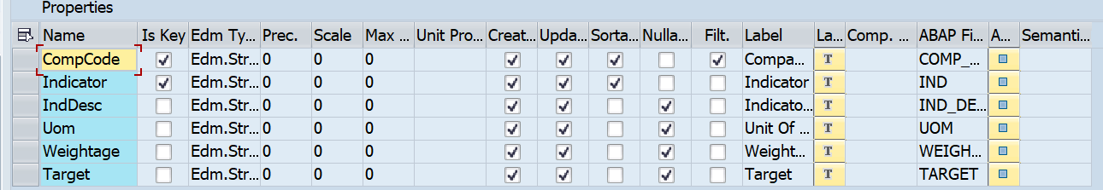

CompanyCodeSHelp -

Header -

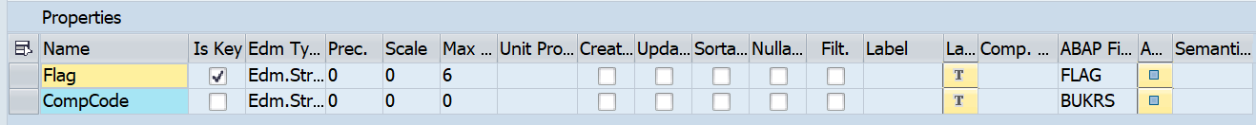

OData for HSE Admin Data -

ContractIdCreateShelp -

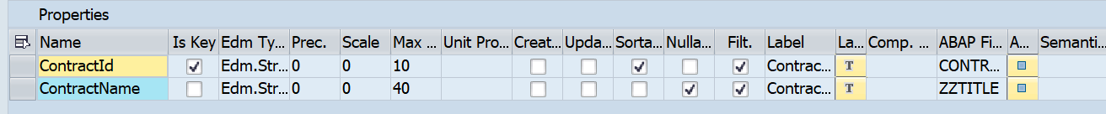

ContractIdShelp -

EvalCreateSHelp -

EvalHeader -

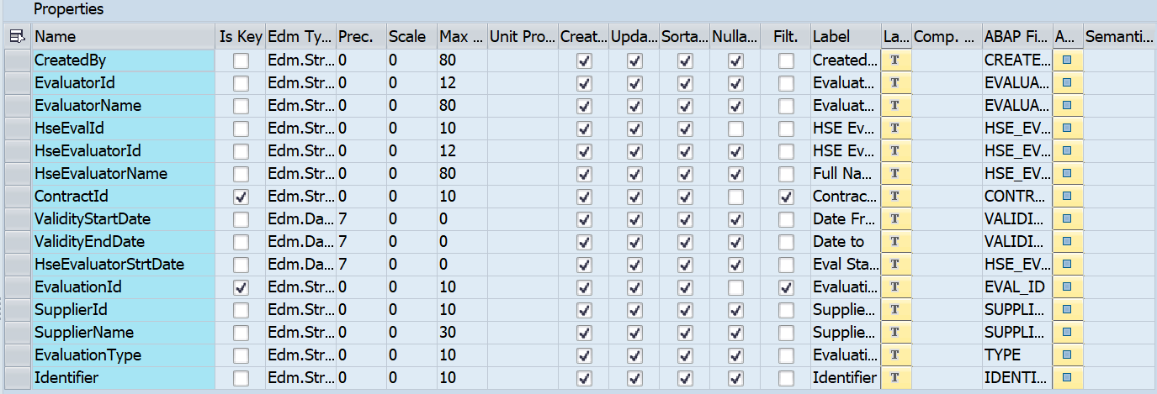

HeaderDetails -

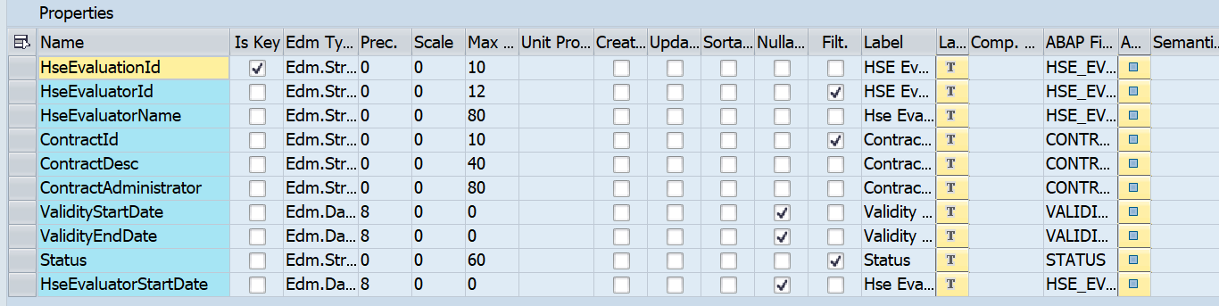

HseEvalIdShelp -

HSEEvalItem -

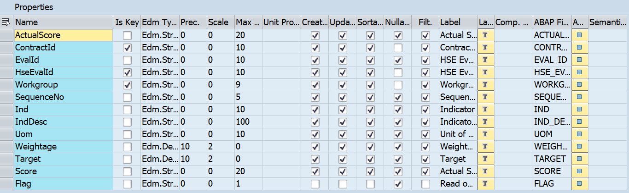

HSEEvaluatorShelp -

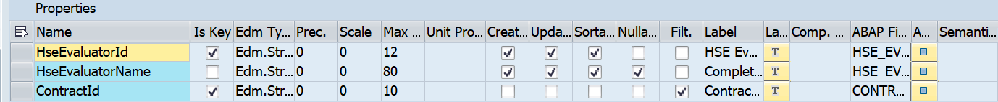

HSEWorkgroupList -

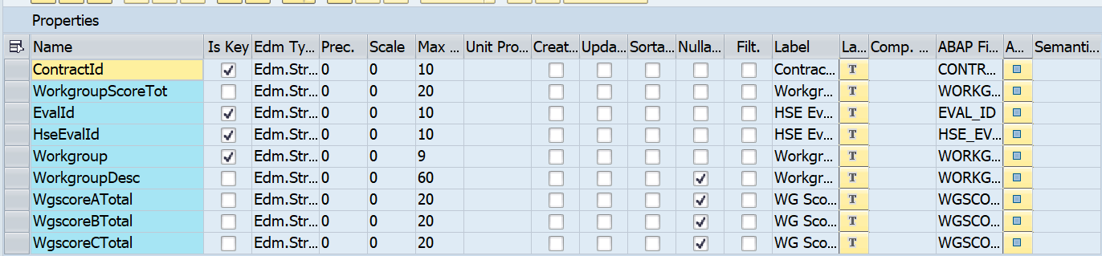

StatusSHelp -

Class ZCL_ZMM_HSE_EVAL_DPC_EXT

Methods Implemented:

/IWBEP/IF_MGW_APPL_SRV_RUNTIME~CREATE_DEEP_ENTITY - Get the data of Deep Entity Detail Data

/IWBEP/IF_MGW_APPL_SRV_RUNTIME~GET_EXPANDED_ENTITYSET - Get the data of Expanded Data

CONTRACTIDCREATE_GET_ENTITYSET - Get the data of Contract ID Create

CONTRACTIDSHELPS_GET_ENTITYSET - Get the data of Contract ID Help

EVALCREATESHELPS_GET_ENTITYSET - Get the data of Eval Create Help

EVALHEADERSET_CREATE_ENTITY - Get the data of Eval Header set

HEADERDETAILSSET_GET_ENTITYSET - Get the data of Header Detail set

HSEEVALIDSHELPSE_GET_ENTITYSET - Get the data of HSE Eval ID help

HSEEVALUATORSHEL_GET_ENTITYSET - Get the data of HSE EVal Help

HSEWORKGROUPLIST_GET_ENTITYSET - Get the data of HSE Workgroup list

STATUSSHELPSET_GET_ENTITYSET - Get the data of Status help

Class ZCL_ZMM_HSE_ADMIN_DPC_EXT

Methods Implemented:

/IWBEP/IF_MGW_APPL_SRV_RUNTIME~CREATE_DEEP_ENTITY - Get the data of Expanded Data

ADMINDATASET_GET_ENTITYSET – Get the data of Admin data set

COMPANYCODESHELP_GET_ENTITYSET – Get the data of Company Code Help

HSE Admin custom table zmm_hseadmin & its fields -

MANDT
COMP_CODE
IND
IND_DESC
UOM
WEIGHTAGE
TARGET
CREATED_ON
CREATED_BY
CHANGED_ON
CHANGED_BY

HSE Eval Header custom table ZMM_HSE_EVAL_H & its fields -

MANDT
HSE_EVAL_ID
CONTRACT_ID
HSE_EVAL_DATE
EVAL_ID
STATUS
HSE_SCORE
HSE_EVALUATOR_ID
COMP_CODE
CREATED_BY
CREATED_ON
DATE_FROM
DATE_TO
HSE_APPROVER
IDENTIFIER

HSE Eval Item custom table ZMM_HSE_EVAL_I & its fields -

MANDT
HSE_EVAL_ID
EVAL_ID
CONTRACT_ID
WORKGROUP
IND
IND_DESC
SCORE
ACTUAL_SCORE
CREATED_ON
CREATED_BY

HSE Eval custom table ZMM_HSE_GRP_SCOR & its fields -

MANDT
CONTRACT_ID
HSE_EVAL_ID
WORKGROUP
WORKGROUP_DESC
WGSCORE_A_TOTAL
WGSCORE_B_TOTAL
WGSCORE_C_TOTAL
WORKGROUP_SCORE_TOT
CREATED_ON
CREATED_BY

HSE Eval custom table ZMM_HSE_IND & its fields -

MANDT
IND
IND_DESC
FLAG

HSE Eval custom table ZMM_T_EVAL_HSE & its fields -

MANDT
MAT_GROUP
MAT_GROUP_DESC

Testing Requirements

Key Unit / Assembly Test Conditions
ID | Condition | Expected results | Cycle Ref.

Outstanding Issues
Issue No | Description | Assigned To | Status | Impact | Resolution

Appendix

Glossary of Terms

Term | Definition

Additional Supporting / Reference Documentation
N/A

