


Business Partner master data Management – Functional Specification Document
Business Partner change

## Business Partner Change from ASMO to Aramco System Using API/BAPI

Document Control:

Author | BELLARMX
Project Name
Created by | BELLARMX
Last Edited | BELLARMX
Number of Pages

Revision History:
Version | Date | Updated by | Change Summary
0.1 | 07/09/2025 | BELLARMX | Draft
0.2 | 07/09/2025 |  | Reviewed and updated the FSD.

Target Readership
Saudi Aramco Project Team
Project Team Members

Reviewers

Name | Role | Date | Signature

Approvers

Name | Role | Date | Signature

1. Business Requirement and context
This document defines the functional requirements for changing Business Partner (BP) master data in one SAP S/4HANA system and synchronizing or transferring it to another SAP S/4HANA system using standard SAP APIs and BAPIs. The objective is to ensure accurate, secure, and real-time or batch-based data synchronization while maintaining data integrity and system alignment.

2. Scope
- Change management for Business Partner data (e.g., address, roles, relationships, classifications & etc.).
- Use of **standard SAP APIs and BAPIs** for data exchange between systems.
- Integration of Business Partner with downstream modules in target system (e.g., SD, MM, FI/CO).
- Data validation and error handling during data transfer.

3. Key SAP Objects and BAPIs Involved
SAP Object | Description | BAPI/API
Business Partner (BP) | Master data for business entities | BAPI_BUPA_CHANGE
Partner Functions | Defines the role of BP in business processes | BAPI_BUPA_ROLE_ASSIGN
Address Data | Address and contact details | BAPI_BUPA_ADDRESS_CHANGE

4. Functional Requirements
4.1 Business Partner Change Trigger
- When a Business Partner is changed in the source system (update of name, address, roles, etc.), the change should trigger an API/BAPI call to propagate the updated data to the target system.
- Change detection can be based on:
- Manual user action (e.g., save in transaction BP)
- Background job (e.g., daily delta extraction)
- Event-driven (e.g., via SAP Event Mesh or IDOC)
4.2 Data Mapping Between Systems
Source Field |  | Target Field | Mapping Logic
BP Number |  | BP Number | Direct mapping, validate existence in target
BP Name |  | Name1/Name2 | Map to appropriate name fields
Address |  | Address Data | Use BAPI_BUPA_ADDRESS_CHANGE
Partner Role |  | Partner Role | Validate against target system values
Classification |  | Classification | Use same or mapped class numbers
Account Groups |  | Account Group | Must be consistent across systems

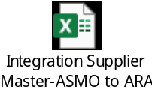
4.3 Data Synchronization Modes:
Mode | Description | API/BAPI Used
Real-time | Sync changes immediately via API call on save | BAPI_BUPA_CHANGE
Batch | Periodic sync using job (e.g., daily) | BAPI_BUPA_GETLIST, then BAPI_BUPA_CHANGE
Delta Sync | Sync only changed BPs using change logs | CDPOS / CDHDR tables with BAPI_BUPA_CHANGE

4.4 Authorization and Security
- Users/systems must have appropriate authorizations in both source and target systems
- Use SAP S/4HANA OData services or Proxy program with proper authentication (e.g., Basic Auth, SAML, OAuth).

4.5 Error Handling and Logging

- If a BAPI call fails in the target system:
  - Log the error with the Business Partner number and error message
  - Retry mechanism (e.g., 3 attempts).
  - Notify support team if retry fails.
- Use SAP transaction ST22 for ABAP dumps or SLG1 for custom logs “ZSCM_ASMO_VEN_ST”

4.6 Audit and Reconciliation
- Maintain logs of successful and failed BP changes.
- Run reconciliation reports daily to compare BP data in source and target systems.

5. Integration Design
5.1 Integration Landscape
- Source System: SAP S/4HANA (e.g., PRD)
- Target System: SAP S/4HANA (e.g., PRC)
- Integration Method:
  - OData API for real-time web-based integration
  - Proxy for synchronous processing
5.2 Integration Flow
- User updates Business Partner in source system.
- System detects change (via user exit, enhancement spot, or BAdI).
- Trigger BAPI_BUPA_GETDETAIL to extract current BP data.
- Call BAPI_BUPA_CHANGE on target system via Proxy service.
- Log success/failure in custom table (e.g., ZSCM_ASMO_VEN_ST *).
- If failed, retry or alert support team.

6. Technical Considerations
6.1 Data Consistency
- Ensure BP number uniqueness across systems.
- Synchronize related master data (e.g., Customer Master, Vendor Master) if used in downstream modules.
6.2 System Compatibility
- Ensure both systems use the same BP category (Organization, Person, Group).
- Validate compatibility of partner roles, classifications, and address types.
6.3 Custom Fields
- If custom fields exist in the BP, ensure they are:
  - Available in both systems.
  - Mapped correctly in the API/BAPI.

7. Testing Strategy
Test Type | Description | Tools Used
Unit Testing | Test BAPI calls independently | SE38 (BAPI tester) & SProxy
Integration Testing | End-to-end sync from source to target | SAP GUI
Performance Testing | Test volume of BP changes | Proxy
Error Handling | Simulate failed BAPI calls | Manual entries, test user

8. Rollout and Fallback Plan
8.1 Rollout Strategy
- Perform integration in phases:
  - Pilot with a small set of BPs
  - Expand to all BPs after validation
- Use OData API for integration.
8.2 Fallback Plan
- If integration fails:
  - Revert to manual BP updates in target system.
  - Use backup data to restore previous BP state.
  - Run reconciliation report to identify discrepancies.
9. Training and Documentation
- Train IT and business users on:
- How to check logs and resolve errors.
- How to validate BP changes across systems.
- Document:
  - BAPI usage and parameters.
  - Integration scenarios and flows.
  - Authorization roles required.
10. Approval and Sign-off
Role | Name | Signature | Date
Business Process Owner
SME
Project Manager

✅ Appendix A: Sample BAPI Usage
Example: Change BP Using BAPI program
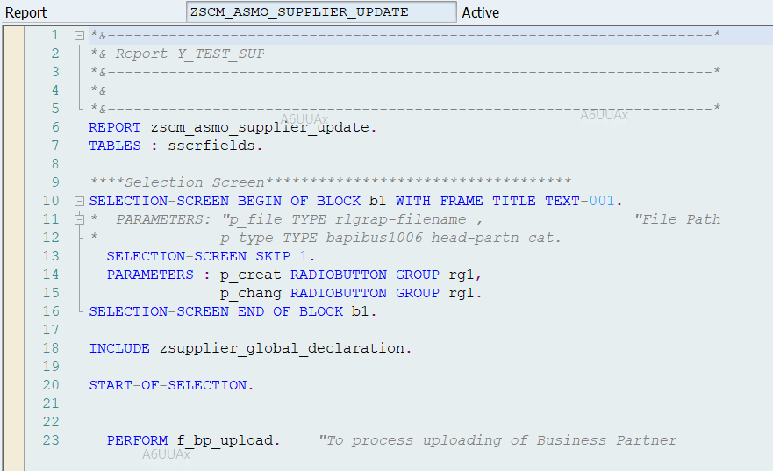

✅ Appendix B: API (SProxy) Sample (RESTful)
Endpoint:
POST /sap/opu/odata/sap/API_BUSINESS_PARTNER/A_BusinessPartnerAddress
Body (JSON):

