LLM EVALUATION ON
DIABETES MELLITUS
Master Project Review Document
A portfolio evaluation of four consumer AI assistants using a 32-question diabetes benchmark.

1. Project Overview
A small, reproducible evaluation of four freely available consumer AI assistants—ChatGPT, Gemini, Claude, and Perplexity—on 32 diabetes mellitus questions grounded primarily in the American Diabetes Association Standards of Care in Diabetes—2026.

Project objective
The project asks a practical question: How accurately do commonly available consumer AI assistants answer nuanced diabetes-related questions under ordinary user-facing conditions?
The evaluation focuses on clinically relevant reasoning, not just selection of a final option. Each response was compared with a predefined gold-standard answer and scored with a fixed rubric.

Systems evaluated
- ChatGPT
- Gemini
- Claude
- Perplexity
All systems were tested using freely available consumer interfaces. Logged-out access was used where available; where login was required, a free account was used. Web retrieval/search was permitted when available because the aim was to evaluate real-world product performance rather than isolated model knowledge.

Evaluation design
- 32 questions covering diagnosis, glycemic monitoring, pharmacotherapy, cardiovascular risk, hypertension, kidney disease, pregnancy-related lipid management, end-of-life care, and diabetes complications.
- Each question was submitted in a fresh conversation/window.
- No follow-up prompts, hints, corrections, or gold-standard answers were provided.
- The first complete response was retained.
- Explanations were limited to 80 words in the question set.
- Evaluation date: 9 August 2026.

Scoring rubric
Maximum possible score: 96 per system.

2. Methodology and Testing Protocol

Evaluation setting
Each AI system was evaluated through its standard consumer-facing interface. Web retrieval/search was permitted when available to reflect typical real-world use rather than isolated model knowledge.

Access conditions
All assistants were evaluated using freely available access. Logged-out access was used where possible. Where a platform required authentication, a free account was used. No paid model or premium feature was intentionally selected.

Test procedure
- The 32-question set and gold-standard answers were finalized before scoring.
- Each question was submitted independently in a fresh conversation/window.
- No previous question, model response, hint, correction, or gold-standard answer was supplied as context.
- The first complete response was recorded.
- Responses were scored against the predefined rubric.
- Each system could obtain a maximum of 3 points per question and 96 points overall.
- Percentage score was calculated as total score / 96 × 100.

Evaluation date
9 August 2026.

Reference standard
Gold-standard answers were prepared primarily from the American Diabetes Association Standards of Care in Diabetes—2026, with page-level references recorded in the source document. Some items explicitly allowed alternative answers when supported by a defensible guideline or high-quality study.

Systems
- ChatGPT
- Gemini
- Claude
- Perplexity
Exact underlying model versions were not consistently disclosed in the consumer interfaces and therefore were not used as a comparison variable.

3. Evaluation Question Paper
1.
A 25-year-old male with no previous history of diabetes, on long-term hemodialysis and with heart failure with preserved ejection fraction, approaches a doctor for consultation. His FPG is 109 mg/dL, 2-hour OGTT plasma glucose is 116 mg/dL, HbA1c is 7.5%, and random plasma glucose is 250 mg/dL. The values given are the higher of repeated values obtained on the same and different occasions.
What is the current diagnosis?
Explain in not more than 80 words.
2.
A 36-year-old male approaches a doctor for consultation. He has had COPD for 5 years, epilepsy for 10 years, type 2 diabetes mellitus for 15 years, and generalized anxiety disorder for 5 years. His investigations show:
A)Insulin: 25.5 µIU/mL
B)FPG: 99 mg/dL
C)2-hour OGTT plasma glucose: 199 mg/dL
C)HbA1c: 6.5%
Which of the above test results is most unlikely?
Explain in not more than 80 words.
3.
The ideal interval for screening for diabetes in individuals is not known; however, 2 years is a reasonable interval.
True or False?
Explain in not more than 80 words.
4.
Annual monitoring for complications of diabetes should be started after the diagnosis of post-cystic fibrosis diabetes.
True or False?
Explain in not more than 80 words.
5.
A 25-year-old male with prediabetes who is currently undergoing lifestyle modification approaches a doctor for consultation regarding initiation of metformin.
Should the doctor consider initiating metformin?
Answer in Yes or No. Explain in not more than 80 words.
6.
Which medication, apart from glucose-lowering medications, would you mandatorily start in a 55-year-old patient with type2 diabetes?
Explain in not more than 80 words.
7.
Glycemic management in type 2 diabetics significantly reduces fracture risk.
True or False?
Explain in not more than 80 words.
8.
Poor glycemic control has been associated with greater severity of hearing impairment.
True or False?
Explain in not more than 80 words.
9.
People with diabetes should reduce the total amount of fat in their diet.
True or False?
Explain in not more than 80 words.
10.
A 57-year-old female with diabetes approaches a doctor for consultation. She has had coronary artery disease for 5 years, for which she is taking Ecosprin. She has also had migraine for 5 years. The doctor wants to assess the patient's glycemic status.
Which of the following tests would be most appropriate?
A. HbA1c
B. FPG
C. 2-hour OGTT plasma glucose
D. Any one of the above
Explain in not more than 80 words.
11.
HbA1c testing should be performed routinely in all patients with diabetes, at the initial assessment and as part of continuing care.
True or False? Justify your answer in not more than 80 words.
12.
Adults with diabetes who have achieved their glycemic goal do not need HbA1c testing more than once a year.
True or False?
Explain in not more than 80 words.
13.
A 30-year-old patient with type 2 diabetes approaches a doctor for consultation regarding glycemic goals. He has had diabetes for 5 years and underwent cholecystectomy last year. He is physically active, likes to go trekking, and has been on metformin for the last 5 years.
What would be the most appropriate HbA1c goal?
A. <6.5%
B. <7.5%
C. Let the patient choose
D. HbA1c goal is not important in the above individual
Explain in not more than 80 words.
14.
A 57-year-old male with type 2 diabetes approaches a doctor for consultation. He has had diabetes for 15 years. His HbA1c 3 months ago was 6.8%, and yesterday it was 7.0%. His FPG 3 months ago was 145 mg/dL and is now 146 mg/dL. His current serum creatinine is 1.3 mg/dL; one month ago, it was 1.7 mg/dL. His urinary albumin-to-creatinine ratio (UACR) was 300 mg/g and yesterday was 301 mg/g. Serum potassium is 5.3 mEq/L. He complains of new-onset intermittent lower backache for 15 days. He is on metformin, insulin glargine, enalapril 30 mg, and dapagliflozin.
Which of the following is the most appropriate next step?
A. Add finerenone
B. Increase insulin glargine by 10 units
C. Ask the patient to intensify lifestyle management
D. Add semaglutide
Explain in not more than 80 words.
15.
A 45-year-old physically active male approaches a doctor for consultation after being diagnosed with type 2 diabetes with an HbA1c of 9%. He has had weight loss in last two months.
Which of the following treatment regimens would be most appropriate?
A. Glargine
B. GLP-1 receptor agonist
C. Glargine plus metformin
D. Metformin plus SGLT2 inhibitor
Explain in not more than 80 words.
16.
When all major cardiovascular risk factors have been treated to within the normal range, the life expectancy of people with diabetes equals that of the general population.
True or False?
Explain in not more than 80 words.
17.
A 45-year-old male with type 2 diabetes approaches a doctor for consultation. He also has asthma and coronary artery disease. At the clinic, his blood pressure is 182/112 mmHg.
Which of the following is the most appropriate next step?
A. Confirm the diagnosis of hypertension
B. Ask the patient to return after 24 hours for repeat measurement
C. Ask the patient to return after 4 hours for repeat measurement
D. Ask the patient to return after 3 weeks of lifestyle modification for repeat measurement
Explain your answer in not more than 80 words.
18.
A 37-year-old male approaches a doctor for consultation. He has had type 2 diabetes for 3 years and hypertension for the last 2 years. He is following lifestyle modification measures. Recently, he has been experiencing intermittent headaches, and his legs feel swollen. He is taking metformin 2,000 mg, enalapril 20 mg, and amlodipine 10 mg. His HbA1c is 6.9%, UACR is 125 mg/g, serum potassium is 5.0 mEq/L, and clinic blood pressure is 135/92 mmHg.
Which of the following is the most appropriate next step?
A. Add chlorthalidone and intensify lifestyle modification
B. Intensify lifestyle modification
C. Reduce amlodipine and add chlorthalidone
D. Reduce enalapril and add indapamide
Explain in not more than 80 words.
19.
A 45-year-old patient with type 2 diabetes approaches a doctor for consultation. He also has hypertension. His FPG is 105 mg/dL, HbA1c is 7.2%, and serum creatinine is 1.25 mg/dL. He has been on metformin for 3 years. Enalapril 10 mg was started 2 weeks ago, at which time his serum creatinine was 1.0 mg/dL.
What is the most appropriate next step?
A. Monitor UACR
B. Reduce the dose of enalapril
C. Stop enalapril and start chlorthalidone
D. Stop enalapril and start lisinopril
Explain in not more than 80 words.
20.
An individual should be considered to have resistant hypertension if blood pressure goals are not being met despite appropriate lifestyle management and maximum tolerated doses of atenolol, lisinopril, and amlodipine.
True or False?
Explain in not more than 80 words.
21.
A 47-year-old male with type 2 diabetes is confirmed to have hypertension with a blood pressure of 152/92 mmHg.
What is the most appropriate next step?
A. Start chlorthalidone
B. Start enalapril
C. Start enalapril plus atenolol
D. Start chlorthalidone plus enalapril
Explain in not more than 80 words.
22.
In some circumstances where the benefits outweigh the risks, lipid-lowering therapy may be continued before conception.
True or False?
Explain in not more than 80 words.
23.
In individuals with type 2 diabetes who are receiving statin therapy, fibrates can be added for further cardiovascular risk reduction.
True or False?
Explain in not more than 80 words.
24.
A 51-year-old male with type 2 diabetes and hypertension who is not at increased risk of bleeding may be started on aspirin for the primary prevention of atherosclerotic cardiovascular disease.
True or False?
Explain in not more than 80 words.
25.
A 46-year-old male with type 2 diabetes has no symptoms of ASCVD. However, he should be screened for ASCVD because diabetes increases the risk of ASCVD.
True or False?
Explain in not more than 80 words.
26.
A 50-year-old male with type 2 diabetes and hypertension approaches a doctor for consultation. He is a smoker, had an episode of myocardial infarction one year ago. Currently, he is taking enalapril 10 mg and metformin 1,500 mg.
Which of the following is the most appropriate next step?
A. Add dapagliflozin
B. Add rosuvastatin and dapagliflozin
C. Add dapagliflozin, rosuvastatin, and semaglutide
D. Add a statin and intensify lifestyle management
Explain in not more than 80 words.
27.
People with type 2 diabetes may develop signs chronic kidney disease without retinopathy.
True or False?
Explain in not more than 80 words.
28.
In people with type 2 diabetes, annual assessment of kidney function with UACR should be started 5 years after diagnosis, irrespective of treatment status.
True or False?
Explain in not more than 80 words.
29.
A 62-year-old male with type 2 diabetes approaches a doctor for consultation. His HbA1c is 7.8%, has remained at approximately this level for 2 years and he is on continuous glucose monitoring. His blood pressure is controlled, and his UACR has been around 50 mg/g for 3–4 years. His cognitive and functional status are normal.
What should be his most appropriate HbA1c goal?
Explain in not more than 80 words.
30.
In type 2 diabetes, at the end of life, most agents used for diabetes management can be discontinued.
True or False?
Explain in not more than 80 words.
31. Long term diabetes is associated with impairment of hearing, smell and taste. True/false
Explain in not more than 80 words.
32. RAS inhibitors can be given in type 2 diabetes for primary and secondary prevention of chronic kidney diseases.
True or False?
Explain in not more than 80 words.

4. Gold-Standard Answers
Prediabetes: HbA1C results are unreliable due to hemodialysis. RBS can not be considered without classical symptoms of diabetes. 2 hourr OGTT is normal but FPG is in impaired range.
Reference: American Diabetes Association Standards of Care 2026, p-s25
A) Insulin. Normal range of insulin is 2-25 microIU/mL After 15 years of type @ diabetes insulin is unlikely to remain at higher normal range. All others are possible.
Reference: American Diabetes Association Standards of Care 2026, Chapter-2
False. 3 years is a reasonable interval. Note: If the answer is true and it explains that certain guidelines consider 2 years as appropriate, then it should be taken as correct answer.
Reference: American Diabetes Association Standards of Care 2026, p. S38
False. Annual monitoring should be started after 5 years. Reference: American Diabetes Association Standards of Care 2026, p. S39
Yes. AS per ADA-26 metformin should be recommended as an option for pre diabetes individuals with high risk individuals e.g. younger individuals for prevention of diabetes.
If the answer is No, the explanation should at least mention that some guidelines would not consider metformin in this situation.
Reference: American Diabetes Association Standards of Care 2026, p. S54
Statins/any drug of statin class. In type 2 diabetics aged 40-75 years moderate intensity statins should be instituted without ASCVD risk factors.
Reference: American Diabetes Association Standards of Care 2026, p. S225
False. Poor Glycemic management increases risk. However reverse doesn’t necessarily decrease risk. ACCORD Intensive glycemic trials did not increase or decrease fracture.
Reference: American Diabetes Association Standards of Care 2026, p. S69
False. No association has been found between the two.
Reference: American Diabetes Association Standards of Care 2026, p. S81
False. There is no optimal percentage of calories from fat for people with diabetes. Type of fat consumed is more important than amount of fat.
Reference: American Diabetes Association Standards of Care 2026, p. S96
10.Glycemia is assessed by HbA1C not FPG or 2-hour OGTT.
Reference: American Diabetes Association Standards of Care 2026, p. S132
. True. Reference: American Diabetes Association Standards of Care 2026, p. S133
. False. Adults with diabetes who have achieved their glycemic goal do not need HbA1c testing more than twice a year.
Reference: American Diabetes Association Standards of Care 2026, p. S137
13. A <6.5%. Lower glycemic goals e.g. <6.5% may be appropriate for individuals with diabetes and good health and function and low treatment risks and burdens.
Reference: American Diabetes Association Standards of Care 2026, p. S136
14. D. Add Semaglutide. In persons with type 2 diabetes with CKD who are on SGLT2i, GLP1-RA should be for further reduction of CKD risk. Some guidelines recommend finerenone but in this patient with potassium already on 5 mEq/L, hyperkalemia is a risk.
Reference: American Diabetes Association Standards of Care 2026, p. S191
15. C. Glargine plus metformin. Initial combination therapy should be considered in individuals presenting with A1C levels >1,5-2% above their individualized glycemic goals. Insulin should be considered as part of any combination plan where catabolic features are present.
Reference: American Diabetes Association Standards of Care 2026, p. S197
16. True.
Reference: American Diabetes Association Standards of Care 2026, p. S216.
Note: Accept False as correct answer if any other good study shows results to the contrary.
17. A. Confirm the diagnosis of hypertension. In Individuals with CVD and blood pressure greater than or equal to 180/110 mmHg it is reasonable to diagnose hypertension at a single visit.
Reference: American Diabetes Association Standards of Care 2026, p. S217
18. C. Reduce amlodipine and add chlorthalidone. Reduce Amlodipine for reduction of oedema and add chlorthalidone for achieving BP goal.
Reference: American Diabetes Association Standards of Care 2026, p. S220
19. A. Monitor UACR. Elevation in serum creatinine upto 30% from baseline should not be confused with AKI.
Reference: American Diabetes Association Standards of Care 2026, p. S222
20. False. A diuretic must be part of treatment plan for declaration of resistant hypertension.
Reference: American Diabetes Association Standards of Care 2026, p. S212
21. D. Start chlorthalidone plus enalapril. For individuals with blood pressure more than or equal to 150/90 mmHg, initial pharmacologic therapy with 2 medications is recommended. Atenolol is not part of the main drug classes recommended.
Reference: American Diabetes Association Standards of Care 2026, p. S221
22. True.
Reference: American Diabetes Association Standards of Care 2026, p. S223
23. False.
Reference: American Diabetes Association Standards of Care 2026, p. S228
24. True.
Reference: American Diabetes Association Standards of Care 2026, p. S229
25. False.
Reference: American Diabetes Association Standards of Care 2026, p. S230
26. C. Add dapagliflozin, rosuvastatin, and semaglutide.
Reference: American Diabetes Association Standards of Care 2026, p. S230-Flow Diagram
27.True. In contrast people with type 1 diabetes rarely develop chronic kidney diseases without retinopathy.
Reference: American Diabetes Association Standards of Care 2026, p. S248
28. False. In all people of type 2 Diabetes assessment of kidney function should be done annually regardless of treatment.
Reference: American Diabetes Association Standards of Care 2026, p. S246
29. <7.0-7.5%. Older adults with diabetes with few and stable coexisting chronic illness, should have lower glycemic goals (e.g.<7.0-7.7%) if CGM is used.
Reference: American Diabetes Association Standards of Care 2026, p. S282
30. True.
Reference: American Diabetes Association Standards of Care 2026, p. S283
31. False. Long term diabetes is associated with impairment of hearing, smell but not taste.
Reference: American Diabetes Association Standards of Care 2026, p. S81
32.False. Routine use of RAS inhibitors solely for the prevention of CKD in diabetics is not recommended.
Reference: American Diabetes Association Standards of Care 2026, p. S250

5. Scoring Rubric
Each of the 32 questions was scored from 0 to 3, giving a maximum possible score of 96.
Score | Classification | Criteria
0 | Incorrect answer | Incorrect answer, regardless of the explanation provided.
1 | Correct answer only | Correct answer, but explanation is absent, incorrect, or does not adequately justify the answer.
2 | Correct answer + explanation | Correct answer with a correct and adequate explanation consistent with the gold-standard answer.
3 | Correct answer + explanation + additional point | Correct answer with an adequate explanation plus an additional correct and relevant point that meaningfully adds to the answer.
Percentage score = (Total score obtained ÷ 96) × 100.

6. Results
AI System | Total Score | Maximum | Percentage
ChatGPT | 76 | 96 | 79.17%
Gemini | 78 | 96 | 81.25%
Claude | 69 | 96 | 71.88%
Perplexity | 69 | 96 | 71.88%

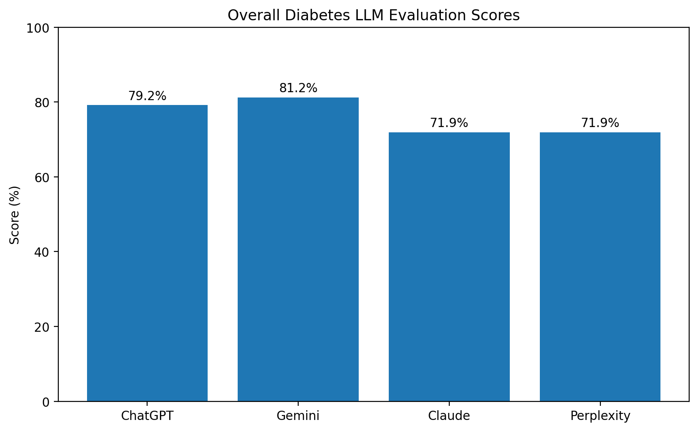
Figure 1. Overall evaluation scores.
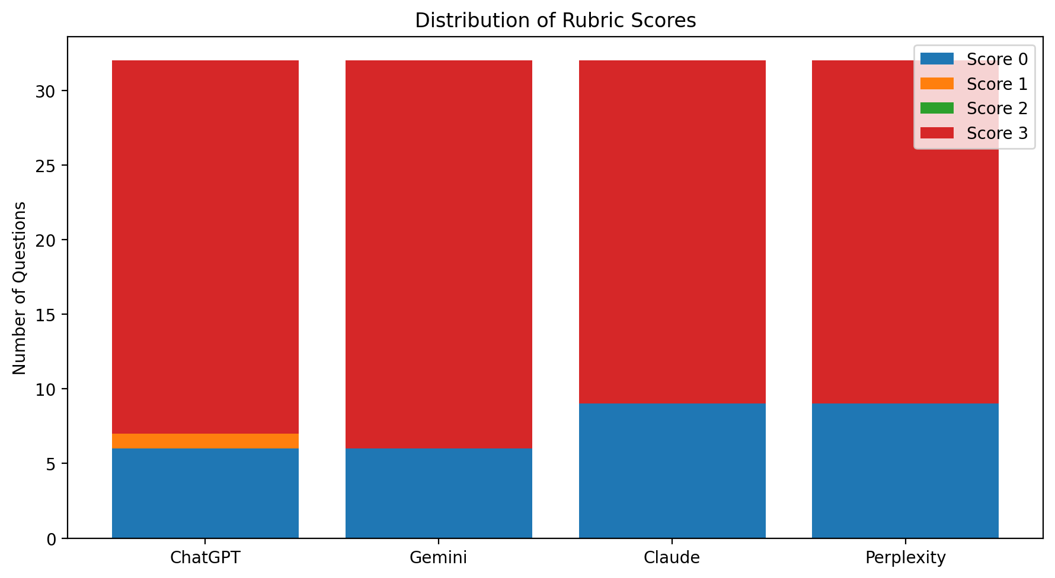
Figure 2. Distribution of rubric scores.

7. Error Analysis

Purpose
This section examines representative failure modes observed during the evaluation of four consumer AI assistants on 32 diabetes-related questions. The aim is not only to identify incorrect answers, but also to characterize *how* the systems failed.
The analysis uses the predefined gold-standard answers and scoring rubric prepared for the project.

1. Plausible mechanistic reasoning despite an incorrect conclusion
Question 8
The gold-standard answer classified the statement linking poor glycemic control with greater severity of hearing impairment as False.
Several systems answered True and produced biologically plausible explanations involving chronic hyperglycemia, microvascular injury, cochlear damage, and neuropathy.

Failure mode
Plausible pathophysiological reasoning inconsistent with the benchmark reference.

Why this matters
This is a clinically important LLM failure mode. A response can sound medically sophisticated and internally coherent while still reaching the wrong conclusion. Such answers may be particularly difficult for non-expert users to recognize as incorrect.

2. Threshold recognition without applying diagnostic qualifications
Question 1
The gold-standard diagnosis was prediabetes. The key considerations were:
- HbA1c was considered unreliable because the patient was on hemodialysis.
- Random plasma glucose could not establish diabetes in the absence of classical hyperglycemic symptoms.
- The 2-hour OGTT value was normal.
- Fasting plasma glucose was in the impaired fasting glucose range.
Some systems instead diagnosed diabetes mellitus, relying heavily on the random plasma glucose threshold and/or elevated HbA1c.

Failure mode
Correct recall of diagnostic thresholds, but incorrect application of the conditions under which those thresholds are valid.

Why this matters
Clinical decision-making frequently depends on qualifications, exceptions, and context rather than isolated numerical cutoffs. Memorizing a threshold is not equivalent to correctly applying a diagnostic criterion.

3. Confusing diagnostic tests with monitoring tests
Question 10
The gold-standard answer was HbA1c for assessment of glycemic status in a patient with established diabetes.
Some systems selected “Any one of the above”, reasoning that HbA1c, fasting plasma glucose, and the 2-hour OGTT are all accepted tests for glycemia.

Failure mode
Failure to distinguish between blood sugar at a point in time and glycemic control over a period of time.

Why this matters
The systems demonstrated relevant factual knowledge but applied it to the wrong clinical objective. This illustrates that medical LLM evaluation should test task interpretation as well as factual recall.

4. Incomplete management despite partially correct reasoning
Question 26
The gold-standard answer was:
Add dapagliflozin, rosuvastatin, and semaglutide.
The patient had type 2 diabetes and established ASCVD following myocardial infarction.
Some systems correctly identified the indication for a high-intensity statin and an SGLT2 inhibitor but omitted the GLP-1 receptor agonist.

Failure mode
Partially correct therapeutic reasoning resulting in an incomplete management plan and inability to follow guidelines fully.

Why this matters
Real clinical management often requires simultaneous consideration of multiple guideline-directed interventions. An answer can contain several correct recommendations and still be incomplete.

5. Correct explanation paired with the wrong final answer
Question 32
The gold-standard answer was False because routine renin-angiotensin system inhibition is not recommended solely for primary prevention of CKD in people with diabetes who do not otherwise have an indication.
One system answered “True, but with important caveats” and then explained that RAS inhibitors are appropriate for secondary prevention but are not recommended for primary prevention in normotensive, normoalbuminuric patients.

Failure mode
Internal contradiction between the final classification and the explanatory reasoning.

Why this matters
This demonstrates why both the final answer and the explanation should be evaluated. Scoring only the explanation could overlook an incorrect conclusion, while scoring only the conclusion would fail to reveal that the model possessed much of the relevant knowledge.

Overall Interpretation
The observed errors were not limited to simple knowledge gaps. Important failure patterns included:
- plausible but unsupported mechanistic reasoning;
- failure to apply diagnostic qualifications;
- confusion between related clinical tasks;
- incomplete multimorbidity management; and
- contradictions between the final answer and the explanation.
These findings support evaluating medical AI assistants on both answer correctness and quality of explanation. A response may be fluent, detailed, and medically plausible while still being clinically incorrect.
The error analysis also shows why domain-expert evaluation remains important. High aggregate scores alone do not reveal whether failures are trivial, reasoning-based, or potentially consequential in clinical use.

Project Context
This error analysis is part of the repository:
LLM Evaluation on Diabetes Mellitus
The project compares four freely available consumer AI assistants using a 32-question diabetes benchmark, predefined gold-standard answers, and a 0-3 scoring rubric.

8. Limitations
- The benchmark contains 32 questions and is intended as a focused portfolio evaluation rather than a comprehensive diabetes benchmark.
- The question author, gold-standard author, and primary scorer were the same evaluator, so independent expert validation and inter-rater reliability were not assessed.
- The 0-3 rubric rewards an additional relevant point at score 3; this can favor responses that provide useful extra detail.
- The study evaluates consumer AI assistants under the tested access conditions and time point. Product behavior may change as models, interfaces, retrieval systems, and defaults are updated.

9. Conclusion
The four systems achieved broadly similar but non-identical performance, with Gemini obtaining the highest aggregate score, followed closely by ChatGPT, while Claude and Perplexity tied. The error analysis shows that aggregate accuracy alone is insufficient: clinically plausible reasoning, incomplete application of diagnostic criteria, task confusion, incomplete management, and internal contradictions were all observed. The project therefore demonstrates a practical workflow for domain-expert evaluation of medical AI outputs using a predefined benchmark, gold-standard answers, structured scoring, quantitative comparison, and qualitative error analysis.

10. Repository Contents
- README.md — GitHub project landing page
- METHODOLOGY.md — evaluation design and testing conditions
- RUBRIC.md — scoring framework
- RESULTS.md — quantitative results
- ERROR_ANALYSIS.md — representative failure-mode analysis
- analysis.py — reproducible analysis script
- original_documents/ — question paper, gold-standard answers, model responses, protocol, and rubric
- results/ — scored workbook and CSV result files
- figures/ — result visualizations

11. Raw Model Responses
The complete verbatim responses from ChatGPT, Gemini, Claude, and Perplexity are retained as separate Word documents in the repository's original_documents folder. They are not reproduced in this master review document to keep the project readable while preserving the underlying evaluation record.

