**ARFF for weka Report**

**Task 1:**

1. **Screenshot of corrected arff file**

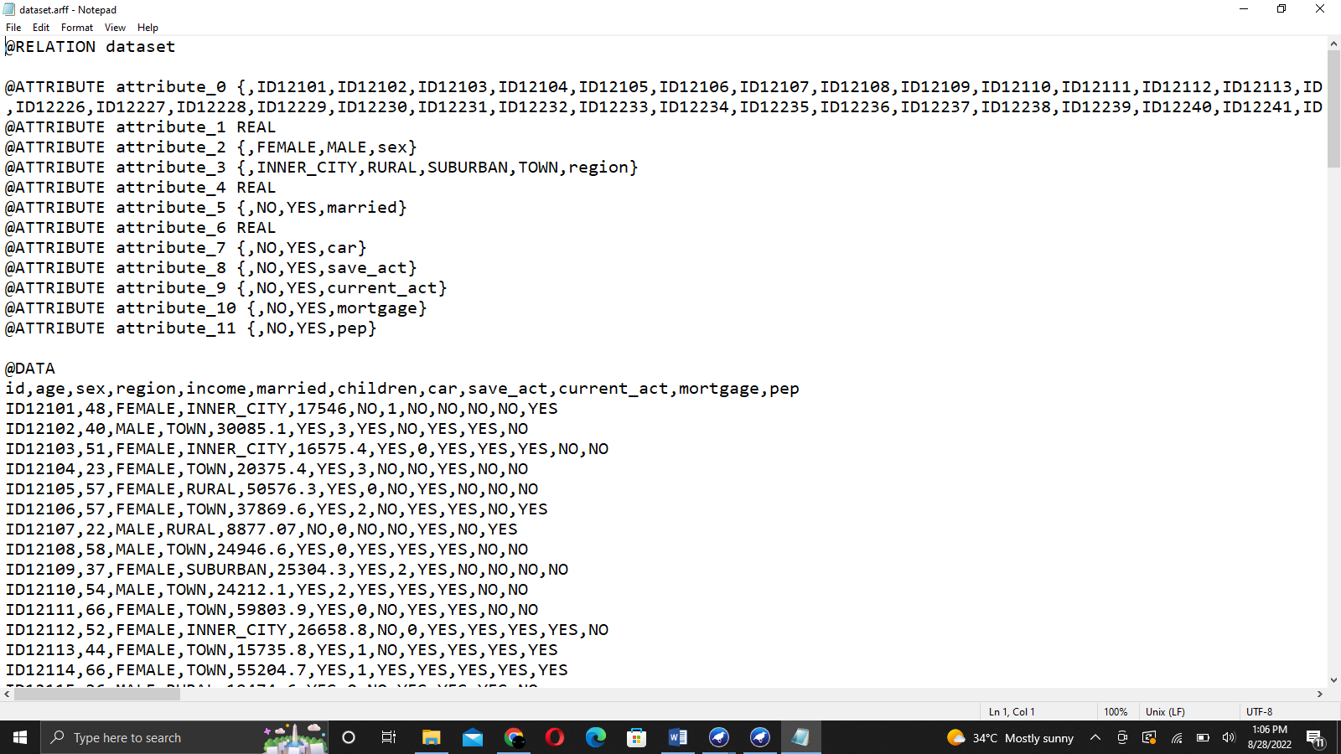

1. **Which attribute in the dataset do you think is useless and did not provide useful**

Children attribute is useless because it didn’t provide useful information for prediction.

1. **How many attributes the dataset has?**

The dataset has total of 12 attributes.

1. **How many instances the dataset has?**

The dataset has 150 instances.

1. **What is the class attribute in the data.arff dataset?**

Id is the class attribute in dataset.arff

1. **What proportion of customers who has a mortgage and live in Inner City?**

14.67%

1. **What proportion of customers who has a mortgage and not living in Inner City?**

16.67%

1. **What proportion of customers have a mortgage, and their income is between**

**$1000 and $10000?**

1.34%

1. **How many customers are married and have no mortgage?**

68.67%

1. **How many customers have not owned a car and have a mortgage?**

31.34%

**Task 2:**

* **The attributes are:**
  + Id
  + Age
  + Sex
  + Region
  + Income
  + Married
  + Children
  + Car
  + Save_act
  + Current_act
  + Mortgage
  + Pep
* **Real value and nominal attributes**

Genuine esteemed credits are numeric traits containing just genuine qualities. These are quantifiable amounts. These qualities can be span scaled, for example, temperature or proportion scaled like mean, or middle.

Ostensible traits address names or some portrayal of things. There is no organization in such traits and they address some classification. For instance, variety.

The board underneath the ongoing connection shows the name of characteristics.

In the right board, the chose characteristic measurements are shown. Select the characteristic "checking_status".

It shows:

Name of the trait

Missing: Any missing upsides of the trait in the dataset. 0% for this situation.

Unmistakable: The quality has 4 particular qualities.

Type: The trait is of the ostensible sort that is, it takes no numeric worth.

Count: Among the 1000 cases, the count of each unmistakable class name is written in the count section.

Histogram: It will show the result class mark for the characteristic. The class mark in this dataset is either positive or negative. There are 700 examples of good (set apart in blue) and 300 cases of awful (set apart in red).

For the mark < 0, the occurrences for good or awful are practically a similar in number.

For mark, 0<= X<200, the examples with choice great are more than cases with terrible.

Also, for name >= 200, the maximum cases happen for good and no checking mark has more occurrences with choice great.

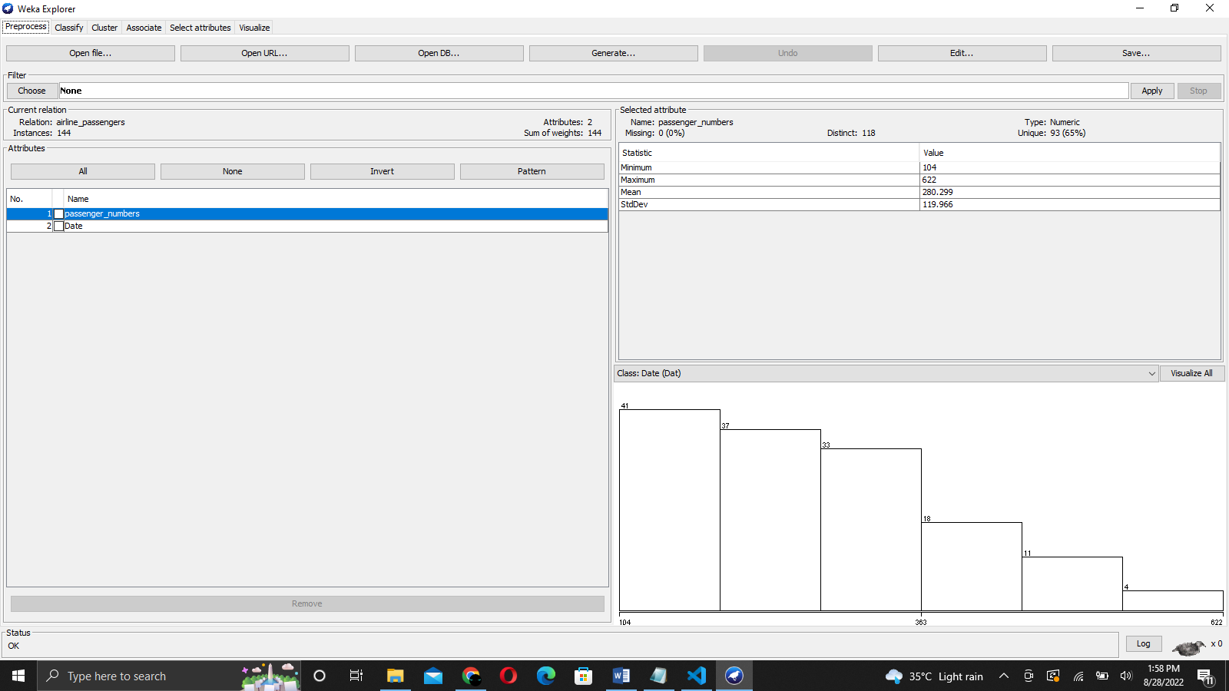

Name: This is the Name of the property.

Type: The kind of the property is numeric.

Missing worth: The property has no missing worth.

Unmistakable: It has 33 particular qualities in 1000 examples. It implies in 1000 cases it has 33 unmistakable qualities.

Novel: It has 5 extraordinary qualities that don't coordinate with one another.

Least worth: The min worth of the property is 4.

Most extreme Value: The maximum worth of the property is 72.

Mean: Mean is adding every one of the qualities separated by cases.

Standard Deviation: Stddeviation of trait span.

Histogram: The histogram portrays the length of 4 units, the maximum cases happen for a decent class. As the span increments to 38 units, the quantity of occasions lessens for good class marks. The span arrives at 72 units which has just a single occasion which characterizes the choice as terrible.

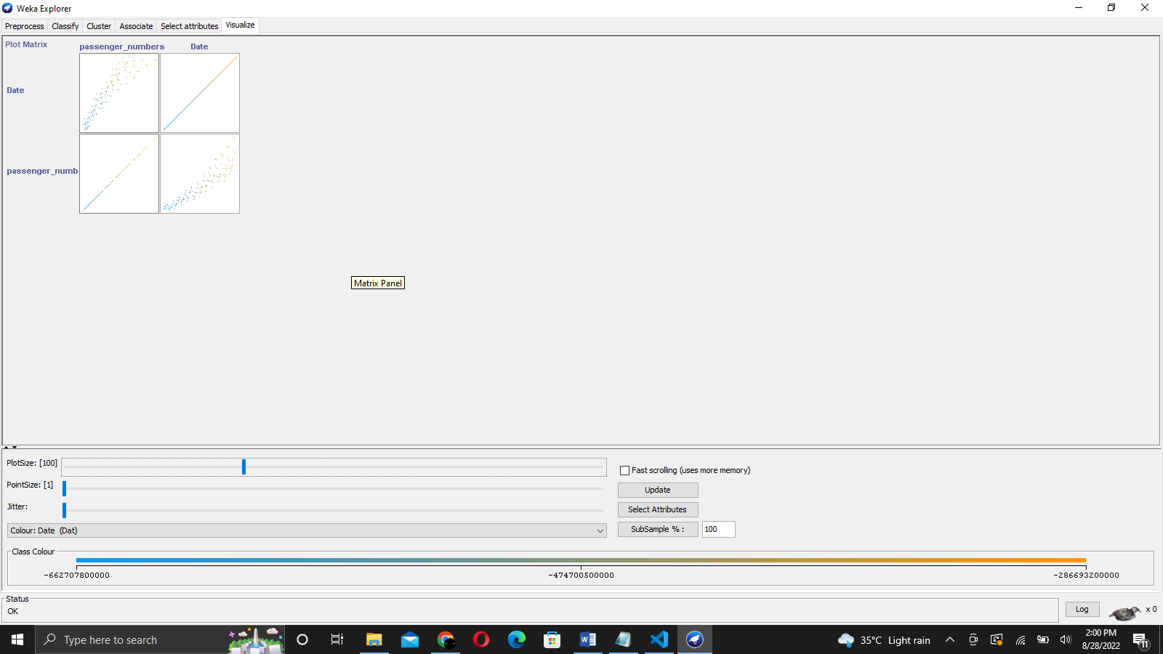

WEKA channels have numerous functionalities to change the quality upsides of the dataset to make it appropriate for the calculations. For instance, the numeric change of characteristics.

Sifting the ostensible and genuine esteemed credits from the dataset is one more instance of utilizing WEKA channels.

**Output**

The genuine esteemed and ostensible qualities credits in the dataset are distinguished. Perception with the class mark is found as histograms.

**Decision Tree**

A choice Tree is the grouping strategy that comprises of three parts root hub, branch (edge or connection), and leaf hub. Root addresses the test condition for various traits, the branch addresses generally potential results that can be there in the test, and leaf hubs contain the name of the class to which it has a place. The root hub is at the beginning of the tree which is additionally called the highest point of the tree.

**J48 Classifier**

It is a calculation to produce a choice tree that is created by C4.5 (an expansion of ID3). It is otherwise called a measurable classifier. For choice tree order, we really want an information base.

Steps include:

#1) Open WEKA traveler.

#2) Select weather.nominal.arff document from the "pick record" under the preprocess tab choice.

Pick dataset

#3) Go to the "Arrange" tab for grouping the unclassified information. Click on the "Pick" button. From this, select "trees - > J48". Allow us likewise to have a brief glance at different choices in the Choose button:

Bayes: It is a thickness assessment for mathematical properties.

Meta: It is a multi-reaction straight relapse.

Capabilities: It is calculated relapse.

Sluggish: It sets the mix entropy consequently.

Rule: It is a standard student.

Trees: Trees characterize the information.

Characterize tab

#4) Click on Start Button. The classifier result will be seen on the Right-hand board. It shows the run data in the board as:

Plot: The order calculation utilized.

Occasions: Number of information lines in the dataset.

Credits: The dataset has 5 ascribes.

The quantity of leaves and the size of the tree depicts the choice tree.

Time is taken to fabricate the model: Time for the result.

Full characterization of the J48 pruned with the characteristics and number of occasions.

Characterized yield data

Envision tree

#5) To envision the tree, right-click on the outcome and select imagine the tree.

Choice tree

Yield:

The result is as a choice tree. The principal characteristic is "standpoint".

On the off chance that the viewpoint is radiant, the tree further examines the dampness. On the off chance that stickiness is high, the class mark play= "yes".

Assuming the viewpoint is cloudy, the class name, play is "yes". The quantity of occurrences which comply with the characterization is 4.

On the off chance that viewpoint is blustery, further grouping happens to examine the trait "breezy". In the event that windy=true, the play = "no". The quantity of occasions which comply with the arrangement for outlook= blustery and windy=true is 2.

**Result**

To apply AI computations, WEKA provides a wide range of test datasets. These sample datasets can be used by the clients to do AI tasks including characterisation, relapse, quality selection, and relationship as well as to become more proficient with the tool.

Several tasks, starting with preprocessing, are completed using WEKA traveller. Preprocessing receives input in the form of an.arff document, processes the data, and produces a product that can be used by other PC programmes. The outcome of preprocessing in WEKA reveals the characteristics existing in the dataset, which may also be used for factual investigation and correlation with grade correlation.

WEKA additionally offers numerous order calculations for choice trees. J48 is one of the well known grouping calculations which yields a choice tree. Utilizing the Classify tab the client can picture the choice tree. Assuming that the choice tree is excessively populated, tree pruning can be applied from the Preprocess tab by eliminating the characteristics which are not needed and beginning the arrangement interaction once more.

**Comparison**

A fundamental probabilistic classifier, the Naive Bayes calculation computes a number of probabilities by counting the occurrences and combinations of values in a given data collection. Given the value of the class variable, the calculation uses the Bayes hypothesis and anticipates that all credits will be free. This contingent freedom supposition rarely plays out as expected in real-world applications, so the calculation is portrayed as being guileless, but it will typically work well and advance quickly in various managed characterization issues.

Genuine positive (TP): A situation is considered real positive if the outcome of a prognosis is p and the genuine worth is likewise p. False positive (FP): However, in the event that the true opinion is n, it is presumed

Two classifiers, gullible bayes calculation what's more, J48 choice tree calculation are utilized for examination. Examination is made on precision, responsiveness and particularity utilizing genuine positive and misleading positive in disarray grid created by the particular calculations. Likewise we can utilize the right furthermore, wrong occasions that give us a generally effective technique for order by utilizing the disarray framework.

A simple C4.5 decision tree is used as the J48 classifier for order. The result is a double tree. The decision tree method is the most beneficial in arrangement problems. Using this technique, a tree is created to represent the order cycle. Each tuple in the data set is subjected to the tree's construction, which creates order for that tuple.

The precision of the characterisation is typically evaluated in order to analyse the display of characterization calculation. However, as characterisation is frequently a subjective matter, the appropriate response may depend on the customer. The use of conventional quantitative assessment approaches, such as determining the reality above, is possible, but these procedures are typically optional. Understanding of the problem by clients is necessary for determining which better best is. Figuring out which better best is relies upon the understanding of the issue by clients. Characterization exactness is normally determined by deciding the level of tuples set in a right class. This overlooks the way that there likewise may be an expense related with a wrong task to some unacceptable class. It would be ideal for this maybe to likewise decide.

This proves that the J48 is a fundamental classifier method that works with a choice tree. Weka's analysis tool was used to extract useful results from the dataset. Moreover, the arbitrary Bayes classifier is producing excellent results. The tests findings related to arrangement accuracy and cost examination are shown in the review. For class contracts in bank datasets with the two attributes Yes and negative, J48 provides better order exactness. However, in this model, when cost examination is valued equally for both classifiers, we can show that J48 is more cost-productive than the Naive Bayes classifier by combining orientation quality.

**Summary**

The J48 is a tree-based calculation that is used to determine how the property vector behaves under different circumstances. The classes for the recently supplied material are also discovered based on the preparation times. The ideas for the result variable expectation were developed through this calculation. The appropriate appropriation of the information is effectively sensible with the aid of tree grouping calculation. J48 is a progression of ID3. The further components of J48 include identifying the lacking qualities, trimming option trees, continuously maximising characteristic values, and so on. The C4.5 calculation is executed using open source Java code by the J48. It offers a variety of options related to tree pruning. Pruning can be used as an accuracy device due to projected over fitting.

For different calculations, the arrangement is accomplished recursively until each and every leaf is unadulterated. For this situation, the arrangement of the information ought to be essentially as exact as could really be expected. The J48 creates the guidelines from which a particular personality of the information is delivered.

Naive bayes (NB) is an order calculation that delivers a probability of a particular arrangement of clarifications connected with a particular class, which vary because of the upsides of the class name variable. The NB classifier has been acknowledged as an essential probabilistic classifier, which depends on clear free standards of Bayesian hypothesis.

In AI and information mining, characterization is an essential issue. In a characterization, the idea of this calculation is to build a classifier with class marks. The NB approach is a managed characterization calculation which utilizes the hypothesis of Bayes.

**Conclusion**

Contract trait has been decided arbitrarily for bank informational index. J48 is applied on the informational index and the disarray framework is produced for class orientation having two potential qualities for example YES or NO.

We have performed arrangement utilizing Naïve Bayes calculation and J48 choice tree calculation on dataset.arff dataset in weka apparatus. Weka instrument give inbuilt calculations to guileless Bayes and J48. genuine up-sides for class a='YES' is 33 while bogus up-sides is 72 though, for class b='NO', genuine up-sides is 170 and bogus up-sides is 25 for example corner to corner components of grid 33+170 =203 addresses the right occurrences ordered and other components 25+72 = 97 addresses the wrong occurrences.

Genuine positive rate = corner to corner component/amount of applicable line

Bogus positive rate = non-corner to corner component/amount of applicable line

Consequently,

TP rate for class a = 33/(33+72) = 0.314

FP rate for class a = 25/(25+170) = 0.128

TP rate for class b = 170/(25+170) = 0.871

FP rate for class b = 72/(33+72) = 0.685

Normal TP rate = 0.677

Normal FP rate = 0.491

Here same, Mortgage trait has been decided for dataset index. Guileless Bayes is applied on the informational index also, the disarray network is created for class orientation having two potential qualities.