Class 5 Graph Design

Tingyi Yang

Jan 22nd, 2019

# Class 05 R graphics intro

# My first boxplot  
  
x <- rnorm(1000,0)  
boxplot(x)

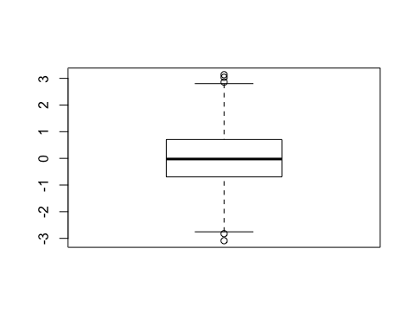

#rnorm is executed first then boxplot  
  
summary(x)

## Min. 1st Qu. Median Mean 3rd Qu. Max.   
## -3.08782 -0.69494 -0.02431 0.00197 0.70521 3.13749

hist(x)

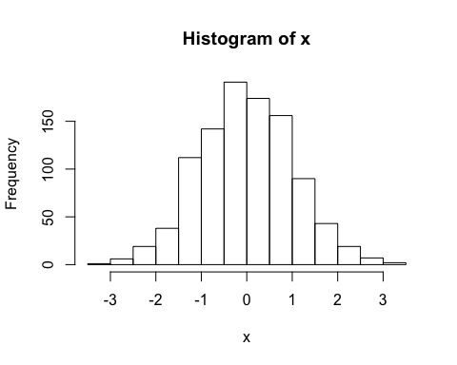

boxplot(x, horizontal = TRUE)

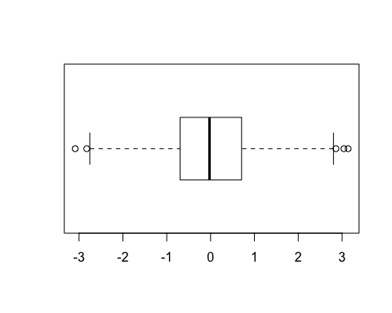

#hands on session 2  
  
y <- read.table("bimm143_05_rstats/weight_chart.txt", header = TRUE)  
plot(y, type="o", pch=15, cex=1.5, lwd=3, lty=3, ylim=c(2,10), xlab="Age(months)", ylab="Weight(kg)", main = "Weight with Age")

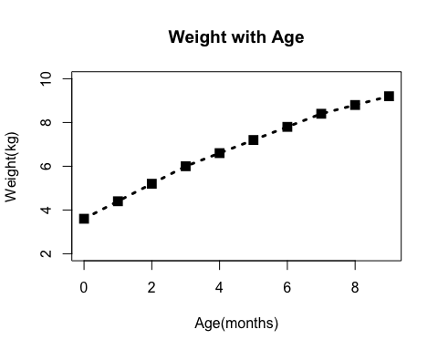

# try a barplot  
  
barplot(VADeaths, beside=TRUE)

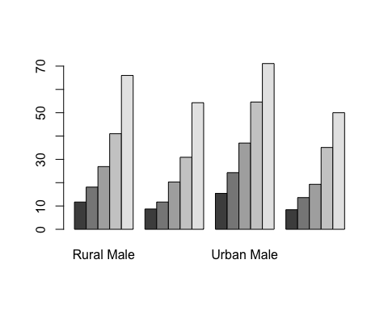

barplot(VADeaths, beside=FALSE)

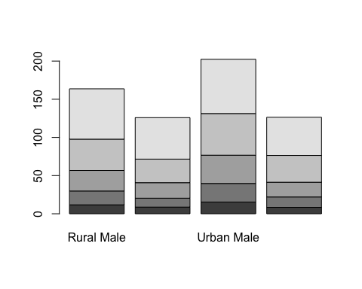

#Input the feature count data  
  
z<- read.table("bimm143_05_rstats/feature_counts.txt", sep = "\t", header = TRUE)  
par(mar=c(5.1,12,4.1,2.1))  
barplot(z$Count, horiz = TRUE, main ="mouse versus feature counts", las=2, xlim= c(0,80000), names.arg = z$Feature)

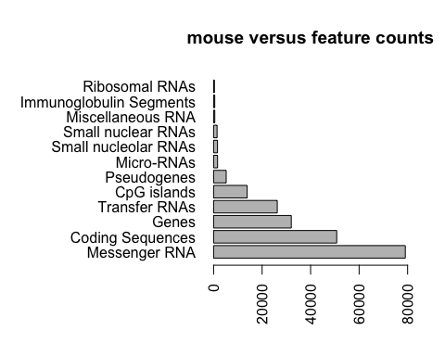

#  
  
hist(c(rnorm(10000),rnorm(10000)+4), breaks = 80)

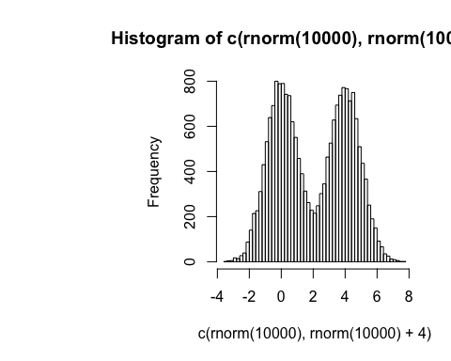

x1 <- c(rnorm(10000),rnorm(10000)+4)  
hist(x1, breaks=80)

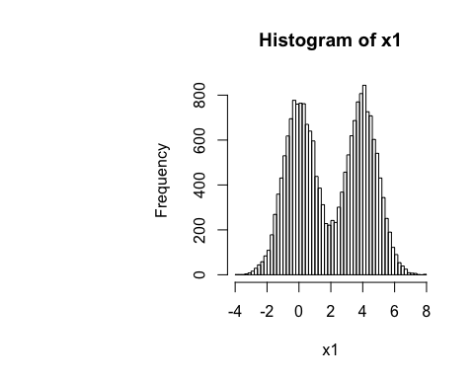

#section 3  
  
m <- read.table("bimm143_05_rstats/male_female_counts.txt", header = TRUE, sep="\t")  
par(mar=c(5.1,4,4.1,2.1))  
barplot(m$Count, names.arg = m$Sample, las=2, col=rainbow(10), ylab="counts")

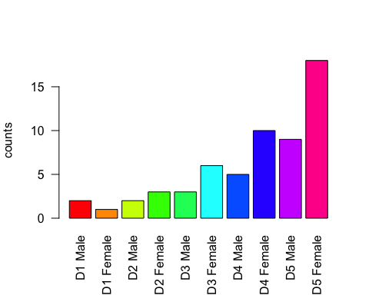

#all barplots need height!!!!!! it is m$Count this time  
  
#  
genes <- read.table("bimm143_05_rstats/up_down_expression.txt", header=TRUE, sep="\t")  
#how many genes in the table  
nrow(genes)

## [1] 5196

#how many up down and all round  
table(genes$State)

##   
## down unchanging up   
## 72 4997 127

#plot  
palette(c("cyan", "magenta", "blue"))  
plot(genes$Condition1,genes$Condition2,col=genes$State)

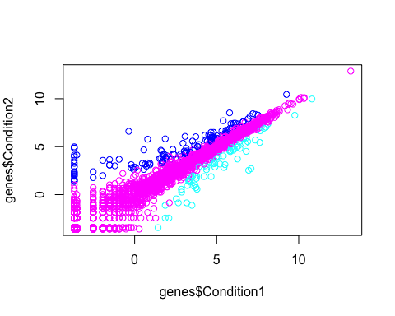

#  
meth <- read.table("bimm143_05_rstats/expression_methylation.txt", header = TRUE, sep = "\t")  
nrow(meth)

## [1] 9241

plot(meth$gene.meth, meth$expression)

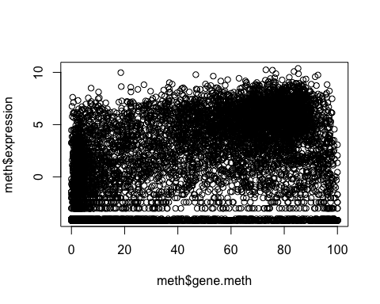

#another way to read the table  
meth2 <- read.delim("bimm143_05_rstats/expression_methylation.txt")  
dencol <- densCols(meth$gene.meth, meth$expression)  
  
plot(meth$gene.meth, meth$expression, col=dencol, pch=20)

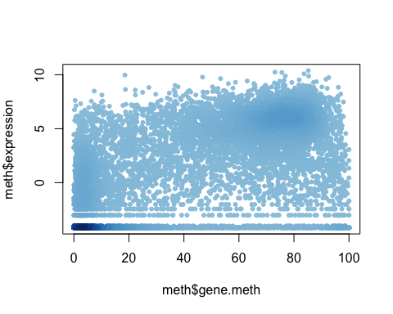

inds <- meth$expression > 0  
plot(meth$gene.meth[inds], meth$expression[inds])

