Cooking Recipe Assistant

Project Overview
Cooking Recipe Assistant is an intelligent, local web application that uses Retrieval-Augmented Generation (RAG) to deliver accurate, personalized recipe recommendations. It integrates a vector database of recipes with a Large Language Model (LLM) to provide responses based on real culinary data, not just AI guesses.

Tools and Technologies

Component | Tool | Purpose
Backend | Flask | API server with Server-Sent Events for real-time streaming.
LLM | Ollama (qwen2.5:1.5b) | Generates natural, formatted recipe responses.
Embeddings | Ollama (nomic-embed-text) | Creates semantic vectors for recipe search.
Vector DB | ChromaDB | Persistent storage for embedded recipes with similarity search.
Data Processing | Pandas | Cleans and prepares CSV recipe data.
Frontend | Vanilla JS / CSS | Interactive chat interface with streaming updates.
Rendering | Marked.js | Converts Markdown responses to HTML.

System Architecture
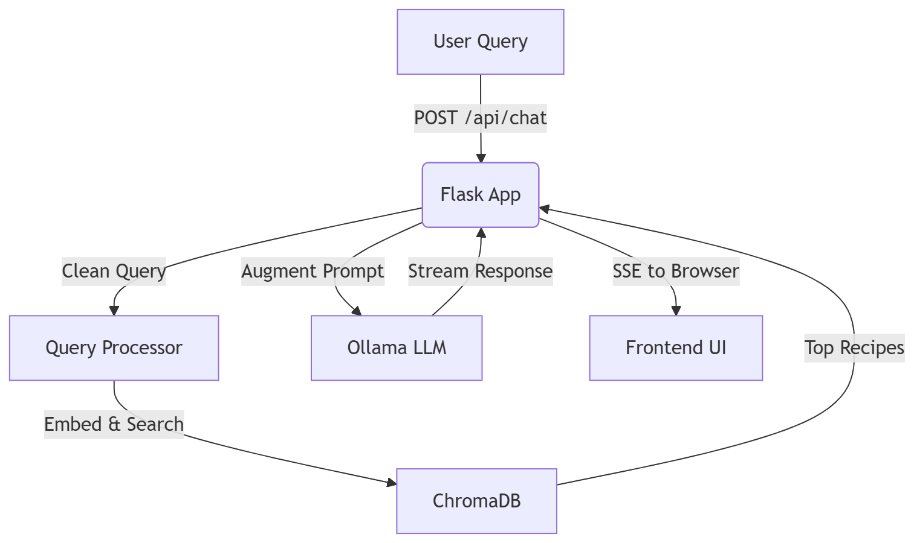

1. Query Processing
User inputs are cleaned to remove noise, then converted to vectors for semantic matching.

2. Retrieval
ChromaDB finds the most relevant recipes based on vector similarity, not keywords.

3. Augmentation
Retrieved recipes are added to the LLM prompt for context-aware generation.

4. Generation
Ollama produces formatted, helpful responses streamed in real-time.

Project Structure
cooking_recipe_assistant/
├── backend/
│ ├── app.py # Flask server and API
│ └── src/
│ ├── _01_data_prep.py # Data cleaning
│ ├── _02_vector_db.py # Vector DB creation
│ └── _03_rag.py # Retrieval logic
│ └── utils/
│ ├── functions.py # Helpers (embedding, cleaning)
│ └── prompts.py # LLM prompts and formats
├── frontend/
│ ├── index.html # Main UI
│ ├── script.js # Chat logic and SSE
│ └── style.css # Styling
├── dataset/
│ ├── _01_raw/
│ │ └── recipes.csv # Original data
│ └── _02_cleaned/
│ └── recipes_cleaned.csv # Processed data
├── chroma_db/ # Vector database
├── requirements.txt # Python deps
├── .env # Config
└── *.md # Documentation

How It Works

1. Data Preparation
- Loads first 1000 recipes from CSV.
- Selects key columns: title, ingredients, directions.
- Cleans data and saves to cleaned CSV.

2. Vector Database
- Embeds title + ingredients into vectors.
- Stores in ChromaDB with metadata.
- Enables fast semantic search.

3. RAG Retrieval
- Searches for top 3 similar recipes.
- Filters by relevance threshold.
- Formats results for LLM.

4. Response Generation
- Uses retrieved context in prompts.
- Streams formatted recipes via SSE.

Key Features
- Semantic Search: Understands meaning, not just words.
- Local AI: No internet required, privacy-focused.
- Real-Time Streaming: Instant response updates.
- Structured Output: Consistent recipe formatting.
- Fallback Logic: Uses internal knowledge if no matches.

Quick Start

Prerequisites
- Python 3.8+
- Ollama installed and running

Setup
1. Install deps: pip install -r requirements.txt
2. Pull models: ollama pull nomic-embed-text and ollama pull qwen2.5:1.5b
3. Prepare data: python backend/src/_01_data_prep.py
4. Build DB: python backend/src/_02_vector_db.py
5. Run app: python backend/app.py
6. Open http://localhost:5000

Troubleshooting

Issue | Solution
Ollama connection failed | Run ollama serve
Model not found | ollama pull <model>
No recipes found | Check data prep and DB build
Slow performance | Reduce dataset size or use GPU

