**1. ReactJS-HOL**

Changing the content of App.js

import logo from './logo.svg';

import './App.css';

function App()

{

  return (

    <h1>Welcome the first session of React</h1>

  );

}

export default App;

**Output:**

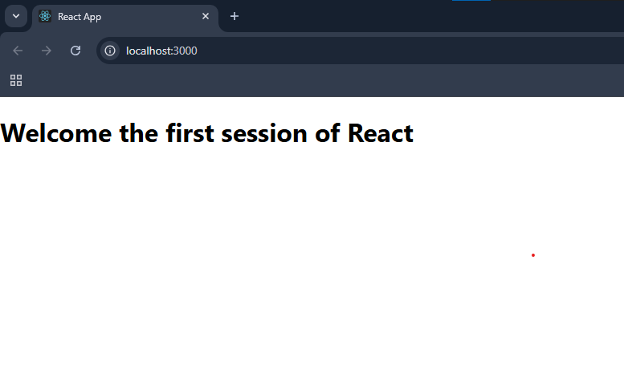

**2. ReactJS-HOL**

import React, { Component } from 'react';

class Home extends Component {

  render() {

    return (

      <div>

        <h3>Welcome to the Home Page of Student Management Portal</h3>

      </div>

    );

  }

}

export default Home;

import React, { Component } from 'react';

class About extends Component {

  render() {

    return (

      <div>

        <h3>Welcome to the About Page of Student Management Portal</h3>

      </div>

    );

  }

}

export default About;

import React, { Component } from 'react';

class Contact extends Component {

  render() {

    return (

      <div>

        <h3>Welcome to the Contact Page of Student Management Portal</h3>

      </div>

    );

  }

}

export default Contact;

import logo from './logo.svg';

import './App.css';

import Home from './Components/Home';

import About from './Components/About';

import Contact from './Components/Contact';

function App() {

  return (

    <div className="container">

      <Home/>

      <About/>

      <Contact/>

    </div>

  );

}

export default App;

**Output:**

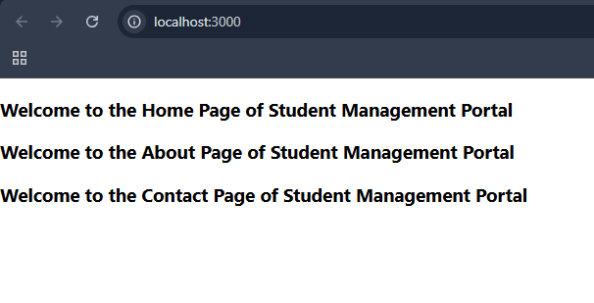

**3. ReactJS-HOL**

import '../StyleSheets/mystyle.css';

const percentToDecimal = (decimal) => {

  return decimal.toFixed(2) + '%';

};

const calcScore = (total, goal) => {

  return percentToDecimal((total / goal) * 100);  // Multiply by 100

};

export const CalculateScore = ({ Name, School, total, goal }) => (

  <div className="formatstyle">

    <h1><font color="Brown">Student Details:</font></h1>

    <div className="Name">

      <b><span> Name: </span></b>

      <span>{Name}</span>

    </div>

    <div className="School">

      <b><span> School: </span></b>

      <span>{School}</span>

    </div>

    <div className="Total">

      <b><span>Total:</span></b>

      <span>{total}</span>

      <span> Marks</span>

    </div>

    <div className="Score">

      <b>Score: </b>

      <span>

        {calcScore(total, goal)}

      </span>

    </div>

  </div>

);

.Name {

    font-weight: 300;

    color: blue;

}

.School {

    color: crimson;

}

.Total {

    color: darkmagenta;

}

.formatstyle {

    text-align: center;

    font-size: large;

}

.Score {

    color: forestgreen;

}

import { CalculateScore } from './Components/CalculateScore';

function App() {

  return (

    <div>

      <CalculateScore

        Name="Steeve"

        School="DNV Public School"

        total={284}

        goal={300}

      />

    </div>

  );

}

export default App;

**Output:**

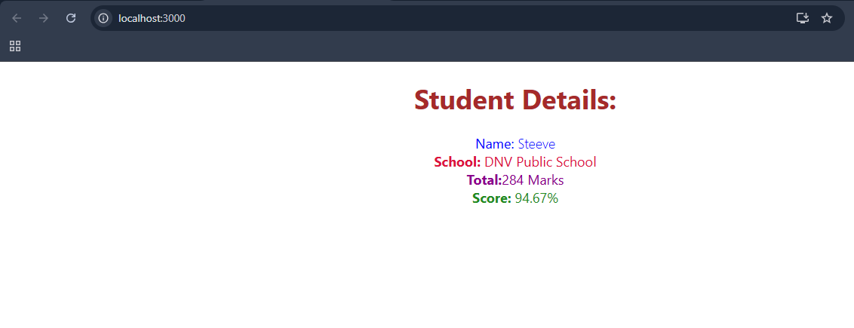

**4. ReactJS-HOL**

class Post {

  constructor(id, title, body){

    this.id = id;

    this.title = title;

    this.body = body;

  }

}

export default Post;

import React from 'react';

import Post from './Post'; // Make sure Post.js is in the same folder

class Posts extends React.Component {

  constructor(props) {

    super(props);

    this.state = {

      posts: [],

      hasError: false

    };

  }

  loadPosts = () => {

    fetch('https://jsonplaceholder.typicode.com/posts')

      .then(response => response.json())

      .then(data => {

        const postList = data.map(post => new Post(post.id, post.title, post.body));

        this.setState({ posts: postList });

      })

      .catch(error => {

        console.error("Error fetching posts:", error);

        this.setState({ hasError: true });

      });

  };

  componentDidMount() {

    this.loadPosts();

  }

  componentDidCatch(error, info) {

    alert("An error occurred: " + error.toString());

    this.setState({ hasError: true });

  }

  render() {

    if (this.state.hasError) {

      return <h2>Something went wrong.</h2>;

    }

    return (

      <div>

        <h1>Blog Posts</h1>

        {this.state.posts.map(post => (

          <div key={post.id}>

            <h2>{post.title}</h2>

            <p>{post.body}</p>

          </div>

        ))}

      </div>

    );

  }

}

export default Posts;

import React from 'react';

import Posts from './Posts';

function App() {

  return (

    <div className="App">

      <Posts />

    </div>

  );

}

export default App;

**Output:**

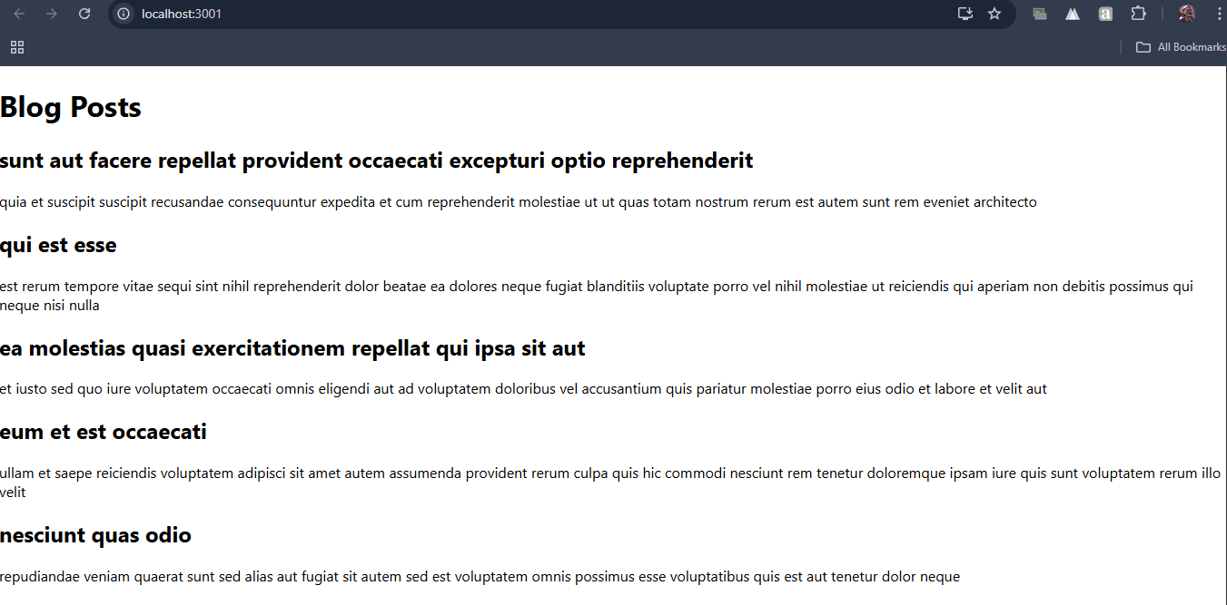

**5. ReactJS-HOL**

.box {

  width: 300px;

  display: inline-block;

  margin: 10px;

  padding: 10px 20px;

  border: 1px solid black;

  border-radius: 10px;

}

dt {

  font-weight: 500;

}

import React from 'react';

import styles from './CohortDetails.module.css';

const CohortDetails = ({ cohort }) => {

  const titleStyle = {

    color: cohort.status === 'ongoing' ? 'green' : 'blue'

  };

  return (

    <div className={styles.box}>

      <h3 style={titleStyle}>{cohort.name}</h3>

      <dl>

        <dt>Batch:</dt>

        <dd>{cohort.batch}</dd>

        <dt>Start Date:</dt>

        <dd>{cohort.startDate}</dd>

        <dt>Status:</dt>

        <dd>{cohort.status}</dd>

      </dl>

    </div>

  );

};

export default CohortDetails;

import React from 'react';

import CohortDetails from './Components/CohortDetails';

function App() {

  const cohorts = [

    {

      name: 'React Bootcamp',

      batch: 'B2025',

      startDate: '2025-07-01',

      status: 'ongoing'

    },

    {

      name: 'Node.js Mastery',

      batch: 'B2024',

      startDate: '2024-12-15',

      status: 'completed'

    }

  ];

  return (

    <div>

      <h1>My Academy Dashboard</h1>

      {cohorts.map((cohort, index) => (

        <CohortDetails key={index} cohort={cohort} />

      ))}

    </div>

  );

}

export default App;

**Output:**