**9. ReactJS-HOL**

import React from 'react';

const ListofPlayers = () => {

  const players = [

    { name: 'Virat', score: 90 },

    { name: 'Rohit', score: 85 },

    { name: 'Gill', score: 80 },

    { name: 'Surya', score: 75 },

    { name: 'Hardik', score: 75 },

    { name: 'Jadeja', score: 80 },

    { name: 'Ashwin', score: 30 },

    { name: 'Shami', score: 20 },

    { name: 'Bumrah', score: 10 },

    { name: 'KL Rahul', score: 65 },

    { name: 'Pant', score: 70 }

  ];

  const filteredPlayers = players.filter(player => player.score < 70);

  return (

    <div>

      <h2>All Players</h2>

      <ul>

        {players.map((player, index) => (

          <li key={index}>{player.name} - {player.score}</li>

        ))}

      </ul>

      <h2>Players with Score Below 70</h2>

      <ul>

        {filteredPlayers.map((player, index) => (

          <li key={index}>{player.name} - {player.score}</li>

        ))}

      </ul>

    </div>

  );

};

export default ListofPlayers;

import React from 'react';

const IndianPlayers = () => {

  const team = ['Virat', 'Rohit', 'Gill', 'Surya', 'Hardik', 'Jadeja'];

  const oddTeam = team.filter((_, index) => index % 2 !== 0);

  const evenTeam = team.filter((_, index) => index % 2 === 0);

  const [p1, p2, p3] = oddTeam;

  const [q1, q2, q3] = evenTeam;

  const T20players = ['Rishabh', 'Sky', 'Pandya'];

  const RanjiTrophyPlayers = ['Pujara', 'Rahane'];

  const mergedPlayers = [...T20players, ...RanjiTrophyPlayers];

  return (

    <div>

      <h2>Odd Team Players</h2>

      <ul>

        <li>{p1}</li>

        <li>{p2}</li>

        <li>{p3}</li>

      </ul>

      <h2>Even Team Players</h2>

      <ul>

        <li>{q1}</li>

        <li>{q2}</li>

        <li>{q3}</li>

      </ul>

      <h2>Merged Players (T20 + Ranji)</h2>

      <ul>

        {mergedPlayers.map((player, index) => (

          <li key={index}>{player}</li>

        ))}

      </ul>

    </div>

  );

};

export default IndianPlayers;

**Modifying App.js**

import React from 'react';

import ListofPlayers from './components/ListofPlayers';

import IndianPlayers from './components/IndianPlayers';

function App() {

  const flag = false; // Change to false to display the other component

  return (

    <div className="App">

      <h1>🏏 Cricket App</h1>

      {flag ? <ListofPlayers /> : <IndianPlayers />}

    </div>

  );

}

export default App;

**Output:**

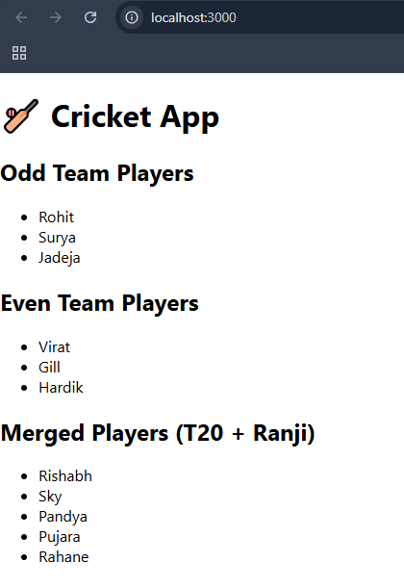

**10. ReactJS-HOL**

import React from 'react';

// Import images from the same folder

import Office1 from './office1.jpg';

import Office2 from './office2.jpg';

import Office3 from './office3.jpg';

const OfficeList = () => {

  const heading = <h1>🏢 Office Space Rental Listings</h1>;

  const offices = [

    {

      id: 1,

      name: "Downtown Heights",

      rent: 75000,

      address: "12 MG Road, Bangalore",

      image: Office1

    },

    {

      id: 2,

      name: "Startup Hub",

      rent: 45000,

      address: "88 Park Street, Kolkata",

      image: Office2

    },

    {

      id: 3,

      name: "Skyline Towers",

      rent: 95000,

      address: "44 Nehru Place, Delhi",

      image: Office3

    }

  ];

  return (

    <div style={{ padding: '20px' }}>

      {heading}

      {offices.map(office => (

        <div key={office.id} style={{

          border: '1px solid #ccc',

          padding: '10px',

          marginBottom: '20px',

          borderRadius: '8px'

        }}>

          <img

            src={office.image}

            alt={office.name}

            style={{ width: '300px', height: '200px', objectFit: 'cover' }}

          />

          <h2>{office.name}</h2>

          <p><strong>Address:</strong> {office.address}</p>

          <p>

            <strong>Rent:</strong>{' '}

            <span style={{

              color: office.rent < 60000 ? 'red' : 'green',

              fontWeight: 'bold'

            }}>

              ₹{office.rent}

            </span>

          </p>

        </div>

      ))}

    </div>

  );

};

export default OfficeList;

**Modifying App.js**

import React from 'react';

import OfficeList from './components/OfficeList';

function App() {

  return (

    <div className="App">

      <OfficeList />

    </div>

  );

}

export default App;

**Output:**

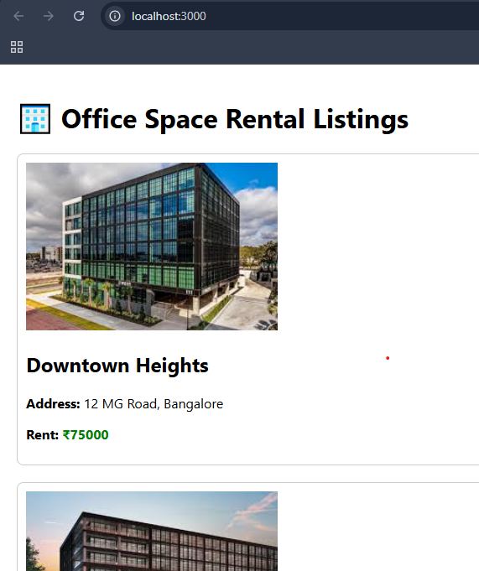

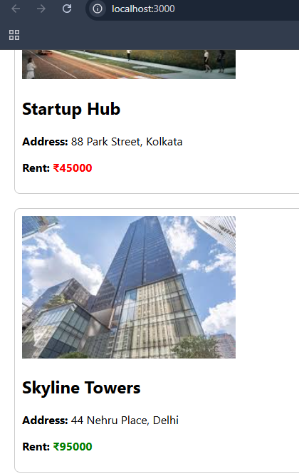

**11. ReactJS-HOL**

import React, { useState } from 'react';

const CounterEvents = () => {

  const [count, setCount] = useState(1);

  const increment = () => {

    setCount(prev => prev + 1);

  };

  const sayHello = () => {

    alert("Hello! This is a static message.");

  };

  const handleIncrement = () => {

    increment();

    sayHello();

  };

  const decrement = () => {

    setCount(prev => prev - 1);

  };

  const sayMessage = (msg) => {

    alert(msg);

  };

  const handleClick = () => {

    alert("I was clicked");

  };

  return (

    <div>

      <p>{count}</p>

      <button onClick={handleIncrement}>Increment</button>

      <br /><br />

      <button onClick={decrement}>Decrement</button>

      <br /><br />

      <button onClick={() => sayMessage("Say welcome")}>Say welcome</button>

      <br /><br />

      <button onClick={handleClick}>Click on me</button>

    </div>

  );

};

export default CounterEvents;

import React, { useState } from 'react';

const CurrencyConvertor = () => {

  const [euro, setEuro] = useState('');

  const [rupees, setRupees] = useState(null);

  const handleSubmit = (e) => {

    e.preventDefault(); // Prevents form refresh

    if (!isNaN(euro) && euro !== '') {

      const result = parseFloat(euro) * 80;

      setRupees(result);

      alert(`Converting to Rupees Amount is ₹${result}`);

    } else {

      alert("Please enter a valid Euro amount.");

    }

  };

  return (

    <div>

      <h2 style={{ color: 'green' }}>Currency Convertor!!!</h2>

      <form onSubmit={handleSubmit}>

        <label>Amount:</label>

        <input

          type="text"

          value={euro}

          onChange={(e) => setEuro(e.target.value)}

        />

        <br /><br />

        <label>Currency:</label>

        <select value="Euro" disabled>

          <option value="Euro">Euro</option>

        </select>

        <br /><br />

        <button type="submit">Submit</button>

      </form>

      {rupees !== null && (

        <p style={{ marginTop: '10px' }}>Converted Amount: ₹{rupees}</p>

      )}

    </div>

  );

};

export default CurrencyConvertor;

**Modifying App.js**

import React from 'react';

import CurrencyConvertor from './components/CurrencyConvertor';

import CounterEvents from './components/CounterEvents';

function App() {

  return (

    <div className="App" style={{ padding: '20px' }}>

      <CounterEvents />

      <br />

      <CurrencyConvertor />

    </div>

  );

}

export default App;

**Output:**

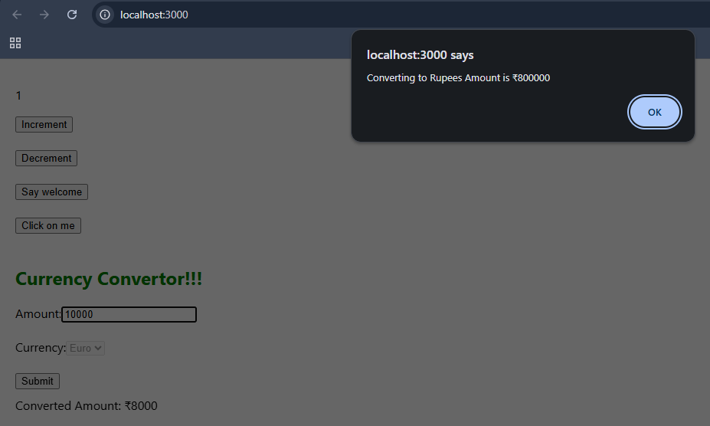

**12. ReactJS-HOL**

import React from 'react';

const FlightList = () => {

  const flights = [

    { id: 1, from: "Delhi", to: "Mumbai", time: "10:00 AM", price: "₹5000" },

    { id: 2, from: "Kolkata", to: "Chennai", time: "2:30 PM", price: "₹4500" },

    { id: 3, from: "Bangalore", to: "Hyderabad", time: "5:45 PM", price: "₹3200" }

  ];

  return (

    <div>

      <h2>Available Flights</h2>

      <ul>

        {flights.map(flight => (

          <li key={flight.id}>

            ✈️ {flight.from} ➡ {flight.to} at {flight.time} - {flight.price}

          </li>

        ))}

      </ul>

    </div>

  );

};

export default FlightList;

import React from 'react';

import FlightList from './FlightList';

const GuestPage = () => {

  return (

    <div>

      <h1>Welcome, Guest!</h1>

      <p>Please login to book tickets.</p>

      <FlightList />

    </div>

  );

};

export default GuestPage;

import React from 'react';

import FlightList from './FlightList';

const UserPage = () => {

  return (

    <div>

      <h1>Welcome, Logged-in User!</h1>

      <p>You can now book your flights.</p>

      <FlightList />

      <button style={{ marginTop: '10px' }}>Book Ticket</button>

    </div>

  );

};

export default UserPage;

**Modifying App.js**

import React, { useState } from 'react';

import GuestPage from './components/GuestPage';

import UserPage from './components/UserPage';

function App() {

  const [loggedIn, setLoggedIn] = useState(false);

  const handleLogin = () => setLoggedIn(true);

  const handleLogout = () => setLoggedIn(false);

  return (

    <div style={{ padding: '20px' }}>

      <h1>🛫 Ticket Booking App</h1>

      {loggedIn ? (

        <>

          <button onClick={handleLogout}>Logout</button>

          <UserPage />

        </>

      ) : (

        <>

          <button onClick={handleLogin}>Login</button>

          <GuestPage />

        </>

      )}

    </div>

  );

}

export default App;

**Output:**

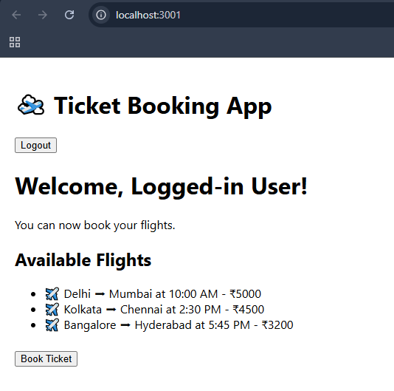

**13. ReactJS-HOL**

import React from 'react';

const CourseDetails = () => {

  const courses = [

    { name: 'Angular', date: '4/5/2021' },

    { name: 'React', date: '6/3/20201' }

  ];

  return (

    <div>

      <h2>Course Details</h2>

      {courses.map((course, index) => (

        <div key={index}>

          <h3>{course.name}</h3>

          <p>{course.date}</p>

        </div>

      ))}

    </div>

  );

};

export default CourseDetails;

import React from 'react';

const BookDetails = () => {

  const books = [

    { title: 'Master React', price: 670 },

    { title: 'Deep Dive into Angular 11', price: 800 },

    { title: 'Mongo Essentials', price: 450 }

  ];

  return (

    <div>

      <h2>Book Details</h2>

      {books.map((book, index) => (

        <div key={index}>

          <h3>{book.title}</h3>

          <p>{book.price}</p>

        </div>

      ))}

    </div>

  );

};

export default BookDetails;

import React from 'react';

const BlogDetails = () => {

  const blogs = [

    {

      title: 'React Learning',

      author: 'Stephen Biz',

      content: 'Welcome to learning React!'

    },

    {

      title: 'Installation',

      author: 'Schewzdenier',

      content: 'You can install React from npm.'

    }

  ];

  return (

    <div>

      <h2>Blog Details</h2>

      {blogs.map((blog, index) => (

        <div key={index}>

          <h3>{blog.title}</h3>

          <p><strong>{blog.author}</strong></p>

          <p>{blog.content}</p>

        </div>

      ))}

    </div>

  );

};

export default BlogDetails;

**Modifying App.js**

import React from 'react';

import CourseDetails from './components/CourseDetails';

import BookDetails from './components/BookDetails';

import BlogDetails from './components/BlogDetails';

function App() {

  const columnStyle = {

    flex: 1,

    padding: '20px',

    borderLeft: '3px solid green',

  };

  return (

    <div className="App" style={{ padding: '20px' }}>

      <div style={{ display: 'flex', justifyContent: 'space-between' }}>

        <div style={{ ...columnStyle, borderLeft: 'none' }}>

          <CourseDetails />

        </div>

        <div style={columnStyle}>

          <BookDetails />

        </div>

        <div style={columnStyle}>

          <BlogDetails />

        </div>

      </div>

    </div>

  );

}

export default App;

**Output:**

