Nama: Tiyas sulis Setyawati Nim : 312410010
Kleas: TI.24.C1

Link figma : https://www.figma.com/proto/q0C5rX5xIl5Q8x8zN98sUJ/Untitled?node- id=1-2062&t=jKCZGmr1AywmJSnE-0&scaling=scale-down&content-scaling=fixed&page-

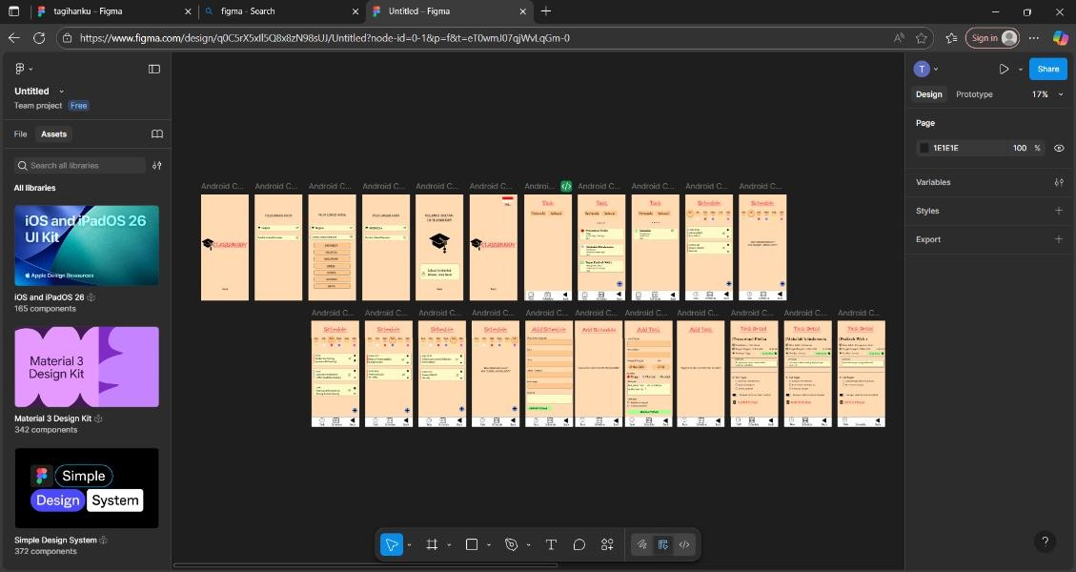
id=0%3A1&starting-point-node-id=1%3A2062

Link Prototype figma : https://www.figma.com/proto/q0C5rX5xIl5Q8x8zN98sUJ/Untitled?node-id=1-2062&starting-point-node-id=1%3A2062

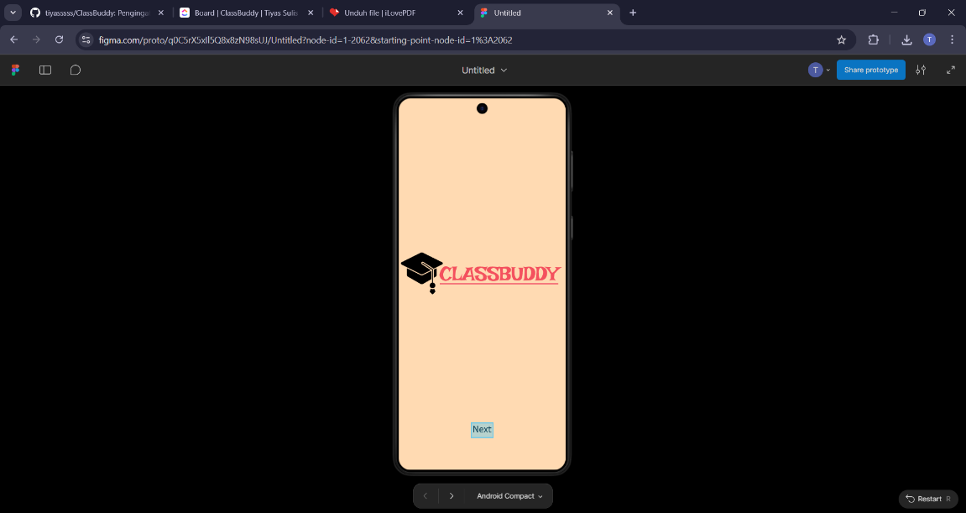

Link Github : https://github.com/tiyasssss/ClassBuddy.git

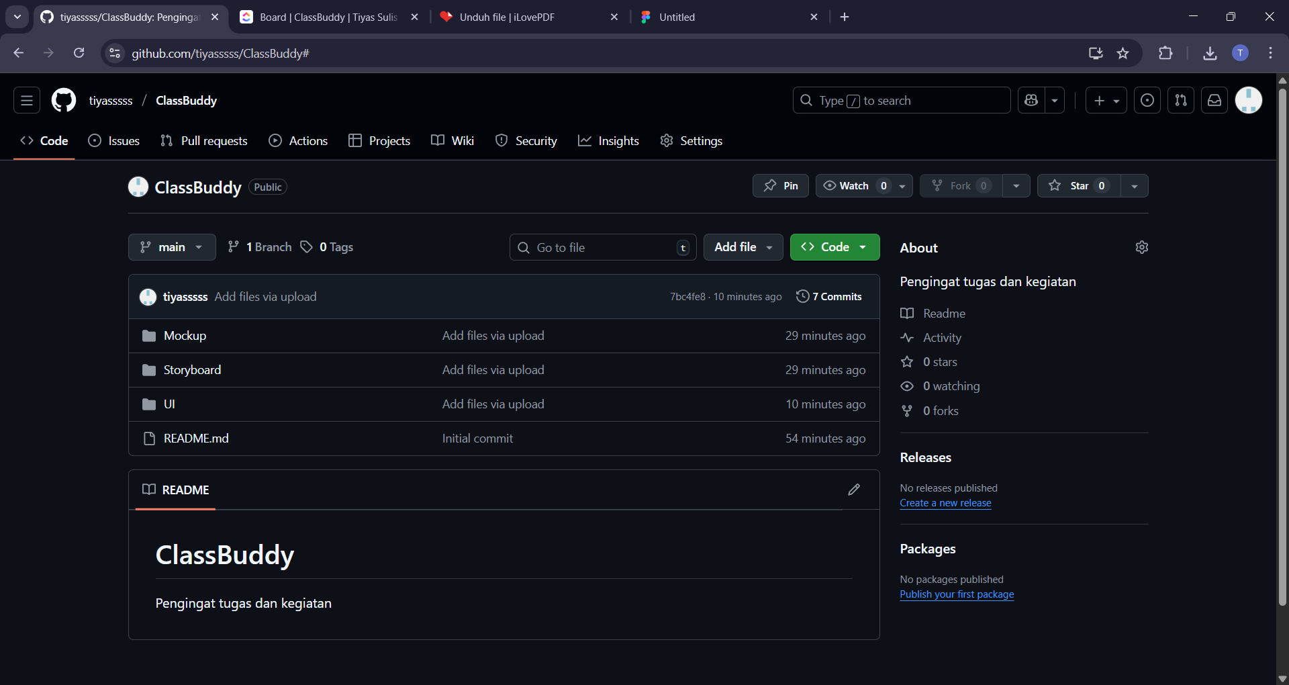

Link Clikup : https://app.clickup.com/90181809866/v/li/901811890430

