[1]

A Face Privacy Protection and Self-decryption Method Based on Humanoid Association Mechanism

Zhongpan Zhu, Qiwei Du, Bin He, *Member, IEEE*, Zhipeng Wang, Gang Li

***Abstract*—** **With the large-scale industry application of artificial intelligence and video surveillance, massive video data storage and personal privacy issues are highlighted, which restrict the application expansion. From the perspective of humanoid memory mechanism, we propose a video abstraction encryption and decryption algorithm based on high and low dimensional information association cognitive mechanism, which uses face recognition algorithm to locate human faces and encrypt the original video with mosaic encryption method, and then perform spatio-temporal index encoding, and further use abstract face feature memory to match and decode with the same identity person to construct a de-mosaic decryption key function. The core innovation is the human-like memory mechanism for parsing and modelling, and combined with specific AI techniques such as YOLO and GAN for initial experimental validation in face encryption and decryption. The algorithm research will be important in the research of video information compression and storage, person re-identification and personal privacy protection.**

***Index Terms*—Enter keywords or phrases in alphabetical order, separated by commas. For a list of suggested keywords, send a blank e-mail to** [keywords@ieee.org](mailto:keywords@ieee.org) **or visit** <http://www.ieee.org/organizations/pubs/ani_prod/keywrd98.txt>

# I. INTRODUCTION

S

urveillance video/image data collection and analysis based on AI and IOT technologies has been an important technical grip for different scenes in smart city development. The trust information extraction in surveillance data has aroused many researchers' interest and motivates the analysis of images from numerous IoT visual sensors [1-3]. However, the massive deployment of visual sensors leads to a number of challenges: firstly, the sheer volume of camera video images leads to a data disaster. With 30 frames per second and 5mb per image, a single camera generates a data storage requirement of 12,656.25Gb in a day, while IHS research indicates that there will be over 1 billion surveillance cameras worldwide after 2021. These video stores take up a lot of hardware resources and no data centre can afford the daily growth of video data and has to be covered periodically [4]. Secondly the redundancy of information in massive camera video data leads to key information overwriting and difficulties in retrieving information based on video []. In addition, massive video transmission occupies a large amount of communication bandwidth, with high communication costs, making it difficult to achieve collaborative use of a large range of cameras for mega-city governance. With the development of AI technology, surveillance cameras have led to the leakage of residents' biometric privacy, raising ethical and regulatory concerns. How to safeguard the function of surveillance cameras while ameliorating the above challenges has become a direction of research for a wide range of scholars.

(类人认知角度)

In this paper, we take a human-like cognitive perspective to carry out based theory research for exploring new models of large-scale camera urban applications. We humans, from infants to the elderly, perceive a large amount of picture information with both eyes over decades and can have long-term clear memories of the people and things we experience and when and where they happened. However, we are often unable to reproduce all of the image information that occurred, but rather combine it with high-dimensional semantic abstraction to achieve coarse-grained picture recall. Our memories of familiar faces of friends or family members are also often not remembered through images of faces, nor are they even identified by specific features such as single eyelids and double eyelids, but rather translated into a general impression of high-dimensional semantic information. In addition, the high-dimensional abstract semantics in our human brain memory plays an important role in blurring human decryption recognition, where humans can recognise the identity of people we are familiar with in blurred or partially obscured images of faces, whereas strangers have difficulty in doing so. This is a result of the long biological evolution of humans to cope with the challenges of massive amounts of AV data, and it is difficult to have a theoretical explanation of the mechanism by which human low-dimensional fine-grained information is correlated to higher-dimensional coarse-grained information. There are even fewer attempts to use the mechanism to implement video processing for massive surveillance cameras. This paper presents a preliminary exploration in this direction, proposing the study of face degradation encryption in video images and then combining high-dimensional semantic information with identity recognition for autonomous decryption, and achieving high approximation face recovery.

# II. RELATED WORK.

## A. face recognition of video surveillance

With the influence of economic globalization and the accelerating pace of urbanization, urban population density has risen, the flow of people and vehicles has increased, and the layout of urban buildings and infrastructure has become more and more complex. This has led to urban construction of traffic, social security and other urban management issues. In recent years, the diversity and complexity of the security situation is gradually increasing, and the means of crime are becoming more and more hidden, which has posed new challenges to the security management of the city. In the security management, the surveillance cameras distributed in all corners of the city play an indispensable role. And in the process of dealing with security problems, face recognition in surveillance videos is a very important task. The traditional way of exclusion is to identify and capture useful information by watching surveillance records through human eyes, but the current human resources are far from being able to meet the actual demand of the development rate. With the development of artificial intelligence technology, AI face recognition technology combined with surveillance camera technology has become an important means to obtain effective information and improve analysis efficiency for mega-city governance. Compared with ordinary videos, surveillance camera videos have low resolution, complex environment, light interference, small facial size and variable orientation[xxx], which makes face recognition in video surveillance a more challenging task.

Methods of face recognition in video surveillance can be broadly classified into two main categories: close-set and open-set[xxx]. Close-set method performs a classification task and it can only recognize the faces that appeared in the training set. The recognition process is to calculate the similarity between the detected faces and known faces one by one, and then select the highest similarity as the output result.[xxx] When a strange face appears, it will result in incorrect classifications. Therefore, this method can generally only be used when there are few people in the video and their identities have all been confirmed, and its universality and scalability are not strong. On the contrary, open-set method can not only recognize faces that have appeared, but also recognize strange faces. If the detected face is judged to be known, the recognition system should output the identity of it. Otherwise, the detected face should be simply ignored or be added into the dataset and become a new category.[xxx] Due to its ability to properly handle unknown faces, this method is more valuable in large scale practical application scenarios. (后面写一些其他人的具体方法)

.

## B. Face encryption and decryption algorithm

To be defined

## C.Brain-like memory cognition

To be defined

# III. PROPOSED APPROACH

## We describe the human brain face perception-memory-association re-identification process through a typical scenario and outline the scientific problem to be solved in this paper. An algorithmic model for solving the problem and a framework for the solution process are then proposed.

## A. Problem description.

The process by which humans perceive faces and recognise their identity based on fuzzy impression memory associations is highly complex. Each of us sees many faces in life scenarios, such as in crowded crowds, at an academic conference we attend, at a dinner party where we meet, etc. However, not all information about faces is generally remembered. However, when meeting new people face-to-face, humans tend to look for déjà vu impressions in brain sessions. Let's start with a typical scenario to describe this process. As shown in Figure 1, we meet a lot of people at academic conferences but not everyone interacts with each other. When the two of you meet again sometime in the future, your mind will unconsciously recall that you have seen such a face at a certain time, place and event, and in combination with the real person in front of you, you seem to recall the scene and get a clearer picture of his features. The process can actually be simplified as the human brain perceives the concrete face image information seen by the eyes to extract high-dimensional abstract semantic features, the high-dimensional abstract semantic features are retrieved and matched with the high-dimensional semantic information indexed in memory combining person, event, time and place, and the past feature-blurred memory scene is clearly reproduced in combination with the current perceived face image.

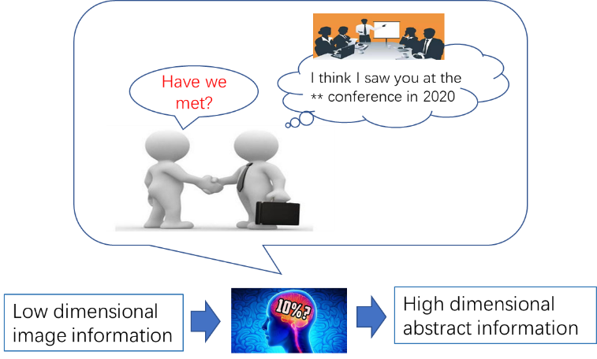

**Fig. 1. Case: Humanlike abstract association based on perceptual feature trigger.**

The general expression of the model is as follows.

(1)

where A1 is the set of low-dimensional full-dimensional information about the face currently perceived by the brain, B1 is the set of high-dimensional abstract semantic features formed by the brain in the mind based on A1, A2p is the set of partially low-dimensional residual information from fuzzy memory in the brain, A2 is the set of low-dimensional full-dimensional information about the face currently perceived by the brain, A2p is a subset of A2, and B2 is the set of high-dimensional abstract semantic features formed by the brain in the mind based on A2 . The algorithm for solving the above expression is as follows.

|  |
| --- |
| **Algorithm: perceives- retrieves-associates-recalls** |
| Input: A1, A2p, B2  Output: A2  For A1 in Brain Do  Using cerebral neural network for high dimensional semantic abstraction  f1(Ai) →AiP, Bi, where A1P ⊊A1, i=1, 2, ……  For B1 in Brain Do  Find B2 in B1，  Meet the maximum face similarity feature  P(A2p| A1p)= f2(B2 ∩ B1 )→1  For A2p in Brain Do  f3(A1, A2p, B2) → A2  return A2 |

## This paper combines the above human-like perceptual associative memory algorithm with the face encryption and decryption requirements of surveillance video to solve the following problems.

## 1) Drawing on the human-like cognitive mechanism, we model and solve the high-dimensional abstract memory and compressed perception process f1 function, and propose an artificial intelligence algorithm for solving Aip and Bi to identify and locate faces in videos, extract high-dimensional semantic features while encrypting video faces with reduced resolution.

## 2) Drawing on human-like associative memory mechanism, the algorithm models the memory storage of high-dimensional semantic features and associative matching f2, and proposes a recall-triggered matching index mechanism to achieve associative memory matching based on B1 and B2.

## 3) Drawing on the human-like perception-triggered recall mechanism, the associative recall of high-dimensional semantic features A1 and B2 low-resolution video is modelled to solve f3 for indexing location as well as high-resolution decryption.

## B. AI Methodologies

Inspired by human-like perception, compressed memory, and associative recall, we propose an algorithmic framework that can be used to encrypt/decrypt surveillance video faces as shown in the figure below.

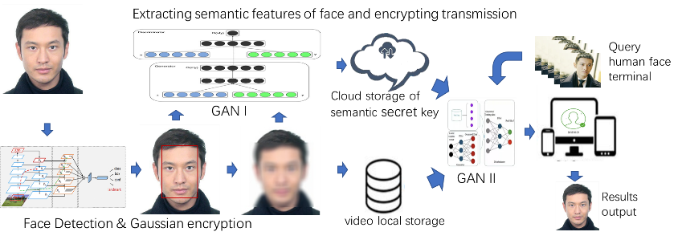

**Fig. 2. Framework of personal self-decryption.**

**1) Encryption method**

For the video frame input V, the YOLO5-face deep learning model ф is used to achieve the recognition and localisation of faces by the surveillance cameras at the edge end, into obtaining A1 = ф(V), YOLO5-face is chosen because the model targets the face recognition segmentation needs, adds landmark branches in YOLOV5, and improves the accuracy of face detection and localisation by regressing the wing loss function through five facial key points.



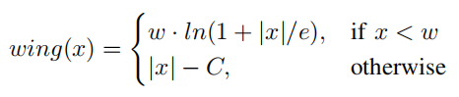

After completing face target detection, the face in the recognition frame is subjected to Gaussian blurring, i.e. a Gaussian convolution budget is applied to the face image with the probability density distribution function shown below.

2) Key storage and matching

Unlike traditional video surveillance systems, this method no longer stores the original video, but chooses to locally store the encrypted video, while uploading the high-dimensional abstract semantics to the cloud for subsequent processing and analysis. For example, for the face retrieval service of post-surveillance, as the local storage of encrypted faces loses a large amount of face feature information, the video cannot be retrieved for review, but needs to be indexed for the high-dimensional semantic B for query service, which is similar to the human perceptual memory. In order to make the AI system capable of human-like high-dimensional abstract computation, we establish an adversarial learning network GAN cognitive model for subsequent analysis of YOLO5-face localised faces, extract high-dimensional abstract semantic features B, and fuse video frame time series, edge camera's own latitude and longitude and pixel coordinates as the sign bit encoding of high-dimensional abstract semantic features into the cloud database, high-dimensional abstract The mapping between the high-dimensional abstract semantic feature B and the encrypted face image frame can be associated with the above marker bit encoding to facilitate the subsequent video decryption work.

The calculation to obtain the high-dimensional abstract semantic B is as follows. Through the previous original video A1 and encrypted video A1p form a paired data set, A1p coupled with random noise э as the input to the generator for training and learning, while A1 is used as the discriminator input for judgement, making A1p +э→A1. In the training process, we embed a subspace model with orthogonal bases in each generative network layer used to obtain the hierarchical semantics of the training model, which in turn uses the abstract semantic feature B1 as the key for decoding A1p and stores it in the cloud-based key repository. The solving process of f1(Ai) is thus completed.

Since the high-dimensional abstract semantic features learned by GAN networks often do not have interpretability, in order to study how to match face retrieval by abstract semantics B1 and B2 also need to conduct in-depth research on abstract semantic B. Currently, in the field of face recognition, the technology of matching features of faces through deep neural networks to determine the identity of faces is more mature, while the abstract semantics B1 and B2 as identity keys to determine the identity of faces becomes more challenging. The other part is classified as impressionistic abstract semantics, which is like the general impression of a human face. identity, rather than simply by matching specific features. It is difficult not to give the formula f2 for solving the feature calculation for B1 and B2 in the context of a specific example, so f2 will be described specifically in the later experimental chapters.

3) Decryption process

The previous section implements the original video encryption and the process of key storage and query matching. This section discusses how to output the the decrypted video A1 by the encrypted video A1p, high-dimensional abstract semantics B1 and the face A2 in the second video that matches the identity of a person in the first video.

This process is equivalent to associative memory, where we can associate images from the past with the current image, and the blurred features of a face can often be made clear again.

In this regard, we build a open-set face re-identification and cGAN-based decryption model. Firstly, through the method described in the previous section, the high-dimensional abstract semantics B2 is extracted from A2. Then, the similarity is calculated between B2 and all the high-dimensional abstract semantics B1i in the key pool corresponding to the encrypted video A1p, and the B1i with the highest similarity is taken. If the similarity is lower than a certain threshold, the face is judged to be strange and further decryption is rejected; if the similarity exceeds a certain threshold, the high-dimensional abstract semantics B1i is added to the generator with A1p as input as a constraint, and the decrypted video A1 is output.

【此处不知道是否有矛盾，是否还需要训练，直接通过B1与A1P求得A1】【感觉不需要再次训练，因为之前已经训练好了生成器，由于这次新出现的人脸之前也出现过，其高维语义特征应该已经被生成器“消化”过，所以只要根据相似度找出该人脸之前存储的特征密钥，喂入生成器直接生成即可】。

# IV. EXPERIMENTS AND RESULTS

## A. Dataset

We acquired face images based on temporal head pose changes of experimental subjects of different genders and ages, and obtained a dataset with Gaussian encryption paired with the original images using a method based on YOLO5-face with Gaussian encryption. 1000 images were acquired for each person, for a total of 20 people with a total of 20,000 images, in order to exclude other background features in the images from the subsequent GAN network high-dimensional semantic abstraction In order to exclude other background features in the images from the subsequent GAN network high-dimensional semantic abstraction, all faces were collected in the same background for the face collection process. The figure below shows a portion of the extracted paired dataset. This data encryption process also validates the feasibility of the video encryption method.

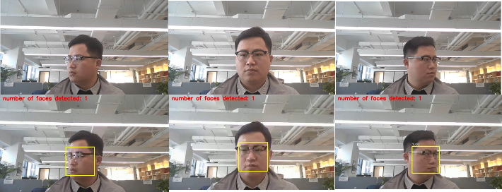

## B. GANI Training and Encryption Process

We refer to the PULSE model to improve the GAN network and complete the training on the above dataset. Based on NVIDIA's StyleGAN algorithm, the PULSE model uses an unsupervised image super-resolution method to transform low-resolution images into high-quality, high-resolution images that can reproduce image detail features such as skin tone, eyes, lips, etc. However, the generated high-resolution face images do not resemble the real looks of the photo subjects. To this end, this paper carries out semi-supervised learning by embedding a subspace model with orthogonal bases in each generative network layer to obtain the hierarchical semantic B1 of the training model, and its network architecture is shown in the following figure.

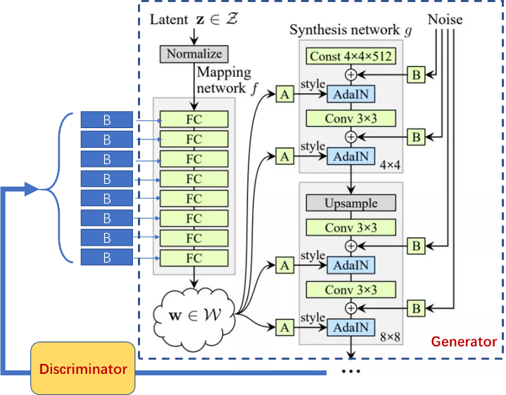

We first extract the original face P1 from the training set, form P2 after mosaic encryption of the original face, and feed P1 and P2 into GAN for training after stitching them together. At the same time, P1 is convolved several times to extract multi-dimensional face features from low-dimensional to high-dimensional, and this information is integrated and encrypted to form a key, which is bound to the identity ID of the processed face and added to the face key pool.

## C. GANI Decryption Process

When decrypting, a newly captured face is input. Firstly, determine whether it has appeared in the dataset based on the similarity of face features. If it has not appeared before, the decryption is rejected. If it has appeared, its identity ID is confirmed and the previously stored feature key is used to guide GAN to decrypt the face with mosaic with the specified id and output the decrypted face.

## D. Results Discussion

The encryption and decryption effects are shown below. We can see that GAN realistically restores the encrypted face guided by the previously stored face feature key.

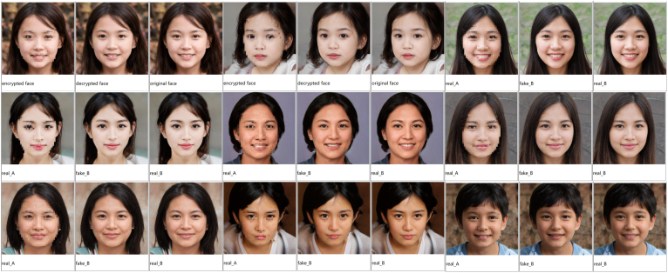

# V. Conclusion

## In this paper, we propose a video abstraction encryption and decryption algorithm based on high and low dimensional information association cognitive mechanism for massive video data disaster and personal privacy problems. When storing the video, the YOLO-based face recognition and face encryption algorithm is used to encrypt the video, while the high and low dimensional semantic information of the face is extracted to form a feature key, and index association is established with the face in the video and stored in the key pool corresponding to the video. When decrypting, the features extracted from the specified new faces are used to search in the key pool, and the matched faces are reduced to clear faces using the GAN model. We initially validate the feasibility of this video encryption and decryption algorithm on a self-built dataset. Our research has important implications in terms of how to strike a balance between privacy protection and machine vision research. In the future, this algorithm is promising to play an important role in privacy protection and big data storage, face re-identification, and other fields.

Appendix

Appendixes, if needed, appear before the acknowledgment.

Acknowledgment

The preferred here.

# 

# IEEE Guidelines and Policies

A full.

References

1. Z. Gao, C. Xu, H. Zhang, S. Li and V. H. C. de Albuquerque, "Trustful Internet of Surveillance Things Based on Deeply Represented Visual Co-Saliency Detection," IEEE Internet of Things Journal, vol. 7, no. 5, pp. 4092-4100, May 2020, doi: 10.1109/JIOT.2019.2963701.
2. Ş. Kolozali et al., "Observing the Pulse of a City: A Smart City Framework for Real-Time Discovery, Federation, and Aggregation of Data Streams," IEEE Internet of Things Journal, vol. 6, no. 2, pp. 2651-2668, April 2019, doi: 10.1109/JIOT.2018.2872606.
3. O. Styles, T. Guha and V. Sanchez, "Multi-Camera Trajectory Forecasting with Trajectory Tensors," IEEE Transactions on Pattern Analysis and Machine Intelligence, doi: 10.1109/TPAMI.2021.3107958.
4. C. W. Chen, "Internet of Video Things: Next-Generation IoT With Visual Sensors," IEEE Internet of Things Journal, vol. 7, no. 8, pp. 6676-6685, Aug. 2020, doi: 10.1109/JIOT.2020.3005727.

**First A. Author** (Fellow, IEEE)

.

**Second B. Author**, photograph and biography not available at the time of publication.

**Third C. Author, Jr.** (Member, IEEE), photograph and biography not available at the time of publication.

1. This work was supported in part by the U.S. Department of Commerce under Grant BS123456. *(Corresponding author: Bin. He).* Here you may also indicate if authors contributed equally or if there are co-first authors.

   The next few paragraphs should contain the authors’ current affiliations, including current address and e-mail. For example, First A. Author is with the National Institute of Standards and Technology, Boulder, CO 80305 USA (e-mail: author@ boulder.nist.gov).

   Second B. Author, Jr., was with Rice University, Houston, TX 77005 USA. He is now with the Department of Physics, Colorado State University, Fort Collins, CO 80523 USA (e-mail: author@lamar.colostate.edu).

   Third C. Author is with the Electrical Engineering Department, University of Colorado, Boulder, CO 80309 USA, on leave from the National Research Institute for Metals, Tsukuba 305-0047, Japan (e-mail: author@nrim.go.jp).

   Mentions of supplemental materials and animal/human rights statements can be included here.

   Color versions of one or more of the figures in this article are available online at http://ieeexplore.ieee.org