Ting-Jui, Hsu(Matr-Nr. 351218)
Exercise Sheet 5

1. Hermite polynomials

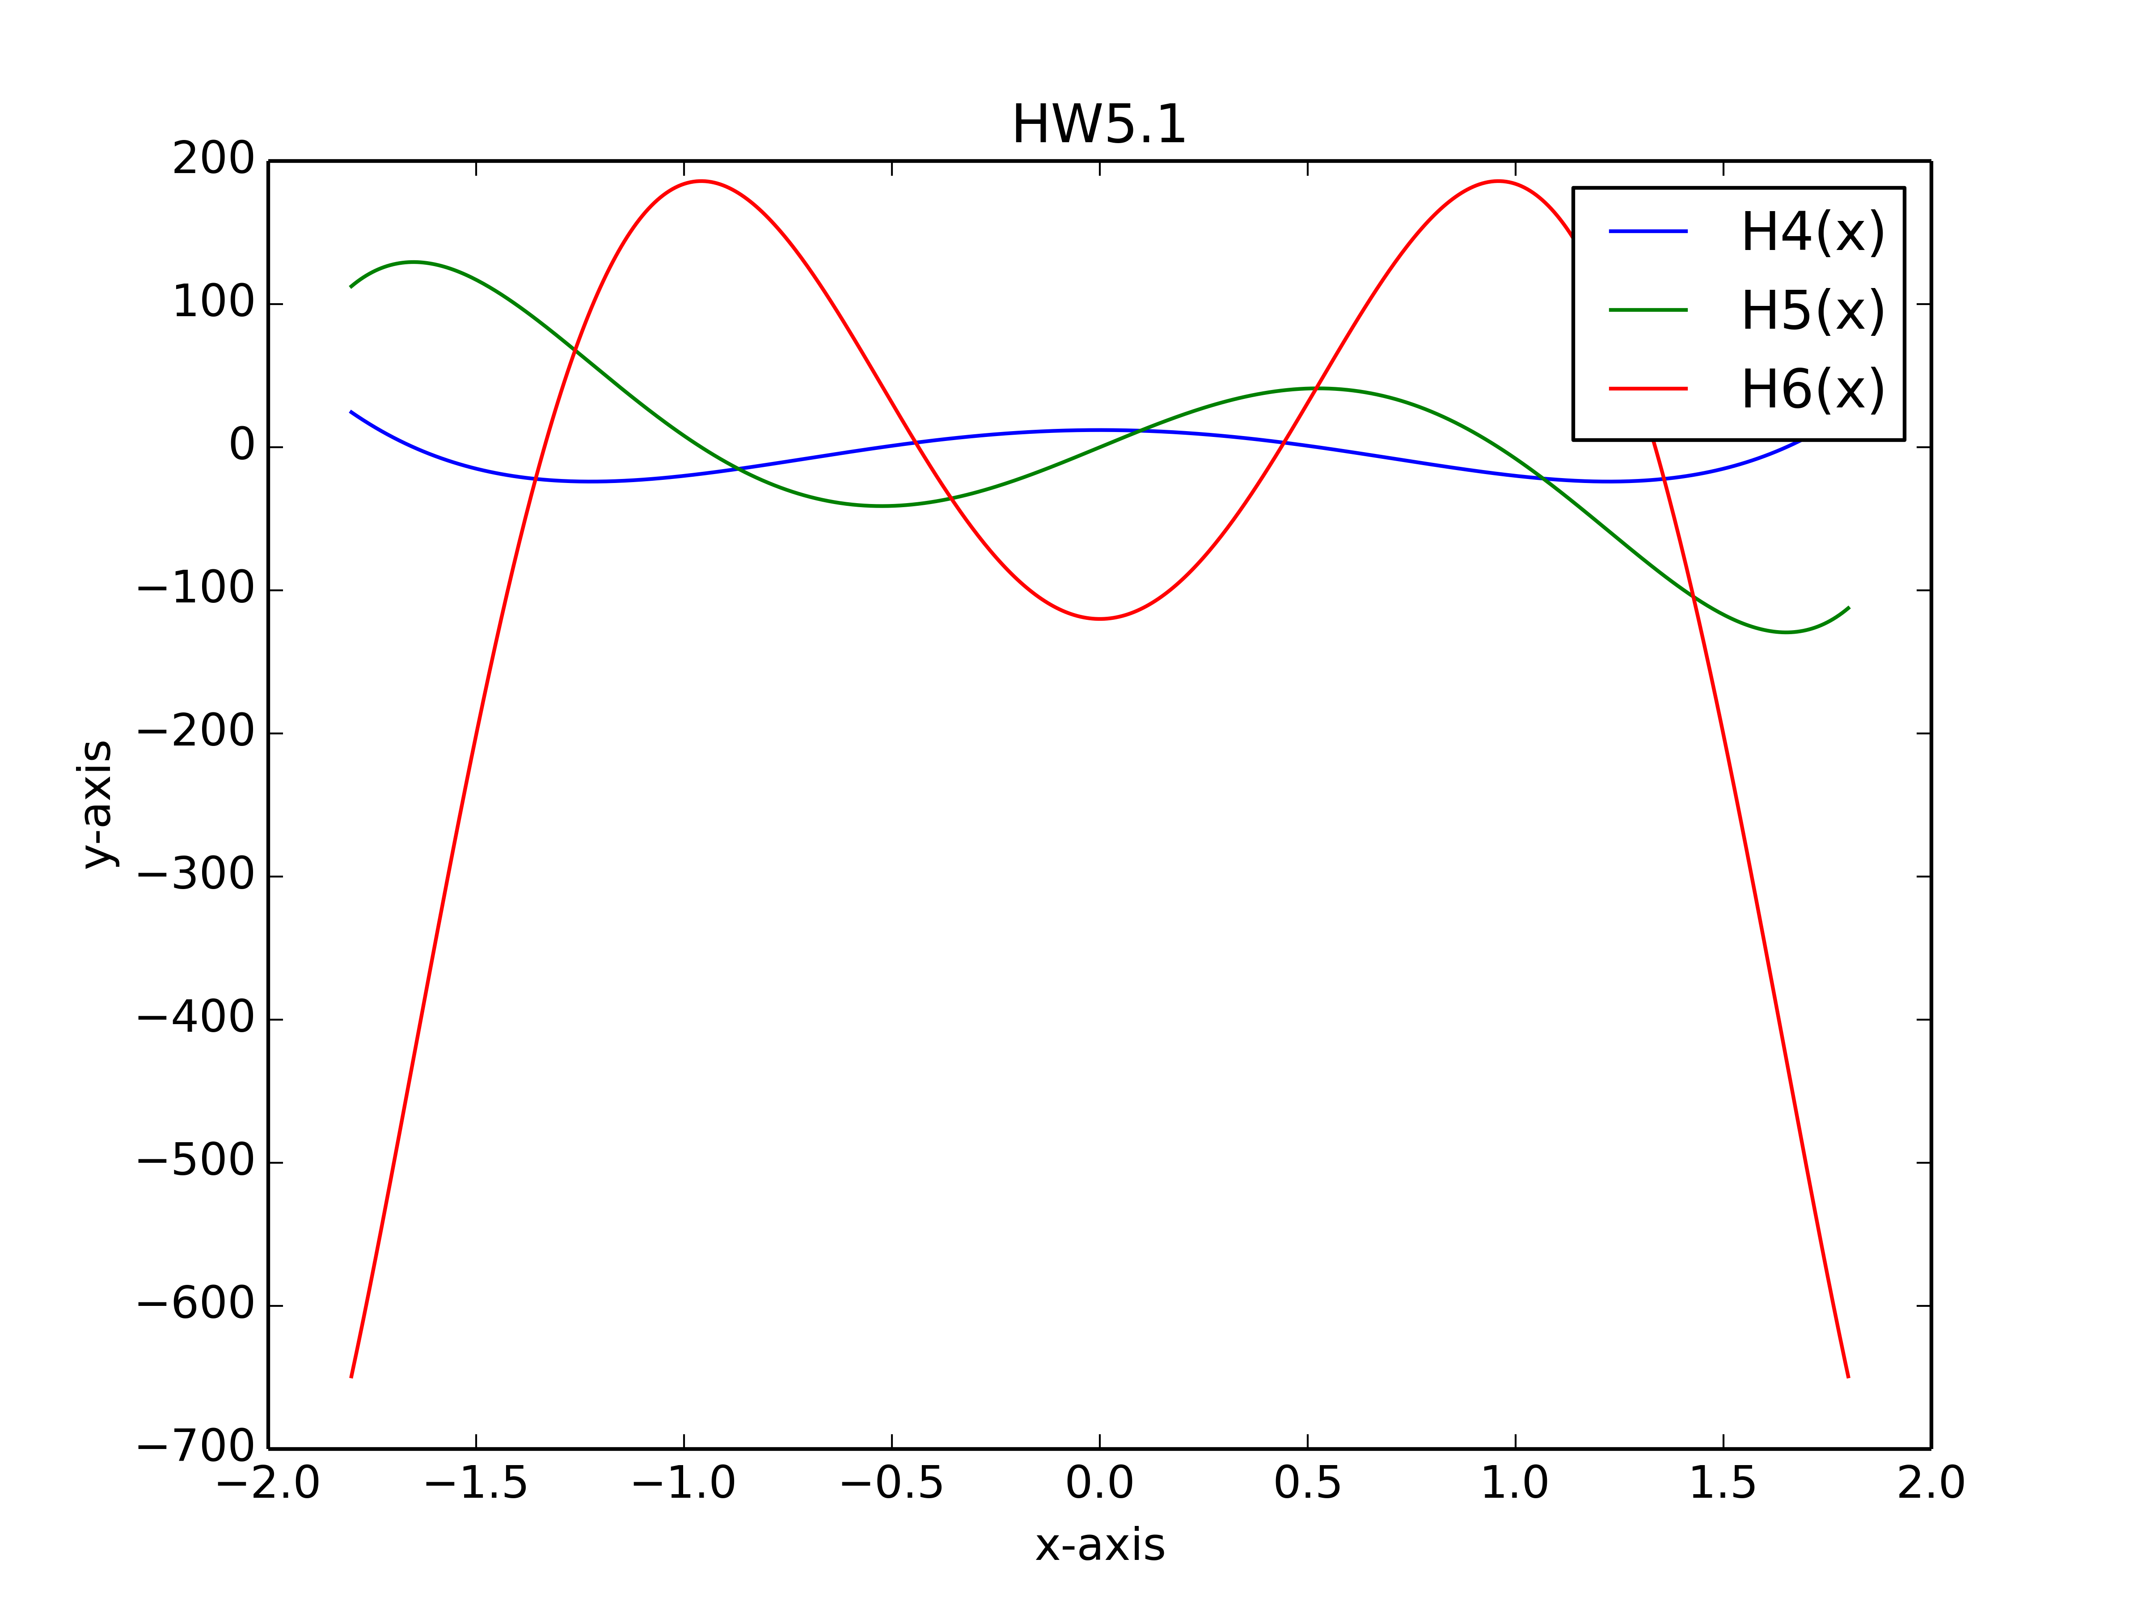
The plots for Hermite polynomials are below:
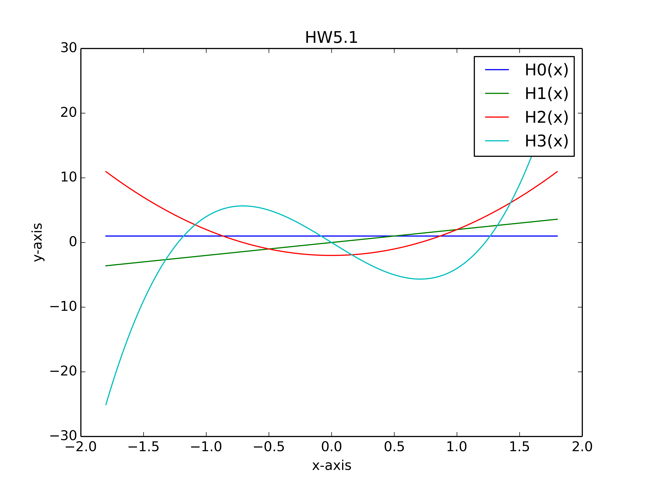
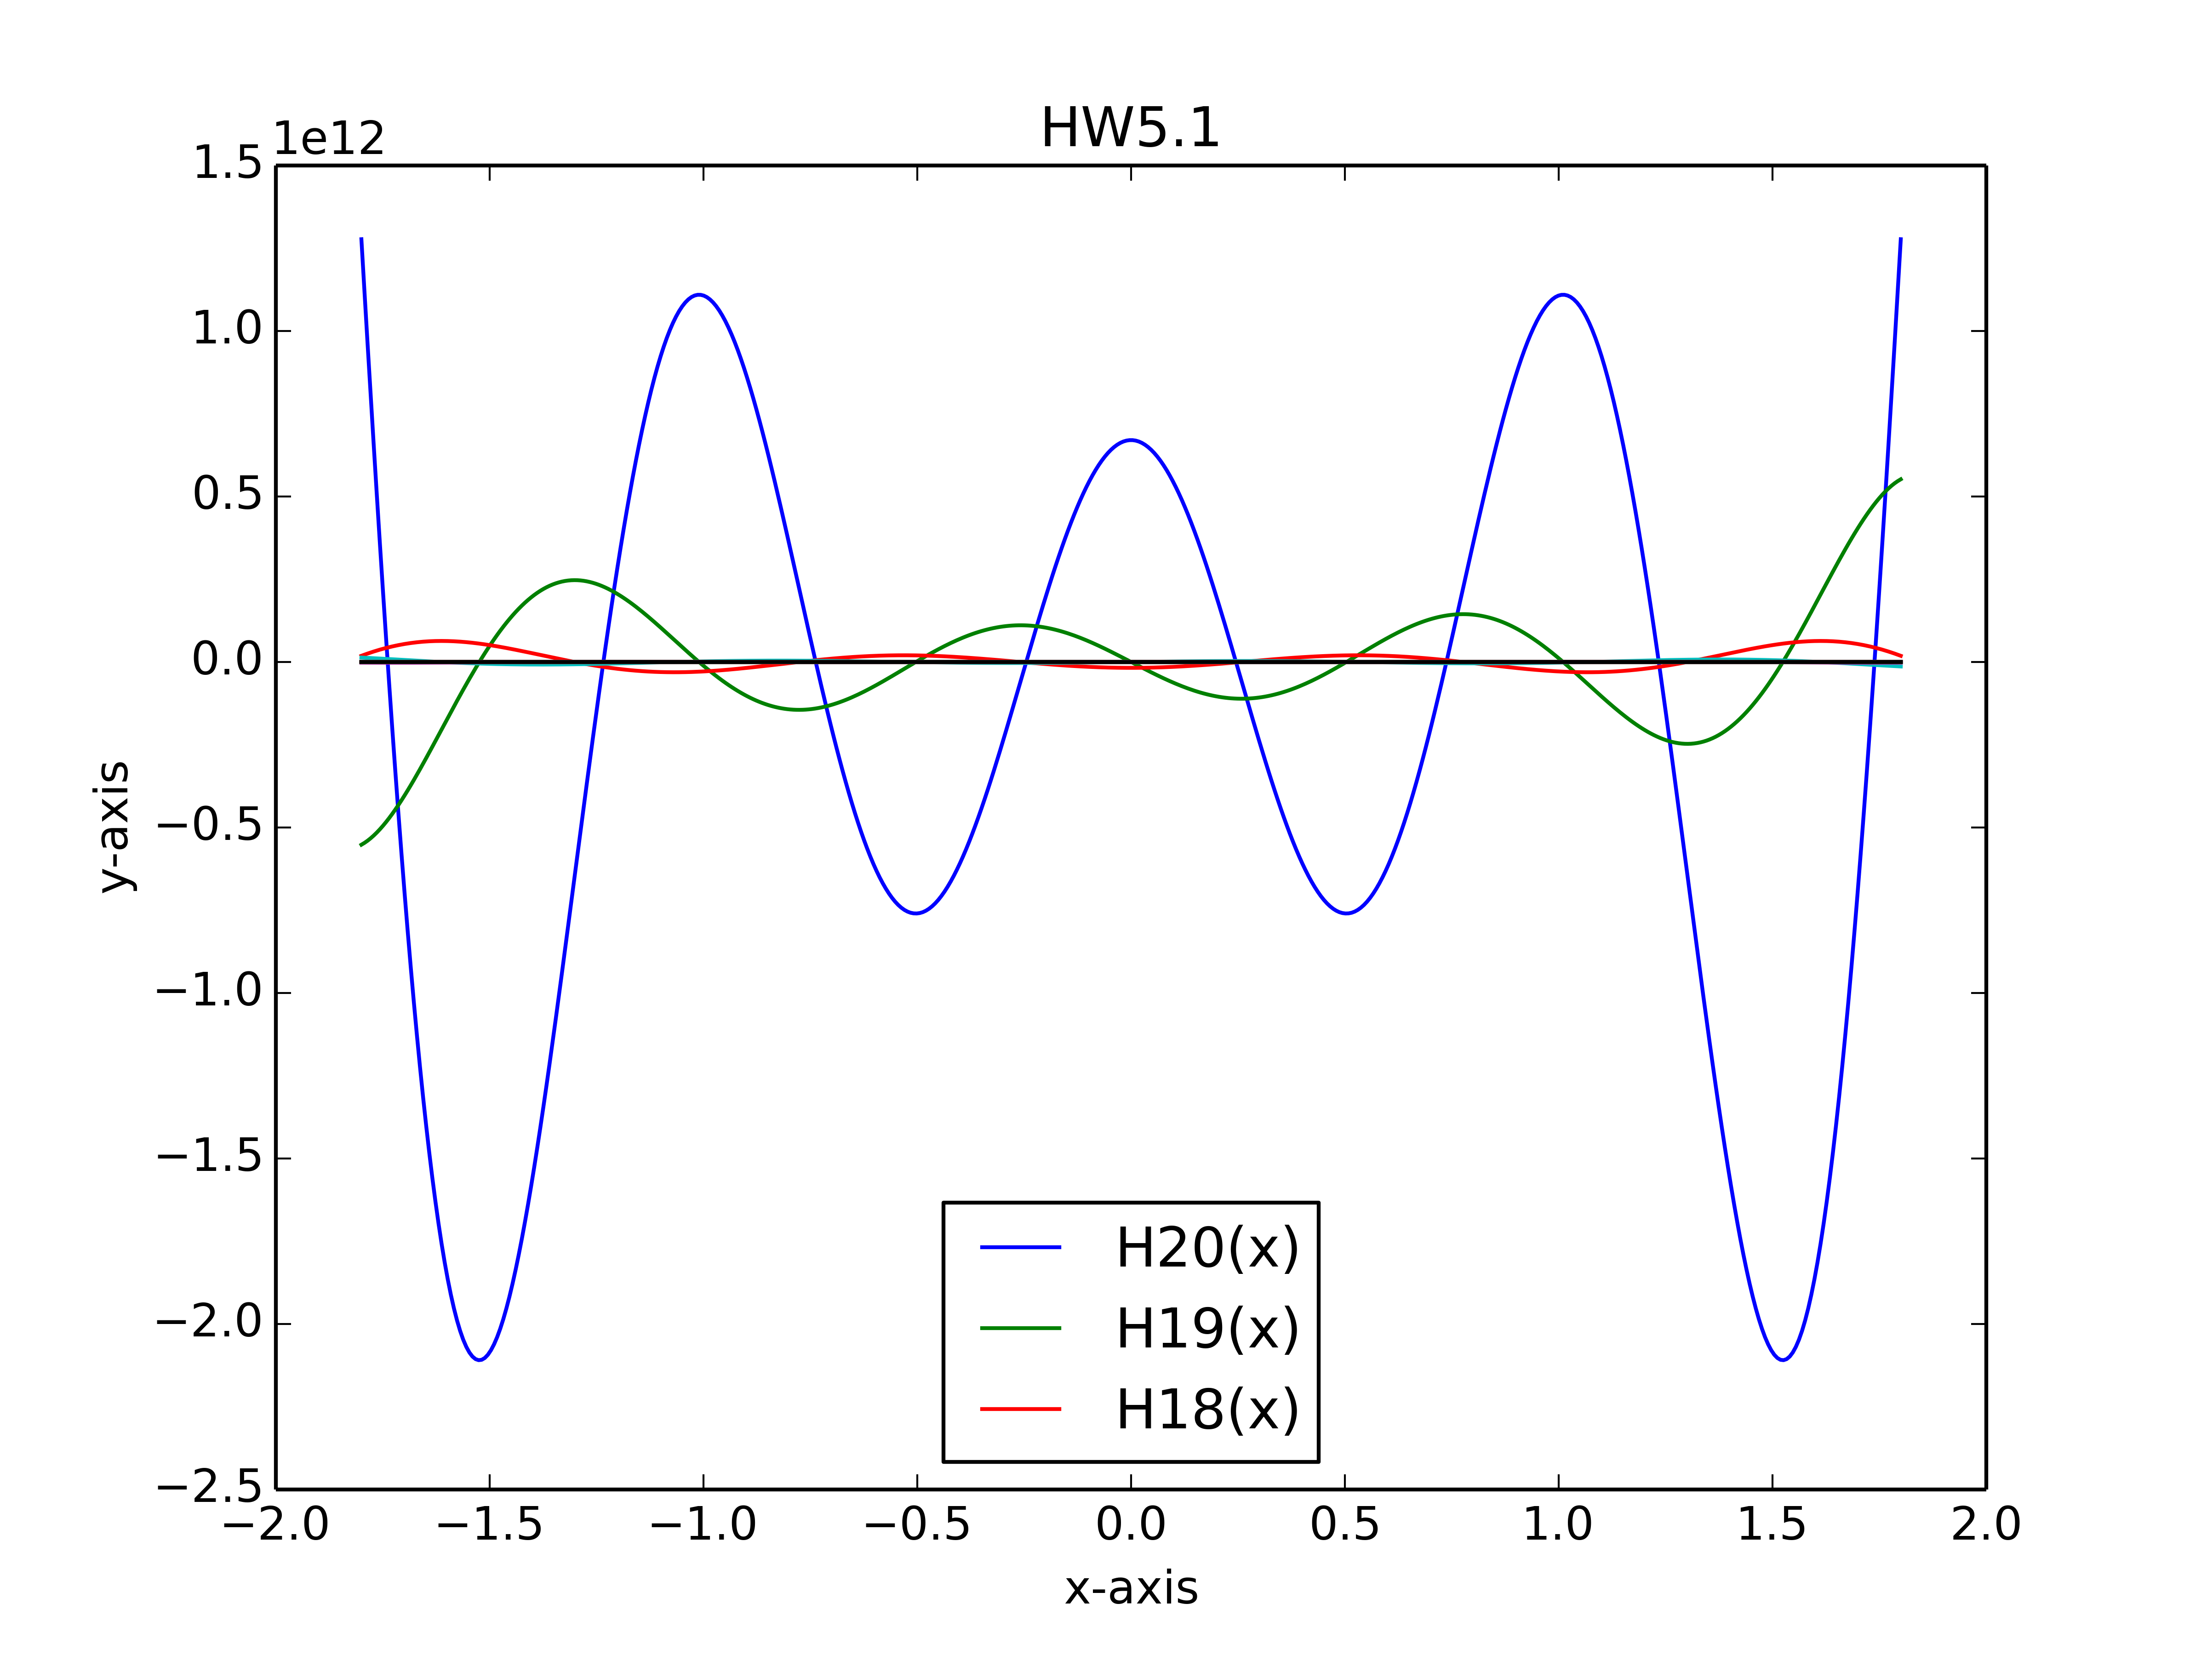
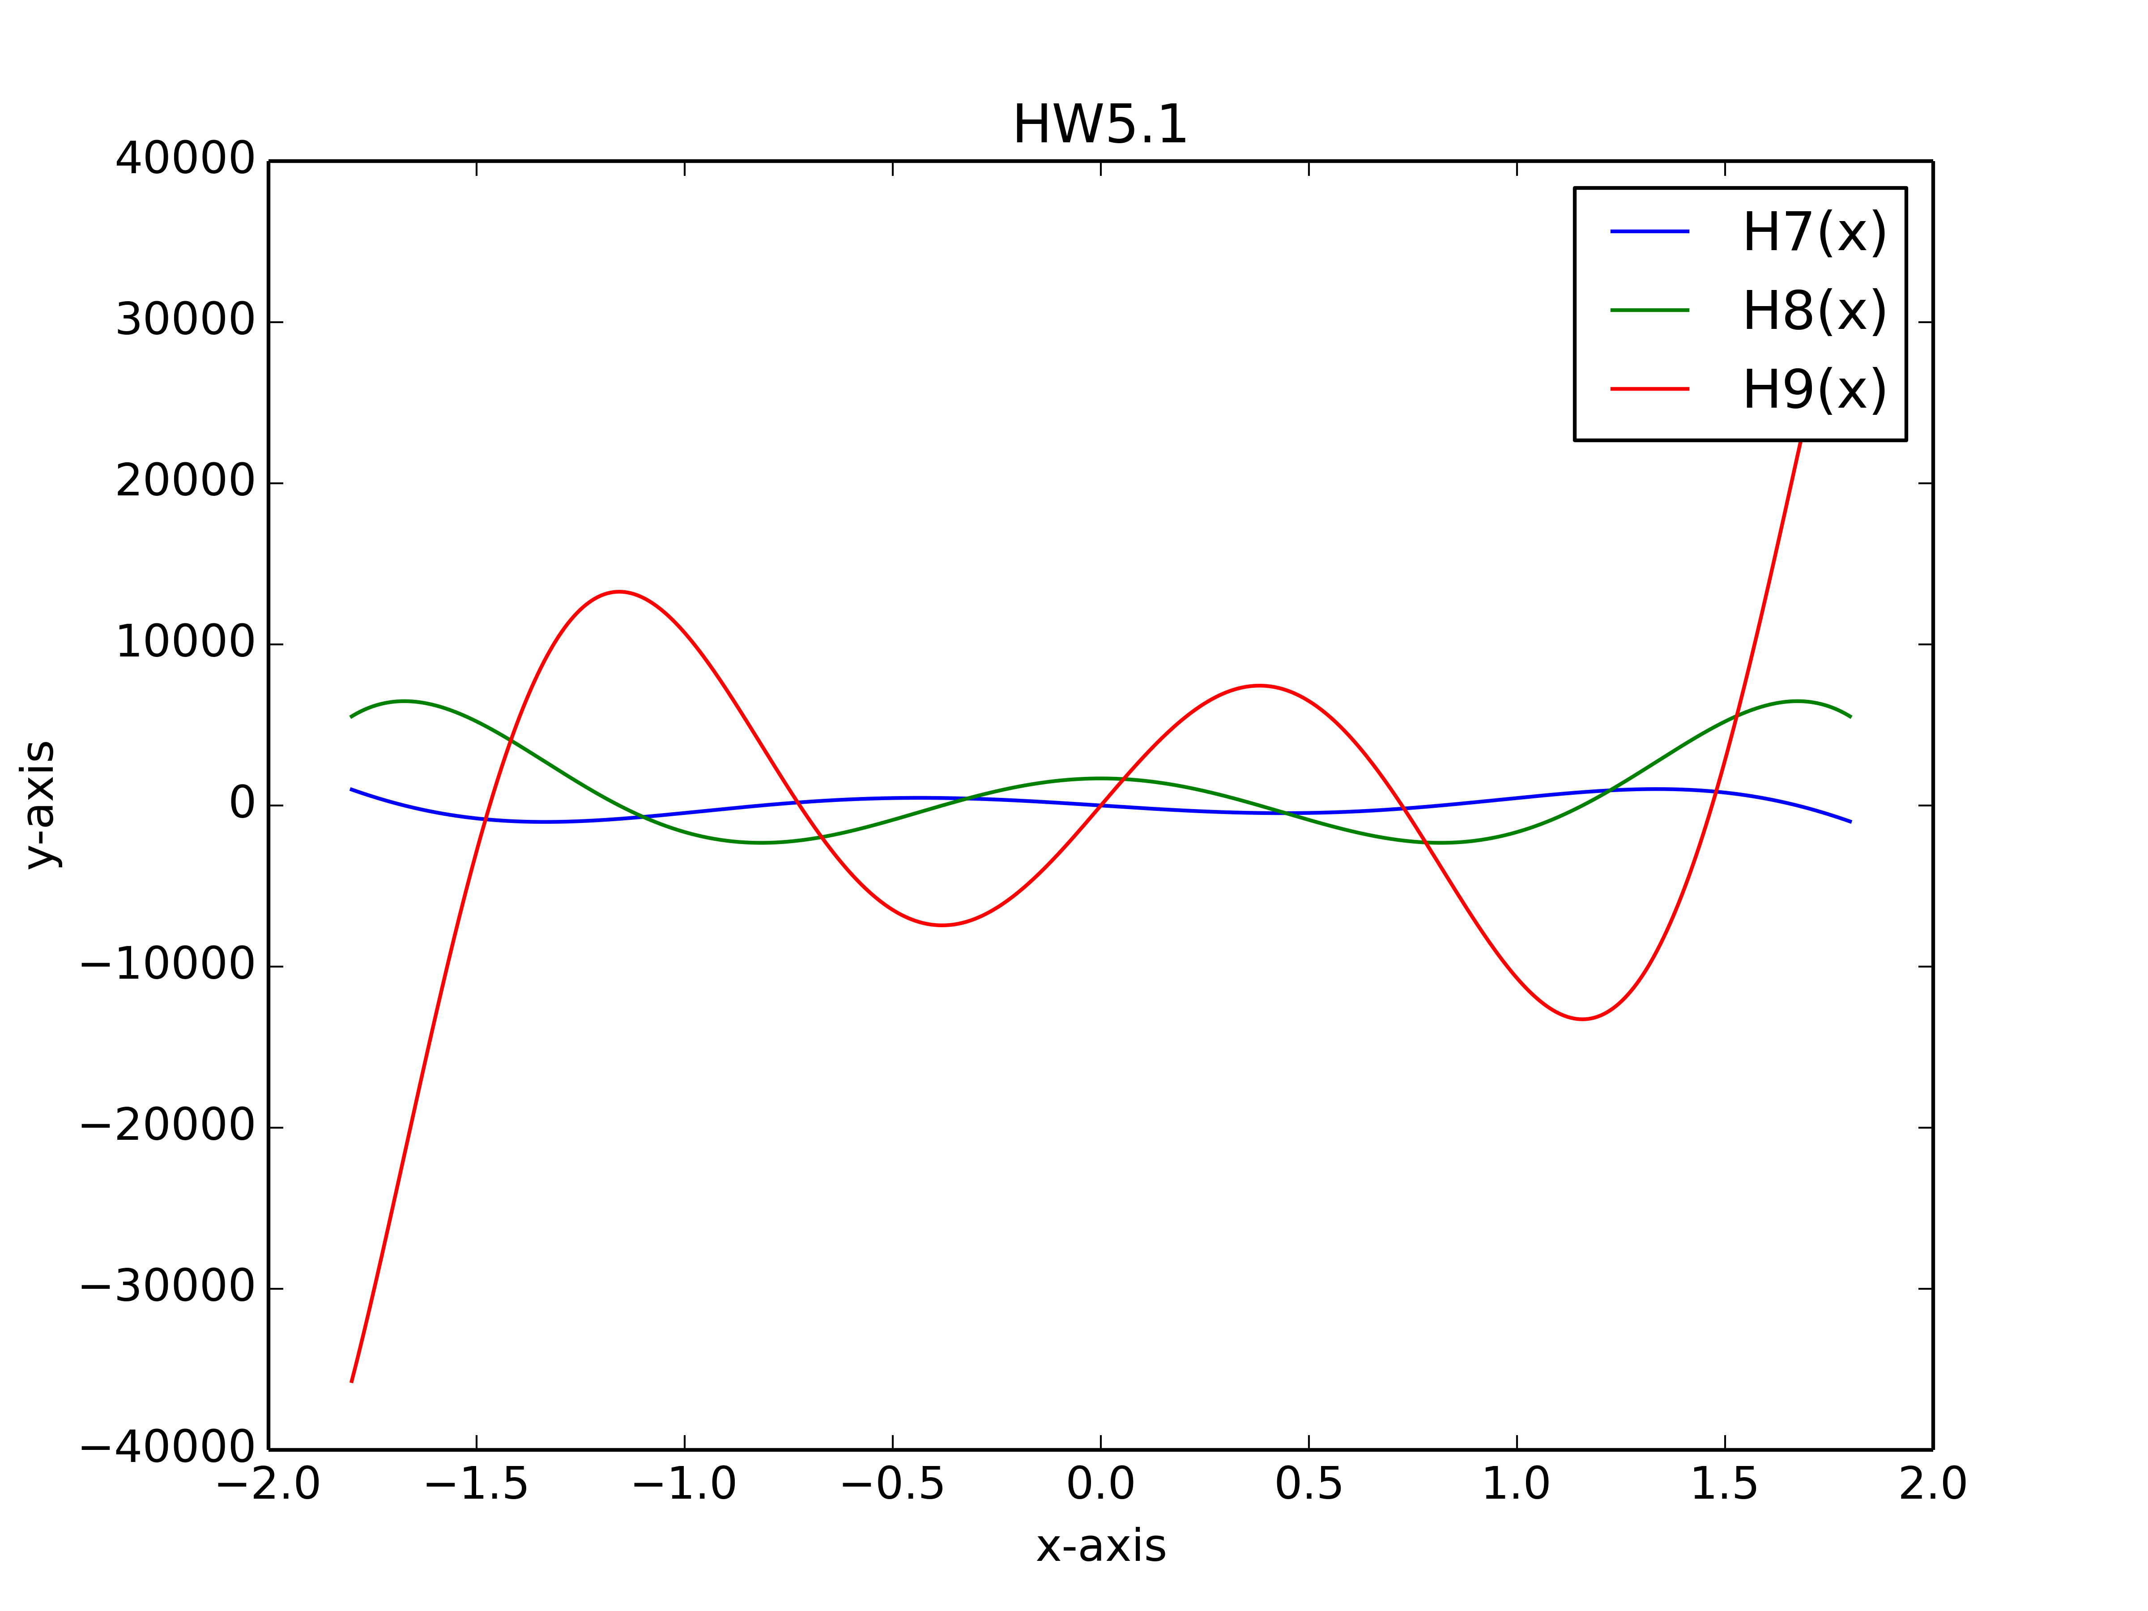
The following are the coefficient of the Hermite polynomials in ascending order:

H 0 (x)= [1, 0, 0, 0, 0, 0, 0, 0, 0, 0, 0, 0, 0, 0, 0, 0, 0, 0, 0, 0, 0]
H 1 (x)= [0, 2, 0, 0, 0, 0, 0, 0, 0, 0, 0, 0, 0, 0, 0, 0, 0, 0, 0, 0, 0]
H 2 (x)= [-2, 0, 4, 0, 0, 0, 0, 0, 0, 0, 0, 0, 0, 0, 0, 0, 0, 0, 0, 0, 0]
H 3 (x)= [0, -12, 0, 8, 0, 0, 0, 0, 0, 0, 0, 0, 0, 0, 0, 0, 0, 0, 0, 0, 0]
H 4 (x)= [12, 0, -48, 0, 16, 0, 0, 0, 0, 0, 0, 0, 0, 0, 0, 0, 0, 0, 0, 0, 0]
H 5 (x)= [0, 120, 0, -160, 0, 32, 0, 0, 0, 0, 0, 0, 0, 0, 0, 0, 0, 0, 0, 0, 0]
H 6 (x)= [-120, 0, 720, 0, -480, 0, 64, 0, 0, 0, 0, 0, 0, 0, 0, 0, 0, 0, 0, 0, 0]
H 7 (x)= [0, -1680, 0, 3360, 0, -1344, 0, 128, 0, 0, 0, 0, 0, 0, 0, 0, 0, 0, 0, 0, 0]
H 8 (x)= [1680, 0, -13440, 0, 13440, 0, -3584, 0, 256, 0, 0, 0, 0, 0, 0, 0, 0, 0, 0, 0, 0]
H 9 (x)= [0, 30240, 0, -80640, 0, 48384, 0, -9216, 0, 512, 0, 0, 0, 0, 0, 0, 0, 0, 0, 0, 0]
H 10 (x)= [-30240, 0, 302400, 0, -403200, 0, 161280, 0, -23040, 0, 1024, 0, 0, 0, 0, 0, 0, 0, 0, 0, 0]
H 11 (x)= [0, -665280, 0, 2217600, 0, -1774080, 0, 506880, 0, -56320, 0, 2048, 0, 0, 0, 0, 0, 0, 0, 0, 0]
H 12 (x)= [665280, 0, -7983360, 0, 13305600, 0, -7096320, 0, 1520640, 0, -135168, 0, 4096, 0, 0, 0, 0, 0, 0, 0, 0]
H 13 (x)= [0, 17297280, 0, -69189120, 0, 69189120, 0, -26357760, 0, 4392960, 0, -319488, 0, 8192, 0, 0, 0, 0, 0, 0, 0]
H 14 (x)= [-17297280, 0, 242161920, 0, -484323840, 0, 322882560, 0, -92252160, 0, 12300288, 0, -745472, 0, 16384, 0, 0, 0, 0, 0, 0]
H 15 (x)= [0, -518918400, 0, 2421619200, 0, -2905943040, 0, 1383782400, 0, -307507200, 0, 33546240, 0, -1720320, 0, 32768, 0, 0, 0, 0, 0]

H 16 (x)= [518918400, 0, -8302694400, 0, 19372953600, 0, -15498362880, 0, 5535129600, 0, -984023040, 0, 89456640, 0, -3932160, 0, 65536, 0, 0, 0, 0]

H 17 (x)= [0, 17643225600, 0, -94097203200, 0, 131736084480, 0, -75277762560, 0, 20910489600, 0, -3041525760, 0, 233963520, 0, -8912896, 0, 131072, 0, 0, 0]

H 18 (x)= [-17643225600, 0, 317578060800, 0, -846874828800, 0, 790416506880, 0, -338749931520, 0, 75277762560, 0, -9124577280, 0, 601620480, 0, -20054016, 0, 262144, 0, 0]

H 19 (x)= [0, -670442572800, 0, 4022655436800, 0, -6436248698880, 0, 4290832465920, 0, -1430277488640, 0, 260050452480, 0, -26671841280, 0, 1524105216, 0, -44826624, 0, 524288, 0]

H 20 (x)= [670442572800, 0, -13408851456000, 0, 40226554368000, 0, -42908324659200, 0, 21454162329600, 0, -5721109954560, 0, 866834841600, 0, -76205260800, 0, 3810263040, 0, -99614720, 0, 1048576]

Source Code for this task:

import scipy as sp
import numpy as np
import matplotlib.pyplot as plt
x0=[1,0,0,0,0,0,0,0,0,0,0,0,0,0,0,0,0,0,0,0,0]
x1=[0,2,0,0,0,0,0,0,0,0,0,0,0,0,0,0,0,0,0,0,0]
x2=[0,0,0,0,0,0,0,0,0,0,0,0,0,0,0,0,0,0,0,0,0]
x3=[0,0,0,0,0,0,0,0,0,0,0,0,0,0,0,0,0,0,0,0,0]
x4=[0,0,0,0,0,0,0,0,0,0,0,0,0,0,0,0,0,0,0,0,0]
x5=[0,0,0,0,0,0,0,0,0,0,0,0,0,0,0,0,0,0,0,0,0]
x6=[0,0,0,0,0,0,0,0,0,0,0,0,0,0,0,0,0,0,0,0,0]
x7=[0,0,0,0,0,0,0,0,0,0,0,0,0,0,0,0,0,0,0,0,0]
x8=[0,0,0,0,0,0,0,0,0,0,0,0,0,0,0,0,0,0,0,0,0]
x9=[0,0,0,0,0,0,0,0,0,0,0,0,0,0,0,0,0,0,0,0,0]
x10=[0,0,0,0,0,0,0,0,0,0,0,0,0,0,0,0,0,0,0,0,0]
x11=[0,0,0,0,0,0,0,0,0,0,0,0,0,0,0,0,0,0,0,0,0]
x12=[0,0,0,0,0,0,0,0,0,0,0,0,0,0,0,0,0,0,0,0,0]
x13=[0,0,0,0,0,0,0,0,0,0,0,0,0,0,0,0,0,0,0,0,0]
x14=[0,0,0,0,0,0,0,0,0,0,0,0,0,0,0,0,0,0,0,0,0]
x15=[0,0,0,0,0,0,0,0,0,0,0,0,0,0,0,0,0,0,0,0,0]
x16=[0,0,0,0,0,0,0,0,0,0,0,0,0,0,0,0,0,0,0,0,0]
x17=[0,0,0,0,0,0,0,0,0,0,0,0,0,0,0,0,0,0,0,0,0]
x18=[0,0,0,0,0,0,0,0,0,0,0,0,0,0,0,0,0,0,0,0,0]
x19=[0,0,0,0,0,0,0,0,0,0,0,0,0,0,0,0,0,0,0,0,0]
x20=[0,0,0,0,0,0,0,0,0,0,0,0,0,0,0,0,0,0,0,0,0]
op1=[0,2,0,0,0,0,0,0,0,0,0,0,0,0,0,0,0,0,0,0,0]
op2=[-2,0,0,0,0,0,0,0,0,0,0,0,0,0,0,0,0,0,0,0,0]
H=[x0,x1,x2,x3,x4,x5,x6,x7,x8,x9,x10,x11,x12,x13,x14,x15,x16,x17,x18,x19,x20]

for i in range(2,len(H),1):
for j in range(len(H[i])-2,-1,-1):
H[i][j]=H[i][j]+op2[0]*(i-1)*H[i-2][j]
H[i][j+1]=H[i][j+1]+op1[1]*H[i-1][j]

print "H is below"
for i in range(0,len(H),1):
print "H",i,"(x)=",H[i]

#plot
l=(1.8)
s=500
i = 0

for i in range (20,-1,-1):
#print i
x1 = np.linspace(-l,l,s)
y1 = H[i][0]*(x1**0)+H[i][1]*(x1**1)+H[i][2]*(x1**2)+H[i][3]*(x1**3)+H[i][4]*(x1**4)+H[i][5]*(x1**5)+H[i][6]*(x1**6)+H[i][7]*(x1**7)+H[i][8]*(x1**8)+H[i][9]*(x1**9)+H[i][10]*(x1**10)+H[i][11]*(x1**11)+H[i][12]*(x1**12)+H[i][13]*(x1**13)+H[i][14]*(x1**14)+H[i][15]*(x1**15)+H[i][16]*(x1**16)+H[i][17]*(x1**17)+H[i][18]*(x1**18)+H[i][19]*(x1**19)+H[i][20]*(x1**20)
plt.plot(x1,y1)

plt.legend(('H20(x)','H19(x)','H18(x)'),'down central')
plt.xlabel("x-axis")
plt.ylabel("y-axis")
plt.title("HW5.1")
plt.savefig("hw5-all.png",dpi=600,format="png")
plt.show()

