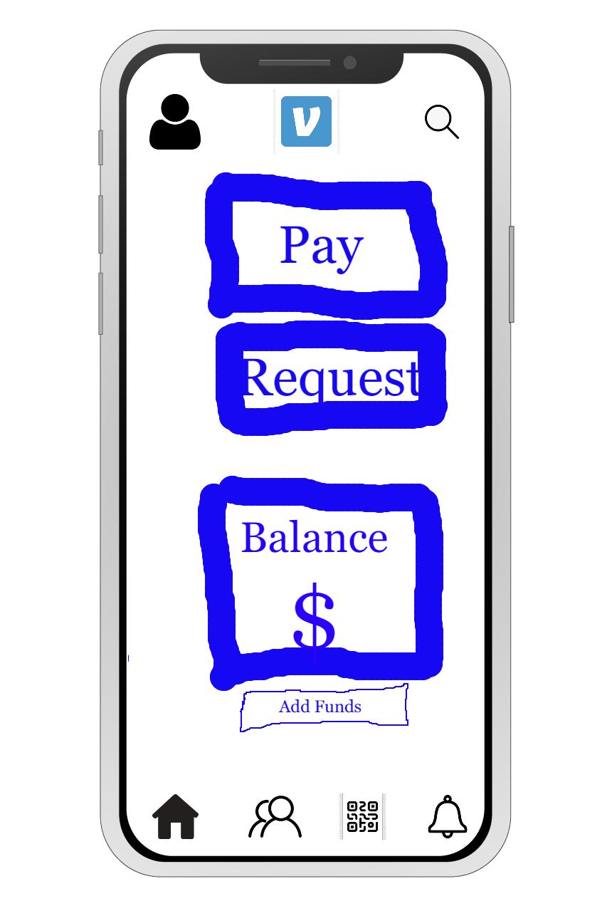

**Tyler Jackson**

Top Navigation Bar: The top navigation bar includes the app logo and a search icon to search for contacts or transactions. This element remains consistent with the previous design but is updated to follow the latest Android guidelines.

User Profile: The user profile section displays the user's profile picture, name, and handle. Users can tap on their profile picture to access account settings and view transaction history.

Balance and Add Funds: This section shows the user's current Venmo balance and includes an "Add Funds" button. Tapping the button allows users to add funds to their account from a linked bank account or credit/debit card.

Transaction Components:

a. "Pay" Button: Users can tap the "Pay" button to initiate a payment to a contact. This opens a new screen to select a contact, enter the payment amount, and include an optional note.

b. "Request" Button: Users can tap the "Request" button to request money from a contact. Similar to the "Pay" button, this opens a new screen for selecting a contact, entering the requested amount, and including an optional note.

Bottom Navigation Bar: The bottom navigation bar includes four icons: Home, Friends, Scan, and Notifications. These allow quick access to various app features such as the home screen, friends list, QR code scanner, and notifications.

Design Decisions:

I maintained the overall goal of the screen by including all necessary components for users to complete primary tasks. My design decisions were driven by the need to improve usability, accessibility, and overall aesthetics.

Clearer Call-to-Action Buttons: I separated the "Pay" and "Request" buttons and placed them prominently in the center of the screen. This makes it easier for users to quickly initiate transactions without confusion.

Improved Transaction Feed: I enhanced the transaction feed's layout to better differentiate between transaction types (sent, received, or requested) and provide a clearer understanding of each transaction's context.

Consistent Navigation: I added a bottom navigation bar to provide consistent access to essential app features, improving overall app navigation.

A new feature introduced in my design is the "Scan" icon in the bottom navigation bar. This allows users to quickly scan QR codes to send or receive payments. One challenge I faced was ensuring the transaction screen remained uncluttered while incorporating this additional functionality. I overcame this by carefully balancing the spacing and layout of the screen's components.