Big picture of the System

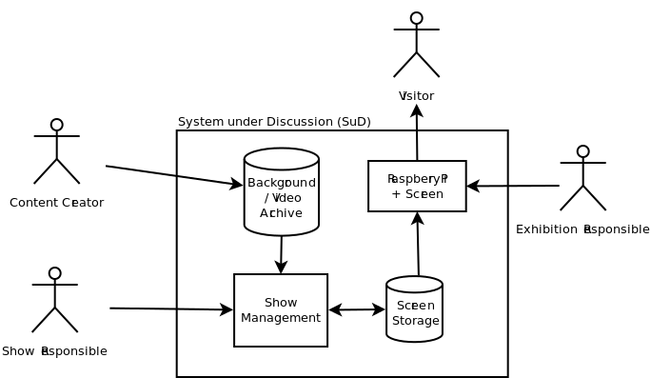

User-Goal List
Content Creator | Make Backgrounds and Videos available for show preparation
Content Creator | Configure position of overlay text
Show Responsible | Prepare show for screen
Show Responsible | Send ready prepared show to screen
Show Responsible | Update show while running
Exhibition Responsible | Prepare a bare Raspberry Pi with the ability to run a show
Exhibition Responsible | Bring show up on a screen
Visitor | Watch show

Basic conditions
- Four Screens hardcoded
- One show belongs to one screen - hard wired

Use-Cases for first demo release
Use-Case 1: Prepare show for screen
Primary Actor: Show Responsible
Scope: Show Management
Level: User goal
Main success scenario:
- Open the show preparation web interface
- Select the screen to be prepared
- Make changes to the show
  - add entries
  - remove entries
  - change entries
- Save changes

Use-Case 2: Bring show up on a screen
Primary Actor: Exhibition Responsible
Secondary Actor: Screen Storage
Scope: Raspberry Pi
Level: User goal
Main Success Scenario:
- Actor connects Raspberry Pi, Screen and Network
- Actor plugs in / switches on Raspberry Pi and Screen
- Raspberry Pi synchronizes the show from the Screen Storage
- Raspberry Pi runs the show on the screen

Use-Case 3: Send ready prepared show to screen
Primary Actor: Show Responsible
Secondary Actor: Screen storage
Scope: Show management
Level: User goal
Main success scenario:
- Open the show preparation web interface
- Select the screen to be sent
- Click “Send show to screen”
- The System prepares the show for the Raspberry Pi and puts it into the Screen Storage where it can be fetched by the Raspberry Pi

Use-Case 4: Update show while running
Primary Actor: Show Responsible
Secondary Actor: Screen storage
Scope: System
Level: User goal
Main success scenario:
- Actor prepares show for screen
- Actor sends ready prepared show to screen
- Raspberry Pi checks at given intervals for updates on the show
  - If a new show is available, Raspberry Pi syncs it
  - Raspberry Pi restarts the show

Use-Case 1.1: Select show
Primary Actor: Show Responsible
Scope: Show management
Level: Subfunction
Main success scenario:
- Actor selects one show from a list
- Show management displays the Playlist for this show

Use-Case 1.2: Add show entry
Primary Actor: Show Responsible
Scope: Show management
Level: Subfunction
Main success scenario:
- Actor clicks on “add slide” or “add video” entry beside the show Playlist
- Show management inserts a new entry of the respective type at the bottom of the Playlist

Use-Case 1.3: Remove show entry
Primary Actor: Show Responsible
Scope: Show management
Level: Subfunction
Main success scenario:
- Actor clicks remove button next to the entry in the Playlist
- A confirmation Dialog asks if the entry should be removed
  - If actor hits “no”, stop here
- Show management removes the entry from the Playlist

Use-Case 1.4: Rearrange show entries
Primary Actor: Show Responsible
Scope: Show management
Level: Subfunction
Main success scenario:
- Actor clicks and drags and drops an entry in the Playlist
- Show management moves the entry to the new position in the Playlist

Use-Case 1.5: Save show
Primary Actor: Show Responsible
Scope: Show management
Level: Subfunction
Main success scenario:
- Actor clicks “save show” button
- Show management makes the new run order persistent

Use-Case 1.6: Send show to screen
Primary Actor: Show Responsible
Secondary Actor: Screen storage
Scope: Show management
Level: Subfunction
Main success scenario:
- Actor clicks “send show to screen” button
- Show management converts the currently saved state of the show into a PiPresent readable format
- Show management puts the converted show into the screen storage.
(the respective Raspberry Pi will fetch it from there)

Use-Case 1.7: View picture entry content
Primary Actor: Show Responsible
Scope: Show management
Level: Subfunction
Main success scenario:
- Actor clicks on a picture entry on the show Playlist
- Show managements opens an editor showing the following content
  - Title of the entry
  - Preview of the image (background)
  - Text field to enter overlay text

Use-Case 1.8: View video entry content
Primary Actor: Show Responsible
Scope: Show management
Level: Subfunction
Main success scenario:
- Actor clicks on a picture entry on the show Playlist
- Show managements opens an editor showing the following content
  - Title of the entry
  - Name of selected Video

Use-Case 1.9: Edit entry title
Primary Actor: Show Responsible
Scope: Show management
Level: Subfunction
Main success scenario:
- Actor clicks a video or picture entry to open the editor
- Actor changes the title

Use-Case 1.10: Change image (background)
Primary Actor: Show Responsible
Secondary Actor: Background / Video Archive
Scope: Show management
Level: Subfunction
Main success scenario:
- Actor clicks a picture entry to open the editor
- Actor clicks the “select background” button
- Show management fetches a list of available backgrounds from the Archive
- Show management brings up a list of backgrounds
- Actor selects one background
  - If the Actor hits “cancel” stop here
- Show management updates the preview image in the editor

Use-Case 1.11: Change overlay text
Primary Actor: Show Responsible
Scope: Show management
Level: Subfunction
Main success scenario:
- Actor clicks a picture entry to open the editor
- Actor changes the overlay text in the text box

Use-Case 1.12: Change movie
Primary Actor: Show Responsible
Scope: Show management
Level: Subfunction
Main success scenario:
- Actor opens a movie entry editor
- Actor selects a new movie
- Show management shows the new movie title

Use-Case 1.13: Save entry
Primary Actor: Show Responsible
Scope: Show management
Level: Subfunction
Main success scenario:
- Actor hits the “Save entry” button inside the editor
- Show management makes all data persistent
- Show management updates the preview image and title in the show playlist on the left

Not included in first demo release
Use-Case xxx: Configure position of overlay text
Primary Actor: Content Creator
Scope: Background / Video Archive
Level: User goal
Main success scenario:
- Content Creator prepares a file describing the overlay text box
  - Position
  - Dimensions
  - Font Face
  - Font Size
- Content Creator puts the description file onto the Background / Video Archive

