**NOAA Technical Information Series NESDIS XXX**

**Version 1.0**

doi: 10.7289/XXXXXXX

**Data Stewardship Maturity Report for**

**NOAA Climate Data Record (CDR) of Upper Atmospheric Temperature 4 Layer Microwave, Version 3.3**

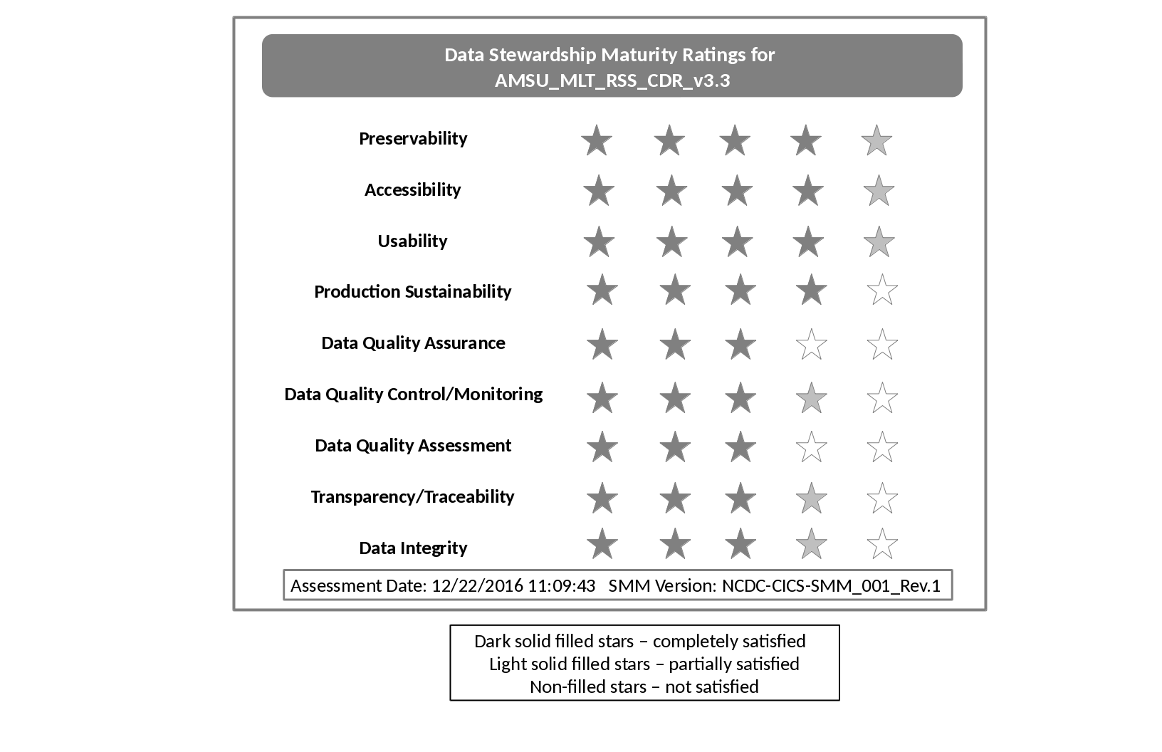

NOAA National Centers for Environmental Information

12/22/2016

|  |  |
| --- | --- |
|  | **U.S. DEPARTMENT OF COMMERCE**  National Oceanic and Atmospheric Administration  National Environmental Satellite, Data, and Information Service |

**Cover Image:** Data stewardship rating diagram for AMSU_MLT_RSS_CDR_v3.3. One to five stars are used to represent Level 1 to 5 ratings, denoting Ad Hoc, Minimal, Intermediate, Advance, and Optimal stages for each of the nine key components, respectively. The dark filled stars indicate that all the practices are completely satisfied. The light filled ones indicated that not all the practices are satisfied. And the non-filled ones indicated that the practices are not satisfied**.**

The stewardship maturity of NCEI data product, AMSU_MLT_RSS_CDR_v3.3, is assessed based on a reference stewardship maturity framework.

**NOAA TECHNICAL MEMORANDUM SERIES**

**National Environmental Satellite, Data, and Information Service**

**The National Environmental Satellite, Data, and Information Service (NESDIS) manages the Nation’s civil Earth-observing satellite systems, as well as global national data bases for meteorology, oceanography, geophysics, and solar-terrestrial sciences. From these sources, it develops and disseminates environmental data and information products critical to the protection of life and property, national defense, and the national economy, energy development and distribution, global food supplies, and the development of natural resources.**

**Publication in the NOAA Technical Memorandum series does not preclude later publication in scientific journals in expanded or modified form. The NESDIS series of NOAA Technical Reports is a continuation of the former NESS and EDIS series of NOAA Technical Reports and the NESC and EDS series of Environmental Science Services Administration (ESSA) Technical Reports.**

**Copies of earlier reports may be available by contacting NESDIS Chief of Staff, NOAA/ NESDIS, 1335 East-West Highway, SSMC1, Silver Spring, MD 20910, (301) 713-3578.**

**NOAA Technical Information Series NESDIS XXX**

**Version 1.0**

doi: 10.7289/XXXXXXXX

**Data Stewardship Maturity Report for**

**NOAA Climate Data Record (CDR) of Upper Atmospheric Temperature 4 Layer Microwave, Version 3.3**

Paul Lemieux III, paul.lemieux@noaa.gov, NOAA National Centers for Environmental Information (NCEI)  
NOAA’s National Centers of Environmental Information (NCEI), 151 Patton Avenue, Asheville, NC 28801-5001, USA

**Recommended Citation:**

Lemieux III, P. (2016), Data stewardship maturity report for NOAA Climate Data Record (CDR) of Upper Atmospheric Temperature 4 Layer Microwave, Version 3.3, *NOAA/NESDIS Technical Report XXX*, doi: 10.7289/XXXXXX.

# Contents

List of Figures 6

List of Tables 7

Preface 8

1. Introduction 9

2. Results 9

4. Acknowledgment 17

5. References 18

# List of Figures

Figure 1. (Page 1) Data stewardship maturity scoreboard for AMSU_MLT_RSS_CDR_v3.3, highlighted with 5-level progressive green scales for each of the nine key components (across), representing Ad Hoc, Minimal, Intermediate, Advance, and Optimal stages (vertical). If more than two cells are highlighted, it denotes that the dataset has completely satisfied the criterion for the lower level but not yet so at the current level.

# List of Tables

Table 1. (Page 9) Dataset and Data Stewardship Maturity Assessment Metadata.

Table 2. (Page 19) Stewardship Maturity Levels and Detailed Justifications for Each of Nine DSMM Key Components for the AMSU_MLT_RSS_CDR_v3.3 Dataset

# Preface

In response to the President's Open Government Initiative and related policies, NOAA has committed to providing improved public access to all of its environmental information, to enable research and commercial innovation through ease of data discovery and use [*Casey*, 2016].

OneStop supports NOAA's efforts by leveraging existing access technologies and infusing specific innovations to provide improved discover, access, and visualization services for NOAA's data. Also, OneStop is viewed by a NESDIS as a pathfinder effort with an initial focus on selected high-priority datasets from NESDIS and other program data meeting OneStop standards, but eventually scalable across NOAA's data. Lastly, OneStop is implementing the USGEO Common Framework for Earth Observation Data and leveraging/supporting the NOAA Big Data Project (BDP) and Big Earth Data Initiative (BEDI) [*Casey*, 2016].

As with any process of improvement planning, agencies need to find out where they are in terms of their compliance to the federal regulations and what they need to do if any areas of non-compliance are identified. To this end, a unified framework would be beneficial for assessing the current stage of stewardship practices applied to individual datasets and for providing a road map that will guide future investments towards enhanced stewardship of environmental datasets. The value and quality of a dataset depends in part on the stewardship practices applied after its development and production. Therefore, a unified framework providing a holistic view of the quality of stewardship practices applied to individual datasets is beneficial to data stewards and users [*Casey*, 2016].

The data stewardship maturity matrix (DSMM), jointly developed by domain (data management, technology, and science) subject matter experts from NOAA’s National Centers for Environmental Information (NCEI) and Cooperative Institute for Climate and Satellites – North Carolina (CICS-NC), provides such a consistent framework [*Peng et al.,* 2015]. The DSMM, leveraging institutional knowledge and community practices and standards, defines a graduated maturity scale for each of nine key components of scientific data stewardship to enable a consistent assessment of the measureable stewardship practices applied to a given data set or product.

The NOAA data stewardship maturity technical series captures stewardship maturity assessment results for individual datasets, provides consistent representation and citable documents of those assessments, ensures transparency, and allows better data quality information integration and content-based search and discovery of NOAA data.

**NOAA Technical Report NESDIS XXX**

**Data Stewardship Maturity Report for**

**NOAA Climate Data Record (CDR) of Upper Atmospheric Temperature 4 Layer Microwave, Version 3.3**

# 1. Introduction

**1.1 Purpose**

The purpose of this document is to describe the results of stewardship maturity assessment for NOAA Climate Data Record (CDR) of Upper Atmospheric Temperature 4 Layer Microwave, Version 3.3, utilizing the Scientific Data Stewardship Maturity Matrix or *DSMM* [*Peng, et al*, 2016]. DSMM defines 5 levels of stewardship maturity stages for Preservability, Accessibility, Usability, Production Sustainability, Data Quality Assurance, Data Quality Control/Monitoring, Data Quality Assessment, Transparency/Traceability, and Data Integrity key components. Each of these components is ranked from ‘*Ad hoc’* to *‘Optimal’* (see Appendix I). This report is based on evaluation performed by NOAA OneStop metadata specialists working with Subject Matter Experts and utilizing the DSMM template [*Peng*, 2015].

**1.2 Scope**

Assessing stewardship maturity - the current state of how datasets are documented, preserved, stewarded, and made accessible publicly, is a critical step towards meeting U.S. federal regulations, organizational requirements, and user needs [*Peng et al*., 2016]. The goal of this document is to provide the consistent and transparent stewardship maturity information to data users and decision-makers.

**1.3 Dataset Outline**

N/A

**1.4 Document Maintenance**

This document is generated and maintained by NOAA’s National Centers for Environmental Information. More on policy is available at <https://www.ngdc.noaa.gov/>.

# 2. Results

The information about dataset and stewardship maturity assessment is summarized in Table 1. The data stewardship maturity ratings are displayed as the scoreboard (Figure 1)and rating diagram (Figure 2) with the detailed justifications in Table 2.

Table 1. Dataset and Data Stewardship Maturity Assessment Metadata.

|  |  |
| --- | --- |
| **Dataset Title** | NOAA Climate Data Record (CDR) of Upper Atmospheric Temperature 4 Layer Microwave, Version 3.3 |
| **Dataset Information URL** | https://dx.doi.org/10.7289/V5WQ01S4; https://www.ncdc.noaa.gov/cdr/fundamental/mean-layer-temperature-rss |
| **Data Provider POC (Name; E-mail: Affiliation)** | NOAA National Centers for Environmental Information (NCEI), ncei.orders@noaa.gov |
| **Dataset POC (Name; E-mail; Affiliation)** | NOAA Climate Data Record Program, rss_msu_contacts@noaa.gov |
| **SMM Version (Document ID and Version Number)** | NCDC-CICS-SMM_001_Rev.1 |
| **SMM POC (Name; E-mail; Affiliation)** | Ge Peng, Ge Peng@noaa.gov, CICS-NC/NCEI |
| **SMM Template Version (Document ID and Version Numbers)** | NCDC_CICS_SMM_0001_Rev1_template_v4.0_20150623 |
| **SMM Template POC** | Paul Lemieux III, paul.lemieux@noaa.gov, NOAA National Centers for Environmental Information (NCEI) |
| **SMM Assessment Version (v<nn>r<mm>, e.g., v01r00)** | v01r01 |
| **SMM Assessment Date (MM/DD/YYYY)** | 2016-06-27 |
| **SMM Assessment POC (Name; E-mail; Affiliation)** | Paul Lemieux III, paul.lemieux@noaa.gov, NOAA National Centers for Environmental Information (NCEI) |
| **Stewardship Maturity Ratings (each key component) (kc1/kc2/kc3/kc4/kc5/kc6/kc7/kc8/kc9)** | 4.5/4.5/4.5/4/3/3.5/3/3.5/3.5 |
| **SMM Original Assessment Date (MM/DD/YYYY)** | 2016-06-10 |
| **SMM Original Assessment POC (Name; E-mail; Affiliation)** | Paul Lemieux III, paul.lemieux@noaa.gov, NOAA National Centers for Environmental Information (NCEI) |
| **SMM Last Modified Date (MM/DD/YYYY)** | N/A |
| **SMM Last Modification POC (Name; E-mail; Affiliation)** | Paul Lemieux III, paul.lemieux@noaa.gov, NOAA National Centers for Environmental Information (NCEI) |
| **SMM modified Date (MM/DD/YYYY)** | N/A |
| **SMM Modification POC (Name; E-mail; Affiliation)** | Paul Lemieux III, paul.lemieux@noaa.gov, NOAA National Centers for Environmental Information (NCEI) |

Table 2. Stewardship Maturity Levels and Detailed Justifications for Each of Nine DSMM Key Components for the AMSU_MLT_RSS_CDR_v3.3 Dataset.

|  |  |
| --- | --- |
| **DSMM Key Component** | **Stewardship Maturity Rating, Justification, and Comments** |
| ***Preservabilty*** *(The state of being preservable)* | **★ Level 4.5**  ***Justification:***  - Archived at NOAA NCEI-NC - Following NOAA Climate Data Record (CDR) Research-2-Operation (R2O) transition process with the Initial Operation Capability (IOC) - Following OAIS RM - Conforms to ISO 19115-2 metadata standard - Conforming to NetCDF CF metadata conventions. - Conforming to CDR Program (CDRP) guidelines on coding and NCEI Archive Branch (AB) guidance on file and variable naming conventions per Submission Agreement (SA) - Plans to transition ISO metadata to newer 19115-1 standard DSM_AE  ***Comments:***  No known external audits of the archive performed at this time |
| ***Accessibility***  *(The state of being searchable and accessible publically)* | **★ Level 4.5**  ***Justification:***  - Collection level searchable online: http://gis.ncdc.noaa.gov/all-records/catalog/main/home.page - Direct file download available: ftp://data.ncdc.noaa.gov/cdr/rss-uat-msu-amsu/ - THREDDS Catalog: http://www.ncdc.noaa.gov/thredds/catalog/cdr/rss-msu-amsu/catalog.html - Dissemination reports available internally for the FTP/HTTP servers - New technology for OneStop search and discovery planned (i.e. ElasticSearch, Hyrax Servers, etc.) This is part of the CDR data group that will be OneStop ready.  ***Comments:***  Dissemination reports are available internally, but not publicly |
| ***Usability***  *(The state of being easy to use)* | **★ Level 4.5**  ***Justification:***  - NetCDF-4 data format (CF compliant) - Data Flow Diagram {{Mears and NOAA CDR Program, 2012} Mears, C., and NOAA CDR Program, (2012), Flow chart for MSU L1B to L2C processing, _Rep. CDRP-DIA-0209 Rev1_, NOAA National Centers for Environmental Information, Asheville, NC., retrieved online: https://www.ncdc.noaa.gov/cdr/fundamental/mean-layer-temperature-rss (Accessed 30 November 2016).} available online here: https://www.ncdc.noaa.gov/cdr/fundamental/mean-layer-temperature-rss - C-ATBD {{Mears, 2013} Mears, C., (2013), Climate Algorithm Theoretical Basis Document (C-ATBD) RSS Version 3.3 MSU/AMSU-A Mean Layer Atmospheric Temperature, _Rep. CDRP-ATBD-0201_, NOAA National Centers for Environmental Information, Asheville, NC. Retrieved here: https://www.ncdc.noaa.gov/cdr/fundamental/mean-layer-temperature-rss (Accessed 30 November 2016).} available online here: https://www.ncdc.noaa.gov/cdr/fundamental/mean-layer-temperature-rss - Error estimates available in the C-ATBD {Mears, 2013} available online here: https://www.ncdc.noaa.gov/cdr/fundamental/mean-layer-temperature-rss - THREDDS allows aggregations of granules by virtually stacking files/timestamps as a single huge file - Visualization tool available at NOAA STAR: http://www.star.nesdis.noaa.gov/smcd/emb/mscat/imageBrowser.php  ***Comments:***  No known external rankings |
| ***Production Sustainability*** *(The state of data production being sustainable and extendable)* | **★ Level 4**  ***Justification:***  - Under NOAA CDR Operation & Maintenance (O&M) - Updated annually - Funding is allocated yearly - Product improvement process in place - CDR program under management by NCEI  ***Comments:***  No comments |
| ***Data Quality Assurance*** *(The state of data quality being assured)* | **★ Level 3**  **Justification:**  - Agile development procedure in place with defined/fixed set of analysis metrics - Master reference data are included in the source code package which is available online: https://www.ncdc.noaa.gov/cdr/fundamental/mean-layer-temperature-rss  ***Comments:***  No known external reviews No published information on data quality assurance metadata |
| ***Data Quality Control/Monitoring*** *(The state of data quality being controlled and monitored)* | **★ Level 3.5**  ***Justification:***  - DQC is done after each data processing - Sampling and analysis of anomalies are automatically detected in the merging code - Procedure documented in the C-ATBD {Mears, 2013} available online here: https://www.ncdc.noaa.gov/cdr/fundamental/mean-layer-temperature-rss  ***Comments:***  No data quality information in the metadata record. |
| ***Data Quality Assessment*** *(The state of data quality being assessed)* | **★ Level 3**  ***Justification:***  - Research assessment available in literature {{Mears and Wentz, 2009} Mears, C., and Wentz, F., (2009), Construction of the Remote Sensing Systems V3.2 atmospheric temperature records from the MSU and AMSU microwave sounders, _Journal of Atmospheric and Oceanic Technology_, 26(6), 1040—1056, doi:10.1175/2008JTECHA1176.1.} available online here: https://dx.doi.org/10.1175/2008JTECHA1176.1 - Numerous papers exist assessing the operational product - Assessment carried out in the NCEI CDR R2O process - CDR Initial Operational Capability (IOC) stage - Product Maturity Matrix assessment {{Mears and NOAA CDR Program, 2012} Mears, C., and NOAA CDR Program, (2012), UAT_4Layer_MW_RSS, _Rep. CDRP-MM-0208 Rev1_, NOAA National Centers for Environmental Information, Asheville, NC., retrieved online: https://www.ncdc.noaa.gov/cdr/fundamental/mean-layer-temperature-rss (Accessed 30 November 2016).} is available and online here: https://www.ncdc.noaa.gov/cdr/fundamental/mean-layer-temperature-rss  ***Comments:***  No data quality assessment information in the metadata record. No known external ranking |
| ***Transparency*** *(The state of being transparent, trackable, and traceable)* | **★ Level 3.5**  ***Justification:***  - CDR Program literature {{Bates, Privette, Kearns, Glance, & Zhao, 2015} Bates, J., Privette, J., Kearns, E., Glance, W., and Zhao, X. (2015), Sustained production of multidecadal climate records: lessons from the NOAA Climate Data Record Program, _Bulletin of the American Meteorological Society_, 97(10), 1573—1582, doi:10.1175/BAMS-D-15-00015.1.} is available online here: https://dx.doi.org/10.1175/BAMS-D-15-00015.1 - C-ATBD {Mears, 2013} available online here: https://www.ncdc.noaa.gov/cdr/fundamental/mean-layer-temperature-rss - DOI assigned: http://dx.doi.org/10.7289/V5WQ01S4 - NCEI OID: DSI 3655_01 - Dataset Configuration Management is EIA-649-B standard compliant and diagrammed in this presentation document {{Hutchins, 2015} Hutchins, C. (2015), Operations and Maintenance (O&M) of NOAA IOC CDRs, http://www1.ncdc.noaa.gov/pub/data/sds/cdr/conferences/2015%20PI%20Annual%20Meeting%20-%20Presentations/Day_1/(A-2)%20Operations%20and%20Maintenance%20(O_M)%20of%20NOAA%20IOC%20CDRs%20-%20(Hutchins).pdf (Accessed 30 November 2016).} available online here: http://www1.ncdc.noaa.gov/pub/data/sds/cdr/conferences/2015%20PI%20Annual%20Meeting%20-%20Presentations/Day_1/(A-2)%20Operations%20and%20Maintenance%20(O_M)%20of%20NOAA%20IOC%20CDRs%20-%20(Hutchins).pdf  ***Comments:***  No OAD available System information available in the C-ATBD {Mears, 2013} |
| ***Data Integrity*** *(The state of data integrity being verifiable)* | **★ Level 3.5**  ***Justification:***    - Checksums generated at ingest which verifies ingest integrity. - Using standard-based technology for generating checksum at ingest. - Checksum verified when customer orders data.  ***Comments:***    No comments |

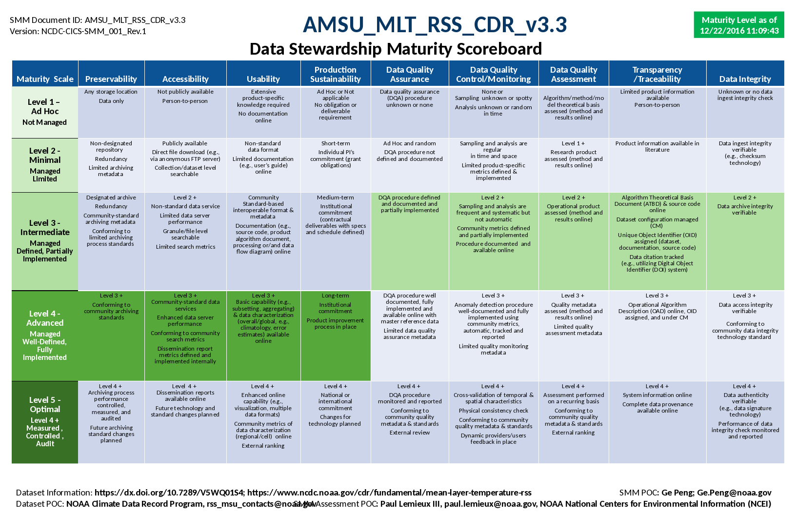

Figure 1. Data stewardship maturity scoreboard for AMSU_MLT_RSS_CDR_v3.3, highlighted with 5-level progressive green scales for each of the nine key components (across), representing Ad Hoc, Minimal, Intermediate, Advance, and Optimal stages (vertical). If more than two cells are highlighted, it denotes that the dataset has completely satisfied the criterion for the lower level but not yet so at the current level.

# 3. Acknowledgment

This work is supported by NOAA OneStop Project. We thank beneficial input from dataset POC(s) and collaborative effort by OneStop Teams, especially the Metadata Team. Guidance from Ge Peng on DSMM was beneficial.

The draft of this data stewardship maturity report is systematically generated by a tool created by Sonny Zinn, and populated with the stewardship maturity assessment done by the author(s) of this report. The tool was developed based on a Word template created collaboratively by Robert Partee II, Raisa Ionin, Paul Lemieux III, Ge Peng, Donald Collins, and Sonny Zinn with beneficial input from NOAA Central Library and NCEI Communication Team.

# 4. References

Peng, G. (2015) The Scientific Data Stewardship Maturity Assessment Model Template, Version: NCDC-CICS-SMM-0001-Rev.1 v4.0 6/23/2015. doi:10.6084/m9.figshare.1211954.

Peng, G., J. Lawrimore, V. Toner, C. Lief , R. Baldwin, N. Ritchey, D. Brinegar, and S. A. Delgreco (2016) Assessing Stewardship Maturity of the Global Historical Climatology Network-Monthly (GHCN-M) Dataset: Use Case Study and Lessons Learned. *D.-Lib Magazine.* **22***,* doi:10.1045/november2016-peng.

**Appendix I**: The Scientific Data Stewardship Maturity Matrix (DSMM)

Table A1: This matrix (Version: NCDC-CICS-SMM-0001-Rev.1. 12/09/2014) describes the criterion used to evaluate data stewardship maturity for each of the nine DSMM key components [*Peng et al.*, 2015].

|  |  |  |  |  |  |
| --- | --- | --- | --- | --- | --- |
| **DSMM Component** | **Level 1 *Ad hoc***  Little or no management | **Level 2**  ***Minimal***  Limited management | **Level 3**  ***Intermediate***  Defined management, partially implemented | **Level 4**  ***Advanced***  Well-defined management, fully implemented | **Level 5**  ***Optimal***  Full management, audited, measured, controlled |
| ***Preservability*** *(The state of being preservable)* | Any storage location  Data only | Non- designated repository  Redundancy  Limited archiving metadata | Designated archive  Redundancy  Community- standard archiving metadata  Conforming to limited archiving standards | Level 3 +  Conforming to community archiving standards | Level 4 +  Archiving process performance controlled, measured, and audited  Future archiving standard changes planned |
| ***Accessibility***  *(The state of being searchable and accessible publicly)* | Not publically available person-to- person | Publically available direct file download (e.g., via anonymous FTP server)  Collection or dataset level searchable online | Level 2 +  Non-standard data service  Limited data server performance  Granule/file level searchable  Limited search metrics | Level 3 +  Community-  standard data service  Enhanced data server performance  Conforming to community search metrics  Dissemination report metrics defined and implemented internally | Level 4 +  Dissemination reports available online  Future technology and standard changes planned |
| ***Usability***  *(The state of being easy to use)* | Extensive product-specific knowledge required  No documentation online | Non-standard data format  Limited documentation (e.g., user’s guide online) | Community standard-based interoperable format & metadata  Documentation (e.g. source code, product algorithm document, processing or/and data flow diagram) online | Level 3 +  Basic capability (e.g., subsetting, aggregating) & data characterization overall/global, e.g., climatology, error estimates) available online | Level 4 +  Enhanced online capability (e.g., visualization, multiple data formats)  Community metrics of data characterization (regional/cell) online  External ranking |
| ***Production Sustainability***  *(The state of data production being sustainable and extendable)* | Ad Hoc or Not applicable  To obligation or deliverable requirement | Short-term  Individual PI’s commitment (grant obligations) | Medium-term  Institutional commitment (contractual deliverables with specs and schedule defined) | Long-term Institutional commitment  Product improvement process in place | Level 4 +  National or international commitment  Changes for echnology planned |
| ***Data Quality Assurance***  *(The state of data quality being assured)* | Data quality assurance (DQA) procedure unknown or none | Ad Hoc and random  QA procedure not defined and documented | DQA procedure defined and documented and partially implemented | DQA procedure well documented, fully implemented and available online with master reference data  Limited data quality assurance metadata | Level 4 +  DQA procedure monitored and reported  Conforming to community quality metadata & standards  External review |
| ***Data Quality Control/Monitoring***  *The state of data quality being controlled and monitored* | None or Sampling unknown or spotty  Analysis unknown or random in time | Sampling and analysis are regular in time and space  Limited product-specific metrics defined & implemented | Level 2 +  Sampling and analysis are frequent and systematic but not automatic  Community metrics defined and partially implemented  Procedure documented and available online | Level 3 +  Anomaly detection procedure well-documented and fully implemented using community metrics, automatic, tracked and reported  Limited quality monitoring metadata | Level 4 +  Cross-validation of temporal & spatial characteristics  Physical consistency check  Conforming to community quality metadata & standards |
| ***Data Quality Assessment***  *(The state of data quality being assessed)* | Algorithm/  method/model  Theoretical basis assessed (methods and results online) | Level 1 +  Research product assessed (methods and results online) | Level 2 +  Operational product assessed (methods and results online) | Level 3 +  Quality metadata assessed  Limited quality assessment metadata | Level 4 +  Assessment performed on a recurring basis  Conforming to community quality metadata & standards  External ranking |
| ***Transparency/ Traceability***  *(The state of being transparent, trackable, and traceable)* | Limited product information available  Person-to-person | Product information available in literature | Algorithm Theoretical Basis Document (ATBD) & source code online  Dataset configuration managed (CM)  Unique Object Identifier (OID) assigned (dataset, documentation, source code)  Data citation tracked (e.g., utilizing Digital Object Identifier (DOI) system) | Level 3 +  Operational Algorithm Description (OAD) online, OID assigned, and under CM | Level 4 +  System information online  Complete data provenance online |
| ***Data Integrity***  *(The state of data integrity being verifiable)* | Unknown or no data ingest integrity check | Data ingest integrity verifiable (e.g, checksum technology) | Level 2 +  Data archive integrity verifiable | Level 3 +  Data access integrity verifiable  Conforming to community data integrity technology standard | Level 4 +  Data authenticity verifiable (e.g., data signature technology)  Performance of data integrity check monitored and reported |