**Kubernetes**

**Introduction**

<https://kubernetes.io/docs/concepts/>

<https://medium.com/@chkrishna/kubernetes-architecture-f7ca63fff46e>

**Working with Kubernetes**

Installing Kubernetes with Minikube

<https://kubernetes.io/docs/setup/learning-environment/minikube/>

for ubuntu

<https://matthewpalmer.net/kubernetes-app-developer/articles/install-kubernetes-ubuntu-tutorial.html>

for windows

<https://www.maketecheasier.com/get-started-with-kubernetes-using-minikube/>

**LAB**

We will be performing basic tasks

Follow all the QuickStart steps from the following Link<https://kubernetes.io/docs/setup/learning-environment/minikube/#quickstart>

**JUST THE QUICKSTART PART**

Reference Screenshot

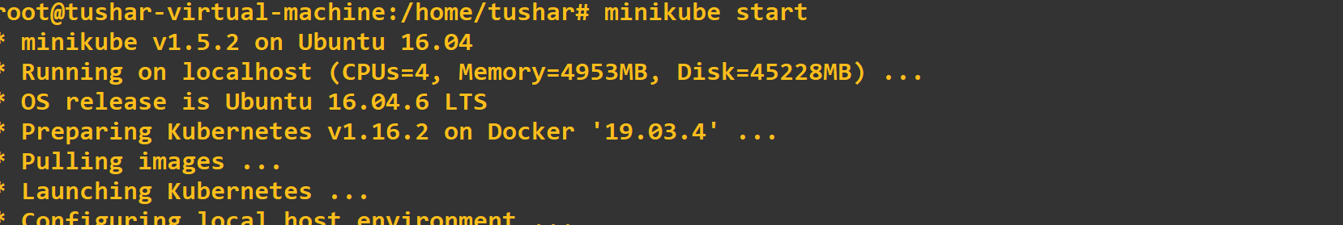

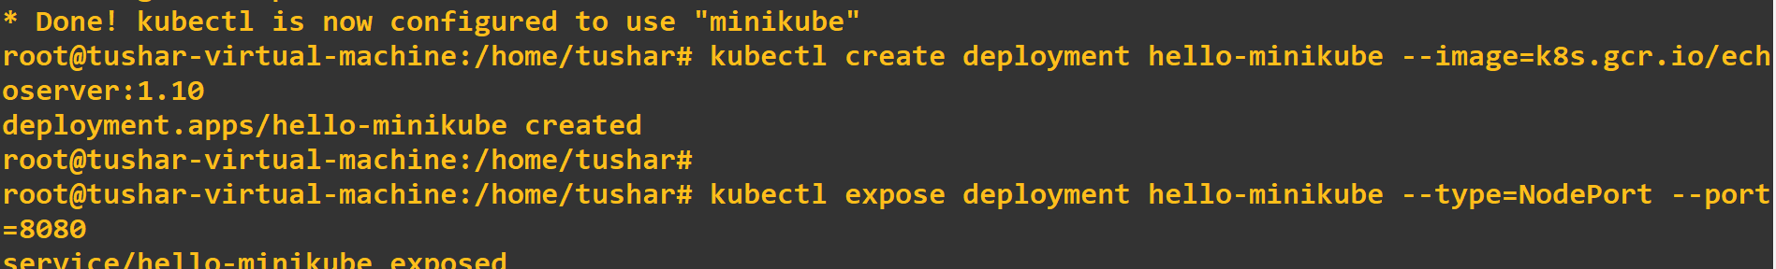

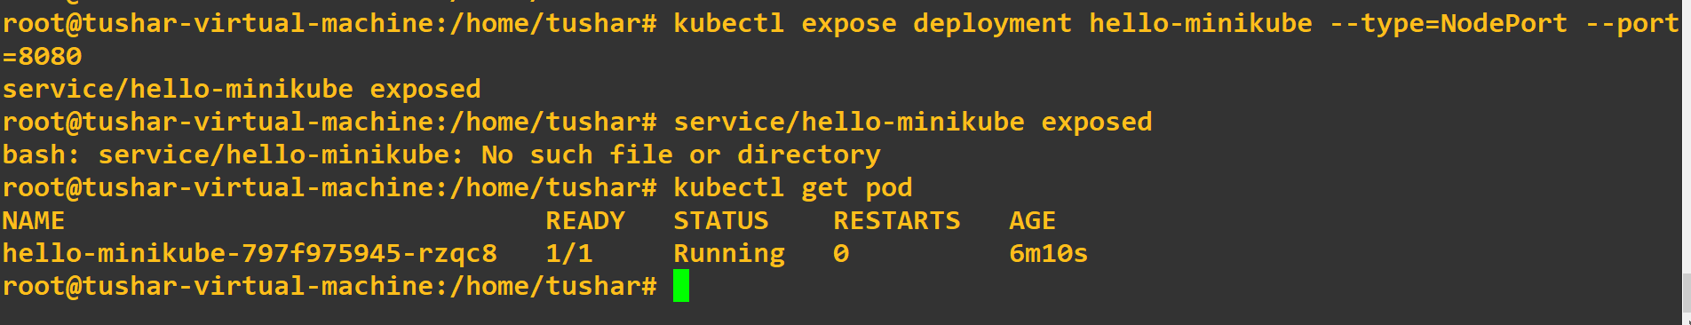

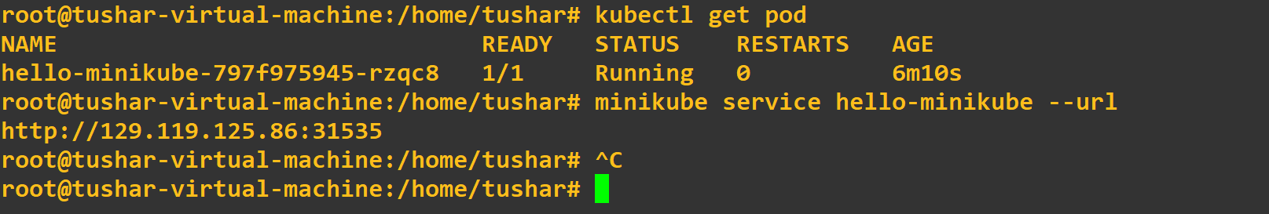

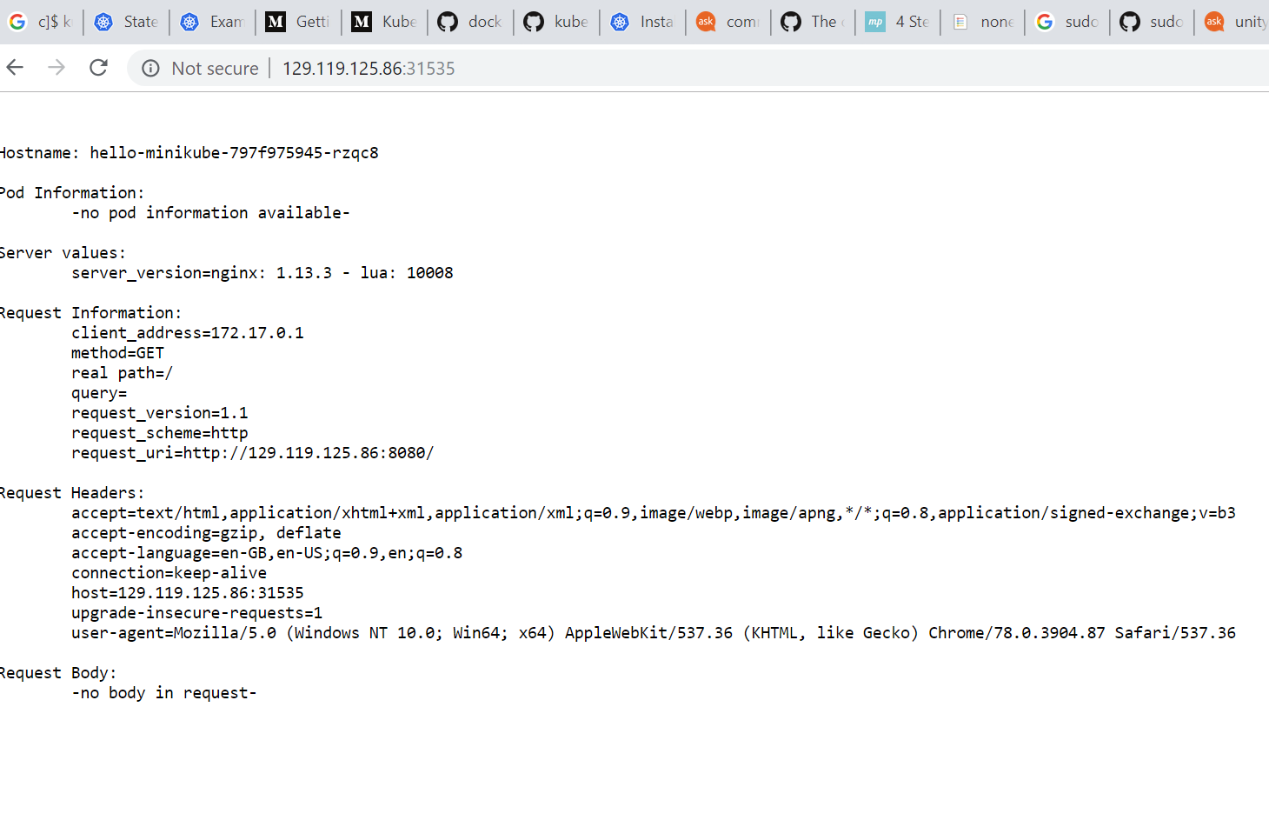

Running a stateless application Deployment: -

Follow this link

<https://kubernetes.io/docs/tasks/run-application/run-stateless-application-deployment/>

Creating and exploring an nginx deployment

Reference Screenshot

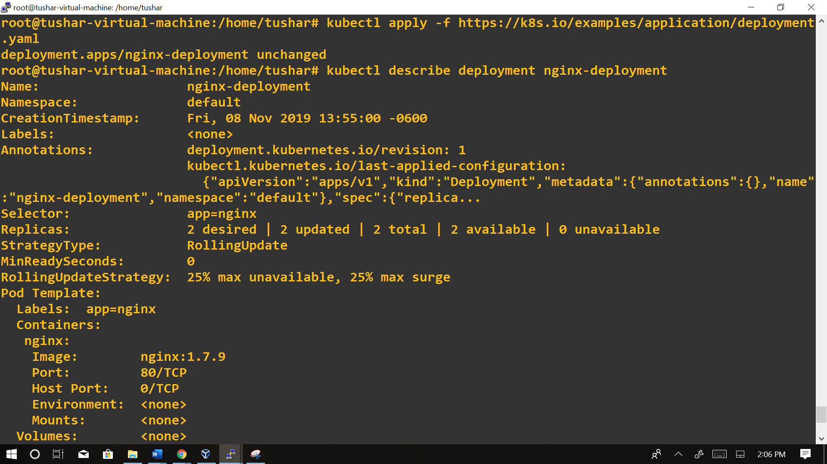

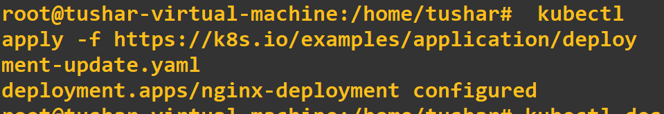

Watch the deployment create pods with new names and delete the old pods

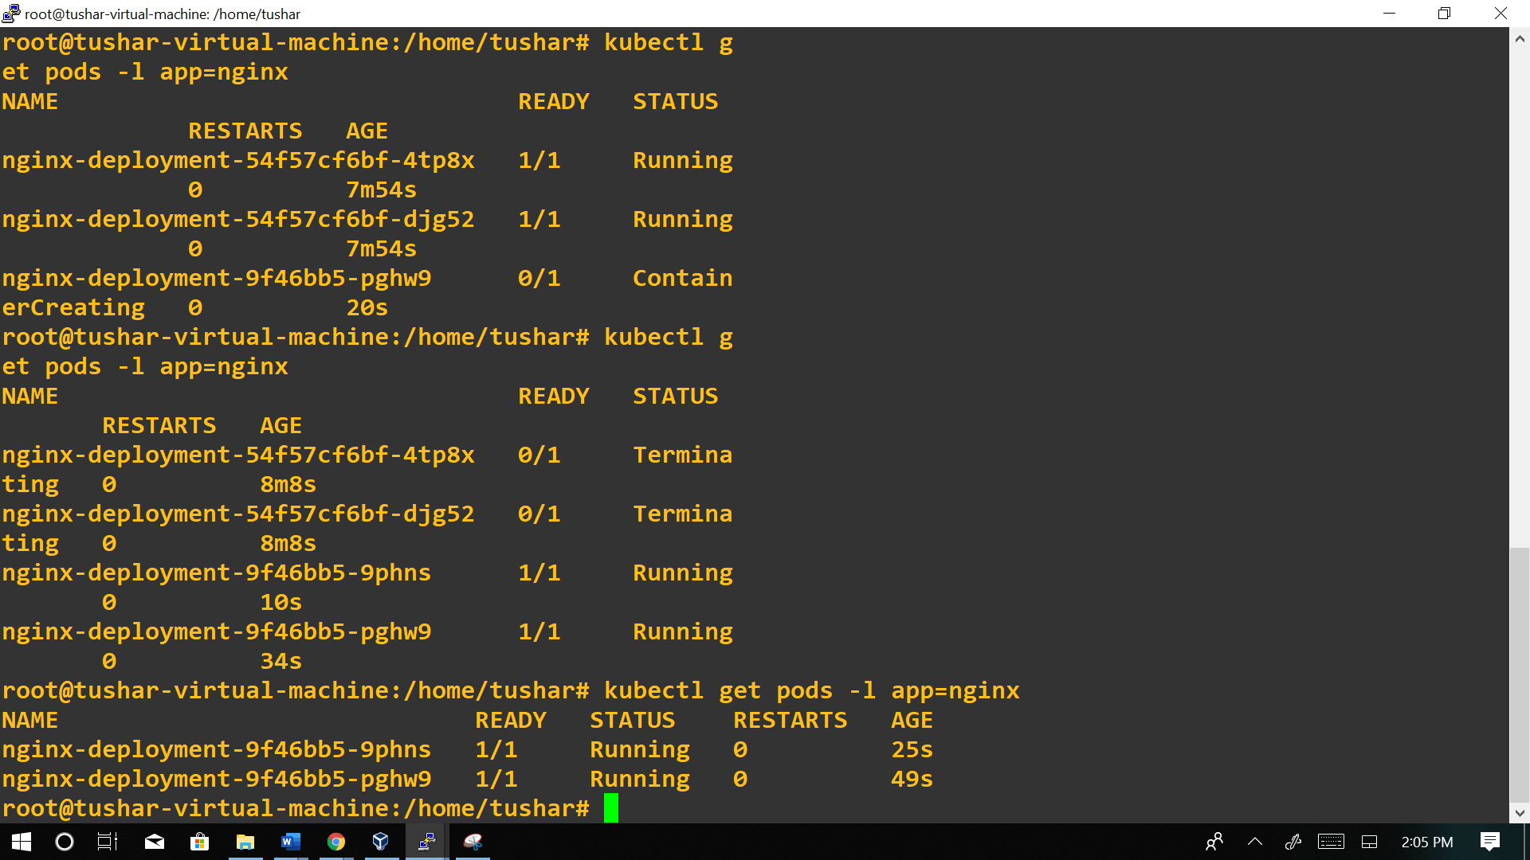

**Scaling the application by increasing the replica count**

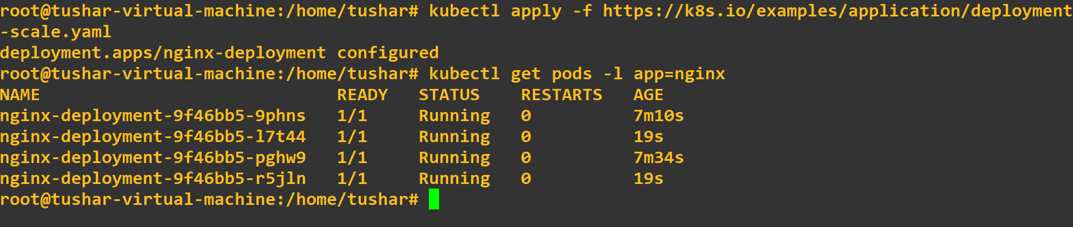

**Run a Single-Instance Stateful Application**

<https://kubernetes.io/docs/tasks/run-application/run-single-instance-stateful-application/>

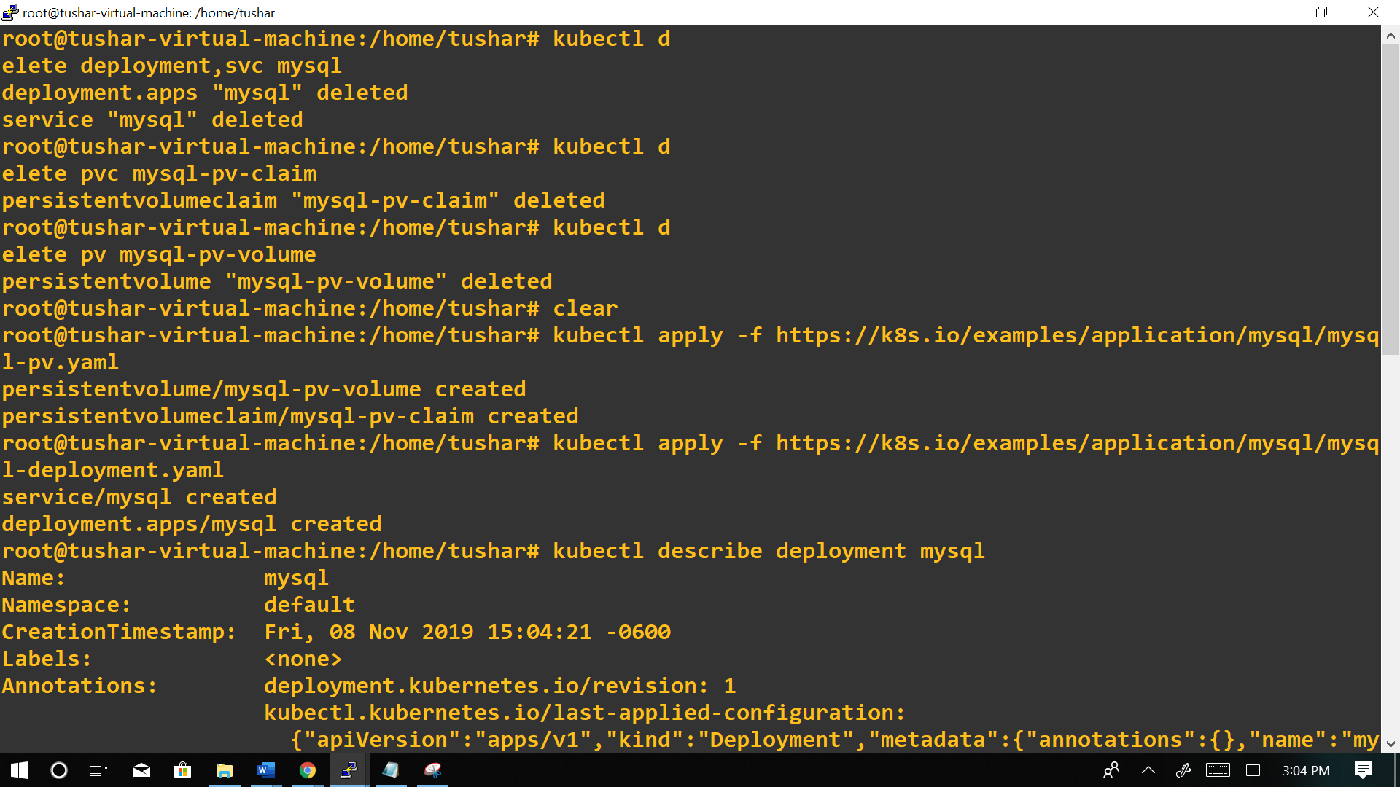

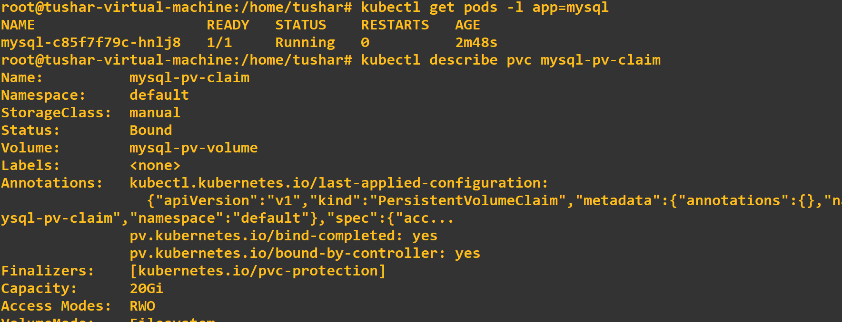



**Stateful application**

<https://kubernetes.io/docs/tutorials/stateful-application/basic-stateful-set/>

reference Screenshot

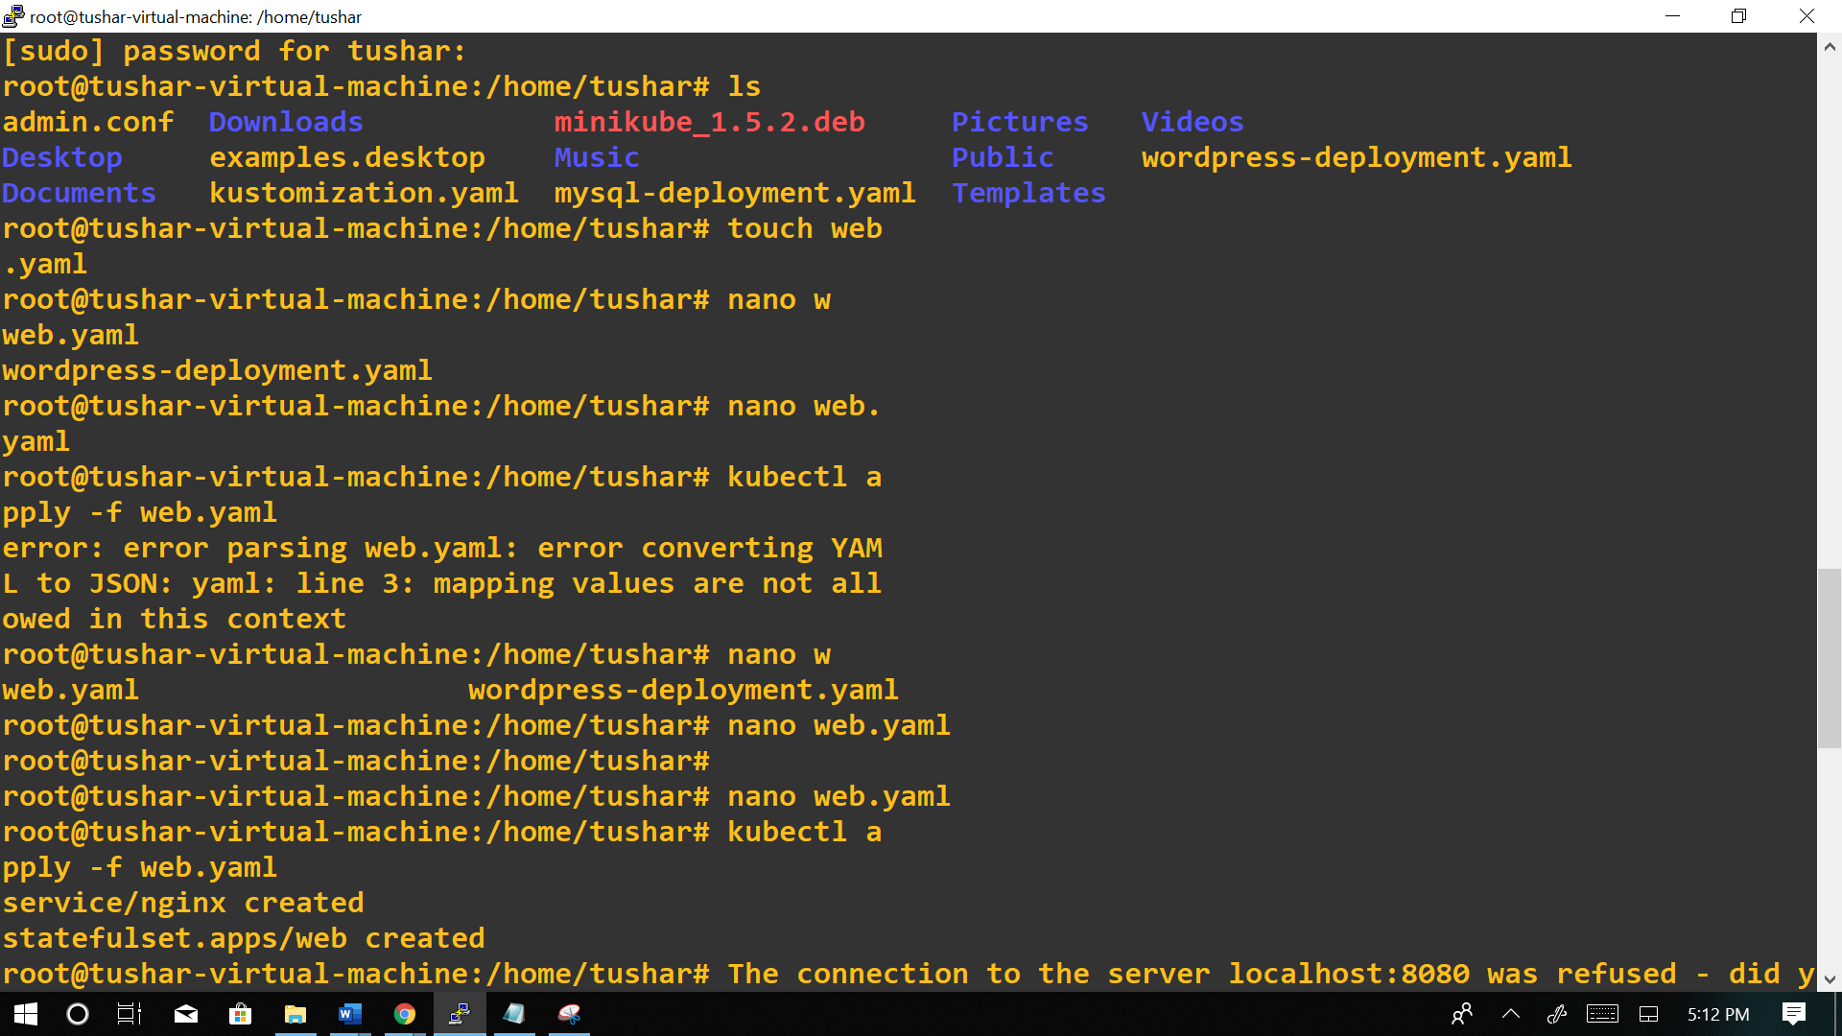

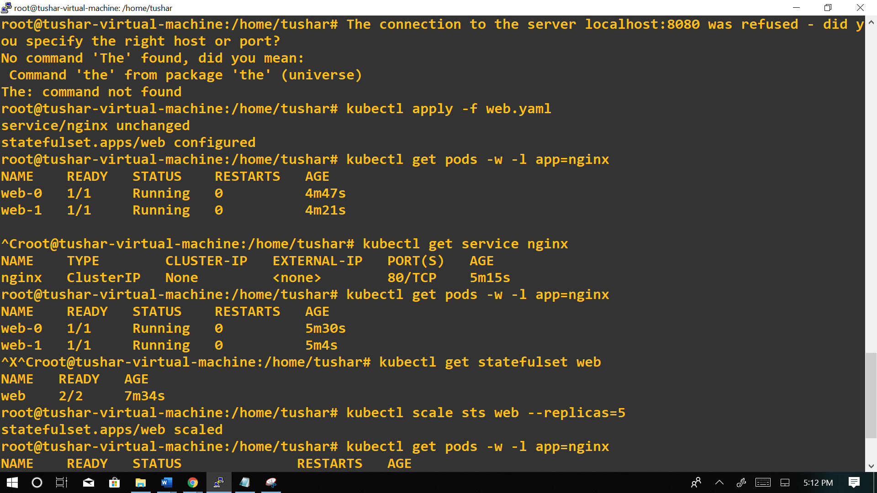

**Scaling up and scaling down**

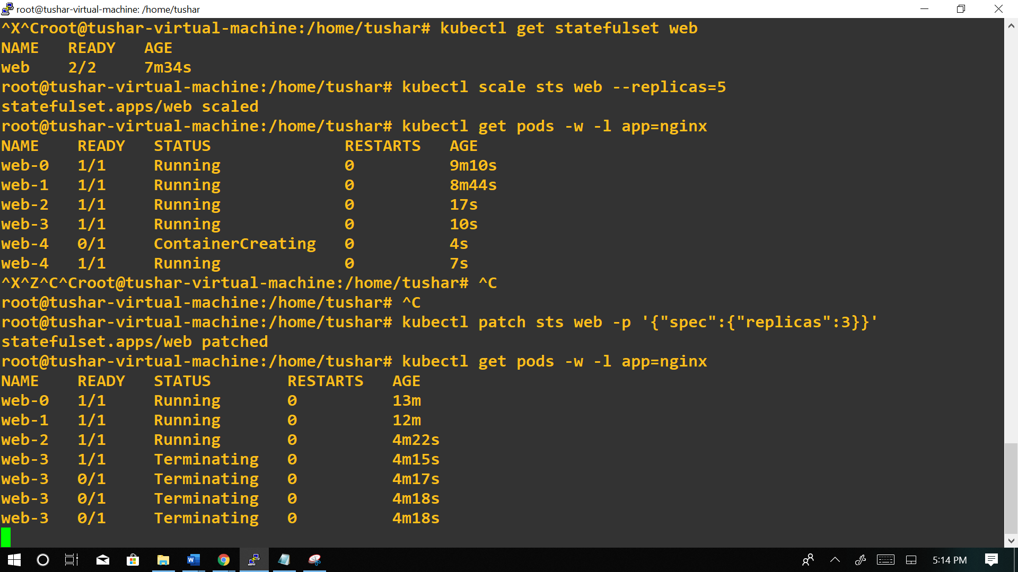

**Ordered pod termination7**

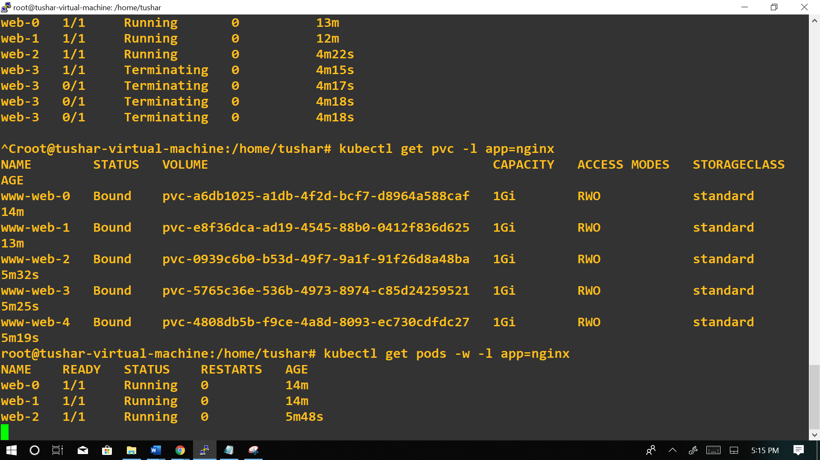

**Interactive tutorials with lab environment**

Go through all the modules

<https://kubernetes.io/docs/tutorials/kubernetes-basics/>

