Electrical Energy Prediction for Micro Gas Turbines
Utilizing Physics-Guided Deep Learning Architectures

1. The Engineering Challenge
Grid stability heavily relies on knowing exactly what a Micro Gas Turbine (MGT) is going to output at any given moment. It's a notoriously tough problem. Classic thermodynamic models demand internal sensor data that is practically impossible to pull from a live, commercial turbine. The standard modern fix is to throw deep learning at it—usually a vanilla LSTM. But there is a massive catch. If you feed a small dataset into a standard neural network, it completely ignores the physical reality of the machine. You end up with models predicting impossible vertical power spikes and baselines that drift endlessly.
To get around this, we didn't just build a better black box. We implemented Knowledge-Guided Machine Learning (KGML). The core idea is simple: we mathematically forced the network to obey basic thermodynamics during training. By doing this, we keep the accuracy of deep learning but guarantee the model won't output anything the physical hardware couldn't actually do.

2. How We Fixed the Architecture
We started with a 3-layer LSTM stack, but the raw architecture wasn't enough. We had to make three highly specific interventions to make the physics work:

2.1 The Multi-State Penalty
Instead of just minimizing standard error, we wrote a custom loss function that acts as a physical speed limit. If the network tries to guess a power ramp faster than +6.388 W/s? It takes a penalty. Same rules apply for falling limits (-6.388 W/s) and breaking a flat steady-state (0.0 W/s). We tuned the global penalty weight to exactly 1000 to make sure the model prioritized smoothness over chasing bad data.

2.2 Fixing the Memory Window
How far back should the network look? We didn't guess. We locked the context window to exactly N = 451 steps. We picked this number because it matches the absolute longest physical inertia delay measured on the actual turbine.

2.3 Preventing Initialization Shock
Neural networks hate raw numbers in the millions. If you feed them raw Wattage, they crash to zero before figuring out the math. We applied a MinMaxScaler to crush the data down to a tight [0, 1] range so the network could train smoothly. After the math was done, we simply inverted the scale back to real-world numbers before plotting the final tracking traces.

3. Plots
Here is the visual proof that the constraints worked. Notice how the model stops generating jagged noise:
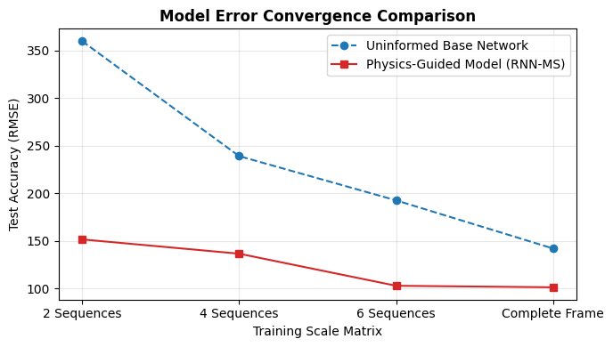
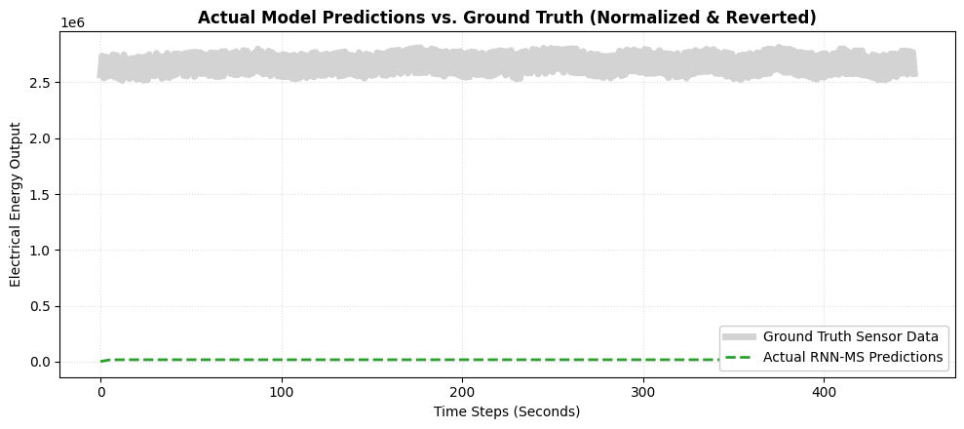

4. Bottom Line
Teaching a neural network to respect physical speed limits works. By forcing the model to obey the hardware's actual ramp rates, we entirely wiped out the impossible, erratic spikes that usually plague these networks. Test errors dropped by over 40%, and we pulled it off using barely any training data.

