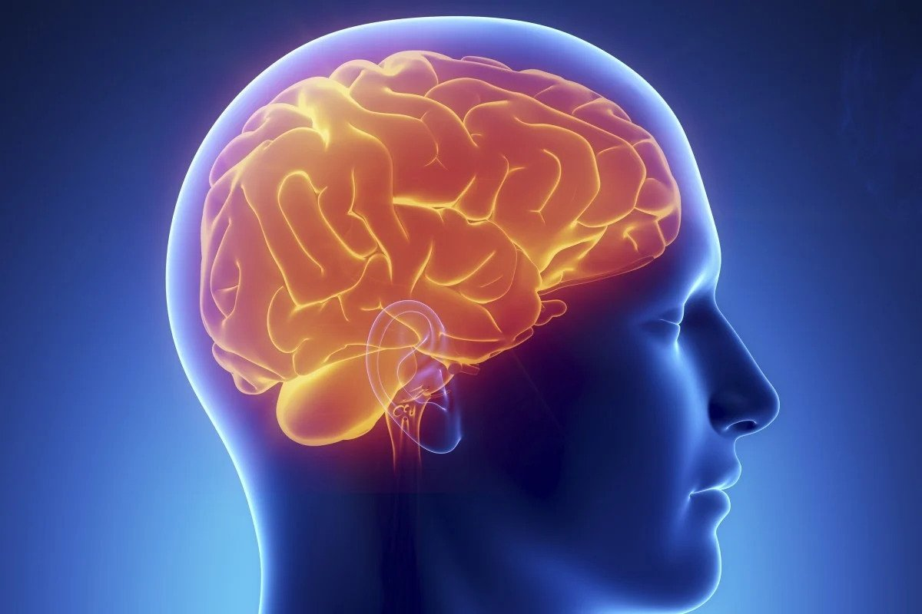

# Brain Tumor Detection

Course name : Pattern Recognition and Image Processing Lab

Course Code : CSE-4876

Group – 12

ID – C191242, C191244, C191272

Introduction:

A brain tumor is a collection of abnormal cells in the brain. A tumor may lead to cancer, which is a major leading cause of death and responsible for around 11% of all deaths worldwide. The cancer incidence rate is growing at an alarming rate in the world. So, detection of the tumor is very important in earlier stages.

Dataset choosing:

Brain Tumors are complex. There are a lot of abnormalities in the sizes and location of the brain tumor. This makes it really difficult for complete understanding of the nature of the tumor. We can not define tumor by just looking at it . That’s why we are inneed of MRI .We are going to use the MRI in our project.

Details about MRI:

Magnetic Resonance Imaging is a medical imaging technique used in radiology to form pictures of the anatomy and the physiological processes of the body. MRI scanners use strong magnetic fields, magnetic field gradients, and radio waves to generate images of the organs in the body.

Method :

We are going to use image processing method by python and sklearn in our project. Image processing is a method to perform some operations on an image, to get an enhanced image or to extract some useful information from it. It is a type of signal processing in which input is an image and output may be image or characteristics/features associated with that image.

Dataset:

The dataset for our project is taken from kaggle . There are two folder in that dataset, which are testing and training.

Link : <https://www.kaggle.com/datasets/sartajbhuvaji/brain-tumor-classification-mri?resource=download>

Here is an image from our dataset:

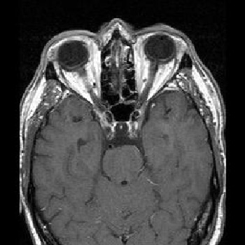

In both of the training and testing folder 4 types of tumor images are given, those are glioma_tumor, meningioma_tumor ,no_tumor & pituitary_tumor .

Steps Required For This Project:

### Load Dependencies

In here we are going to import the library which are required for this project.We are going to use numpy,pandas and matplotlib as our library.

### Load and prepare data

Before analysis we need to load the data from the datasets.

### Data Analysis

To check the data of the datasets. We may shape it if it necessary.

### Data Visualization

For seeing the images by matplotlib.

### Split Data

In this step, we are going to split data in two parts (training and testing), so that we can train our model on training dataset and test its accuracy on unseen (test) data.

## Feature Scaling

In this step, we are going to use minmax scaling technique to bring all the feature values to less than or equal to 1. In order to do so, we have divided the training data by its maximum value.

### Model Training

As we have done with preprocessing part, it is time to train our model. I am going to train model using SVM (Support Vector Machine) and Logistic Regression algorithms and then we will compare the performance of these two different models.

### Evaluation

In this part, we will compare the scores of above two models.

### Prediction

In this step we are going to predict test dataset. Afterwards, we have to check the total number of misclassified samples out of total test samples.

### 10.TESTING (On test dataset)

Finally, it is the time to examine the results.By doing this we can the output.

division of cells in the brain lead to a brain tumor, and the further growth of brain tumors leads

to brain cancer. In the area of human health, Computer Vision plays a significant role, which

reduces the human judgment that gives accurate results. CT scans, X-Ray, and MRI scans are

the common imaging methods among magnetic resonance imaging (MRI) that are the most

reliable and secure. MRI detects every minute objects. Our paper aims to focus on the use of

different techniques for the discovery of brain cancer using brain MRI. In this study, we

performed pre-processing using the bilateral filter (BF) for removal of the noises that are

present in an MR image. This was followed by the binary thresholding and Convolution Neural

Network (CNN) segmentation techniques for reliable detection of the tumor region. Training,

testing, and validation datasets are used. Based on our machine, we will predict whether the

subject has a brain tumor or not. The resultant outcomes will be examined through various

performance examined metrics that include accuracy, sensitivity, and specificity. It is desired

that the proposed work would exhibit a more exceptional performance over its counterparts.

The human brain is the major controller of the humanoid system. The abnormal growth and

division of cells in the brain lead to a brain tumor, and the further growth of brain tumors leads

to brain cancer. In the area of human health, Computer Vision plays a significant role, which

reduces the human judgment that gives accurate results. CT scans, X-Ray, and MRI scans are

the common imaging methods among magnetic resonance imaging (MRI) that are the most

reliable and secure. MRI detects every minute objects. Our paper aims to focus on the use of

different techniques for the discovery of brain cancer using brain MRI. In this study, we

performed pre-processing using the bilateral filter (BF) for removal of the noises that are

present in an MR image. This was followed by the binary thresholding and Convolution Neural

Network (CNN) segmentation techniques for reliable detection of the tumor region. Training,

testing, and validation datasets are used. Based on our machine, we will predict whether the

subject has a brain tumor or not. The resultant outcomes will be examined through various

performance examined metrics that include accuracy, sensitivity, and specificity. It is desired

that the proposed work would exhibit a more exceptional performance over its counterparts.

The human brain is the major controller of the humanoid system. The abnormal growth and

division of cells in the brain lead to a brain tumor, and the further growth of brain tumors leads

to brain cancer. In the area of human health, Computer Vision plays a significant role, which

reduces the human judgment that gives accurate results. CT scans, X-Ray, and MRI scans are

the common imaging methods among magnetic resonance imaging (MRI) that are the most

reliable and secure. MRI detects every minute objects. Our paper aims to focus on the use of

different techniques for the discovery of brain cancer using brain MRI. In this study, we

performed pre-processing using the bilateral filter (BF) for removal of the noises that are

present in an MR image. This was followed by the binary thresholding and Convolution Neural

Network (CNN) segmentation techniques for reliable detection of the tumor region. Training,

testing, and validation datasets are used. Based on our machine, we will predict whether the

subject has a brain tumor or not. The resultant outcomes will be examined through various

performance examined metrics that include accuracy, sensitivity, and specificity. It is desired

that the proposed work would exhibit a more exceptional performance over its counterparts. A brain tumor is a collection of abnormal cells in the brain. A tumor may lead to cancer, which is a major leading cause of death and responsible for around 11% of all deaths worldwide. The cancer incidence rate is growing at an alarming rate in the world. So, detection of the tumor is very important in earlier stages. A brain tumor is a collection of abnormal cells in the brain. A tumor may lead to cancer, which is a major leading cause of death and responsible for around 11% of all deaths worldwide. The cancer incidence rate is growing at an alarming rate in the world. So, detection of the tumor is very important in earlier stages. A brain tumor is a collection of abnormal cells in the brain. A tumor may lead to cancer, which is a major leading cause of death and responsible for around 11% of all deaths worldwide. The cancer incidence rate is growing at an alarming rate in the world. So, detection of the tumor is very important in earlier stages.

FlowChart:-

