Report on implementation

To use our Mesh functions, we have made the following interface for your convenience. This interface is being called by pressing h.

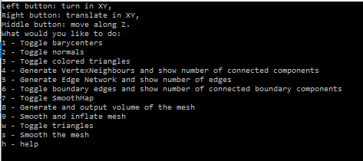

As can be seen, the smooth map is displayed, where green shows smooth areas and red shows rough areas.. Using number 9, the mesh is being smoothed and then inflated again, to compensate for volume loss through smoothing.

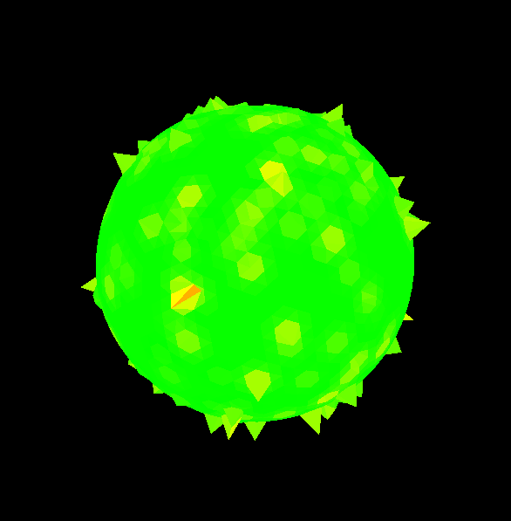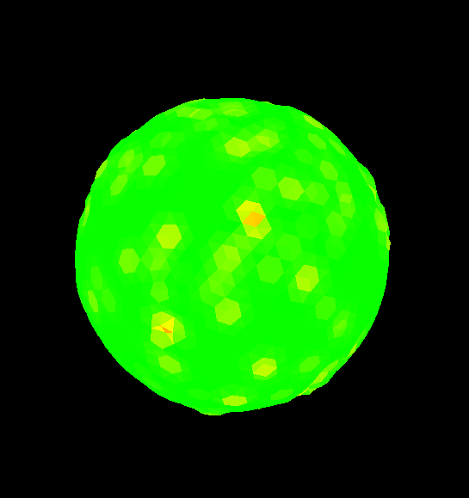

Different meshes can be loaded into the application. You have the option to draw the filled triangles or only the wireframe. Pressing number 2 shows the normal of each of all triangles with yellow lines, where number 3 draws the mesh accourding to the order in which the triangles are stored, in a rainbow colored palette. Much fabulous.

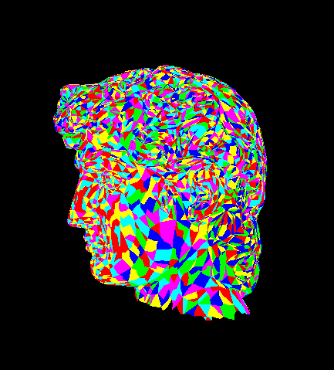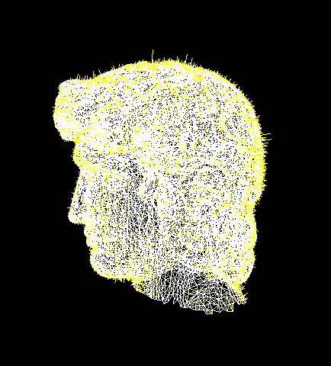

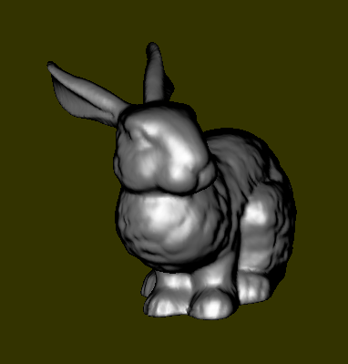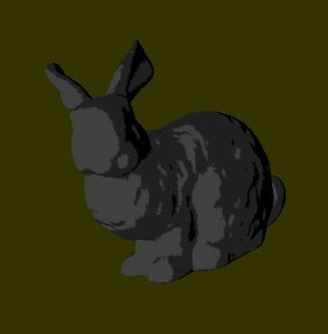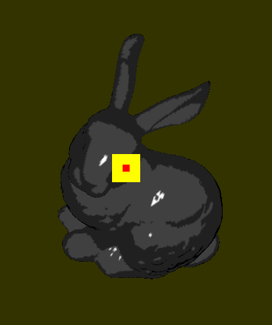

The first image shows Lambertian Shading combined with Blinn-Phong shading. The second image shows the toon shading on the bunny, which uses thresholds for the lighting levels. The third image shows the light source with the specularities it creates on the toon-shaded bunny. Will the real bunny shady please stand up?