**Lab 1 - Part 1: Worksheet**

*Please include your full name, group number, and student number at the top of the first page you submit. For this lab, you have to submit 2 scripts and one figure.*

1. For each of the 10 cases below, write a command line that would execute the task asked. **Each case can be executed with a single command**. For example, y=x.^2;z=3*y; are 2 commands while z=3*x.^2 is only one (they are equivalent). Create a script where you write your 10 command lines and submit it.
   1. Create a matrix A, with 5 columns and 100 rows, filled with random numbers between -1 and 2.
   2. Create a matrix B, same size as the matrix A, so that each element of B is equal to the corresponding element in A raised to the power 3.
   3. Create the vector x equal to the second column of A.
   4. Create the vector y equal to the second to last column of B.
   5. Create a mask m masking positive values in y.
   6. Substitute all negative values in y with a random number between 0 and 2.
   7. Plot y vs x using red circles as markers (no line between your points; you can use an additional command line to open a new figure).
   8. Do the same plot, but with blue crosses instead of red circles, and exclude points for which x is larger than 1 (you can use an additional command line to open a new figure).
   9. Create the vector C equal to the sum of the columns of B.
   10. Put the numbers in C into ascending order (there is a Matlab function for this).
   11. Plot the exponential of C as a function of C, using black dashed line (you can use an additional command line to open a new figure).
2. Download the file **wrongscript.m** from the course website. If you try to run it, you will get at least one bug. Keep modifying the script until it runs properly and produces the exact same figure as the one below. If you modify, add, or delete a line, add a comment above it to clarify what you did. You can add a comment in Matlab using “%your comment”; Matlab will ignore any line starting with a % symbol when you run a script. Submit your modified script.

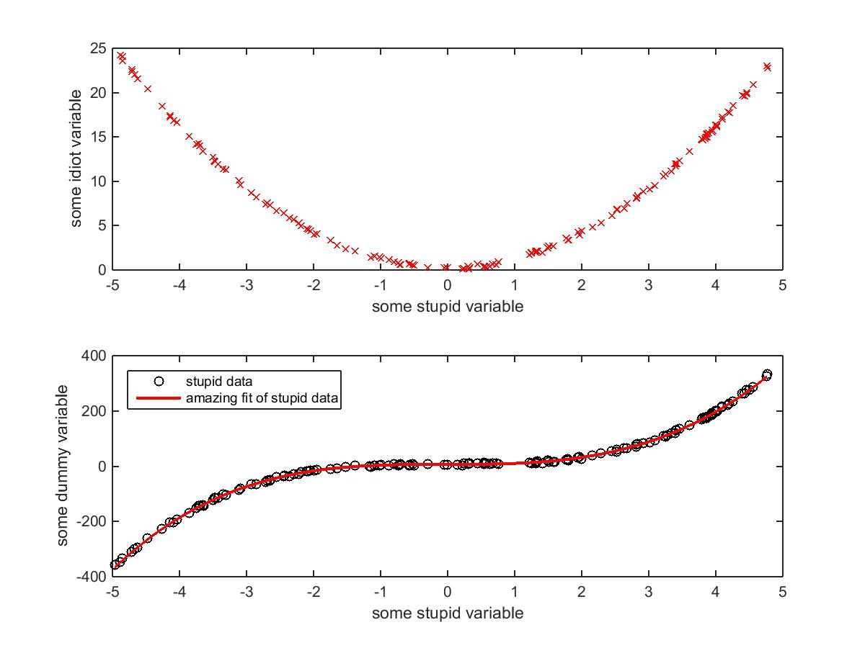

1. Download the file Lab1_data.mat from the course website. Be certain to place it in the correct directory when you save it. Now at the Command prompt enter

>> load Lab1_data.mat

This will load two new variables into your Workspace. These are

* 1. The row vector D which consists of increasing, but unevenly spaced, depths in metres, from 0 to 342 m. The length of D is 11,698 elements.
  2. The corresponding temperature vector T which has the measured temperatures in degrees Celsius at the depths given in D. The length of T is equal to that of D.

The temperature vector has some missing values. If a temperature measurement is missing or corrupted, the corresponding temperature field is filled with -9999 to indicate that no data is available. For example, a portion of D and T may look like this

D: [... 124.5 124.9 125.6 126.0 ...]

T: [... 8.734 8.964 -9999 9.210 ...]

Make a graph of T (x-axis) against -D (y-axis), but *plotting only depths greater than 250 m and excluding the missing data points*. You will have to use logical indexing to do this as you do not know where the missing values are located. Remember to initialize your figure as you see fit, and to label the two axes. Submit your graph.

**Hint**: If you create a mask using one variable, you can use that mask to index into *other*

variables as well, as long as both variables are the same size.

-------------------------------------------------------------------------------------------------------------------

Plotting the dependent variable (temperature) along the x-axis is common practice in oceanography if the independent variable is depth. This makes it easy to visualize a depth profile. This data is from Powell Lake on the upper Sunshine Coast of BC.