511 Project Proposal: Modelling Air-sea-ice feedbacks in DMS production in an Arctic environment

Tereza Jarníková, Student number: 81586142

The trace gas dimethylsulfide (DMS) is a biogenic sulphur gas produced by several species of phytoplankton in the open ocean. Once produced, this volatile gas is emitted into the atmosphere, where it is oxidized to form non-seasalt sulphate and methane-sulfonic acid. A seminal 1987 paper by Charleson et al proposed a feedback loop between the production of dimethylsulfide and regional climate. In this theory, called the CLAW hypothesis, the oxidation products of DMS in the atmosphere form cloud condensation nuclei (CCN), which act as precursors to clouds, which in turn increase planetary albedo, cooling the Earth. This temperature decrease will then have effects on primary productivity [1]. The implication of this scheme is that the biological activity of primary producers exerts a control on climate. Since the publication of the CLAW hypothesis, the idea of a phytoplankton-mediated biological climate control has provided the motivation for the study of the mechanisms of production of DMS, as well an investigation of the climactic effects of its oxidation products, in the international community.

For this exercise, I would like to create a seasonal (1-month resolution) model that uses DMS as a state variable to investigate feedbacks between DMS, cloud cover, and sea-ice cover in the Canadian Arctic. I am choosing to focus on the Canadian Arctic for two reasons: firstly, because the Arctic is the site of my recent field expedition, and I have unpublished DMS data that can be used to inform the state variable, and secondly, because the presence of sea-ice in the Arctic has been demonstrated to have important effects on the ecosystem and its DMS production by, for example, Levasseur et al’s 2013 measurements of extremely high DMS produced by under-ice diatoms [2].

Understanding the production of DMS and its effects is a complicated question. The drivers of DMS production are only partially understood, and, because of the significant challenges inherent in measuring DMS in the field, in-situ measurements of DMS remain relatively sparse in the world ocean. My model will necessarily be an oversimplification of the dynamics at play, and, in some cases, I may not have meaningful data to input into the parameters. In the following paragraphs, I would like to sketch out both the understood factors in the DMS-climate feedback cycle and the scheme for my proposed simplified model. I will also include potential data sources and the methodology I aim to use.

**Model overview and general approach**

A model of DMS-climate interaction can be schematically broken down into two parts: the biological mechanisms of DMS production (which occur under the sea surface), and the fate of DMS in the atmosphere. A comprehensive overview of both parts can be seen in Fig 1a, originally published in Stefels 2007 [3]. My proposed box model is shown in Fig 1b. I aim to construct the model using a set of interdependent ordinary differential equations that are also dependent on a limited suite of weather data. Here I will elaborate on the interdependencies of the factors in the model, as well as potential data sources (where known).

**Components of the model**

**1).DMS concentration.** From Stefels’ diagram, it can be seen that final seawater DMS concentration is the product of a complex web of biological activity that includes several other sulphur compounds that act as precursors of DMS, the presence or absence of bacterial activity, species present in the phytoplankton assemblage, and multiple other factors. In my highly simplified model, which aims to focus on DMS-atmosphere-ice feedbacks, DMS is solely dependent on primary productivity – the seawater sulphur cycle is not parametrized.

*Base data source:* Jarnikova 2015, unpublished data, averaged.

**2.) DMS flux.** DMS flux (the amount of DMS reaching the atmosphere) is dependent on DMS concentration and windspeed and is calculated as the following:

*F*DMS = kDMS (DMSSW) (1 − Α)0.4 [4]

Here, A is fractional sea-ice cover and k is gas transfer velocity, which is windspeed-dependent.

*Base data source:* Windspeed and sea-ice: NCEP/NCAR reanalysis products [5]

**3). CCN.** I am not yet sure how to parametrize the contribution of DMS flux to total CCN counts In the Arctic. For the time being, I’ve found both measurements of DMS-based aerosols and CCN in the Arctic, and I hope to use them as a basis for this process.

*Base data source:* Yum 2001 [6] Rempillo 2011 [7]

**4). Albedo.** I will use output from the CCN portion of the model to derive a cloud optical thickness that can be used to derive albedo. A relationship between CCN and cloud optical thickness is described in Andreae 2009 [8]. Base cloud cover could be obtained from the MODIS cloud product [9].

*Base data sources:* [8],[9],[paper by Dutch author that Phil told me about]

**5). Primary productivity.** In my model, primary productivity (PP) will be related to photosynthetically active radiation (PAR) and sea ice - and an increase in albedo will decrease available PAR, and an increase in sea-ice will reduce PAR to 0 in affected areas. Because my model is not assemblage-specific, I will use satellite chlorophyll concentrations from the NASA OBPG products as a proxy for PP, and obtain PAR from these products as well.

*Base data sources:* NASA OBPG products [10]

**6). Sea ice.** Sea ice is dependent on sea-surface temperature (above-zero temperature causes sea ice to melt), as well as albedo. In turn, sea ice affects primary productivity (no PP in ice covered areas), DMS flux to the atmosphere, and under-ice diatoms and under-ice DMS reservoirs.

*Base data source:* Ice cover and temperature: [5] Albedo: see above.

**7). Under-ice diatoms.** A 2013 paper by Levasseur et al showed that under-ice diatoms had extremely high DMS concentrations and could act as a reservoir of DMS that would be emitted to the atmosphere upon melt. In this parametrization, under-ice diatom concentration would be dependent solely on sea-ice proportion.

*Base data source:* Levasseur 2013 [2]

**8). Under-ice DMS.** The source of under-ice DMS is ice diatoms, which are dependent on ice proportion. (It may be simpler, though less accurate, for the model to conflate parts 7) and 8).) Under-ice DMS gets released to the atmosphere when ice melts – in the equations, a negative change in ice will correspond to a positive change in DMS flux from this source.

*Base data source:* Levasseur 2013 [2]

Though this proposed model greatly oversimplifies the links between phytoplankton, DMS, atmospheric processes, and ice, I hope to use it to investigate sensitivities in the relationships between these variables.

**References:**

[1]. Charlson, Robert J., et al. "Oceanic phytoplankton, atmospheric sulphur, cloud albedo and climate." *Nature* 326.6114 (1987): 655-661.

[2]. Levasseur, M. "Impact of Arctic meltdown on the microbial cycling of sulphur."*Nature Geoscience* 6.9 (2013): 691-700.

[3]. Stefels, Jacqueline, et al. "Environmental constraints on the production and removal of the climatically active gas dimethylsulphide (DMS) and implications for ecosystem modelling." *Phaeocystis, major link in the biogeochemical cycling of climate-relevant elements*. Springer Netherlands, 2007. 245-275.

[4]. Nightingale, Philip D., et al. "In situ evaluation of air-sea gas exchange parameterizations using novel conservative and volatile tracers." *Global Biogeochem. Cycles* 14.1 (2000): 373-387.

[5]. <http://www.esrl.noaa.gov/psd/data/gridded/tables/ocean.html>

[6]. Yum, Seong Soo, and James G. Hudson. "Vertical distributions of cloud condensation nuclei spectra over the springtime Arctic Ocean." *Journal of Geophysical Research: Atmospheres (1984–2012)* 106.D14 (2001): 15045-15052.

[7]. Rempillo, Ofelia, et al. "Dimethyl sulfide air‐sea fluxes and biogenic sulfur as a source of new aerosols in the Arctic fall." *Journal of Geophysical Research: Atmospheres (1984–2012)* 116.D17 (2011).

[8]. Andreae, Meinrat O. "Correlation between cloud condensation nuclei concentration and aerosol optical thickness in remote and polluted regions."*Atmospheric Chemistry and Physics* 9.2 (2009): 543-556.

[9]. <https://ladsweb.nascom.nasa.gov/data/search.html>

[10]. <http://oceancolor.gsfc.nasa.gov/cms/>

**Figures**

**Figure 1a Detailed DMS model (originally Stefels 2007)**

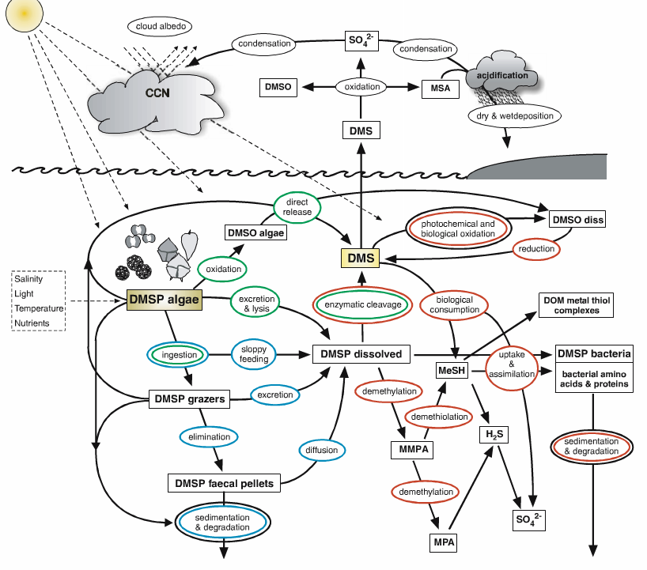

**Figure 1b - My proposed box model.**

