A simplified DMS Arctic Model: Investigating Air-Sea-Ice feedbacks

Tereza Jarníková

December 2, 2015

Abstract

1. Introduction

The trace gas dimethylsulfide (DMS) is a biogenic sulphur compound produced by several species of phytoplankton in the world ocean. Once formed, this volatile gas is emitted into the atmosphere, where it is oxidized to form non-seasalt sulphate and methane-sulfonic acid. A seminal 1987 paper by Charleson et al proposed a feedback loop between the production of dimethylsulfide and regional climate. In this theory, called the CLAW hypothesis, the oxidation products of DMS in the atmosphere form cloud condensation nuclei (CCN), which act as precursors to clouds, which in turn increase planetary albedo, cooling the Earth. This negative radiative forcing will then have effects on primary productivity, creating a feedback loop [1]. The implication of this scheme is that the biological activity of primary producers exerts a control on climate.

Since the publication of the CLAW hypothesis, the idea of a phytoplankton-mediated biological climate control has provided the motivation for the study of the mechanisms of production of DMS, as well an investigation of the climactic effects of its oxidation products, in the international community. [* magnitude of flux of DMS to atmosphere!] Though the strength of the climactic feedback of DMS is currently debated, it is important to have an understanding of the magnitude of potential DMS climate effects in light of a drastically changing climate.

In polar regions, DMS production is largely controlled by the presence of sea ice, which determines the area of open ocean available for phytoplankton growth and introduces an additional reservoir of DMS that is stored under the ice in quantities up to 100 times higher than those found in the open ocean [2]. The Arctic Ocean, which is currently experiencing rapid changes in sea ice cover and phytoplankton assemblage, is likely to consequently experience shifts in the production dynamics of DMS in the near future, with one modeling study suggesting an 80% increase in DMS flux over the course of the next century [3]. This gives reason for the study of DMS dynamics specifically in Arctic environments. Here, I explore these dynamics using a box model that runs over the course of one year. The model uses forcing from observed environmental data from the Arctic Ocean region.

2. The Model

A schematic of the box model is shown in Figure 1, with relationships considered in the model represented by black arrows. The strength of these relationships is seasonally dependent on environmental parameters such as temperature, available radiation, windspeed, and percent sea ice cover – thus, the parameters in the equations change with every timestep depending on time of year. In the following section, I describe the equations governing individual model components, as well as the environmental parameters.

2.1: Box 1 - Primary Productivity

Phytoplankton are primary producers – they fix aqueous carbon dioxide and produce organic carbon compounds, one of which is DMS. This model quantifies the effects of DMS production, and so requires an estimate of primary productivity. In this model, the equation estimating primary productivity is adapted from a Nutrient-Phytoplankton-Zooplankton box model used in a DMS modeling study by Gabric et al [3]. The original equation uses Lotka-Volterra predator-prey dynamics, wherein phytoplankton and zooplankton are coupled – phytoplankton growth is dependent on environmental parameters and nitrogen abundance, while zooplankton growth is dependent on the zooplankton grazing rate on phytoplankton. Phytoplankton death rate is dependent on zooplankton abundance. (We modeled this system in EOSC 511 in terms of rabbits and foxes). Because neither nitrogen or zooplankton are components of my model, I represented primary productivity as a function of environmentally-dependent growth rate and a fixed death rate χ as follows:

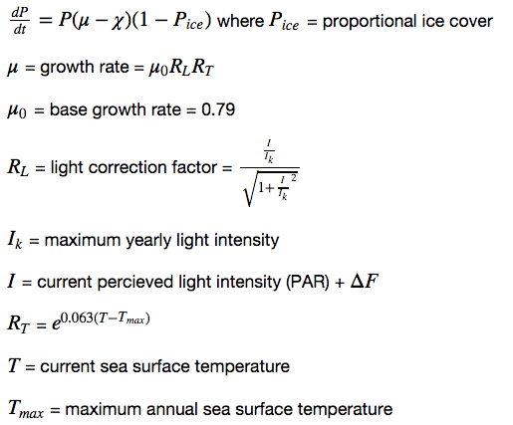

Here, a change in phytoplankton abundance at each timestep is dependent on the abundance of phytoplankton, as well as on 3 environmental parameters: the relative abundance of sea ice, the sea surface temperature, and the perceived light intensity (see section [*] for a description of the data sources of these parameters). The growth rate is dependent on temperature and light intensity, where light intensity is compared to maximum light seen over the course of the year. The radiative forcing feedback is represented in the change in perceived light intensity (whose baseline value is taken from satellite data) due to DMS-induced radiative forcing (see section [*]). Phytoplankton abundance is measured by chlorophyll density (units: [*]).

2.2: Box 2 - Sea DMS

Estimation of DMS from phytoplankton abundance is a non-trivial question, as DMS intracellular abundance can vary by 2 orders of magnitude between phytoplankton species. Furthermore, a large biological network of sulphur-consuming and producing processes, which is environmentally variable and remains poorly resolved, can change the concentration of seawater DMS. (For a discussion of this network, see Stefels et al [4]). However, interestingly, it has been shown that for certain assemblages, such as those not dominated by diatom blooms, an estimation of DMS from chlorophyll has predictive power [5]. For the purpose of this model, I therefore assume that DMS concentration increases linearly with phytoplankton abundance, using a linear parameter γ. I calibrated this parameter to yield DMS concentrations matching those observed on the 2015 GEOTRACES Arctic expedition in August [*]



2.3: Box 3 - DMS flux

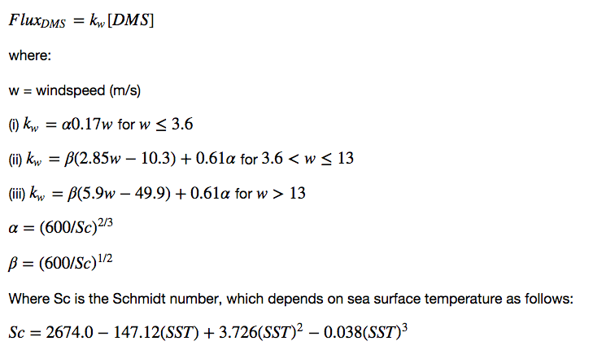Upon production, the rate of emission of DMS to the atmosphere (that is, DMS flux) to the atmosphere is dependent on the DMS transfer velocity *kw* , which was experimentally determined by Liss and Merlivat [6]. I use their equations here as follows:

We see that the DMS emission is nonlinearly dependent on 2 environmental variables: windspeed and Schmidt number. For the temperatures that Arctic model operates in (see section [*]) the Schmidt number decreases with temperature. However, the average Arctic windspeeds, the *kw*  is given by equation ii, and increases with windspeed. Because Arctic summers are characterized by comparatively higher temperatures and comparatively lower windspeeds, Schmidt number and the windspeed have opposite effects on the final *kw*.

2.4: Box 4 - CCN

The effect of DMS flux on cloud condensation nuclei is given by a sensitivity parameter from a global observational study by Woodhouse et al [6]. For the northern hemisphere, Woodhouse found a very low relative effect of DMS on CCN, with a .02-.09% change in CCN density for every 1% change in DMS flux. The sensitivity parameter varies seasonally from .02 in summer (June) to .09 in winter (December), and I interpolated it to vary seasonally. [*]

The equation for changes in CCN is as follows:

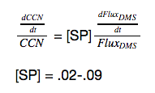

2.5: Box 5- Radiative forcing

The equation for radiative forcing is taken from Meskhizde et al [5], who used a statistical model to describe changes in CCN and their relative effect on radiative forcing above phytoplankton blooms in the Southern Ocean. This equation is an significant oversimplification in several senses. Firstly, it assumes that the cloud albedo *Rc* is constant and therefore that its effect on forcing is uniform. However, a change in cloud condensation nuclei changes the *Rc ,* which is not accounted for in this parametrization, and furthermore *Rc* also changes with sun zenith angle, cloud height, and liquid water content. Therefore, using a seasonally-dependent single ratio for cloud cover and a constant value for cloud albedo will not capture the complexity of realistic cloud radiative forcing dynamics. The second oversimplification lies in the parametrization of the DMS flux effect on CCN, where the scaling factor (1/3) is based on statistical observations of CNN above phytoplankton bloom in the Southern Ocean. The Southern Ocean has large blooms of exceptionally high-DMS producing phytoplankton, and it may not be reasonable to assume that this observed CCN-forcing effect would be similar in smaller blooms. The magnitude of forcing is also based on two environmental parameters: perceived light intensity and cloud cover (see section [*])

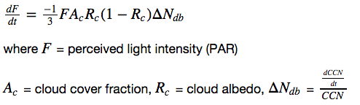

2.6: Box 6- Ice DMS

In terms of DMS dynamics, the Arctic environment is characterized by a unique phenomenon: large under-ice assemblages of high-DMS producing diatoms [2]. These diatoms can create reservoirs of DMS of concentrations several orders of magnitude higher than DMS found in the open ocean – while the average global DMS concentration is 3 nM, under-ice concentrations of 29nM-2000nM have been found in various regions of the Arctic Ocean sea-ice [2]. When this ice melts, this DMS can be emitted to the atmosphere as a rapid pulse of DMS flux. I parametrized this by assuming that the reservoir of under-ice DMS was uniformly 100nM, and that when some proportion of the ice melted, its DMS was released into the atmosphere. In the model, I then added this DMS contribution to the DMS produced at each timestep, and it was then factored into subsequent equations. The parametrization is as follows:

­­

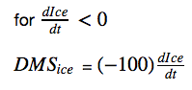

2.7: Environmental Parameters and Data Sources­­

The model equations given above are determined by given by several environmental parameters which vary seasonally. These are summarized below in Table 1, along with their data sources:­

|  |  |  |
| --- | --- | --- |
|  | **­­ Environmental Parameter** | **Data Source** |
| EP1 | Perceived Light Intensity (PAR) | OceanColor MERIS PAR Monthly Climatology |
| EP2 | Sea Surface Temperature | World Ocean Atlas Monthly Climatology |
| EP3 | Ice Cover | NCEP/NCAR reanalysis |
| EP4 | Wind Speed | NCEP/NCAR reanalysis |
| EP5 | Cloud Cover | [*] |
| EP6 | CCN sensitivity parameter | Woodhouse 2010 |

2.7.1: Data Processing

For EP3 and EP4, raw daily mean climatologies were downloaded as NetCDF files, and average values were found for the area north of the Arctic circle (latitude = 66.56 degrees). These were then binned into monthly averages and reinterpolated using the cubic numpy interp1d function to get values for each day of the model run. These values were then stored in a dictionary that retrieved them at the appropriate day at each timestep. For EP1 and EP2, the above was repeated with the difference that the raw values were already given as monthly means. EP2 data were taken from a .mat file, so monthly average values were input into python. The EP5 cloud cover parameter­ [*]. The EP6 CCN sensitivity parameter was interpolated from average summer and winter Northern Hemisphere values. For an overview of the interpolated environmental parameters that force the model, see Figure 2.

Numerics

Implementation

Results and Discussion

Conclusion and Future Work

References

[1]Charlson

[2] Levasseur under-ice dynamics

[3] Gabric

[4] Stefels

[5] Meskhisde

[6]