1. **Briefly describe the artifact. What is it? When was it created?**

The artifact that I will enhance is the Travlr Website from the CS465 full stack engineer class January 2025. The goal of the project was to create a website that utilizes the web and database to create a single page application for a traveling company. I was responsible for building the functionality of the front end and the backend of the application. Creating and configuring NoSQL database with data models and a schema for data files and storage. Wiring the database to the server, test the RESTful API, and refactor the code to work successfully with the front end.

1. **Justify the inclusion of the artifact in your ePortfolio. Why did you select this item? What specific components of the artifact showcase your skills and abilities in software development? How was the artifact improved?** I selected this artifact because I can display interface design and architectural design key features that make up software design. The overall system architecture of web applications is made up of three components: Client, database, server. The client component is broken down into four sections Web browser followed by the client session, then Traveler portfolio leading into the graphic library. This provides how the web application client is fed information through an authenticated server. Once the web app is accessed and the portfolio has populated the database component is working to view what’s in the database that reflects any changes made by MongoDB. All these components and subcomponents are possible from the server that authenticates information and sent the Client session. Previously I couldn’t show the user interface on the required device.
2. **Did you meet the course outcomes you planned to meet with this enhancement in Module One? Do you have any updates to your outcome-coverage plans?** Yes, I was able to have the code functionality work on the compatible device .

‘’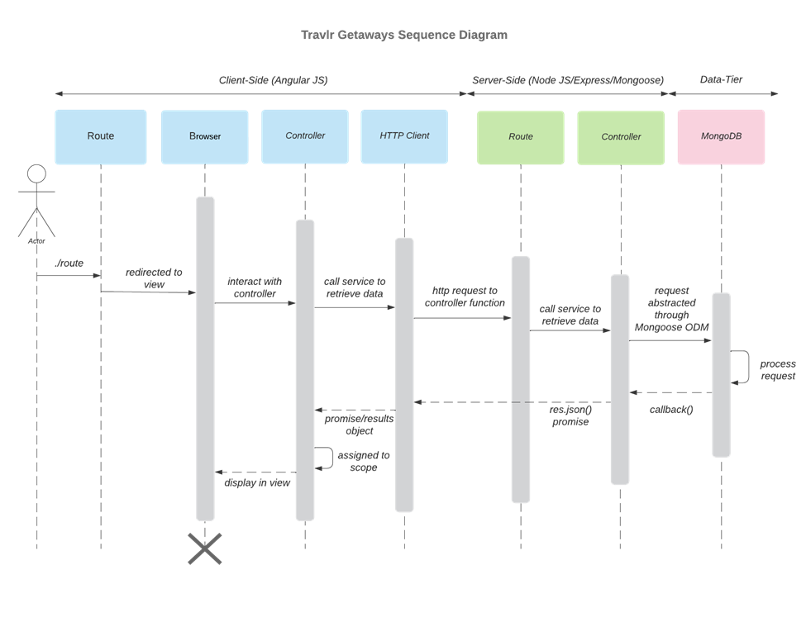

The process starts with the actor (user) who goes to the computer and gets on the browser to go to the website. Now the client side is displaying the information on the webpage. If the actor clicks on a button/tag the HTTP Client will toggle between the server and client. The HTTP client will send to the API a request for each page the actor clicks on. The request goes to the MongoDB Database where all data is stored and waits to display on the webpage .

1. **Reflect on the process of enhancing and modifying the artifact. What did you learn as you were creating it and improving it? What challenges did you face?** The sequence diagram helped me with how everything is supposed to connect and work between the http client routing to the controller to the DB.