Thomas Back

CS470: Intelligent Systems

Project 1: Fred Flintstone problem-solving
Part 1

January 30th, 2018

Dynamically Assigned Board Output:
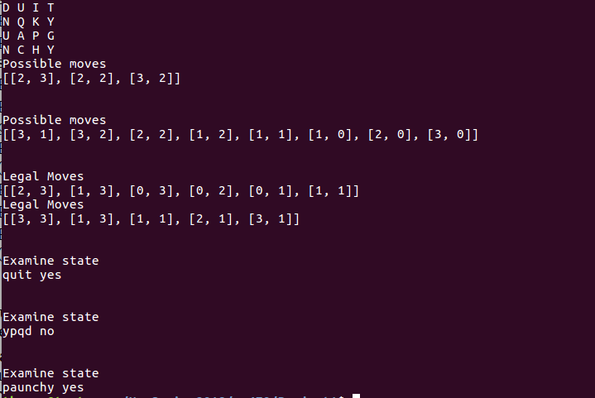

Fully Commented Code:
#### Boggle Solver Main ####
#### By Thomas Back ####
#### 1/24/2018 CS470 ####

import time

class boggleSolver:

def __init__(self):
self.board = []
self.n = 0

#loads NxN board into matrix
def loadBoard(self, boardFile):
#temp array
temp = []
count = 0

board = open(boardFile)
board = board.read()
board.strip(' ')

#for loop to loop through letters, disregards white space
for letter in range(len(board)):
#if reached new line, save that dimension within array
if board[letter] == '\n':
self.board.append(temp)
temp = []
if self.n == 0:
self.n = count
count = 0

#if blank space, skip
elif board[letter] == " ":
continue

#append the letter to the temp array to be inserted as row into the board array
else :
temp.append(board[letter])
count += 1

return self.board

def printBoard(self,board):

#placeholder for a row of letters to be printed at once
printLine = ""

#with a 2d array we will have nested for loops to print from row and col
for col in range(len(board)):

for row in range(len(board[col])):
printLine = printLine + board[col][row] + " "

print(printLine)
printLine = ""

def withinBoundsCheck(self, Position):
#Helper function that returns false if the positions are less than 0 or greater than or equal to the max, N

if Position[0] < 0 or Position[0] >= self.n:
return False

if Position[1] < 0 or Position[1] >= self.n:
return False

return True

def possibleMoves(self, currPos, board):
#generates all possible next positions, (x-y pairs in a list, set or whatver you decide)
#we could load currPos as a list of two elements, [0] always x, [1] always y
#first check if the currpos is within the bounds of the board
possMovesArr = []

if not self.withinBoundsCheck(currPos):
print("Error, current position is not within bounds\n")
return -1

#if within the bounds then move on
currPos[0] += 1
if self.withinBoundsCheck(currPos):
possMovesArr.append(currPos[:])

currPos[1] += 1
if self.withinBoundsCheck(currPos):
possMovesArr.append(currPos[:])

currPos[0] -= 1
if self.withinBoundsCheck(currPos):
possMovesArr.append(currPos[:])

currPos[0] -= 1
if self.withinBoundsCheck(currPos):
possMovesArr.append(currPos[:])

currPos[1] -= 1
if self.withinBoundsCheck(currPos):
possMovesArr.append(currPos[:])

currPos[1] -= 1
if self.withinBoundsCheck(currPos):
possMovesArr.append(currPos[:])

currPos[0] += 1
if self.withinBoundsCheck(currPos):
possMovesArr.append(currPos[:])

currPos[0] += 1
if self.withinBoundsCheck(currPos):
possMovesArr.append(currPos[:])

return possMovesArr

def legalMoves(self, possibleMoves, visited):

for i in possibleMoves:
if i in visited:
possibleMoves.remove(i)

return possibleMoves

def examineState(self, board, currPos, path, dictionary):
#adds the currpos to the path and forms the word that should be created with that path
dic = open(dictionary)
dic = dic.read()
dic = dic.lower()
word = ''

path.append(currPos)

for i in path:
word += board[i[0]][i[1]]

#now compute the word that should be formed
word = word.lower()
if word in dic:
return word + " yes"
else:
return word + " no"

def main():
solve = boggleSolver()
myboard = solve.loadBoard('fourboard3.txt')
solve.printBoard(myboard)

possibles = solve.possibleMoves([3,3], myboard)
print("Possible moves")
print(possibles)
print("\n")

possibles = solve.possibleMoves([2,1], myboard)
print("Possible moves")
print(possibles)
print("\n")

possibles = solve.possibleMoves([1,2], myboard)

print("Legal Moves")
print(solve.legalMoves(possibles, [[1,0], [2,0], [2,1], [2,2]]))

possibles = solve.possibleMoves([2,2], myboard)
print("Legal Moves")
print(solve.legalMoves(possibles, [[1,1], [1,2], [1,3], [2,3], [3,2]]))
print("\n")

print("Examine state")
print(solve.examineState(myboard, [0,3], [[1,1], [0,1], [0,2]], "twl06.txt"))
print("\n")

print("Examine state")
print(solve.examineState(myboard, [0,0], [[3,3], [2,2], [1,1]], "twl06.txt"))
print("\n")

print("Examine state")
print(solve.examineState(myboard, [3,3], [[2,2], [2,1], [2,0], [3,0], [3,1], [3,2]], "twl06.txt"))

if __name__ == "__main__":
main()

