Thomas Back

CS 470

Professor Doerry

2/2/2018

Project 1: Fred Flinstone Boggle-Solver

Analysis:
1.
A boggle board can be thought of a grid with an axis for each letter. Depending on the value of N, the board will always be an NxN value, giving the agent the knowledge to begin the search at each position of the board. The rules of boggle allow a path to be followed to any surrounding panel, including across and diagonal panels, the only restriction being that a previously visited panel can never be used as a possible option in the same search branch. With this in mind the agent computes possible paths, and sorts out the possible paths with valid path options by cross referencing the previous path. Once a collection of all next valid moves is created, the same set of steps can be followed recursively, branching out into searches based on the next panel that is selected. At each panel, that panel’s letter is added to a string to be passed through each recursion to be checked if it is a valid string within the dictionary, and if it is a complete word, before running each next iteration. If it is not a word, the search branch will be cut by returning out of that iteration. One global structure has a found word added to it from each search branch as the list of found words.
2.
a.
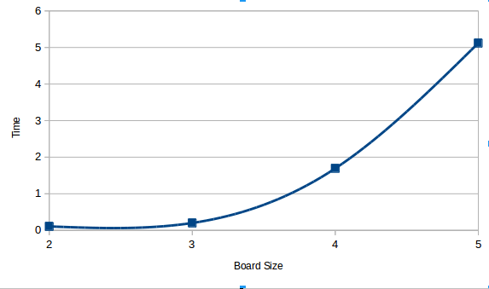
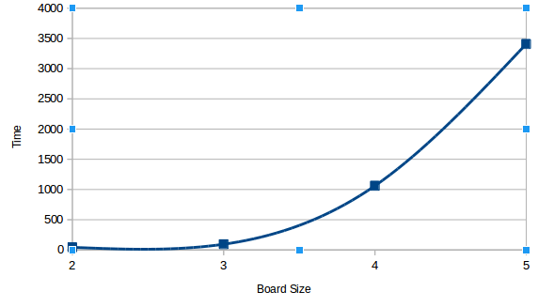
On the 2x2 board the solver was able to find 3 unique words; the 3x3 board found 0 words; the 4x4 board returned 71 words.

