Thomas Back

CS 470

Professor Doerry

2/20/2018

Project 2: Road Warrior Pt. 1

Output 1 -5
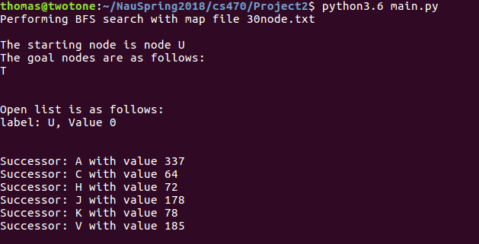
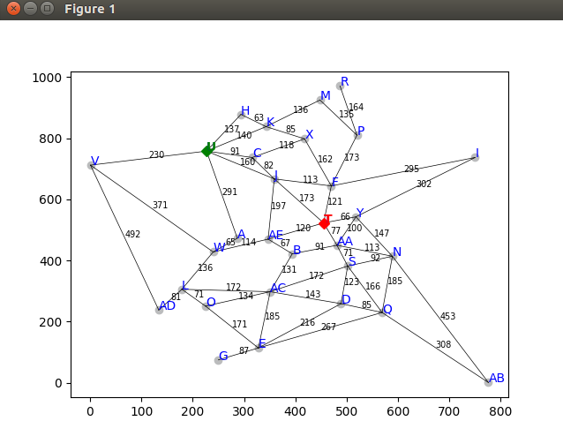
30 Node Map Visualized

Output 6-7 and 3-4
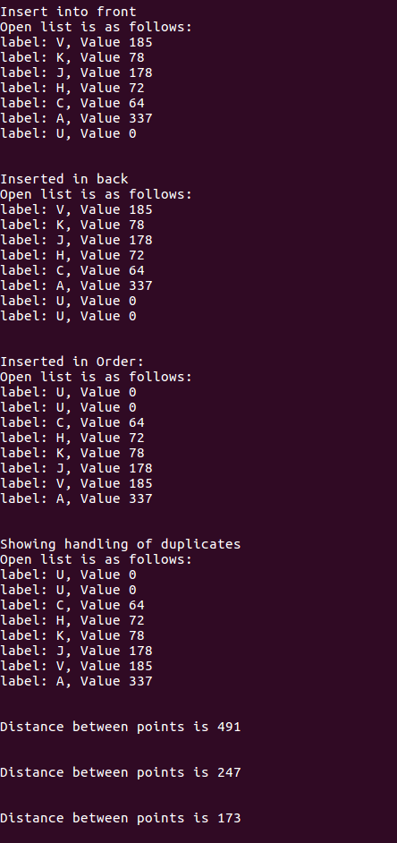

Code:
import numpy
from scipy.spatial import distance
import matplotlib
from graphviz import GraphViz

##thes search node class with two attributes, the label,
#and value as the path cost from start to this node

class SearchNode:

def __init__(self,label):
self.label = label

self.coordinates = ()

self.successors = []
#value is the path cost
self.value = 0

##class to load map
class Searcher:

def __init__(self, map):
self.map = map

#list to be able to find already entered nodes
self.searchNodesList = []

#define the open list
self.openList = []

self.successorArray = []

self.goalNodesArray = []

def loadMap(self):

#read in file line by line and begin inserting these into
#search nodes

#positions list to see if the name has already been entered
labelsList = []

with open(self.map, "r") as nodes:
for line in nodes:

tuple = eval(line)
if tuple[0] not in labelsList:

labelsList.append(tuple[0])

new = SearchNode(tuple[0])
self.searchNodesList.append(new)
new.coordinates = tuple[3]

if tuple[1] not in labelsList:

labelsList.append(tuple[1])

#create a search node for the successor if none exists
newSuccessor = SearchNode(tuple[1])
self.searchNodesList.append(newSuccessor)

#doubly link the two nodes, with the edge value in between
new.successors.append((newSuccessor, tuple[2]))
newSuccessor.successors.append((new, tuple[2]))

#now add the coordinates

newSuccessor.coordinates = tuple[4]

else:
#if we already have the 2nd value, find it and update its connections
for i in self.searchNodesList:
if i.label == tuple[1]:
i.successors.append((new, tuple[2]))
else:

for i in self.searchNodesList:
if i.label == tuple[0]:

#make cases for if the second label already exists
if tuple[1] not in labelsList:
labelsList.append(tuple[1])

#create new search node
newSuccessor = SearchNode(tuple[1])
self.searchNodesList.append(newSuccessor)
i.successors.append((newSuccessor, tuple[2]))

newSuccessor.successors.append((i, tuple[2]))
newSuccessor.coordinates = tuple[4]

else:
for j in self.searchNodesList:
if j.label == tuple[1]:
i.successors.append((j, tuple[2]))
j.successors.append((i, tuple[2]))

# for nodes in self.searchNodesList:
# print("%s is a node" % (nodes.label))
# print(" its coordinates are %d, %d " % (nodes.coordinates[0], nodes.coordinates[1]) )
# print("It has the sucessors ")
# for successors in nodes.successors:
# print(" %s with edge value %d" % (successors[0].label, successors[1]) )

def performSearch(self, searchType, startNodeString, goalNodes, expansion, verbose):

startNode = ""
#First state type of search and name of input file
print("Performing %s search with map file %s \n" % (searchType, self.map))

#Setting start nodes and goal nodes
for nodes in self.searchNodesList:
if startNodeString == nodes.label:
startNode = nodes

for goals in goalNodes:
if goals == nodes.label:
self.goalNodesArray.append(nodes)

print("The starting node is node %s " % (startNode.label) )
print("The goal nodes are as follows: ")
for goals in self.goalNodesArray:
print("%s" % (goals.label) )

print("\n")

##Grapher functionality
# grapher = GraphViz()
# grapher.loadGraphFromFile("30node.txt")
# grapher.plot()
# grapher.markStart(startNode.label)
# grapher.markGoal(goalNodesArray[0].label)
# cont = input("Continue")

#append the start node to the open list
self.openList.append(startNode)

#Print the open list for part one
self.showOpenList()

#generate successors of starting node
self.generateSuccessors(startNode)
print("\n")

#insert children of starting node at front
print("Insert into front")
self.insert("front")

#inser children of starting node at back
print("Inserted in back")
self.insert("back")

#insert children of starting node in order
print("Inserted in Order: ")
self.insert("order")

#Show handling of
print("Showing handling of duplicates")
self.successorArray = []
test1 = SearchNode("K")
test1.value = 500

test2 = SearchNode("C")
test2.value = 91

test3 = SearchNode("J")
test3.value = 10

self.successorArray.append(test1)
self.successorArray.append(test2)
self.successorArray.append(test3)
self.insert("order")

##hSLD testing
self.hSLD("V")

self.hSLD("AC")

self.hSLD("J")

if searchType == "BFS":
return

elif searchType == "DFS":
return

elif searchType == "BEST":
return

elif searchType == "A*":
return

else:
print("Error searchType is invalid \n")
return

#Straight Line Distance
def hSLD(self, node):

#calculate sldistance between two points
for i in self.searchNodesList:
if i.label == node:
pointA = i.coordinates
pointA =(pointA[0], pointA[1])

for i in self.goalNodesArray:
pointB = i.coordinates
goalPoint = (pointB[0],pointB[1])

dist = distance.euclidean(pointA, goalPoint)

print("Distance between points is %d" % (dist) )
print("\n")

#Hdir
def hDIR(self):
return

def showOpenList(self):

print("Open list is as follows: ")
for open in self.openList:

print("label: %s, Value %d" % (open.label, open.value) )
print("\n")

def generateSuccessors(self, currNode):

self.successorArray = []

for i in currNode.successors:
i[0].value += i[1]
self.successorArray.append(i[0])

self.successorArray.sort(key = lambda c: c.label)

for i in self.successorArray:
print("Successor: %s with value %d" % (i.label, i.value) )

# self.openList.remove(currNode)

# for i in successorArray:
# self.openList.append(i)

def insert(self,insertType):

for i in self.openList:
for j in self.successorArray:
if i.label == j.label:
self.successorArray.remove(j)

if insertType == "front":
for i in self.successorArray:
self.openList.insert(0, i)

elif insertType == "back":
self.openList.append(i)

elif insertType == "order":
#sort by value of cheapest node
for i in self.successorArray:
self.openList.append(i)

self.openList.sort(key = lambda c: c.value)

else:
print("Bad insert type")
return

self.showOpenList()

def main():
mainSearch = Searcher("30node.txt")
mainSearch.loadMap()
mainSearch.performSearch("BFS", "U", ["T"], 0, 0)

if __name__ == "__main__":
main()

