CMPEN 472
HOMEWORK 10: Analog Signal Acquisition with HCS12
Trishita Bhattacharya

440Hz Sign wave plots:
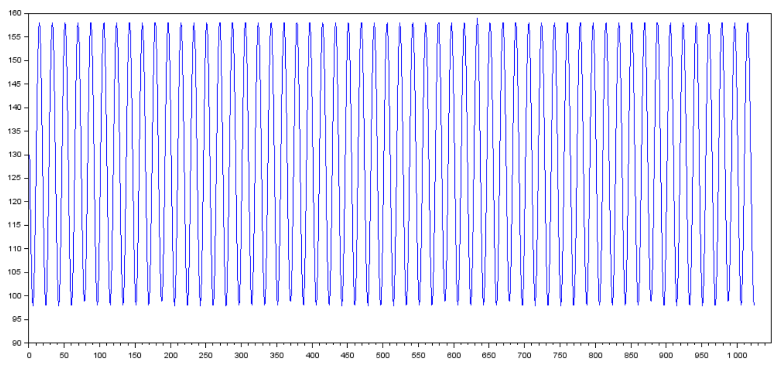
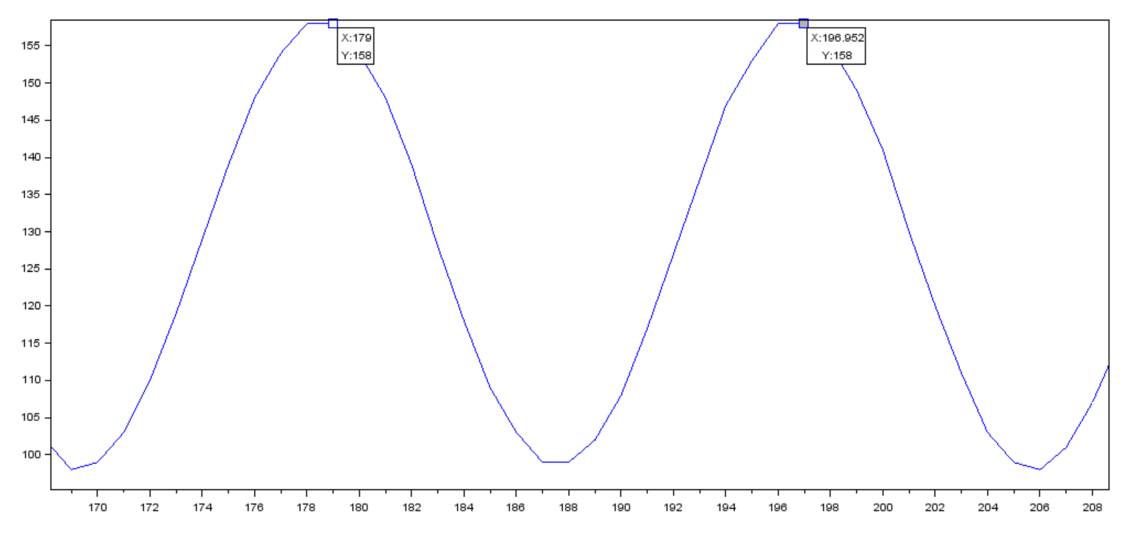
The two consecutive peaks of the sine wave signal are at 179 and 196.95. Since the signal is sampled at the rate 8KHz, the time period of the signal is (196.95 – 179)/ 8000 = 0.002244s. This corresponds to 445Hz which is ≈440Hz, the frequency of the signal generated from the tone generator.
1000Hz square wave plots:
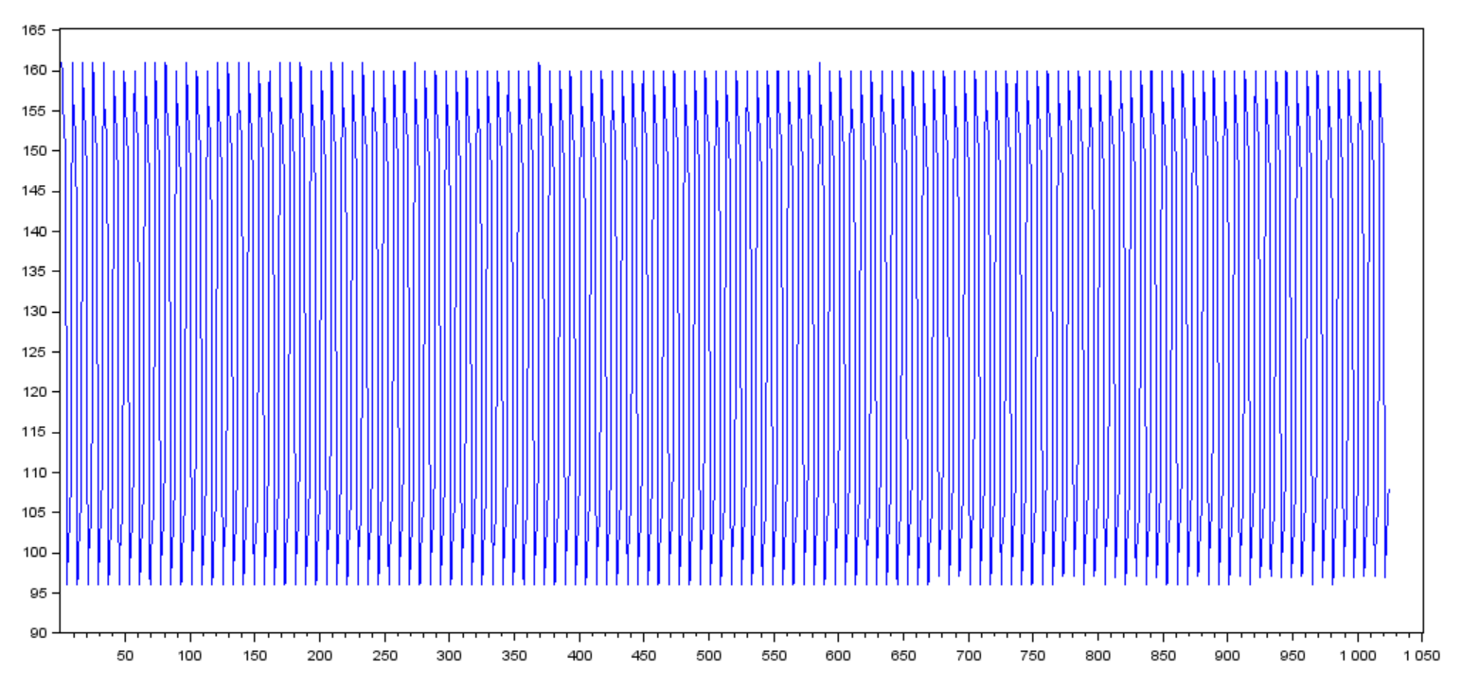

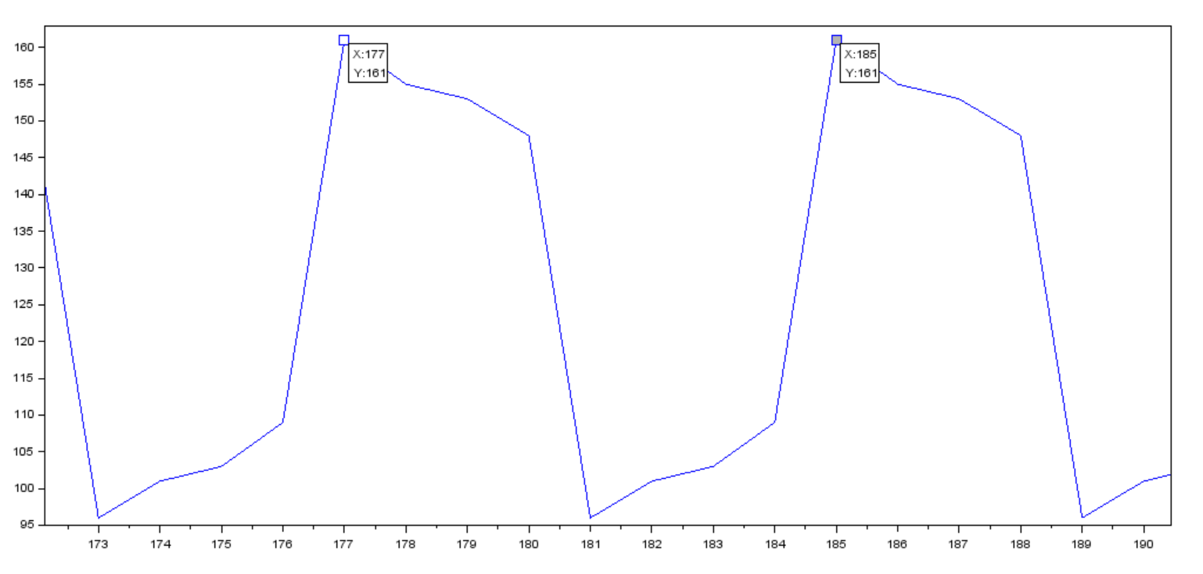
The two consecutive peaks of the square wave signal are at 177 and 185. Since the signal is sampled at the rate 8KHz, the time period of the signal is (185 – 177)/ 8000 = 0.001s. This corresponds to 1000Hz which is the frequency of the signal generated from the tone generator. The resulting graph doesn’t have proper square waves probably due to some effect from the capacitance of the audio jack.

440Hz triangle wave plots:
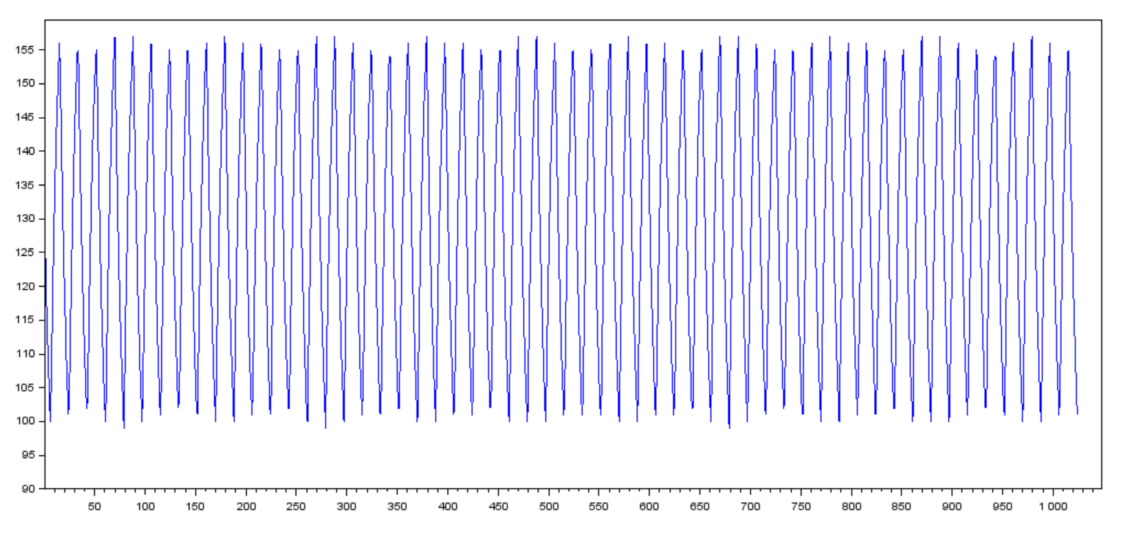

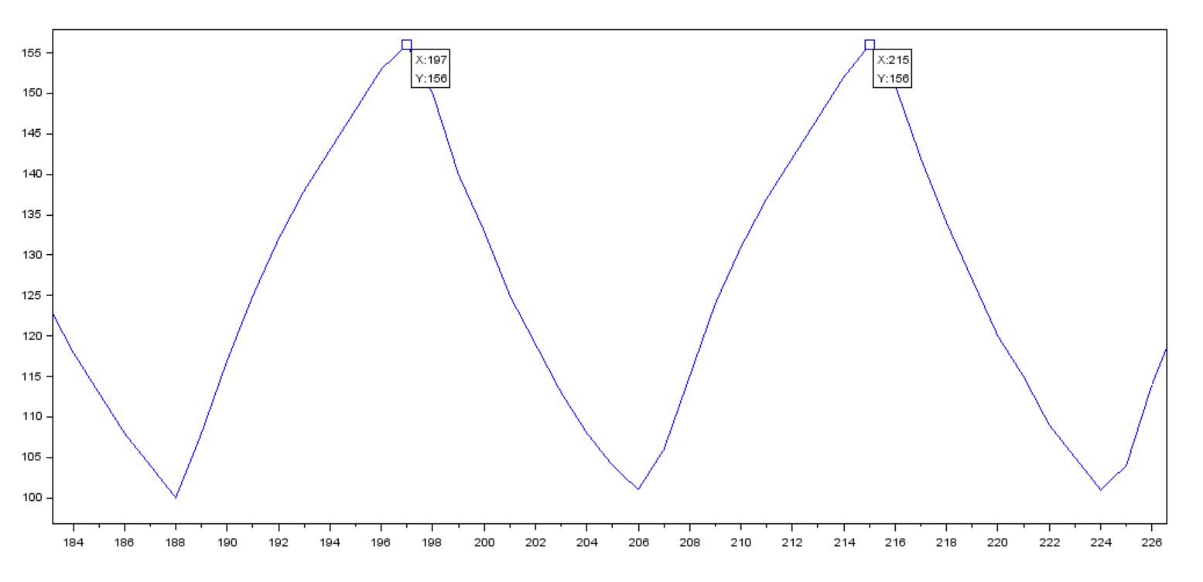
The two consecutive peaks of the sine wave signal are at 197 and 215. Since the signal is sampled at the rate 8KHz, the time period of the signal is (215 – 197)/ 8000 = 0.00225. This corresponds to 444Hz which is ≈440Hz of the signal generated from the tone generator. The resulting graph doesn’t have proper triangular waves probably due to some effect from the capacitance of the audio jack.

Mixed 440Hz and 550Hz sign wave plots:
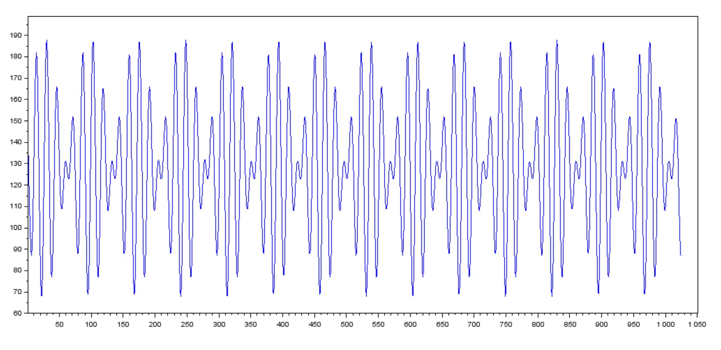

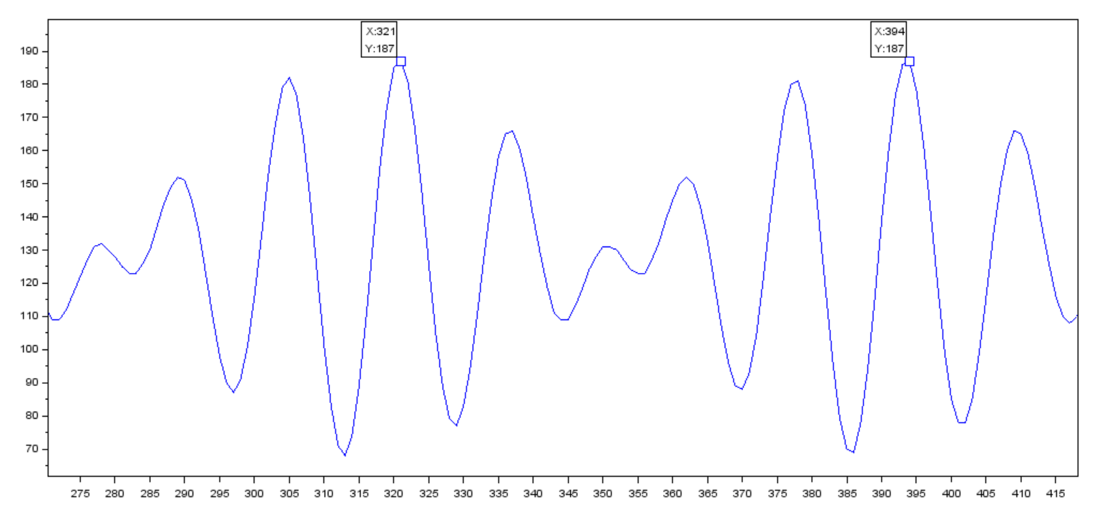
The two consecutive peaks of the sine wave signal are at 197 and 215. Since both the 440Hz and 550Hz sine signal is sampled at the rate 8KHz, the time period of the resultant signal is (394 – 321)/ 8000 = 0.009125s.
FFT of mixed 440Hz and 550Hz signal wave:
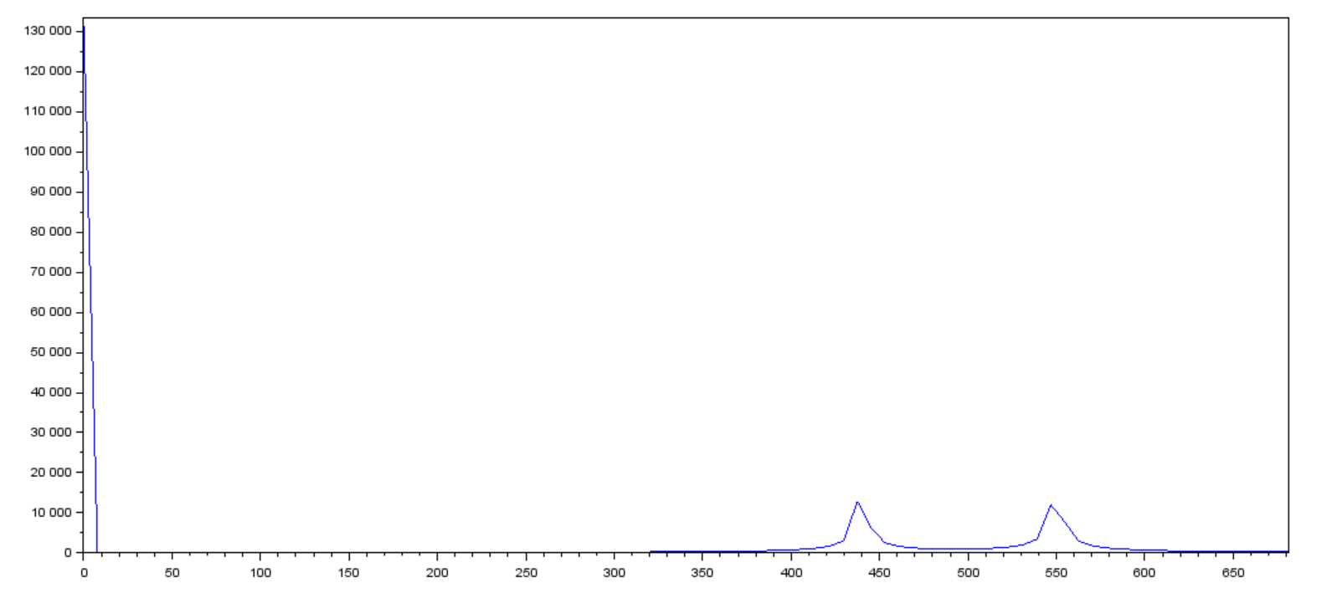
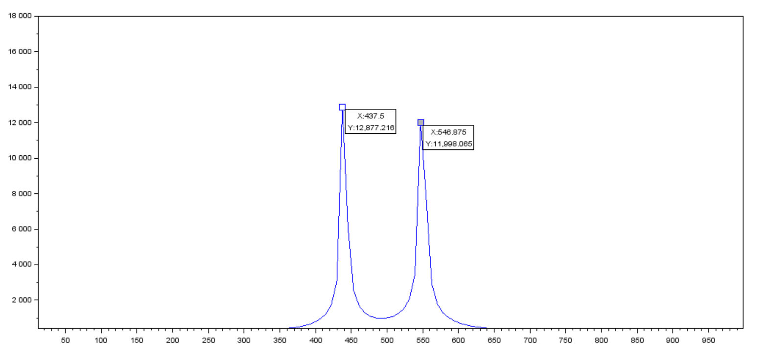

The fft of the mixed 440Hz and 550Hz signal shows peaks at 437.5 ≈ 440Hz, 546.875 ≈ 550Hz and 0 Hz. While the peaks at 440 and 550Hz shows that the signal contains those two frequencies, the peak at 0Hz shows the signal contains a 0Hz frequency too, a result of shift in signal vs voltage graph since it operates at 5V.
Code used to produce fft graph:
cd 'C:\Users\trish\Downloads\SBDRx3\SBDRx3'
y = read('RxData3.txt',1,1024);
F = fft(y);
f = 8000*(0:512)/1024;
n = size(f,'*');
plot(f,abs(F(1:n)));

