1. Installing the Allen Institute Brain Modeling Toolkit (BMTK)

# Installation/Setup

1. You must have Anaconda3 and Neuron installed correctly for BMTK to work. Details at the end of this document.
2. You must also install a git client to get the latest BMTK code. Download and install Git for Windows at (<https://git-scm.com/download/win>) and install with all the default settings.
3. From the ‘Git Bash’ prompt installed earlier execute the following commands:

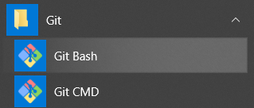

cd C:/Users/<your_username>/Desktop

mkdir temp_bmtk_install

cd temp_btmk_install

git clone <https://github.com/AllenInstitute/bmtk>

Now close the Git Bash Window

1. Next, run **setup** and **install** from the **Anaconda Prompt** (We will also ensure that **old versions of BMTK are removed too**)

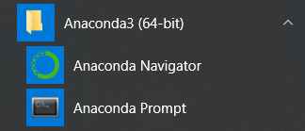

cd C:\Users\<your_username>\Desktop\temp_bmtk_install\bmtk

pip uninstall bmtk

python setup.py install

You can now safely delete the temp_bmtk_install directory using the command

cd ../..

rd /s /q C:\Users\<your_username>\Desktop\temp_bmtk_install

1. Now that BTMK is installed, visit the directory you want to **build** your model in and run BMTK’s directory setup. The network directory is where the node/edge configuration files will sit. For example, the following will change directory to your desktop, create a project directory (bmtk_model), create a network directory for btmk to use, and initialize the directory for your further customization. **This step will only be run once!**

cd C:\Users\<your_username>\Desktop

mkdir my_bmtk_model

cd my_bmtk_model

mkdir network

python -m bmtk.utils.sim_setup -n ./network bionet

This will create the bmtk directory structure at the present location “$BASE.dir”, and create the following files and nested directories:

Nested directories: biophys_coponents, network, output

Json files: circuit_config.json, simulation_config.json

1. In Windows you may be met with compilation errors like the following:

C:\Users\Tyler\Desktop\my_bmtk_model\biophys_components\mechanisms

Was unable to compile mechanism in $COMPONENTS_DIR/mechanisms

This is normal. You will need to compile your mod files any time they change. Run mknrndll in the (\biophys_components\mechanisms\modfiles\) directory then copy the resulting dll file to the parent directory (\biophys_components\mechanisms\)

__________________________________

SOME GENERAL INFORMATION

* Main reference for BMTK and BioNet: Gratiy et al. (2018) *BioNet*: A Python interface to NEURON for modeling large-scale networks. PLoS ONE 13(8): e0201630.
* BMTK is a python-based API to interface with NEURON, NEST,……
* API (Application Programming Interface) is a protocol intended to be used as an interface by software components to communicate with each other. It is basically a set of programming instructions and standards for accessing web-based applications or web tools.
* JSON (Java Script Object Notation) is a lightweight data-interchange format. It is easy for humans to read and write. It is easy for machines to parse and generate. It is based on the Java programming language, Standard ECMA-262 3rd edition, Dec 1999
* See document “99-Additional_BMTK_info” for additional information

# Anaconda/Neuron Installation

1. Download and install Anaconda3 (<https://www.anaconda.com/download/#download>)
2. Download and install Neuron (<https://www.neuron.yale.edu/neuron/download>)
3. Ensure your environment variables are set
   1. Type ‘control in the windows search bar and click control panel
   2. Click system and security
   3. Click system

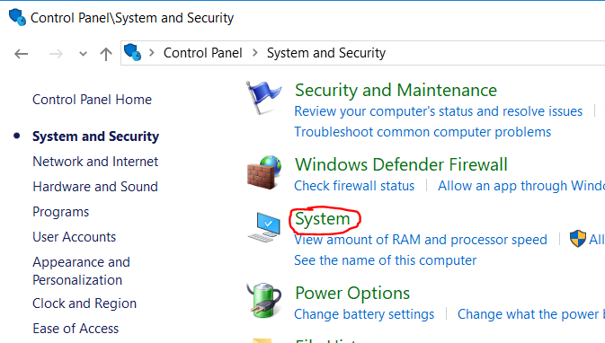

* 1. Click ‘advanced system settings’

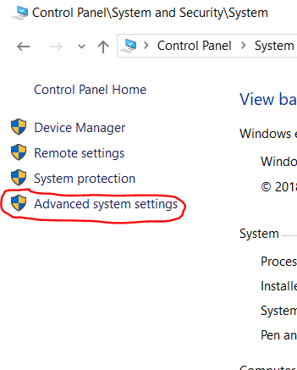

* 1. Click ‘Environment Variables’
  2. Ensure that ‘NEURONHOME’ and ‘PYTHONPATH’ exist and point to the correct install locations

