11- Advanced BMTK

Contents

Instructions 1

Custom Synapses 1

Custom Cell Positions 5

Dynamic Synapse Properties 5

Dynamic Node Properties 6

Recurrent Synapses 7

Rule Based Synapses 8

# Instructions

This document assumes you have completed the necessary steps in **02-Single_Cell_Hoc_BMTK** or **03-Networked_Hoc_BMTK**

# Custom Synapses

Included with the mod files from our HCO network from 03-Networked_Hoc_BMTK is a custom inhsyn.mod file. We can direct BMTK to use this file by taking the following steps

1. Copy the entire my_bmtk_model folder to a new folder called my_bmtk_model_syn.
2. In this new folder, create a new file named synapses.py and add the following code to this file:

|  |  |
| --- | --- |
|  | **synapses.py** |
| 1  2  3  4  5  6  7  8  9  10  11  12  13  14  15  16  17  18  19  20  21  22  23  24  25  26  27  28  29  30  31  32  33  34  34  35 | from bmtk.simulator.bionet.pyfunction_cache import add_synapse_model  from neuron import h  def InhSyn(syn_params, sec_x, sec_id):  """Create a inhsyn synapse  :param syn_params: parameters of a synapse  :param sec_x: normalized distance along the section  :param sec_id: target section  :return: NEURON synapse object  """  lsyn = h.inhsyn(sec_x, sec=sec_id)  if syn_params.get('esyn'):  lsyn.esyn = float(syn_params['esyn'])  if syn_params.get('gmax'):  lsyn.gmax = float(syn_params['gmax'])    return lsyn  def inhsyn(syn_params, xs, secs):  """Create a list of inhsyn synapses  :param syn_params: parameters of a synapse  :param xs: list of normalized distances along the section  :param secs: target sections  :return: list of NEURON synpase objects  """  syns = []  for x, sec in zip(xs, secs):  syn = InhSyn(syn_params, x, sec)  syns.append(syn)  return syns  def load():  add_synapse_model(InhSyn, 'inhsyn', overwrite=False)  add_synapse_model(InhSyn, overwrite=False)  return |

1. Things to note:
   1. (To use this in your model simply change everywhere InhSyn and inhsyn is defined to your synapse name, with variable name changes to line 14+)
   2. Line 1: add_synapse_model function is called to add custom synapses to BMTK’s python function cache, allowing BMTK to “see” and use your synapse file
   3. Line 4: syn_params will be a dictionary containing parameters defined in the json file referenced when creating edges (shown later)
   4. Line 12: h.inhsyn will instantiate the inhsyn neuron hobject
   5. Line 14-17: Set properties of the synapse by:
      1. Checking to see if the parameter has been defined
      2. Setting the synapse value to the supplied syn_params value
   6. Line 19: Create an additional function for BMTK to handle lists of synapses, we simply link it to our previous InhSyn function to prevent code duplication
   7. Line 34: Call load() in your build_network.py and run_bionet.py scripts early on to notify BMTK that you have custom synapses. (also shown later)
2. Create a new file called my_inhsyn.json in ./biophys_components/synaptic_models/ and place the following into it (Note how esyn and gmax appear in this file and the synapse function we defined previously)

|  |  |
| --- | --- |
|  | **my_inhsyn.json** |
| 1  2  3  4  5 | {  "esyn":"-80",  "gmax":"40e-3"  } |

1. In build_network1.py, we can now import this synapse file, call the load function, and use the synapse when defining our edges. See the complete file below with explanations.

|  |  |
| --- | --- |
|  | **build_network1.py** |
| 1  2  3  4  5  6  7  8  9  10  11  12  13  14  15  16  17  18  19  20  21  22  23  24  25  26  27  28  29  30  31  32  33  34  34  35  36  37  38  39  40  41  42  43  44  45  46  47 | from bmtk.builder.networks import NetworkBuilder  import synapses  synapses.load()  net1 = NetworkBuilder('hco_net')  net1.add_nodes(N=1,  cell_name='HCOCell1',  model_type='biophysical',  model_template='hoc:HCOcell',  morphology='blank.swc'  )    net1.add_nodes(N=1,  cell_name='HCOCell2',  model_type='biophysical',  model_template='hoc:HCOcell',  morphology='blank.swc'  )      net1.add_edges(source={'cell_name': 'HCOCell1'}, target={'cell_name':'HCOCell2'},  connection_rule=1,  syn_weight=40.0e-02,  dynamics_params='my_inhsyn.json',  model_template='inhsyn',  delay=0.0,  target_sections=["soma"],  distance_range=[0,999])    net1.add_edges(source={'cell_name': 'HCOCell2'}, target={'cell_name':'HCOCell1'},  connection_rule=1,  syn_weight=40.0e-02,  dynamics_params='my_inhsyn.json',  model_template='inhsyn',  delay=0.0,  target_sections=["soma"],  distance_range=[0,999])  net1.build()  net1.save_nodes(output_dir='network')    net1.build()  net1.save_edges(output_dir='network') |

1. Things to note:
   1. Lines 2 and 4: import the synapses file we just created and load the synapses by calling the load function.
   2. Lines 27,28, 36,37: reference the synapse name and dynamics_params file json created earlier
2. Run `python build_network1.py` to build the network.
3. Add the synapse load function to the top of run_bionet.py like the following:

|  |  |
| --- | --- |
|  | **run_bionet.py (snippet)** |
| 1  2  3  4  5  6  7  8  9 | import os, sys  from bmtk.simulator import bionet  from bmtk.simulator.bionet.default_setters.cell_models import loadHOC  import synapses  synapses.load()  bionet.pyfunction_cache.add_cell_model(loadHOC, directive='hoc', model_type='biophysical') |

1. You are now ready to run your network, run `python run_bionet.py simulation_config1.json` then `python plot_test.py`. You should notice small changes in the dynamics of the synapse output from previous tests.

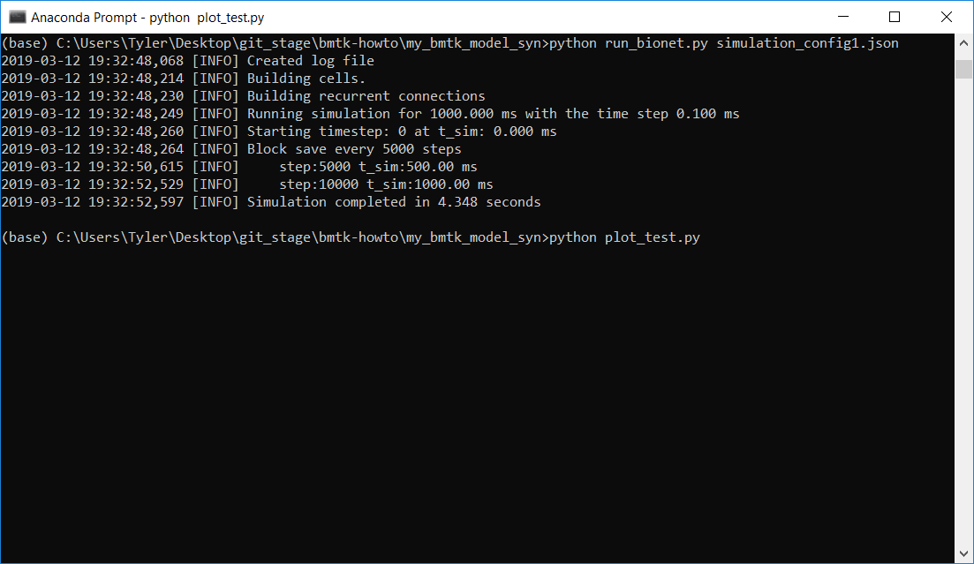

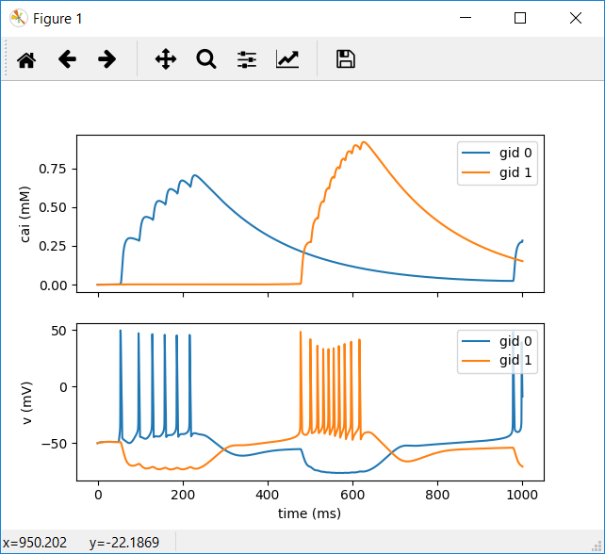

# Custom Cell Positions

**Columnar cell positioning** and cell **rotation** with **randomized rotations**:

<https://github.com/AllenInstitute/bmtk/blob/develop/docs/tutorial/03_single_pop.ipynb>

# Dynamic Synapse Properties

Edge properties like delay can be changed dynamically, per connection, rather than a blanket set value.

See the following for a great example use case:

<https://github.com/AllenInstitute/bmtk/blob/develop/docs/examples/bio_450cells_exact/build_network.py>

|  |  |
| --- | --- |
|  | **snippet.py** |
| 1  2  3  4  5  6  7  8  9  10  11  12  13  14  15  16  17  18  19  20  21  22  23  24  25  26  27  28  29  30  31  32  33  34  34  35  36  37  38  39  40  41  42  43  44  45  46  47 | def build_edges(src, trg, sections=['basal', 'apical'], dist_range=[50.0, 150.0]):  """Function used to randomly assign a synaptic location based on the section (soma, basal, apical) and an  arc-length dist_range from the soma. This function should be passed into the network and called during the build  process.  :param src: source cell (dict)  :param trg: target cell (dict)  :param sections: list of target cell sections to synapse onto  :param dist_range: range (distance from soma center) to place  :return:  """  # Get morphology and soma center for the target cell  swc_reader = morphologies[trg['model_name']]  target_coords = [trg['x'], trg['y'], trg['z']]  sec_ids, sec_xs = swc_reader.choose_sections(sections, dist_range) # randomly choose sec_ids  coords = swc_reader.get_coord(sec_ids, sec_xs, soma_center=target_coords) # get coords of sec_ids  dist = swc_reader.get_dist(sec_ids)  swctype = swc_reader.get_type(sec_ids)  return sec_ids, sec_xs, coords[0][0], coords[0][1], coords[0][2], dist[0], swctype[0]  …  cm = internal.add_edges(source={'ei': 'e'}, target={'ei': 'e', 'model_type': 'biophysical'},  connection_rule=n_connections,  connection_params={'prob': 0.2},  dynamics_params='AMPA_ExcToExc.json',  model_template='Exp2Syn',  delay=2.0)  cm.add_properties('syn_weight', rule=6.0e-05, dtypes=np.float)  cm.add_properties(['sec_id', 'sec_x', 'pos_x', 'pos_y', 'pos_z', 'dist', 'type'],  rule=build_edges,  rule_params={'sections': ['basal', 'apical'], 'dist_range': [30.0, 150.0]},  dtypes=[np.int32, np.float, np.float, np.float, np.float, np.float, np.uint8]) |

# Dynamic Node Properties

See

<https://github.com/AllenInstitute/bmtk/blob/develop/bmtk/simulator/bionet/default_setters/cell_models.py#L43>

When creating your node anything in the dynamics_params[“params”] section will be passed to the hoc cell.

net.add_nodes(N=1, ….

dynamics_params={‘params’:[0.332,3.88]}

…

}

Simply use these in your hoc init as $1, $2, etc…

This is especially useful when testing multiple nodes with different leak channel conductances.

# Recurrent Synapses

Example of connecting neurons back to neurons they’re connected to. (Also at <https://gist.github.com/tjbanks/8228e341e33f65d641bccc6f187e0895>)

|  |  |
| --- | --- |
|  | **snippet.py** |
| 1  2  3  4  5  6  7  8  9  10  11  12  13  14  15  16  17  18  19  20  21  22  23  24  25  26  27  28  29  30  31  32  33  34  34  35  36  37  38  39  40  41  42  43  44  45  46  47  48  49  50  51  52  53  54  55  56  57  58  59  60  61  62  63  64  65  66  67  68  69 | ###########################################################  # Build connections  ###########################################################  #Connect CA3o->CA3e Inhibitory  dynamics_file = 'CA3o2CA3e.inh.json'  conn = net.add_edges(source={'pop_name': 'CA3o'}, target={'pop_name': 'CA3e'},  connection_rule=hipp_dist_connector,  connection_params={'con_pattern':syn[dynamics_file]['con_pattern']},  syn_weight=5.0e-03,  dynamics_params=dynamics_file,  model_template=syn[dynamics_file]['level_of_detail'],  distance_range=[0.0, 300.0],  target_sections=['soma'],  delay=0.0)  conn.add_properties(['sec_id','sec_x'],rule=(0, 0.5), dtypes=[np.int32,np.float])  conn.add_properties('delay',  rule=syn_dist_delay,  rule_params={'base_delay':syn[dynamics_file]['delay']},  dtypes=np.float)  ###########################################################  # Build recurrent connection rules  ###########################################################  def hipp_recurrent_connector(source,target,all_edges=[],min_syn=1, max_syn=1):  """  General logic:  1. Given a *potential* source and target  2. Look through all edges currently made  3. If any of the current edges contains  a. the current source as a previous target of  b. the current target as a previous source  4. Return number of synapses per this connection, 0 otherwise (no connection)  """  for e in all_edges:  if source['node_id'] == e.target_gid and target['node_id'] == e.source_gid:  return random.randint(min_syn,max_syn)  return 0  ###########################################################  # Build recurrent connections  ###########################################################  #Connect CA3e->CA3o Excitatory  dynamics_file = 'CA3e2CA3o.exc.json'  conn = net.add_edges(source={'pop_name': 'CA3e'}, target={'pop_name': 'CA3o'},  connection_rule=hipp_recurrent_connector,  connection_params={'all_edges':synlist},  syn_weight=5.0e-03,  dynamics_params=dynamics_file,  model_template=syn[dynamics_file]['level_of_detail'],  distance_range=[0.0, 300.0],  target_sections=['soma'],  delay=0.0)  conn.add_properties(['sec_id','sec_x'],rule=(0, 0.5), dtypes=[np.int32,np.float])  conn.add_properties('delay',  rule=syn_dist_delay,  rule_params={'base_delay':syn[dynamics_file]['delay'],'dist_delay':0.1}, #Connect.hoc:274 0.1 dist delay  dtypes=np.float) |

When synapses are created a line similar to the following will need to be added to the connection rule:

syn_list.append({'source_gid':source['node_id'],'target_gid':target['node_id']})

syn_list = [] will need to be initialized outside of the connection method as well.

# Rule Based Synapses

If we want to define connections very specifically we can make use of the “all_to_one” iterator when adding edges.

|  |  |
| --- | --- |
|  | **snippet.py** |
| 1  2  3  4  5  6  7  8  9  10  11  12  13  14  15  16  17  18  19  20  21  22  23  24  25  26  27  28  29  30  31  32  33  34  34  35  36  37  38  39  40  41  42  43  44  45  46  47  48  49  50  51  52  53  54  55  56  57  58  59  60  61  62 | ###########################################################  # Build strict connection rules  ###########################################################  def hipp_MF_connector(source,targets,min_syn=1, max_syn=1):  """  Exactly 2 connections from source to target  Pick a random in the target area  /docs/tutorial/04_multi_pop.ipynb:384:  "To tell the builder to use this schema, we must set iterator='all_to_one'  in the add_edges method. (By default this is set to 'one_to_one'. You can  also use 'one_to_all' iterator which will pass in a single source and all  possible targets)."  """    total_targets = len(targets)  syns = np.zeros(total_targets)  x_ind = 0  n = 0  while n < 2:  target_index = random.randint(0,total_targets-1)  target = targets[target_index]  dx = target['positions'][x_ind] - source['positions'][x_ind]  #prob = 1/ (exp( ((abs(dx) -0)^2)/ (2 * (2^2)))) // Standard deviation of 2 compared to 3 in pp projections More limited longitudianal spread  prob = 1/(math.exp(((abs(dx)-0)**2)/(2*(2**2))))  if random.random() < prob:  n=n+1  syns[target_index] = random.randint(min_syn,max_syn)  return syns  ###########################################################  # Build strict connections  ###########################################################  #Connect DGg->CA3e Excitatory (Exactly 2 connections allowed) NOTICE: iterator is 'one_to_all'  dynamics_file = 'DGg2CA3e.exc.json'  conn = net.add_edges(source={'pop_name': 'DGg'}, target={'pop_name': 'CA3e'},  iterator='one_to_all',  connection_rule=hipp_MF_connector,  connection_params={},  syn_weight=5.0e-03,  dynamics_params=dynamics_file,  model_template=syn[dynamics_file]['level_of_detail'],  distance_range=[0.0, 300.0],  target_sections=['soma'],  delay=0.0)  conn.add_properties(['sec_id','sec_x'],rule=(0, 0.5), dtypes=[np.int32,np.float])  conn.add_properties('delay',  rule=syn_dist_delay,  rule_params={'base_delay':syn[dynamics_file]['delay']}, #Connect.hoc:274 0.1 dist delay  dtypes=np.float) |