We would like to thank all reviewers for careful reading, helpful comments, and constructive suggestions, which have significantly improved the presentation of our manuscript.
We have carefully considered all comments from the reviewers and revised our manuscript accordingly. The manuscript has also been double-checked, and the typos and grammar errors we found have been corrected. In the following section, we summarize our responses to each comment from the reviewers. We believe that our responses have well addressed all concerns from the reviewers. We hope our revised manuscript can be accepted for publication.

Reviewer 1:
Comments:
The proposed work is novel, with good contribution in the field of crack detection however paper organization and literature review is weak. I have following suggestions to improve paper quality.
1. Paper should be properly formatted by removing extra white spaces and general syntax should be correct (grammatical errors should be removed.)
Thank you so much for your careful check. The paper has been checked and revised to remove extra white spaces. Some syntax has been revised. The revision details are shown below:
In Abstract part:
1. ‘decision making’ is revised to ‘decision-making’;
2. ‘Efficiency Crack Segmentation Neural Network’ is revised to ‘Efficient Crack Segmentation Neural Network’;
3. delete ‘the’ before ‘detection accuracy’;
4. ‘comparing’ is revised to ‘compared’;
5. delete ‘the’ before ‘accuracy and efficiency metrics’
In Introduction part:
1. delete ‘the’ before ‘image-based technologies’;
2. ‘focuses on the pavement cracks detection’ is revised to ‘focuses of the pavement cracks detection’;
3. ‘interested by’ is revised to ‘attractive to’;
4. ‘engineer’ is revised to ‘engineers’;
5. ‘decision makers’ is revised to ‘decision-makers’;
6. ‘The parallel max pooling’ is revised to ‘A parallel max pooling’;
7. delete ‘the’ before ‘accuracy’;
8. delete ‘the’ before ‘real-time’
In Literature Review part:
1. ‘by attention module’ is revised to ‘with an attention module’;
2. ‘other kind source data’ is revised to ‘other kind of source data’;
3. ‘to handle’ is revised to ‘in handling’;
4. ‘is’ is revised to ‘are’;
5. delete ‘the’ before ‘real-time work’;
6. add ‘an’ before ‘FPS’;
In Methodology:
1. delete ‘the’ before ‘batch normalization’;
2. ‘p value’ is revised to ‘p-value’;
3. ‘layers’ is revised to ‘layer’;
4. ‘worked’ is revised to ‘worked on’;
5. ‘increased’ is revised to ‘increases’;
6. ‘layers’ is revised to ‘layer’;
7. ‘take the full input as consideration’ is revised to ‘take the full input into consideration’;
8. ‘with’ is revised to ‘by’;
9. ‘in’ is revised to ‘on’;
10. ‘related on’ is revised to ‘related to’;
11. ‘Models includes’ is revised to ‘Models include’;
12. add ‘an’ before ‘FCN network’;
13. delete ‘the’ before ‘Zou’;
14. add ‘of’ before ‘0.9’;
15. add ‘an’ before ‘optimizer’;
16. ‘real-time oriented’ is revised to ‘real-time-oriented’;
17. ‘overlaps’ is revised to ‘overlap’;
18. ‘much’ is revised to ‘many’;
19. ‘needed’ is revised to ‘need’;
20. ‘are’ is revised to ‘is’;
In Results part:
1. ‘to’ is revised to ‘of’;
2. ‘statistic’ is revised to ‘statistics’;
3. ‘is’ is revised to ‘are’;
4. ‘light weight’ is revised to ‘lightweight’;
5. delete ‘a’ before ‘mobile usage’;
6. ‘has’ is revised to ‘have’;
7. delete ‘a’ before ‘second place’;
8. ‘amounts’ is revised ‘amount’;
9. ‘get’ is revised to ‘gets’;
2. Please separate literature review section from introduction section. Introduction section should mainly discuss introduction to problem statement, motivation behind proposed work, target audience and contributions of the work.
Thanks for pointing this out. The literature review has been separated from the introduction section. We discussed the problem statement, motivation, target audience and contribution of the work in the introduction part.
3. Please prepare a more thorough and detailed literature review with more references from the relevant field of study.
Thanks for your comments. We have included a dedicated section for literature review. The literature review has been expanded by including more related references. For example, we included some new references about Unet to show the previous work which has been done in the efficient neural network: “Ronneberger et al. [1] presented an Unet model for biomedical image segmentation, which can use the annotated images more efficiently by using consisting of a contracting path to capture context and a symmetric expanding path to enable precise localization. Liu et al. [2] modified the Unet architecture to make it adopted in crack detection. The modified Unet was tested on a self-collected dataset and got an F1 score of 0.9. However, the efficiency of the model was not evaluated.” Except the deep learning-based methods, other crack segmentation method including image-based and machine learning-based methods are also introduced: “Three major kinds of crack detection methods have been presented in recent years. These include image-based methods like edge detection [3] and OTSU [4], machine learning-based methods including K-Means [5] and Support Vector Machine (SVM) [6] and deep learning-based methods which is the most advanced technology and has drawn much attention due to its superior performance in crack segmentation [7].” Moreover, we reorganized the arrangement of the previous literature.
[1] O. Ronneberger, P. Fischer, and T. Brox, "U-net: Convolutional networks for biomedical image segmentation," in International Conference on Medical image computing and computer-assisted intervention, 2015: Springer, pp. 234-241.
[2] Z. Liu, Y. Cao, Y. Wang, and W. Wang, "Computer vision-based concrete crack detection using U-net fully convolutional networks," Automation in Construction, vol. 104, pp. 129-139, 2019.
[3] H. Han, H. Deng, Q. Dong, X. Gu, T. Zhang, and Y. Wang, "An advanced Otsu method integrated with edge detection and decision tree for crack detection in highway transportation infrastructure," Advances in Materials Science and Engineering, vol. 2021, 2021.
[4] Y. Quan, J. Sun, Y. Zhang, and H. Zhang, "The method of the road surface crack detection by the improved Otsu threshold," in 2019 IEEE International Conference on Mechatronics and Automation (ICMA), 2019: IEEE, pp. 1615-1620.
[5] C. Fang, L. Zhe, and Y. Li, "Images crack detection technology based on improved K-means algorithm," journal of multimedia, vol. 9, no. 6, p. 822, 2014.
[6] Y. Sari, P. B. Prakoso, and A. R. Baskara, "Road crack detection using support vector machine (SVM) and OTSU algorithm," in 2019 6th International Conference on Electric Vehicular Technology (ICEVT), 2019: IEEE, pp. 349-354.
[7] Q. Mei and M. Gül, "A cost effective solution for pavement crack inspection using cameras and deep neural networks," Construction and Building Materials, vol. 256, p. 119397, 2020.
4. Authors should briefly explain their process of selecting the optimal hyper-parameters.
Thank you for your comments. In this paper, the hyper-parameters mainly include the batch size, epochs, and learning rate during the training procedure. The hyperparameters used in this paper is mainly followed and learned from other papers and based on the limitation of our GPUs. For example, in Zhang’s work [1], he used an improved SSD network to detect the defects in rail system, the batch size used is 16, the learning rate is 0.0001 after 1000 iterations. Usually, a larger batch size can improve training efficiency and provide a better estimation of the true gradient. However, due to the limitation of our GPUs memory, the largest acceptable batch size is 16. Therefore, we use batch size 16 in our work. The networks used in this work become stable in loss after 300 epochs. Therefore, we use epochs as 300. Moreover, because the batch size, epochs and learning rate would impact model’s training time and FPS, we keep all the models using the same training strategy to control the variable. We added some sentences in the Methodology part to describe it more clearly. For example, ‘A learning rate of 1e-4 and a batch size of 16 are utilized during the training.’ is revised to ‘A learning rate of 1e-4 is used during the training, and a batch size is set to 16 according to other research work and the limitation of the GPUs.’ And we added the reason for why choosing 300 epochs: ‘This is because the loss of all the models keeps stable after 300 epochs running.’
[1] H. Zhang et al., "MRSDI-CNN: Multi-model rail surface defect inspection system based on convolutional neural networks," IEEE Transactions on Intelligent Transportation Systems, vol. 23, no. 8, pp. 11162-11177, 2021.
5. Mention limitations of the proposed work, followed by future research directions.
Thanks for your comments. The limitation of the proposed work and future research direction are described in the last paragraph of the Conclusion: “Although ECSNet showcases promising efficiency in crack segmentation, there are a few notable limitations that require attention. Firstly, further optimization of the model is needed to reduce computational requirements and enhance overall efficiency, especially when dealing with larger datasets or real-time deployment scenarios. Secondly, the presence of data biases can impact the model's performance, necessitating the need for careful consideration of dataset quality and diversity during training. Addressing these limitations can be achieved by incorporating a multi-scale module to capture cracks of varying sizes and exploring transfer learning techniques to improve the generalization and robustness of ECSNet. These future directions have the potential to enhance the model's efficiency, mitigate data biases, and enable wider applicability of ECSNet in practical crack segmentation tasks.”
6. Referencing style should be consistent and aligned with IEEE ITS format. (For example please see reference number 18 and 20).
Thanks for your carefully checking. The referencing style has been changed to consistent and aligned with IEEE T-ITS. Here is an example of the IEEE T ITS reference format:
S. Gago, S. F. Elena, R. Flores, and R. Sanjuán, “Extremely high mutation rate of a hammerhead viroid,” Science, vol. 323, no. 5919, p. 1308, Mar. 2009.
Based on this, the new reference has been revised and is shown below:
[1] W. Wang, and C. Su, “Deep learning-based real-time crack segmentation for pavement images,” KSCE Journal of Civil Engineering, vol. 25, no. 12, pp. 4495-4506, 2021.
[2] J. Liu, X. Yang, S. Lau, X. Wang, S. Luo, V. C. S. Lee, and L. Ding, “Automated pavement crack detection and segmentation based on two‐step convolutional neural network,” Computer‐Aided Civil and Infrastructure Engineering, vol. 35, no. 11, pp. 1291-1305, 2020.
[3] T. Wen, H. Lang, S. Ding, J. J. Lu, and Y. Xing, “PCDNet: Seed Operation–Based Deep Learning Model for Pavement Crack Detection on 3D Asphalt Surface,” Journal of Transportation Engineering, Part B: Pavements, vol. 148, no. 2, pp. 04022023, 2022.
[4] T. Zhang, D. Wang, A. Mullins, and Y. Lu, “Integrated APC-GAN and AttuNet Framework for Automated Pavement Crack Pixel-Level Segmentation: A New Solution to Small Training Datasets,” IEEE Transactions on Intelligent Transportation Systems, 2023.
[5] S. Luo, J. Yao, J. Hu, Y. Wang, and S. Chen, “Using Deep Learning-Based Defect Detection and 3D Quantitative Assessment for Steel Deck Pavement Maintenance,” IEEE Transactions on Intelligent Transportation Systems, 2022.
[6] H. Zhang, Y. Song, Y. Chen, H. Zhong, L. Liu, Y. Wang, T. Akilan, and Q. J. Wu, “MRSDI-CNN: Multi-model rail surface defect inspection system based on convolutional neural networks,” IEEE Transactions on Intelligent Transportation Systems, vol. 23, no. 8, pp. 11162-11177, 2021.
[7] L.-C. Chen, G. Papandreou, F. Schroff, and H. Adam, “Rethinking atrous convolution for semantic image segmentation,” arXiv preprint arXiv:1706.05587, 2017.
[8] J. Long, E. Shelhamer, and T. Darrell, "Fully convolutional networks for semantic segmentation." pp. 3431-3440.
[9] A. Howard, M. Sandler, G. Chu, L.-C. Chen, B. Chen, M. Tan, W. Wang, Y. Zhu, R. Pang, and V. Vasudevan, "Searching for mobilenetv3." pp. 1314-1324.
[10] A. Paszke, A. Chaurasia, S. Kim, and E. Culurciello, “Enet: A deep neural network architecture for real-time semantic segmentation,” arXiv preprint arXiv:1606.02147, 2016.
[11] O. Ronneberger, P. Fischer, and T. Brox, "U-net: Convolutional networks for biomedical image segmentation." pp. 234-241.
[12] Y. Liu, J. Yao, X. Lu, R. Xie, and L. Li, “DeepCrack: A deep hierarchical feature learning architecture for crack segmentation,” Neurocomputing, vol. 338, pp. 139-153, 2019.
[13] H. Han, H. Deng, Q. Dong, X. Gu, T. Zhang, and Y. Wang, “An advanced Otsu method integrated with edge detection and decision tree for crack detection in highway transportation infrastructure,” Advances in Materials Science and Engineering, vol. 2021, 2021.
[14] Y. Quan, J. Sun, Y. Zhang, and H. Zhang, "The method of the road surface crack detection by the improved Otsu threshold." pp. 1615-1620.
[15] C. Fang, L. Zhe, and Y. Li, “Images crack detection technology based on improved K-means algorithm,” journal of multimedia, vol. 9, no. 6, pp. 822, 2014.
[16] Y. Sari, P. B. Prakoso, and A. R. Baskara, "Road crack detection using support vector machine (SVM) and OTSU algorithm." pp. 349-354.
[17] Q. Mei, and M. Gül, “A cost effective solution for pavement crack inspection using cameras and deep neural networks,” Construction and Building Materials, vol. 256, pp. 119397, 2020.
[18] X. Sun, Y. Xie, L. Jiang, Y. Cao, and B. Liu, “Dma-net: Deeplab with multi-scale attention for pavement crack segmentation,” IEEE Transactions on Intelligent Transportation Systems, vol. 23, no. 10, pp. 18392-18403, 2022.
[19] Z. Qu, C.-Y. Wang, S.-Y. Wang, and F.-R. Ju, “A method of hierarchical feature fusion and connected attention architecture for pavement crack detection,” IEEE Transactions on Intelligent Transportation Systems, vol. 23, no. 9, pp. 16038-16047, 2022.
[20] T. Chen, Z. Cai, X. Zhao, C. Chen, X. Liang, T. Zou, and P. Wang, “Pavement crack detection and recognition using the architecture of segNet,” Journal of Industrial Information Integration, vol. 18, pp. 100144, 2020.
[21] Z. Xu, H. Guan, J. Kang, X. Lei, L. Ma, Y. Yu, Y. Chen, and J. Li, “Pavement crack detection from CCD images with a locally enhanced transformer network,” International Journal of Applied Earth Observation and Geoinformation, vol. 110, pp. 102825, 2022.
[22] Y. Hou, S. Liu, D. Cao, B. Peng, Z. Liu, W. Sun, and N. Chen, “A deep learning method for pavement crack identification based on limited field images,” IEEE Transactions on Intelligent Transportation Systems, vol. 23, no. 11, pp. 22156-22165, 2022.
[23] B. Xu, and C. Liu, “Pavement crack detection algorithm based on generative adversarial network and convolutional neural network under small samples,” Measurement, vol. 196, pp. 111219, 2022.
[24] F. Liu, J. Liu, and L. Wang, “Deep learning and infrared thermography for asphalt pavement crack severity classification,” Automation in Construction, vol. 140, pp. 104383, 2022.
[25] Z. Liu, X. Gu, J. Chen, D. Wang, Y. Chen, and L. Wang, “Automatic recognition of pavement cracks from combined GPR B-scan and C-scan images using multiscale feature fusion deep neural networks,” Automation in Construction, vol. 146, pp. 104698, 2023.
[26] A. G. Howard, M. Zhu, B. Chen, D. Kalenichenko, W. Wang, T. Weyand, M. Andreetto, and H. Adam, “Mobilenets: Efficient convolutional neural networks for mobile vision applications,” arXiv preprint arXiv:1704.04861, 2017.
[27] J. Pang, H. Zhang, H. Zhao, and L. Li, “DcsNet: a real-time deep network for crack segmentation,” Signal, Image and Video Processing, pp. 1-9, 2022.
[28] Z. Liu, Y. Cao, Y. Wang, and W. Wang, “Computer vision-based concrete crack detection using U-net fully convolutional networks,” Automation in Construction, vol. 104, pp. 129-139, 2019.
[29] V. Badrinarayanan, A. Kendall, and R. Cipolla, “Segnet: A deep convolutional encoder-decoder architecture for image segmentation,” IEEE transactions on pattern analysis and machine intelligence, vol. 39, no. 12, pp. 2481-2495, 2017.
[30] S. Ioffe, and C. Szegedy, "Batch normalization: Accelerating deep network training by reducing internal covariate shift." pp. 448-456.
[31] K. He, X. Zhang, S. Ren, and J. Sun, "Delving deep into rectifiers: Surpassing human-level performance on imagenet classification." pp. 1026-1034.
[32] K. He, X. Zhang, S. Ren, and J. Sun, "Deep residual learning for image recognition." pp. 770-778.
[33] T. Kurbiel, and S. Khaleghian, “Training of deep neural networks based on distance measures using RMSProp,” arXiv preprint arXiv:1708.01911, 2017.
[34] E. Salcedo, M. Jaber, and J. R. Carrión, “A Novel Road Maintenance Prioritisation System Based on Computer Vision and Crowdsourced Reporting,” Journal of Sensor and Actuator Networks, vol. 11, no. 1, pp. 15, 2022.
Reviewer 2:
Comments:
Thank you for submitting the manuscript to T-ITS.

1. Please revise the abstract. It should include the best achievements of the proposed work wrt to the performance improvements and timing complexity quantitatively.
Thanks for your comments. We have revised the abstract accordingly by adding the quantity of the achievement of the proposed network. In ABSTRACT, the sentence “The results demonstrate strong performance in both accuracy and efficiency comparing to other state-of-the-art models including DeepLabV3, FCN, LRASPP, Enet and DeepCrack. It is promising that ECSNet obtains the second place F₁ score and an Intersection over Union (IoU). Furthermore, our model gains the largest Frames Per Second (FPS) and lowest training time among all the models.” is revised to “The results demonstrate strong performance in both accuracy and efficiency comparing to other state-of-the-art models including DeepLabV3, FCN, LRASPP, Enet, Unet and DeepCrack. It is promising that ECSNet obtains the second place with a F₁ score of (84.45%) and an Intersection over Union (IoU) of 73.08%. Furthermore, our model gains the largest Frames Per Second (FPS) and lowest training time among all the models which is 73.29 and 5011 seconds, respectively.”
2. Index terms - The first letter of the first keyword must be capitalized, while others are comma-separated and in non-cap format. Besides, the keywords should reflect the central theme of the research in alphabetical order. For a list of suggested keywords, visit https://www.ieee.org/content/dam/ieee-org/ieee/web/org/pubs/taxonomy_v101.pdf
Thank you so much for pointing this out. The “Index Terms” has been revised to: Deep learning, image segmentation, pavement crack detection, real-time task.
3. Quite well-written. However, there are some issues. It is recommended to find a native English speaker to revise the manuscript to correct grammatical issues, including, wrong/missing punctuations, articles, and so forth. For example,
"Efficiency Crack Segmentation Neural Network (ECSNet)" --> "Efficient Crack Segmentation Neural Network (ECSNet)"
Thank you so much for your careful check. We have thoroughly checked and corrected the grammatical errors and typos in the revised manuscript. The revision details are shown below.
In Abstract part:
1. ‘decision making’ is revised to ‘decision-making’;
2. ‘Efficiency Crack Segmentation Neural Network’ is revised to ‘Efficient Crack Segmentation Neural Network’;
3. delete ‘the’ before ‘detection accuracy’;
4. ‘comparing’ is revised to ‘compared’;
5. delete ‘the’ before ‘accuracy and efficiency metrics’
In Introduction part:
1. delete ‘the’ before ‘image-based technologies’;
2. ‘focuses on the pavement cracks detection’ is revised to ‘focuses of the pavement cracks detection’;
3. ‘interested by’ is revised to ‘attractive to’;
4. ‘engineer’ is revised to ‘engineers’;
5. ‘decision makers’ is revised to ‘decision-makers’;
6. ‘The parallel max pooling’ is revised to ‘A parallel max pooling’;
7. delete ‘the’ before ‘accuracy’;
8. delete ‘the’ before ‘real-time’
In Literature Review part:
1. ‘by attention module’ is revised to ‘with an attention module’;
2. ‘other kind source data’ is revised to ‘other kind of source data’;
3. ‘to handle’ is revised to ‘in handling’;
4. ‘is’ is revised to ‘are’;
5. delete ‘the’ before ‘real-time work’;
6. add ‘an’ before ‘FPS’;
In Methodology:
1. delete ‘the’ before ‘batch normalization’;
2. ‘p value’ is revised to ‘p-value’;
3. ‘layers’ is revised to ‘layer’;
4. ‘worked’ is revised to ‘worked on’;
5. ‘increased’ is revised to ‘increases’;
6. ‘layers’ is revised to ‘layer’;
7. ‘take the full input as consideration’ is revised to ‘take the full input into consideration’;
8. ‘with’ is revised to ‘by’;
9. ‘in’ is revised to ‘on’;
10. ‘related on’ is revised to ‘related to’;
11. ‘Models includes’ is revised to ‘Models include’;
12. add ‘an’ before ‘FCN network’;
13. delete ‘the’ before ‘Zou’;
14. add ‘of’ before ‘0.9’;
15. add ‘an’ before ‘optimizer’;
16. ‘real-time oriented’ is revised to ‘real-time-oriented’;
17. ‘overlaps’ is revised to ‘overlap’;
18. ‘much’ is revised to ‘many’;
19. ‘needed’ is revised to ‘need’;
20. ‘are’ is revised to ‘is’;
In Results part:
1. ‘to’ is revised to ‘of’;
2. ‘statistic’ is revised to ‘statistics’;
3. ‘is’ is revised to ‘are’;
4. ‘light weight’ is revised to ‘lightweight’;
5. delete ‘a’ before ‘mobile usage’;
6. ‘has’ is revised to ‘have’;
7. delete ‘a’ before ‘second place’;
8. ‘amounts’ is revised ‘amount’;
9. ‘get’ is revised to ‘gets’;
4. uncommon abbreviations must be introduced when the terminology appears in the manuscript, including the abstract. Once an abbreviation is introduced, then it should not be repeatedly redefined. There are many abbreviations in the manuscript that have been redefined. For example, Intersection over Union (IoU). Please fix such issues.
Thanks for pointing this out. The abbreviations have been revised accordingly. The details have shown below:
In Introduction:
1. “Intersection over Union (IoU)” is revised to “IoU”;
2. “a higher mean Intersection over Union (mIoU)” is revised to “a higher mean IoU”;
3. “Frame Per Second (FPS)” is revised to “FPS”;
4. “Efficient Crack Segmentation Neural Network (ECSNet)” is revised to “ECSNet”;
In Methodology:
1. “Efficient Crack Segmentation Neural Network (ECSNet)” is revised to “ECSNet”;
2. “F₁ score (F₁)” is revised to “F₁ score”
3. Part C Evaluation Metrics: “Intersection over Union (IoU)” is revised to “IoU”;
4. “Frame Per Second (FPS)” is revised to “FPS”;
In Conclusion:
1. “Efficient Crack Segmentation Neural Network (ECSNet)” is revised to “ECSNet”;
5. It is important to have a dedicated section for literature review.
Thanks for your comments. We have included a dedicated section for literature review. We have reorganized the arrangement of the previous literature as well as added some new references to enlarge the content of literature review.
6. Equations also must be correctly punctuated, like below.
y = mx + c, (1)
where y, m, x, and c stand for output, rate of change, input, and bias respectively.
or it can be written as below.
The output y is computed using input x and parameter c as in Equation (1).
y = mx + c. (1)

In both ways of presentation observe the placement of "," and "." Please revise all the equations presented in the manuscript.
Thank you for your comments. All the equations in the manuscript have been revised. The details are shown below:
1) $y=\frac{x-E[x]}{\sqrt{Var\left[x\right]+ϵ}}×γ+β$ (1) is revised to $y=\frac{x-E[x]}{\sqrt{Var\left[x\right]+ϵ}}×γ+β,$ (1)
2) $P=\left(H×W×D+B\right)×K$ (2) is revised to $P=\left(H×W×D+B\right)×K,$ (2)
3) $R_{1}=\frac{1×1×D×K+\left(3×3×K\right)×K+\left(1×1×K\right)×D }{\left(3×3×D\right)×D}$(3) is revised to $R_{1}=\frac{1×1×D×K+\left(3×3×K\right)×K+\left(1×1×K\right)×D }{\left(3×3×D\right)×D},$(3)
4) $R_{2}=\frac{(n×n×D)×D}{(1×n×D)×D+(n×1×D)×D}$ (4) is revised to $R_{2}=\frac{(n×n×D)×D}{(1×n×D)×D+(n×1×D)×D},$ (4)
5) $PReLU\left(x\right)=\left\{\begin{aligned}x,x≥0 \\ Ax,x<0\end{aligned}\right.$ (5) is revised to $PReLU\left(x\right)=\left\{\begin{aligned}x,x≥0 \\ Ax,x<0\end{aligned},\right.$ (5)
6) $F_{1}=\frac{2PR}{P+R}$ (6) is revised to $F_{1}=\frac{2PR}{P+R},$ (6)
7) $P=\frac{TP}{TP+FP}$ (7) is revised to $P=\frac{TP}{TP+FP},$ (7)
8) $R=\frac{TP}{TP+FN}$ (8) is revised to $R=\frac{TP}{TP+FN},$ (8)
9) $IoU=\sum_{i,j}^{k}{\frac{p_{ii}}{p_{ij}+p_{ji}-p_{ii}}}$ (9) is revised to $IoU=\sum_{i,j}^{k}{\frac{p_{ii}}{p_{ij}+p_{ji}-p_{ii}}},$ (9)
7. It would be great to make all of the figures and tables captions self-informing, what is the message that they are conveying, and why this is important. The relevant info is usually missing; one must search for it in the text.
Thanks for your comments. We rewrite the captions of the figures and tables to make them self-informing. The details are shown below:
1. “Figure 3. The F1 score and IoU of all the testing models.” has been revised to “Figure 3. The F1 score and IoU of all the tested models. The models are organized in ascending order based on the IoU values achieved on the DeepCrack dataset. The blue bar stands for the IoU and the orange bar stands for the F1 score of each model. The black error bar is the standard deviation.”
2. ‘Figure 4. The visualization of detection results of compared methods on the DeepCrack Dataset: (a) original image; (b) ground truth; (c) DeepCrack; (d) ECSNet; (e) Enet; (f) FCN; (g) DeepLabV3; (h) LRASPP.’ has been revised to ‘Figure 4. The visualization of detection results of different deep learning methods on the DeepCrack Dataset: (a) original image; (b) ground truth; (c) LRASPP; (d) DeepLabv3; (e) FCN; (f) Enet; (g) Unet; (h) ECSNet; (i) DeepCrack. The red circle shows models including FCN, DeepLabv3 and LRASPP are intermittent in prediction compared to the ground truth.’
3. ‘Figure 5. The training time, FPS and parameters of each model.’ has been revised to ‘Figure 5. The efficiency-related performance of each model. The blue bar stands for the training time used by each model. The yellow bar is the FPS of each model performed on the DeepCrack dataset. The green points are the parameters contained in the models. The black error bar is the standard deviation.’
4. ‘Figure 6. The relationship between IoU and the number of parameters in each model.’ has been revised to ‘Figure 6. The relationship between IoU and the number of parameters in each model. Each point means a different test and there are three tests for each model.’
5. ‘Figure 7. The relationship between IoU and Training Time of each model.’ has been revised to ‘Figure 7. The relationship between IoU and Training Time of each model. Each point means a different test and there are three tests for each model.’
6. ‘Figure 8. The relationship between IoU and FPS in each model.’ has been revised to ‘Figure 8. The relationship between IoU and FPS in each model. Each point means a different test and there are three tests for each model.’
8. How did you choose the number of layers, type, and interconnection among them? Is there any justification for finalizing the network structure?
Thanks for your comments. As our objective was to develop a neural network architecture that could achieve acceptable accuracy on crack segmentation tasks while maintaining computational efficiency, we investigated various CNNs including Enet, FCN and DeepCrack by analyzing their strength and weakness. Some strategies in this study are used and learned from other’s work, for example, the ECS-Block is adopted and modified from Enet’s structure. The main justification for finalizing the network is mainly on the number of ECS-Block used during the up-sampling and the kernel size of convolutional layers as the kernel size can affect the information extraction from the crack images. We use IoU as the evaluation metric to do the justification. Therefore, we can get the best kernel size and number of blocks based on the IoU.
8.1. What is the complexity of the model, in terms of the number of trainable parameters, training time, memory footprint, and inference time?
Thanks for your comments. We included a Table 1 in the RESULTS-Part B. The model parameters, average training time, memory footprint and average inference time are important indexes to indicate the efficiency of the model. Table 1 shows these parameters of each model.
TABLE 1. The complexity of different methods, including model parameters, average training time, memory footprint and average inference time.
Models | Params (M) | Training Time (S) | Memory Footprint (MB) | Inference Time (MS)
LRASPP | 3.22 | 3036.8 | 24.74 | 16.52
DeepLabv3 | 39.63 | 16244.4 | 307.62 | 22.64
FCN | 32.95 | 12291.8 | 256.01 | 20.37
Enet | 0.36 | 6494.3 | 3.047 | 17.85
Unet | 13.39 | 14560.6 | 103.45 | 15.61
ECSNet | 0.41 | 5011.2 | 2.52 | 13.66
DeepCrack | 30.90 | 108967.7 | 244.57 | 33.93

8.2. What is the training strategy used, in terms of the loss function, learning rate, batch size, justification for the chosen optimizer, etc.?
Thank you for your comments. The hyperparameters used in this paper is mainly learned from other papers and the limitation of our GPUs. For example, in Zhang’s work [1], he used an improved SSD network to detect the defects in rail system, the batch size used is 16, the learning rate is 0.0001 after 1000 iterations. Usually, a larger batch size can improve training efficiency and provide a better estimation of the true gradient. However, due to the limitation of our GPUs memory, the largest acceptable batch size is 16. Therefore, we use batch size 16 in our work. The networks used in this work become stable in loss after 300 epochs. Therefore, we use epochs as 300. Moreover, because the batch size, epochs and learning rate would impact model’s training time and FPS, we keep all the models using the same training strategy to control the variable.
In order to describe more clearly, The “All models are trained using Root Mean Squared Propagation (RMSProp) with a momentum 0.9 as optimizer to update the network. A learning rate of 1e-4 and a batch size of 16 are utilized during the training. BCEWithLogitsLoss is used as the loss function, which combines a sigmoid layer and the Binary Cross Entropy in one single class. This loss is more numerically stable than using a plain Sigmoid followed by a BCELoss . Totally 300 epochs are trained on each network.”
is revised to
“All models are trained using Root Mean Squared Propagation (RMSProp) with a momentum of 0.9 as an optimizer to update the network. A learning rate of 1e-4 is used during the training, and a batch size is set to 16 according to other research work [1] and the limitation of the GPUs. BCEWithLogitsLoss is used as the loss function, which combines a sigmoid layer and the Binary Cross Entropy in one single class. This loss is more numerically stable than using a plain Sigmoid followed by a BCELoss. Totally 300 epochs are trained on each network. This is because the loss of all the models keeps stable after 300 epochs running.”
[1] H. Zhang et al., "MRSDI-CNN: Multi-model rail surface defect inspection system based on convolutional neural networks," IEEE Transactions on Intelligent Transportation Systems, vol. 23, no. 8, pp. 11162-11177, 2021.
9. It is recommended to revise the following work that targets a similar problem in another domain "IEEE TRANSACTIONS ON INTELLIGENT TRANSPORTATION SYSTEMS, VOL. 23, NO. 8, AUGUST 2022, MRSDI-CNN: Multi-Model Rail Surface Defect Inspection System Based on Convolutional Neural Networks"
Thanks for your comments. We have carefully reviewed the suggested paper and found it to be highly relevant to our research topic. This work has been revised according to the recommended paper.

10. Is it significant to show subfigure (c) in Fig. 1? The detail of ReLU and PReLU can be found plentiful in the literature, textbooks, and other sources.
Thanks for your advice. It is true that the detail of ReLU and PReLU can be found in the textbooks and online. Thus, the graph of ReLU and PReLU has been removed from the Figure 1 as shown below.
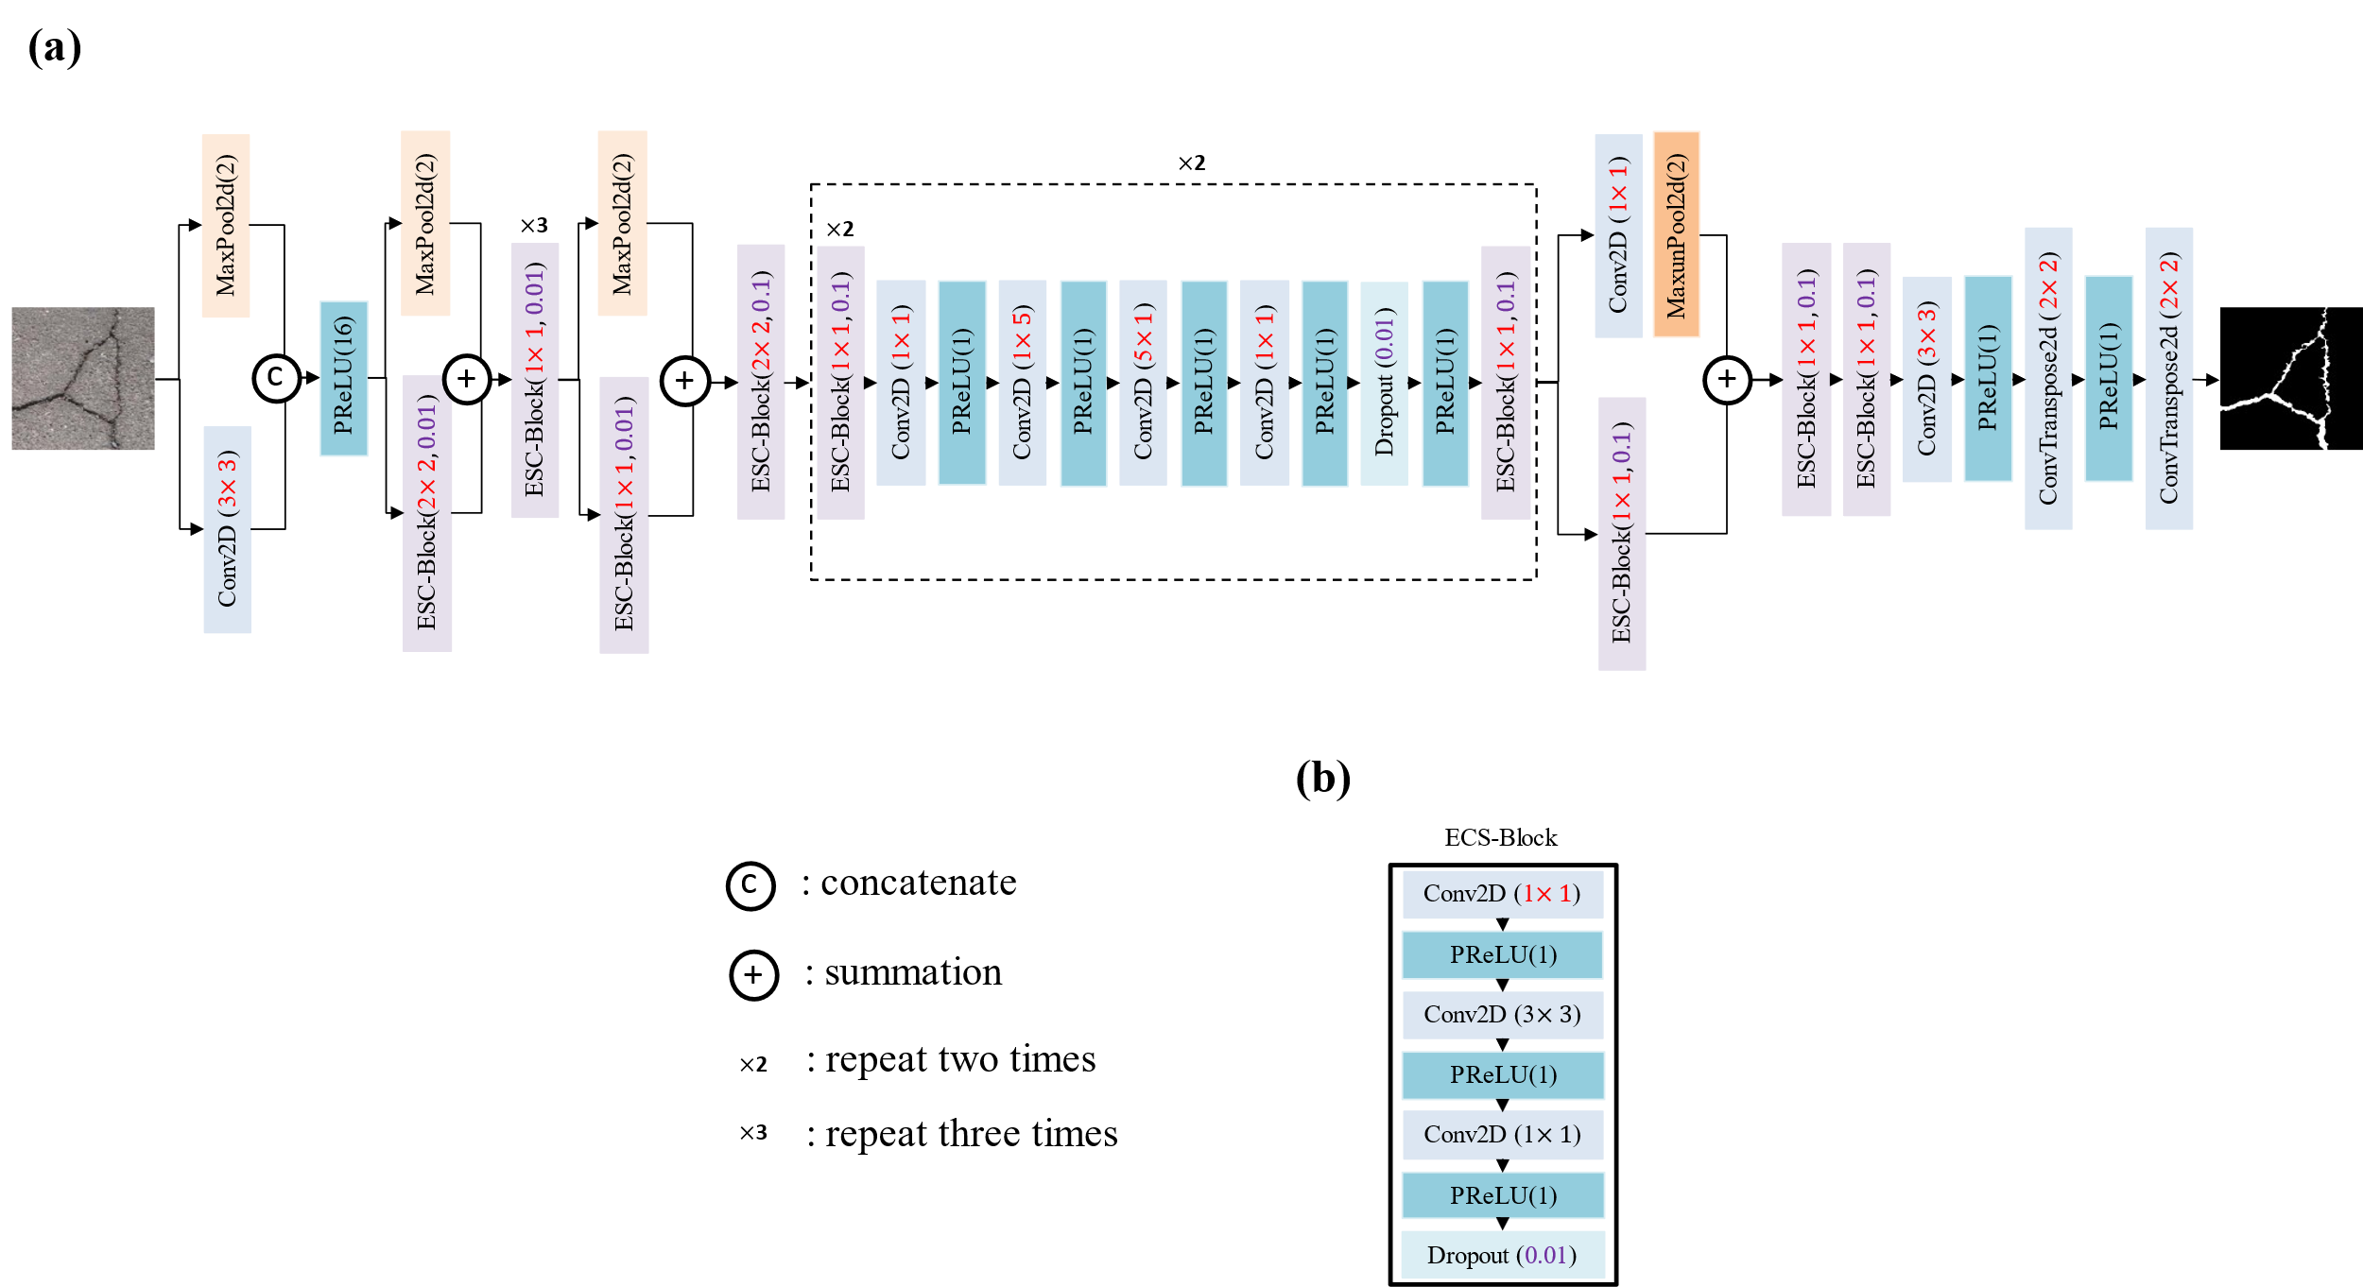

Figure 1. The architecture of the proposed ECSNet and its components: (a) The architecture of the proposed ECSNet; (b) The structure of an ECS-Block which is consisting of three convolutional layers: 1×1 Conv2D, 3×3 Conv2D and 1×1 Conv2D. The PReLU is used as an activation function in the ECS-Block. A dropout layer is placed at the end of the ECS-Block.
11. The contribution of the work could be elaborated more.
Thanks for your comments. We elaborated the contribution of the work in the Results part. The paragraph has been revised to “In this work, an ECSNet is proposed for real-time pavement crack detection tasks. This model is designed as a lightweight real-time semantic segmentation model with high computational efficiency. An ECS-block consisting of 1×1 Conv2D, n×n Conv2D and 1×1 Conv2D is introduced to network as an alternative of a normal n×n Conv2D to reduce the model parameter and improve the computing speed. It shows the parameters contained in an ECS-block are 8.5 times lower than a normal n×n Conv2D. A parallel max pooling and convolutional operation are also introduced in the network to replace the sequence of convolution layer and max pooling layer, which speed up the downsizing and filtering process.
The proposed ECSNet is compared with other popular models, including DeepLabv3, LRASPP, FCN, Enet, Unet, and DeepCrack. According to the overall performance on the DeepCrack Dataset, the ECSNet obtains an F1 score of 84.45 and an IoU of 73.08, which outperforms all the popular models except the model DeepCrack. The segmentation result from ECSNet is clearer and more continuous than DeepLabv3, LRASPP and FCN. It is also demonstrated that the ECSNet has the highest FPS (73.29) and lowest training time (5011 seconds) among all trained models. Comparing the IoU with efficiency metrics, it is worth noticing that the proposed ECSNet keeps a good balance between the accuracy and efficiency metrics. It only losses 2.8% of IoU to gain a 2.5 times higher FPS compared to DeepCrack model, which shows that ECSNet is a well-designed real-time image segmentation algorithm for the pavement crack detection task.”

Reviewer 3:
Comments:
In this manuscript, a deep learning model architecture, ECSNet, is proposed for real-time pavement surface crack detection. By comparing with DeepLabV3, FCN, LRASPP, Enet, and DeepCrack models, ECSNet shows a great balance of efficiency and accuracy. The research is very interesting. And the following issues should be addressed.
1. After the augmentation of the original images, the training set is processed by changing the color to gray. Please explain why only the training set is processed. What about the test set? Is that reasonable to compare the performance of ECSNet by the gray images with that of a model, such as DeepLabV3, trained for RGB figures?
Thanks for your comments. The testing set is preprocessed by changing the color to gray as well as the training set. We change the statement from “After augmentation, the training set is processed by changing the color to gray.” to “The training and testing set will be processed by changing the color to gray before input the images into the model.”
For the model DeepLabv3, it is also trained and tested on the gray pictures. During the training, the first layer of DeepLabv3 is changed from:
(conv1): Conv2d(3, 64, kernel_size=(7, 7), stride=(2, 2), padding=(3, 3), bias=False)
To:
(conv1): Conv2d(1, 64, kernel_size=(7, 7), stride=(2, 2), padding=(3, 3), bias=False)
The input channels were changed from 3 to 1, which means that the network DeepLabv3 can work on the gray images. We did the same modifications to all the other models to make them work on the gray images.
A sentence “The input channels of all the models are set to one, so that the gray images can used as input to train and test the model.” has been added to the METHODOLOGY Part B, paragraph 2 to explain this more clearly.
2. The UNet network is a classic network for image segmentation tasks. Recently it has been used for crack segmentation tasks. Why not choose it as a comparison model?
Thanks for your comment. It is true that the Unet is a very classic image segmentation network which is first used in biomedical images and then been used in other areas including crack segmentation. Therefore, we included the Unet to compare with our proposed method. We added a paragraph in METHODOLOGY to introduce the Unet.
“(5) Unet: We include the popular Unet architecture, which is widely recognized for its effectiveness in semantic segmentation tasks. Unet consists of an encoder-decoder structure with skip connections that allow for the fusion of low-level and high-level features, facilitating precise localization of cracks in pavement images. The encoder part captures contextual information, while the decoder part reconstructs the segmented output.”
And then, we download the Unet code from the GitHub and run the code on the same DeepCrack Dataset. The graphs were replotted to include the Unet result as shown below.

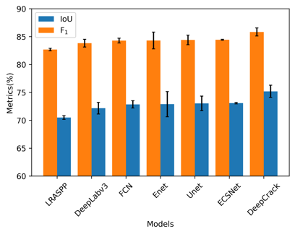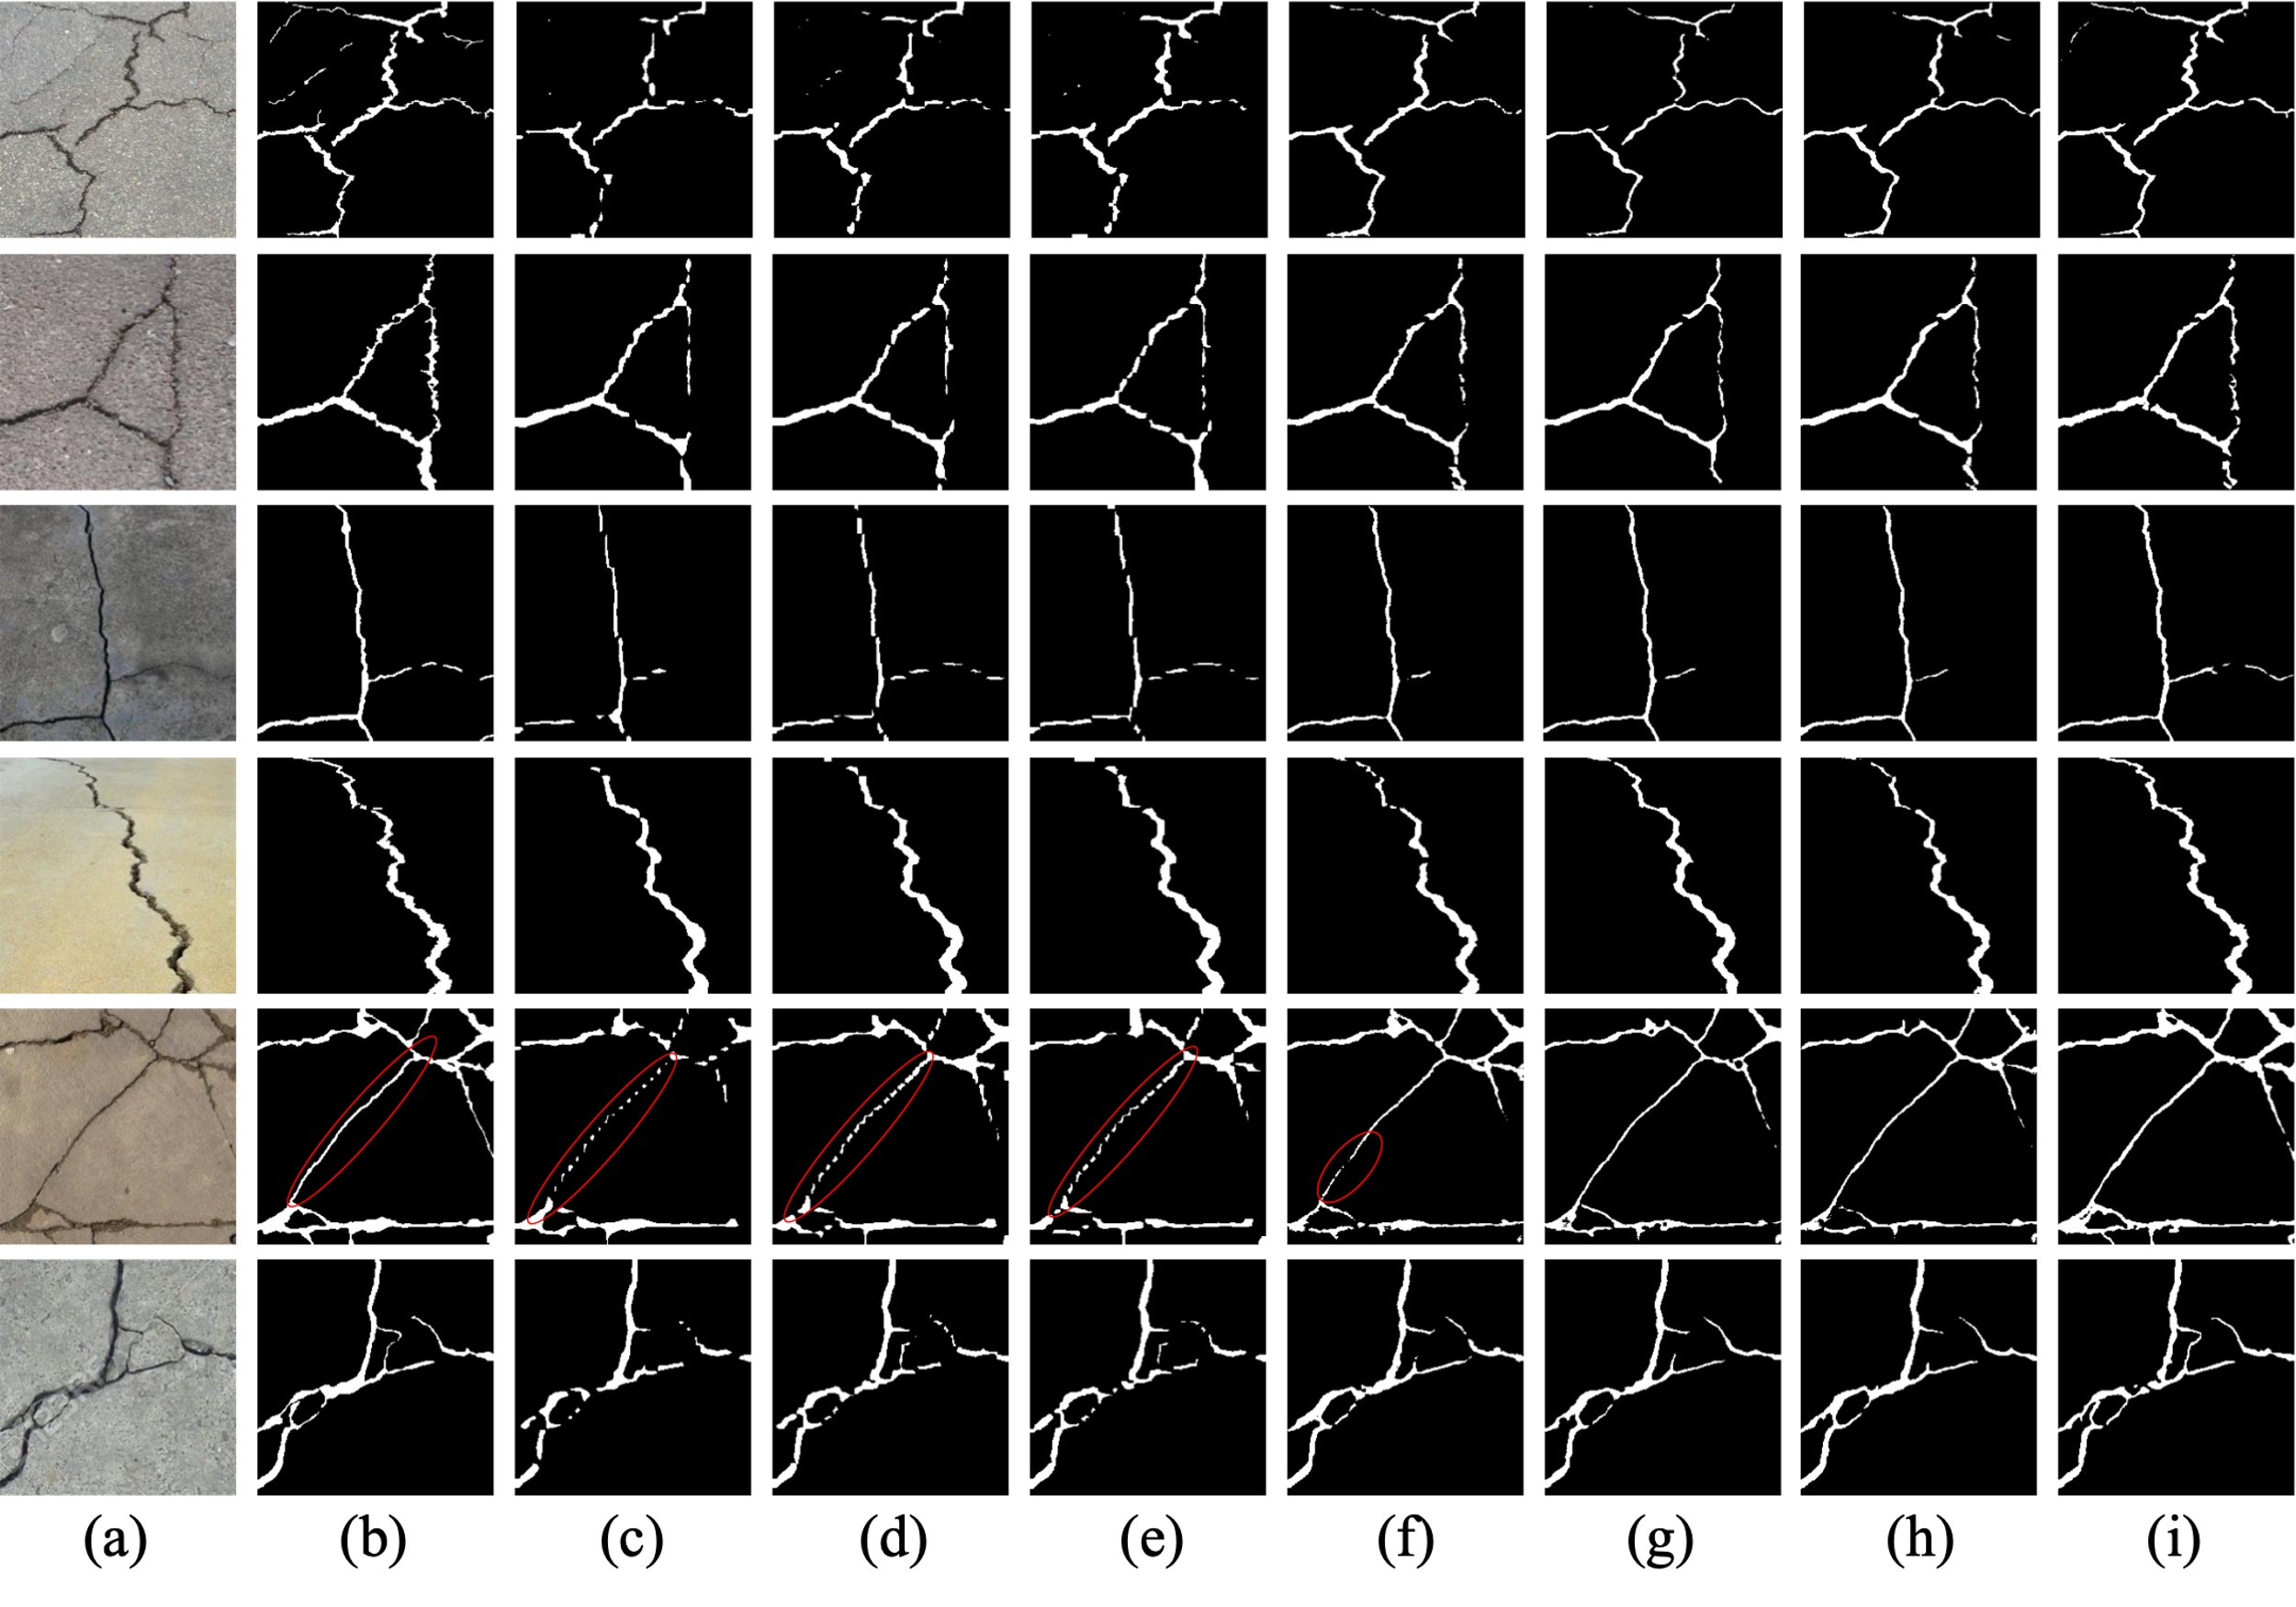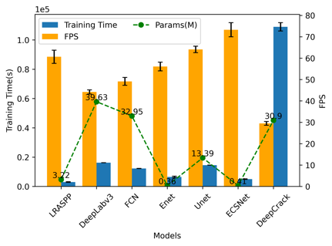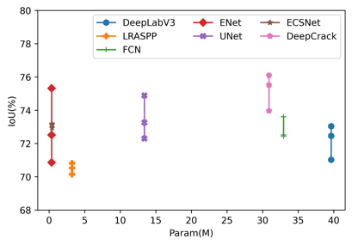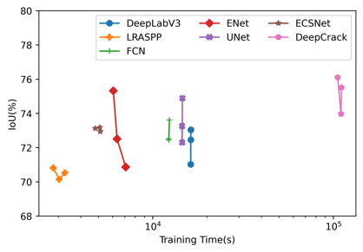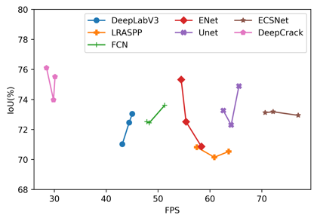
It is noteworthy that the Unet is a quite competitive network compared to other models. It got the third highest IoU (73.03) and F1 score (84.41) among all the models. It also got the second highest FPS (64.09) which is just lower than our proposed network (FPS is 73.29).

3. In the "Methodology" part of this manuscript, the title of "Part C" is missing.
Thanks for your careful check. The “Part D” has been changed to “Part C”.
4. There is a typo of BCS in “There are two parameters for the BCS-Block" in line 6 of page 2.
Thank you so much for your careful check. The typo has been revised.
5. Page 1, " the computational cost from the proposed ECS-Block is 8.5 times less than a standard convolutional operation". It is confusing for the "8.5 times less than".
We are so sorry for the confusing.
$R_{1}=\frac{1×1×D×K+\left(3×3×K\right)×K+\left(1×1×K\right)×D }{\left(3×3×D\right)×D}$ (1)
In equation (1), the R₁ value means the ratio of the total parameters included in the ECS-Block and a standard $3×3$ conv2D. Because a $3×3$ conv2D is popular used in other networks, calculating the R₁ can show that how much does our proposed block reduce the total parameters. Through calculation, R₁ is 8.5 in this work. In other words, the computational cost of the proposed ECS-Block is 8.5 times lower than that of a standard convolutional operation.
Therefore, the sentence in the paper has been revised to “Therefore, based on the Equation (3), $R_{1}$ equaling to 8.5 means that the computational cost of the proposed ECS-Block is 8.5 times lower than that of a standard convolutional operation.”
6. In this manuscript, the ECSNet was trained three times. Is there any use of k-fold cross-validation among different training times?
Thank you for your comments. We didn’t use k-fold cross-validation because of data leakage. In k-fold cross-validation, each image is used in both training and testing at some point. This repeated usage of data across folds can potentially introduce data leakage, where information from the test set leaks into the training process. Data leakage can lead to overly optimistic performance estimates and fail to provide an accurate representation of the model's generalization capability. In other words, it will cause overfit problem. In our work, we just run the model three times. We will get different results because the initializing of the weights and bias in the network is random. By running three times, the results would be more meaningful in statistics.
7. Please explain how the error bars were calculated in Figure 3 and Figure 5. It should be explained in the text where it is first cited.
Thanks for your comments. In Figure 3, the error bar stands for the standard deviation of IoU and F1 score. This is because each model was run three times on the same dataset. Therefore, we can get three IoU and F₁ for each model. (And because of the random initialing of weights and bias of the network, we will get different IoU and F1 value from each prediction.) Then, we calculated the average value and standard deviation based on these three results. By doing this, we can show the robust of the method. This is because if we only test the model once, we cannot tell if the result is caused by accident. By doing this, the results would be more meaningful in statistics. This is the same for the Figure 5. In Figure 5, the error bar stands for the standard deviation of training time and FPS.
We have included a sentence in METHODOLOGY Part B to explain it: “Each model is trained and tested three times. The mean value and standard deviation would be calculated to represent the average performance and robustness of the model. By doing this, the results would be more statistically meaningful.”
8. It is recommended that the visualization results in Figure 4 be arranged in the same order as the models listed in Figures 3 and Figure 5.
Thanks for your advice. The models in Figure 4 have been arranged to have the same order as the models listed in Figure 3 and 5. The replotted images are shown below.
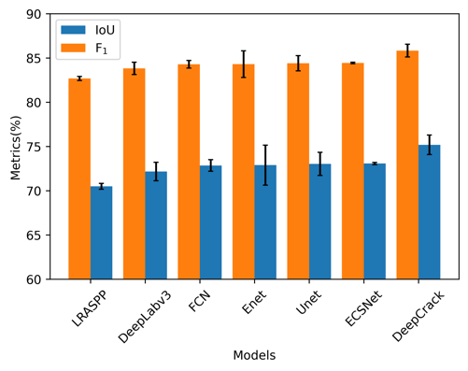
Figure 3. The F₁ score and IoU of all the tested models. The models are organized in ascending order based on the IoU values achieved on the DeepCrack dataset. The blue bar stands for the IoU and the orange bar stands for the F₁ score of each model. The black error bar is the standard deviation.

Figure 4. The visualization of detection results of compared methods on the DeepCrack Dataset: (a) original image; (b) ground truth; (c) LRASPP; (d) DeepLabv3; (e) FCN; (f) Enet; (g) Unet; (h) ECSNet; (i) DeepCrack.
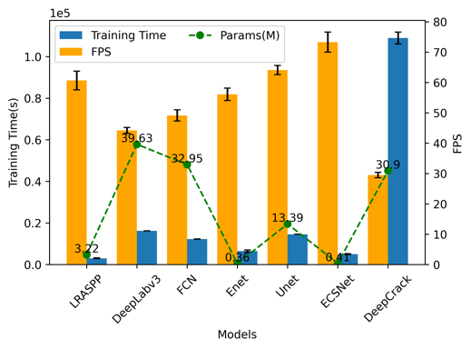
Figure 5. The efficiency-related performance of each model. The blue bar stands for the training time used by each model. The yellow bar is the FPS of each model performed on the DeepCrack dataset. The green points are the parameters contained in the models. The black error bar is the standard deviation.

