STFT-Based Condition-Aware CNN with Conditional GAN Augmentation for Multi-Depth Soil Moisture Prediction from GPR A-Scans
Tianjie Zhang, [Advisor Name]
Department of Civil and Environmental Engineering, Rutgers, The State University of New Jersey, Piscataway, NJ 08854, USA
Abstract
Accurate monitoring of soil moisture beneath pavements and around buried pipelines is critical for infrastructure integrity assessment, yet existing methods either require invasive sensor installation or provide only point measurements. Ground-penetrating radar (GPR) offers a non-invasive alternative, but extracting reliable moisture estimates from GPR A-scan signals remains challenging due to complex wave propagation effects and limited labeled datasets. This paper proposes a machine learning pipeline for simultaneous multi-depth soil moisture prediction from single-pass GPR A-scans. The pipeline comprises three components: (1) Short-Time Fourier Transform (STFT) signal representation, which converts each A-scan into a 2D time-frequency spectrogram; (2) a condition-aware convolutional neural network (CA-CNN) that jointly encodes the STFT image with known deployment metadata (soil type and pipe diameter); and (3) a conditional Wasserstein GAN with gradient penalty (cWGAN-GP) that augments the training set by generating physically plausible synthetic A-scans. Experiments on a controlled sandbox dataset (135 samples, 3 conditions, 4 depth layers) show that the proposed method achieves an average R² = 0.825, outperforming a 1D CNN on raw A-scans by 14.0 percentage points. A systematic ablation study demonstrates that augmentation in the signal domain is essential: five standard image-domain augmentations consistently degrade performance, confirming that STFT pixels carry physical meaning that must be preserved.
Keywords: Ground-penetrating radar; Soil moisture; Short-Time Fourier Transform; Convolutional neural network; Conditional GAN; Data augmentation; Non-destructive testing

1. Introduction
Soil moisture in the near-surface zone governs the mechanical behavior of road subgrades and the corrosion environment of buried pipelines. Elevated moisture accelerates soil settlement, contributes to frost heave in cold climates, and promotes electrochemical corrosion of metallic pipe walls. Early, non-invasive detection of anomalous moisture conditions is therefore an enabling capability for infrastructure health monitoring.
The conventional approach — embedding time-domain reflectometry (TDR) sensors at selected depths — provides accurate point measurements but requires excavation and is impractical for systematic spatial surveys. Ground-penetrating radar (GPR) is a well-established non-destructive testing technique that propagates electromagnetic (EM) pulses into the ground and records the reflected waveform (A-scan) at the surface. Because EM propagation velocity and attenuation in soil are both governed by the soil’s dielectric permittivity εᵣ, which in turn is dominated by the volumetric water content through the Topp equation (1980), GPR A-scans contain, in principle, information about soil moisture at multiple depths.
However, extracting quantitative moisture estimates from raw A-scans is non-trivial. The reflected signal is a superposition of contributions from the soil matrix, the pipe, and multiple reflection paths, all entangled in the time domain. Physics-based inversion via travel-time picking requires precise knowledge of the pipe geometry and fails when the first-break signal is obscured by near-field effects. This motivates data-driven approaches that learn the mapping from GPR waveform features to moisture directly from labeled examples.
Recent work has demonstrated that CNNs applied to STFT spectrograms of GPR A-scans can outperform feature-engineered baselines for pavement moisture assessment (Cao et al., 2022). However, a systematic comparison between raw-signal and time-frequency representations, as well as the effect of different augmentation strategies under small-sample conditions, has not been reported.
This paper makes the following contributions:
(1) We show empirically that STFT representation provides a +0.112 R² advantage over raw A-scan 1D CNN, and that a condition head on a 1D CNN yields no improvement (+0.001), confirming that condition encoding depends on a rich input representation.
(2) We propose a condition-aware 2D CNN (CA-CNN) encoding soil type and pipe diameter as one-hot features, achieving R² = 0.816 without augmentation.
(3) We demonstrate that cWGAN-GP augmentation in the A-scan domain yields R² = 0.825, while five standard image-domain augmentations consistently degrade performance.
(4) We provide a full ablation study across six model variants on a three-condition controlled dataset, offering a replicable benchmark for GPR-based moisture prediction.

2. Related Work

2.1 Physics-based GPR inversion for soil moisture
The classical approach to GPR-based moisture estimation relies on travel-time inversion. The two-way travel time t of the direct reflection from a buried interface at depth d is t = 2d√εᵣ/c, where c is the speed of light. With a known depth, the dielectric permittivity εᵣ can be recovered, and volumetric water content θᵥ is estimated via the empirical Topp equation (1980): θᵥ = −5.3×10⁻² + 2.92×10⁻²εᵣ − 5.5×10⁻⁴εᵣ² + 4.3×10⁻⁶εᵣ³. This approach has been applied to road subgrade monitoring (Benedetto, 2013; Shangguan et al., 2015) and near-surface agricultural soil (Huisman et al., 2003). Its principal limitations are the requirement for known interface depth, sensitivity to antenna height variation, and inability to separate overlapping reflections from multiple layers.

2.2 Machine learning for GPR signal interpretation
Data-driven approaches have been applied to GPR for object detection, subsurface anomaly classification, and rebar depth estimation. For moisture specifically, Cao et al. (2022) applied STFT followed by ResNet-18 to GPR A-scans collected on asphalt pavement and reported R² > 0.90 for surface-layer moisture. Their work established the value of time-frequency representation but did not investigate multi-depth prediction or augmentation strategies. We include a 1D CNN on raw A-scans as a baseline to isolate the contribution of the STFT representation.

2.3 GAN-based augmentation for NDT signals
Data augmentation via generative adversarial networks (GANs) has been explored for defect detection in ultrasonic testing, eddy-current inspection, and magnetic flux leakage. A key design choice is whether to augment in the original measurement domain or in a derived feature domain. Prior work in medical imaging suggests that augmentation respecting measurement physics yields more reliable improvements than photometric transforms (Shorten & Khoshgoftaar, 2019). To the best of the authors’ knowledge, the present study is the first to compare signal-domain and spectrogram-domain augmentation for GPR moisture regression, and to show that STFT pixels carry physical meaning that is destroyed by standard image transforms.

3. Experimental Setup and Dataset

3.1 Soil box preparation
To conduct controlled experiments, two rigid bulk containers (112 cm × 104 cm × 51 cm) made of high-density polyethylene (HDPE) were used to prepare soil boxes with buried metallic pipes. One box contains sandy soil and the other contains sandy clay soil. The hydraulic permeability values used in this study were obtained from manufacturer-provided material specifications. The sandy soil has hydraulic permeability of 1.1×10⁻⁴ m/s according to ASTM D2434 (the standard constant-head permeability test method for granular soils). The sandy clay soil has hydraulic permeability of 5.3×10⁻⁶ m/s according to ASTM D5084 (a flexible-wall permeameter method for low-permeability soils).
Due to the presence of structural voids at the rigid bulk container’s base, soil was initially backfilled and compacted until it reached the level of the internal ribs, creating a uniform flat surface. Subsequently, metallic pipes were positioned on this prepared base, followed by layer-by-layer soil filling and compaction. In the sand soil box, a 5 cm-diameter pipe was placed on one side of the container (pipe center 42.5 cm from the top surface) and a 10 cm-diameter pipe was placed on the other side (pipe center 40.0 cm from the top). For the sandy clay box, only a 10 cm-diameter pipe (pipe center 35.0 cm from the top) was placed. All embedded pipes are well-coated metallic pipes.

3.2 Moisture monitoring instrumentation
To monitor the variation of volumetric moisture content (VMC) in the soil, EC-5 moisture sensors (METER Inc., USA) were installed during soil filling. Near each pipe, three EC-5 sensors were embedded at depths of 8 cm, 22 cm, and 35 cm below the surface to measure VMC at the top (T), middle (M), and bottom (B) layers, respectively. To provide surface moisture, a time-domain reflectometer (TDR) probe (Spectrum Technologies, Inc.) was used to measure the surface VMC (S layer, 0 cm). This four-depth arrangement (S, T, M, B) captures the moisture profile from the surface to the vicinity of the buried pipe, providing the multi-output regression target for the machine learning models. The dielectric constants of the two soils at different moisture contents were additionally measured using a Percometer (Adek, LLC) to characterize the material properties.

3.3 GPR data acquisition
For GPR testing, a Quantum Imager GPR system (US Radar Inc., USA) with an operating frequency of 950 MHz was employed. Pipe scans were acquired by moving the antenna perpendicular to the pipe length in a fixed-offset single-pass configuration (no antenna displacement measurement). To create a range of moisture scenarios, manual moistening was performed by pouring water on both boxes, and measurements were taken at each stable moisture state. Each A-scan consists of 256 time samples at Δt = 0.0996 ns, covering a total time window of approximately 25 ns. All GPR measurements, moisture sensor readings, and Percometer measurements were performed simultaneously to ensure temporal consistency between the signal and label.
Figure 4 illustrates the experimental setup including soil box construction and sensor installation (a) and the field testing procedures with GPR and soil property measurements (b).

3.4 Dataset statistics
Three experimental conditions arise from the two soil types and pipe diameters (Table 1). Within each condition, moisture was varied by adding water incrementally; each stable moisture state at each antenna position constitutes one sample. The total dataset contains n = 135 samples. All experiments use stratified 5-fold cross-validation (CV) with stratification on the condition label to ensure equal representation of all three conditions in each fold.

Table 1. Dataset summary: three experimental conditions.
Condition | Soil | Pipe dia. | Pipe center depth | n
5-cm sand | Clean sand | 5 cm (2 in) | 42.5 cm | 47
10-cm sand | Clean sand | 10 cm (4 in) | 40.0 cm | 48
10-cm clay | Sandy clay | 10 cm (4 in) | 35.0 cm | 40

The prediction target for each A-scan is a 4-dimensional vector [θₛ, θₜ, θₘ, θᵇ] representing the VMC (%VWC) at depths S = 0 cm, T = 8 cm, M = 22 cm, and B = 35 cm simultaneously.

4. Methodology
The proposed pipeline proceeds in three stages (see Fig. 3): (1) STFT conversion of the raw A-scan to a 2D time-frequency spectrogram, (2) condition-aware 2D CNN regression, and (3) cWGAN-GP augmentation of the training set in the A-scan domain.

4.1 STFT Signal Representation
The raw A-scan x[n] (n = 0,…,255) is converted to a time-frequency spectrogram via the Short-Time Fourier Transform: X(m, k) = |Σ x[n] · w[n − mH] · exp(−j2πkn/N_FFT)|², where w is a Hann window of length N_w = 32, hop size H = 4 samples, and N_FFT = 512. The spectrogram covers the frequency range [0, 3] GHz, retaining 153 frequency bins and 57 time frames, yielding a 153 × 57 image normalized to [0, 1] per sample.
The motivation for STFT representation is two-fold. First, moisture increases the soil’s dielectric permittivity εᵣ, reducing EM propagation velocity and shifting reflection arrival times in the time axis. Second, moisture increases electrical conductivity σ, attenuating high-frequency components more strongly. Both effects manifest as interpretable spatial patterns in the STFT spectrogram (Fig. 2): wetter samples show later arrival times and suppressed high-frequency energy.
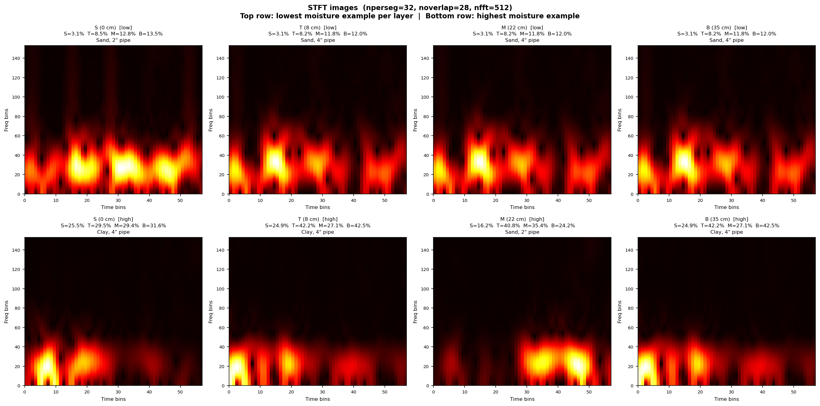
Fig. 2. STFT spectrograms: low moisture (left) vs. high moisture (right). High moisture delays reflection arrival (time axis) and suppresses high-frequency energy (frequency axis).

4.2 Condition-Aware CNN (CA-CNN)
The base 2D CNN processes the STFT spectrogram with three convolutional blocks (Conv2D → BatchNorm → ReLU → MaxPool) with channel widths 1→16→32→64, followed by global average pooling to yield a 512-dimensional feature vector f. For the condition-aware variant, soil type (2 classes) and pipe diameter (2 classes) are encoded as one-hot vectors concatenated to the CNN features, and two FC layers map the 516-dimensional vector to 4 moisture outputs (Dropout 0.3 before FC-128). Training: Adam lr = 10⁻³, ReduceLROnPlateau (factor 0.5, patience 30), early stopping (patience 80), batch 16, max 300 epochs.
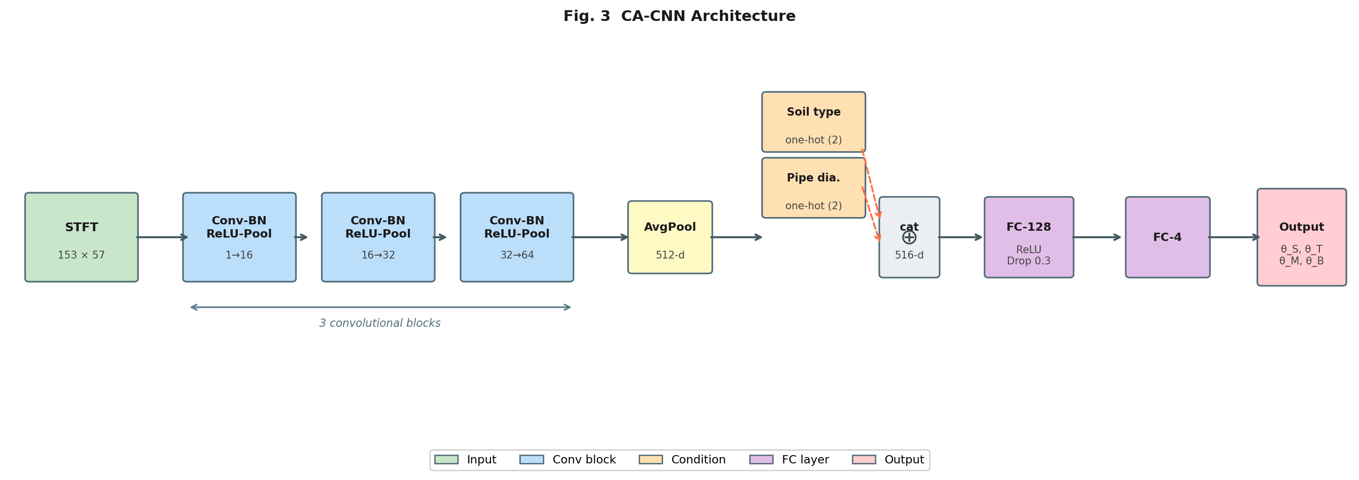
Fig. 3. CA-CNN architecture. The STFT spectrogram passes through three convolutional blocks and global average pooling; the feature vector is concatenated with one-hot condition encodings before two FC layers that regress 4 moisture outputs.

4.3 Conditional WGAN-GP Data Augmentation
A conditional WGAN-GP is trained to generate synthetic A-scans conditioned on the condition vector c = [cₛ; cₚ; θ̅] ∈ ℝ⁸. Both generator and critic are fully connected networks with LeakyReLU activations. Training: 500 epochs, Adam lr = 10⁻⁴, 5 critic steps per generator step, gradient penalty λ = 10. Synthetic moisture labels are generated via convex interpolation between two randomly sampled training labels (λ ∼ Uniform(0.3, 0.7)). Within each fold, the GAN is trained on the training split only, and 2× the training set size in synthetic samples is appended, preventing validation leakage.
The key motivation for augmenting in the A-scan domain is that STFT pixels represent physical observables: the horizontal axis encodes arrival time (causally related to permittivity and depth), and the vertical axis encodes frequency (related to attenuation). We test this hypothesis directly in Section 5.3.

5. Results

5.1 Progressive Model Comparison
Table 2 presents the cross-validated R² for each depth layer and the average across all four depths for all six model variants. The proposed method achieves R² = 0.825, an improvement of 14.0 percentage points over the 1D CNN baseline (R² = 0.685).

Table 2. Cross-validated R² (5-fold) for all model variants. Yellow rows are new experiments; green row is the proposed method.
Model | S | T | M | B | Avg R² | ±std
1D CNN (raw A-scan) | 0.734 | 0.638 | 0.674 | 0.695 | 0.685 | 0.052
CA-1D CNN (raw A-scan) | 0.730 | 0.664 | 0.631 | 0.720 | 0.686 | 0.057
STFT + 2D CNN | 0.870 | 0.754 | 0.743 | 0.820 | 0.797 | 0.056
STFT + CA-2D CNN | 0.853 | 0.800 | 0.781 | 0.828 | 0.816 | 0.056
STFT + CA-2D CNN + noise aug. | 0.839 | 0.744 | 0.785 | 0.834 | 0.801 | 0.055
STFT + CA-2D CNN + cWGAN-GP ★ (proposed) | 0.884 | 0.764 | 0.811 | 0.843 | 0.825 | 0.051

Adding a condition head to the 1D CNN yields no improvement (0.685 → 0.686), while the same head on the STFT CNN yields +0.019 (0.797 → 0.816). This confirms that condition encoding depends on a rich input representation. Simple Gaussian noise augmentation slightly reduces performance (0.816 → 0.801), while cWGAN-GP improves it (0.816 → 0.825). The T-layer (8 cm) consistently shows the lowest R² across all models, receiving mixed contributions from both the near-surface zone and the pipe-interaction zone.
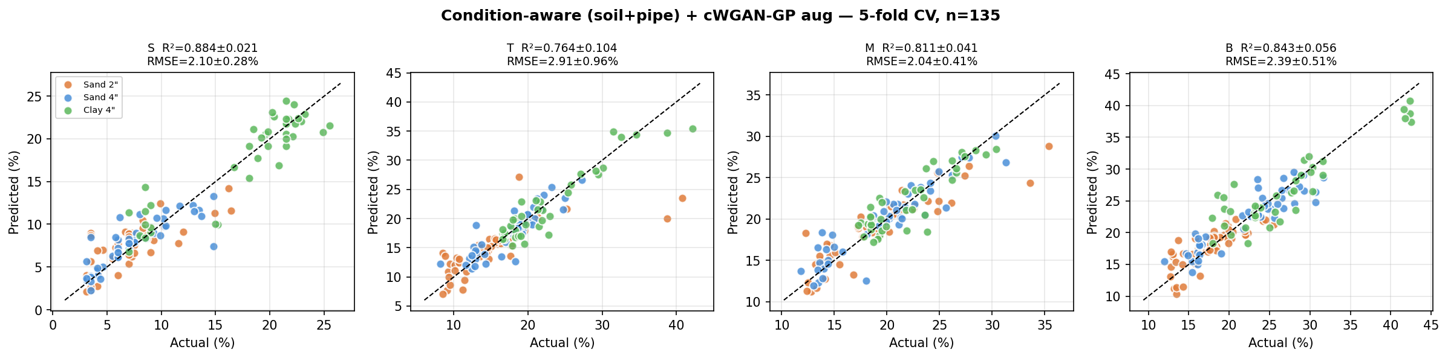
Fig. 5. Predicted vs. actual VMC (%VWC) for the proposed method (STFT + CA-CNN + cWGAN-GP). Color encodes experimental condition. Dashed line: ideal prediction.

5.2 Ablation: STFT versus Raw A-Scan
The STFT advantage over the plain CNN is +0.112 R² (0.797 vs. 0.685), and over the conditioned baseline is +0.130 R² (0.816 vs. 0.686). The absence of any benefit from the condition head on the 1D CNN (0.685 → 0.686) is an informative negative result: the network cannot leverage known metadata when the signal representation is not rich enough. The STFT representation encodes moisture effects as 2D spatial patterns, allowing the condition head to attribute these patterns to the correct soil type and geometry.

5.3 Ablation: Augmentation Domain
Table 3 compares five standard image-domain augmentations against cWGAN-GP augmentation in the A-scan domain.

Table 3. Augmentation ablation: average R². Image-domain augmentations applied to STFT spectrogram; cWGAN-GP applied to raw A-scans before STFT conversion.
Augmentation strategy | Avg R² | Δ vs. No aug.
No augmentation (CA-2D CNN) | 0.816 | —
Image-domain augmentations (applied to STFT)
Horizontal shift | 0.710 | −0.106
Brightness / contrast | 0.698 | −0.118
Gaussian blur | 0.722 | −0.094
Gaussian noise | 0.711 | −0.105
CLAHE | 0.695 | −0.121
Signal-domain augmentation (applied to raw A-scan)
cWGAN-GP ★ (proposed) | 0.825 | +0.009

All five image-domain augmentations degrade performance significantly, with CLAHE producing the largest drop (−0.121 R²). By contrast, cWGAN-GP generates new A-scan signals in the original time domain; the STFT conversion is applied afterward, so the resulting spectrogram is physically consistent with the conditioned moisture label.
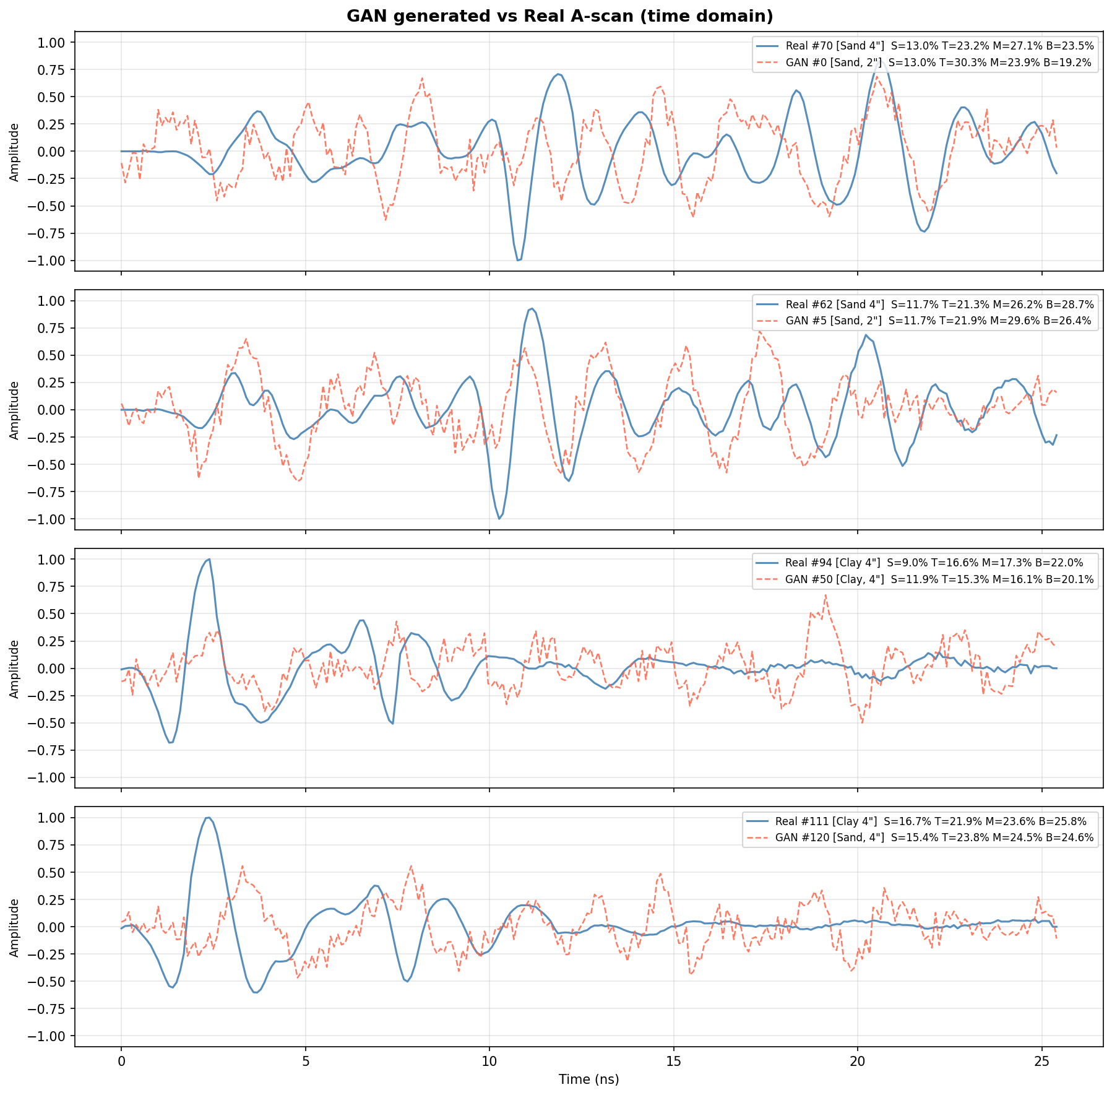
Fig. 4. Real A-scans vs. GAN-generated A-scans (top) and corresponding STFT spectrograms (bottom). Generated signals reproduce the main reflection event and high-frequency attenuation characteristics.

5.4 Comparison with Physics-Based Inversion
As a non-ML reference, travel-time inversion applies the first-break arrival detection, computes εᵣ from the known pipe depth, and estimates moisture via the Topp equation. This physics-based method yields r = 0.545, RMSE = 6.1%VWC for the clay condition, where the pipe reflection is relatively prominent. For the sand conditions, the method fails due to interference between the pipe reflection and container wall echoes. The proposed ML method achieves R² = 0.825 across all conditions without requiring knowledge of pipe geometry.
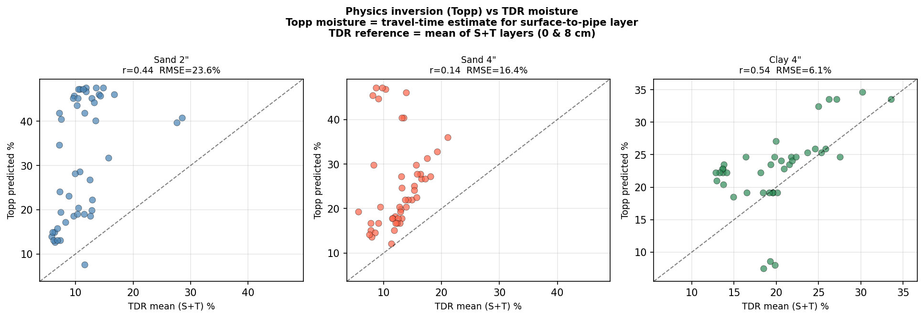
Fig. 6. Physics-based inversion results (travel-time + Topp equation). Reasonable correlation is obtained only for the clay condition.

6. Discussion

6.1 Per-layer prediction difficulty
The consistent ordering R²ₛ > R²ᵇ > R²ₘ > R²ₜ across all models suggests that prediction difficulty is not simply a function of depth. The T-layer (8 cm) is located below the near-surface zone but above the pipe, receiving mixed contributions from the soil matrix and the top of the pipe’s interaction zone. The M-layer (22 cm) is at a comparable depth to the pipe axis. These observations suggest that future architectures could benefit from explicitly modeling the multi-layer propagation problem.

6.2 Effect of soil type and pipe diameter
The condition-aware head improves performance over the unconditioned STFT CNN (+0.019 R²). However, the absolute improvement is modest, suggesting that the STFT CNN already learns partially separable representations for the three conditions. Future work could explore more expressive condition fusion strategies, such as feature-wise linear modulation (FiLM, Perez et al., 2018), which modulates each feature map by condition-dependent scale and shift parameters.

6.3 Limitations and future directions
This study has several limitations. The dataset (n = 135) is small, and the three experimental conditions represent a limited subset of real-world soil and infrastructure scenarios. The model was trained and tested under the same experimental setup, which does not evaluate generalization to field conditions. For practical deployment, transfer learning or domain adaptation from simulation-to-real data would be needed. We trained a CycleGAN (Zhu et al., 2017) to translate FDTD-simulated A-scans (gprMax, Warren et al., 2016; n_sim = 375) to the real signal domain; preliminary results show R² = 0.749, remaining below the supervised baseline. Closing this simulation-to-real gap is an important future direction. Additionally, the current experiment uses a fixed-offset antenna without displacement measurement; a scanning system would provide a 2D B-scan encoding additional spatial information.

7. Conclusion
We presented a machine learning pipeline for multi-depth soil moisture prediction from single-pass GPR A-scans. The pipeline consists of STFT-based signal representation, a condition-aware 2D CNN encoding known deployment metadata, and cWGAN-GP data augmentation in the A-scan domain. On a controlled sandbox dataset with 135 samples across three experimental conditions using HDPE soil boxes with buried metallic pipes and EC-5 moisture sensors at four depths, the proposed method achieves an average R² = 0.825, outperforming a 1D CNN on raw A-scans by 14.0 percentage points. A key finding is that augmentation domain matters: five image-domain augmentations on STFT spectrograms consistently degrade performance, while cWGAN-GP augmentation in the A-scan domain improves it. Future work will focus on simulation-to-real transfer to reduce dependence on labeled field data, and extension to scanning acquisitions for 2D moisture mapping.

References
ASTM. (2010). D5084: Standard Test Methods for Measurement of Hydraulic Conductivity of Saturated Porous Materials Using a Flexible Wall Permeameter. ASTM International.
ASTM. (2022). D2434: Standard Test Method for Measurement of Hydraulic Conductivity of Coarse-Grained Soils. ASTM International.
Benedetto, A. (2013). Water content evaluation in unsaturated soil using GPR signal analysis in the frequency domain. Journal of Applied Geophysics, 97, 19–26.
Cao, Q., Estes-Srigley, A., & Leng, Z. (2022). Prediction of the moisture content in asphalt pavement base course using ground penetrating radar and machine learning. Construction and Building Materials, 354, 129131.
Giannakis, I., Giannopoulos, A., & Warren, C. (2021). Realistic FDTD GPR antenna models optimised using a novel linear/non-linear training approach. 18th International Conference on Ground Penetrating Radar.
Huisman, J. A., Hubbard, S. S., Redman, J. D., & Annan, A. P. (2003). Measuring soil water content with ground penetrating radar: A review. Vadose Zone Journal, 2(4), 476–491.
Perez, E., Strub, F., de Vries, H., Dumoulin, V., & Courville, A. (2018). FiLM: Visual reasoning with a general conditioning layer. AAAI Conference on Artificial Intelligence.
Shangguan, P., Al-Qadi, I., Coenen, A., & Zhao, S. (2015). Algorithm development for the application of ground-penetrating radar on asphalt pavement compaction monitoring. International Journal of Pavement Engineering, 17(3), 189–200.
Shorten, C., & Khoshgoftaar, T. M. (2019). A survey on image data augmentation for deep learning. Journal of Big Data, 6(1), 1–48.
Topp, G. C., Davis, J. L., & Annan, A. P. (1980). Electromagnetic determination of soil water content: Measurements in coaxial transmission lines. Water Resources Research, 16(3), 574–582.
Warren, C., Giannopoulos, A., & Giannakis, I. (2016). gprMax: Open source software to simulate electromagnetic wave propagation for Ground Penetrating Radar. Computer Physics Communications, 209, 163–170.
Zhu, J.-Y., Park, T., Isola, P., & Efros, A. A. (2017). Unpaired image-to-image translation using cycle-consistent adversarial networks. ICCV 2017, 2223–2232.

