We would like to thank the Editor and all reviewers for careful reading, helpful comments, and constructive suggestions, which have significantly improved the presentation of our manuscript.
We have carefully considered all comments from reviewers, and revised our manuscript accordingly. The manuscript has also been double-checked, and the typos and grammar errors we found have been corrected. In the following section, we summarize our responses to each comment from the reviewers. We believe that our responses have well addressed all concerns from the reviewers. We hope our revised manuscript can be accepted for publication.

The presented manuscript is devoted to the segmentation of potholes in pavement surface images. The authors propose a new neural network architecture that combines transformer-based and CNN-based networks. Before publication, the following comments need to be addressed:
i) Critical comment: Careful revision and unification of mathematical symbols, equations, and function names are necessary. The mathematical descriptions in Sections 2.1, 2.2, and 2.3 include a significant number of typos. A comprehensive list is not provided; only a few examples are stated.
- Attention vs. \italic{Attention}
- Eq. 4 is based on $W_1$, $W_2$, $b_1$, and $b_2$, but the explanation mentions only $W$ and $b$.
- Eq. 5: Explain the operator $\times$ (e.g., $x \times \phi(x)$).
- Provide the numerical values for $e^{-5}$ and $e^{-2}$.
- Eq. 7: Explain the operator $*$ (e.g., $... (U * W_{\text{conv}} + ...)$).
- Eq. 10: Why $w$ is bold?
We thank the reviewer for the careful reading and for pointing out inconsistencies in our mathematical notation. We have thoroughly revised Sections 2.1–2.3 to unify symbols, function names, and operator definitions.
1) We revise Attention to Attention.
2) we added: “ $W_{1}$, $W_{2}$ are the weights of layers; $b_{1}$ and $b_{2}$ are the bias of layers.”
3) The “$×$” ambiguity is removed by using element-wise notation where needed.
4) We defines the operator “*” as 2-D convolution;
5) Eq. (10–11) (RMSProp) now consistently uses bold w\mathbf{w}w and g\mathbf{g}g for parameter and gradient vectors, and we define each symbol.
6) We use bold to represent vectors or matrices/tensors (e.g., W, Q, K, V).
These changes correct the typos, remove ambiguities, and align the paper with standard DL notation. We believe this substantially improves clarity and reproducibility.

2) Please provide the formula for BCEwithLogistsLoss within the text.
We thank the reviewer for this helpful suggestion. We have now added the explicit formula of the Binary Cross-Entropy with Logits Loss (BCEWithLogitsLoss) in Section 2.3.
$L_{BCE}=-\frac{1}{N}\sum_{i=1}^{N}{[y_{i}logσ\left(z_{i}\right)+(1-y_{i})log⁡(1-σ\left(z_{i}\right))]}$ (12)
Where $σ\left(z_{i}\right)$ is the sigmoid function.
This clarifies how the loss combines the sigmoid activation and binary cross-entropy components, ensuring reproducibility and transparency of the training setup.

3) The labels on the graphs in Figure 6 are unreadable.
Thanks for your comment. We enlarge the labels in the images as shown below.
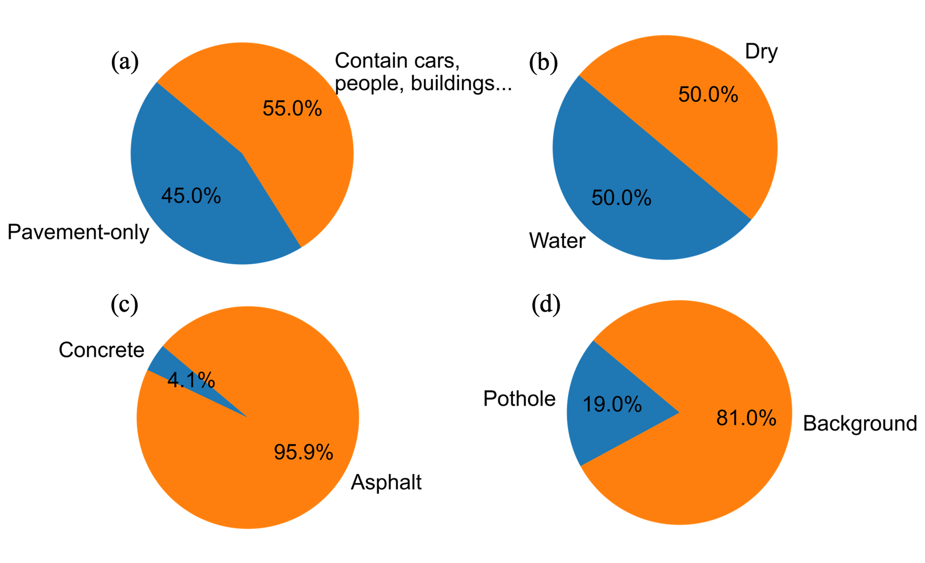

4) In the last paragraph of Section 3.1, the figure number should be corrected to 6.
We thank the reviewer for noticing this typographical error. The figure reference in the last paragraph of Section 3.1 has been corrected to “Figure 6” to accurately correspond to the dataset composition illustration.
5) While the comparison with other methods is appreciated, it is unclear whether their hyperparameters were tuned for optimal performance. Could you specify how the hyperparameters were handled to ensure a fair comparison?
We thank the reviewer for this important comment. To ensure fair and unbiased comparison, all models—including U-Net, FCN, LRASPP, E-Net, AttuNet, and PoFormer—were trained and evaluated under identical experimental settings. We added “To ensure a fair comparison, all baseline models (U-Net, FCN, LRASPP, E-Net, and AttuNet) and the proposed PoFormer were trained and evaluated under identical experimental configurations. Each model used the same dataset split (80% for training and 20% for testing), input resolution of 512×512 pixels, and BCEWithLogitsLoss as the objective function. The RMSProp optimizer with an initial learning rate of 1×10⁻⁴ and batch size of 8 was applied consistently across all models. The learning rate decayed by a factor of 0.98 every 10 epochs, and training was conducted for 100 epochs. All implementation details followed either the original architecture papers or their official PyTorch implementations to ensure consistency and reproducibility.
In this work, all experiments were implemented in Python 3.10 using the PyTorch 2.2.0 framework with CUDA 12.1 and cuDNN 8.9 support. Model training and testing were performed on a workstation equipped with an Intel(R) Core(TM) i9-10900X CPU, an NVIDIA RTX A4000 GPU (16 GB memory), and 64 GB RAM, running Windows 10 Professional (64-bit). ” at the end of section 2.3.

Overall, I believe this article makes a valuable contribution to the field of segmentation problems in civil/transport engineering. Researchers in this area often face a lack of data, which is why models are typically trained using unsupervised learning approaches. For this reason, I particularly appreciate the authors' decision to make the dataset available to other researchers in the field.
We sincerely thank the reviewer for the positive and encouraging feedback. We are pleased that the reviewer recognizes the contribution of our open dataset and its potential value to the research community. We agree that data scarcity remains a key challenge in pavement and civil engineering applications, and we hope that by releasing our annotated pothole dataset, other researchers can build upon this work to advance data-driven and deep-learning-based segmentation research. We have ensured that the dataset and corresponding annotations are publicly accessible through the GitHub repository referenced in Section 3.1 and the Data Availability Statement.

