We would like to thank the Editor and all reviewers for careful reading, helpful comments, and constructive suggestions, which have significantly improved the presentation of our manuscript.
We have carefully considered all comments from reviewers, and revised our manuscript accordingly. The manuscript has also been double-checked, and the typos and grammar errors we found have been corrected. In the following section, we summarize our responses to each comment from the reviewers. We believe that our responses have well addressed all concerns from the reviewers. We hope our revised manuscript can be accepted for publication.

Reviewer 3:
The authors propose a “PoFormer”, which is a Transformer-CNN hybrid model to detect the pothole. The author designs an open-source dataset to validate the proposed method.
Firstly, this manuscript has the following formatting issues:
1. The image quality of Figure 6 is poor.
Thanks for your comment. We enlarge the font in the images as shown below.
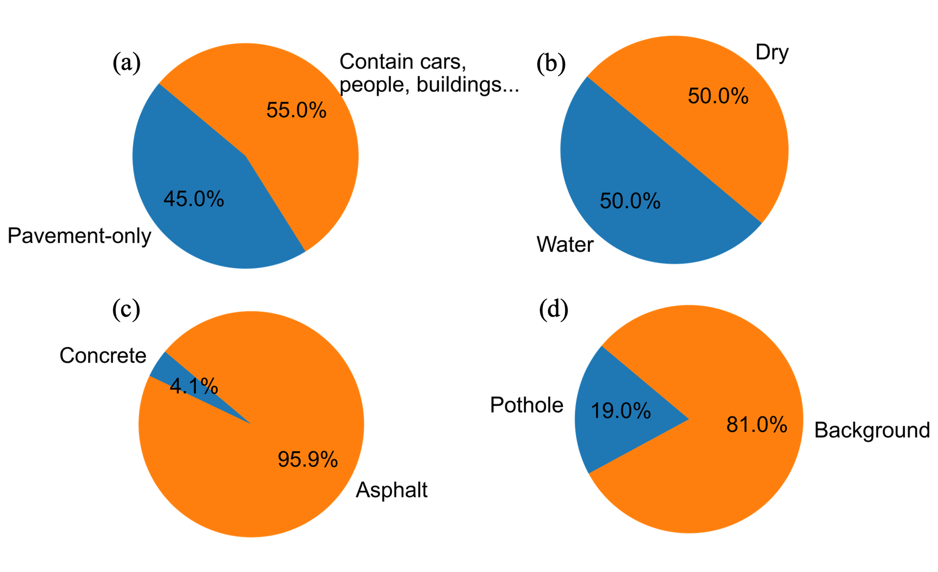

2. Some conference papers' references do not indicate the year. For example [14], [30-31], [39- 42] and [45].
Thanks for your careful check. We revised these references accordingly and added the year as shown below:
14. Buza, E.; Omanovic, S.; Huseinovic, A. Pothole detection with image processing and spectral clustering. In Proceedings of the Proceedings of the 2nd International Conference on Information Technology and Computer Networks, 2013; p. 4853.
30. Zheng, S.; Lu, J.; Zhao, H.; Zhu, X.; Luo, Z.; Wang, Y.; Fu, Y.; Feng, J.; Xiang, T.; Torr, P.H. Rethinking semantic segmentation from a sequence-to-sequence perspective with transformers. In Proceedings of the Proceedings of the IEEE/CVF conference on computer vision and pattern recognition, 2021; pp. 6881-6890.
31. Cordts, M.; Omran, M.; Ramos, S.; Rehfeld, T.; Enzweiler, M.; Benenson, R.; Franke, U.; Roth, S.; Schiele, B. The cityscapes dataset for semantic urban scene understanding. In Proceedings of the Proceedings of the IEEE conference on computer vision and pattern recognition, 2016; pp. 3213-3223.
39. Ioffe, S.; Szegedy, C. Batch normalization: Accelerating deep network training by reducing internal covariate shift. In Proceedings of the International conference on machine learning, 2015; pp. 448-456.
40. Ronneberger, O.; Fischer, P.; Brox, T. U-net: Convolutional networks for biomedical image segmentation. In Proceedings of the International Conference on Medical image computing and computer-assisted intervention, 2015; pp. 234-241.
41. Howard, A.; Sandler, M.; Chu, G.; Chen, L.-C.; Chen, B.; Tan, M.; Wang, W.; Zhu, Y.; Pang, R.; Vasudevan, V. Searching for mobilenetv3. In Proceedings of the Proceedings of the IEEE/CVF international conference on computer vision, 2019; pp. 1314-1324.
42. Long, J.; Shelhamer, E.; Darrell, T. Fully convolutional networks for semantic segmentation. In Proceedings of the Proceedings of the IEEE conference on computer vision and pattern recognition, 2015; pp. 3431-3440.
45. He, K.; Zhang, X.; Ren, S.; Sun, J. Deep residual learning for image recognition. In Proceedings of the Proceedings of the IEEE conference on computer vision and pattern recognition, 2016; pp. 770-778.

In addition, there are several unclear parts in the experimental protocol:
1. Based on the manuscript’ title “… Using Multi Sensor Inspection Data”, the reviewer subjectively believes that the author may use the sensor fusion architecture. However, according to 2.1. Pavement Distress Data Acquisition Vehicle and 3.1. Dataset Characteristics for Opensource Data Access, the reviewer discovered that the author only used images for pothole recognition. The author needs to consider whether the title accurately reflects the research content.
We thank the reviewer for this helpful comment. We agree that the phrase “Using Multi-Sensor Inspection Data” in the title may be misleading, as it could imply that sensor-fusion techniques were employed. In our study, the dataset consists of image data acquired from a multi-sensor imaging system (line-scan camera and infrared/laser lighting), but no sensor fusion was performed. To ensure that the title precisely reflects the research content, we have removed the phrase “Using Multi-Sensor Inspection Data” from the title.

2. The sources of experimental data need to be clarified. According to Line 144-147 and Line 393 of the manuscript:
Line 144-147: “To ensure the quality and diversity of the dataset, part of the images was collected using a pavement distress inspection vehicle [37], while the rest were sourced from open access repositories.”
Line 393: “The dataset comprises 1183 manually annotated RGB images of potholes.” The reviewer investigated open source databases of reference [37]. The open source database in reference [37] only has 263 pothole images. Only a quarter of the author's experimental images are included. The author must clarify the necessity of section 2.1 and its relationship with section 3.1.
We thank the reviewer for carefully checking the dataset sources. We apologize for the lack of clarity in distinguishing our self-collected images from those available in the open-source dataset referenced as [37]. To clarify: Reference [37] contains 263 pothole images, which were partially adopted as an open-source component of our dataset. In addition, our team collected 920 new images from internet. After combining both sources, the final dataset comprised 1183 manually annotated images, as reported in Section 3.1. we added “The final dataset used in this study combines 263 pothole images from the open-source PaveDistress dataset and 920 images collected from publicly available internet sources. Unlike the PaveDistress dataset, which primarily features isolated pavement views, the internet-sourced images include diverse and complex backgrounds such as vehicles, pedestrians, vegetation, and roadside buildings” in the section 3.1.

3. In 2.2 Overall Evaluation Procedure, although the author compared 5 kinds of models, these models are all old models and it is difficult to highlight the innovation of the experimental results.
We thank the reviewer for this valuable comment. We agree that many of the baseline models used in our experiments were originally proposed several years ago. However, these models—U-Net, FCN, LRASPP, E-Net, and AttuNet—remain the most widely adopted and standardized benchmarks in current pavement distress and pothole segmentation research. For instance, recent studies in IEEE T-ITS (2023) [44], and Automation in Construction (2023) [34] and thus we continue to evaluate new architectures against these baselines to ensure fair and comparable performance metrics. In the future, we will add more new models to do the benchmark. We added “Although these models were originally proposed several years ago, they remain the dominant benchmarks for pixel-level pavement distress segmentation tasks due to their balance of computational efficiency and accuracy. Recent studies [34,44] have continued to employ U-Net, FCN, LRASPP, E-Net, and AttuNet as reference baselines to ensure consistency and comparability in evaluating new algorithms. These architectures rep-resent different design philosophies: FCN and U-Net as early encoder–decoder models, E-Net for real-time segmentation, LRASPP for mobile efficiency, and AttuNet for atten-tion-based enhancement under limited data. Therefore, including these models provides a comprehensive and standardized baseline for assessing the performance of the proposed PoFormer.” In the section 2.3.

4. In 2.3. Evaluation Metrics, the author defined the Pixel Accuracy (PA) index. However, from the perspective of engineering practice, the main concern of road maintenance is whether there are road surface distresses (e.g., cracks, rutting, deformation, uneven settlements, patches and potholes). The author's experimental design only focuses on detecting a single road surface distress (i.e., potholes). Furthermore, the author's experimental design requires that the detected pothole images must be completely consistent. The author must explain the significance of the PA index in the engineering practice of road maintenance.
We appreciate the reviewer’s insightful observation. We agree that, in engineering practice, road maintenance decisions are guided by whether a pavement section exhibits any surface distresses such as cracks, rutting, or potholes, rather than by per-pixel accuracy alone.
To clarify, in this study the Pixel Accuracy (PA) metric was used to complement IoU by quantifying the overall classification reliability of each image at the pixel level. A higher PA indicates that the model can correctly distinguish pavement surface pixels from defect pixels, which directly relates to accurate distress quantification. It is an essential step for automated maintenance prioritization and volume estimation of defects.
We have revised Section 2.3 to explicitly explain how PA connects to engineering practice, emphasizing that accurate pixel-level segmentation supports the estimation of defect area and severity, which are key parameters for maintenance planning and cost estimation. We added “While the PA and mPA indices are standard image segmentation metrics, their engineering relevance lies in quantifying the reliability of pavement surface condition assessment. In road maintenance practice, accurate pixel-level classification enables precise estimation of the defect area, proportion, and severity, which are critical indicators for maintenance prioritization and resource allocation. Therefore, PA serves as an indirect measure of how accurately the system can assess the extent of pavement deterioration, supporting data-driven decision-making in pavement management systems.” In the section 2.4.

5. The author emphasizes in Figure 6 that the road background is a key factor affecting the performance of the pothole detection algorithm. However, this seems to be a fake topic. The author's open-source dataset sources include vehicles, people, trees, and buildings. However, according to the experimental design of the open-source dataset [37], these heterogeneous features will not appear in the image background. The author must clarify the experimental design framework.
We thank the reviewer for identifying this potential ambiguity. The focus of this study is on pavement pothole segmentation, and it is not directly related to the original experimental design of the previously published dataset. Only 263 pothole images from the open-source PaveDistress dataset [37] were used, while the majority—920 images—were newly collected from the internet to enrich the dataset diversity. These web-sourced images contain complex and heterogeneous backgrounds, including vehicles, pedestrians, and roadside objects, as illustrated in Figure 4. We added “The final dataset used in this study combines 263 pothole images from the open-source PaveDistress dataset and 920 images collected from publicly available internet sources. Unlike the PaveDistress dataset, which primarily features isolated pavement views, the internet-sourced images include diverse and complex backgrounds such as vehicles, pedestrians, vegetation, and roadside buildings.” In the section 3.1.

