tjbrailey_ontology_vis

POLI 191A/B

Thomas Brailey

12/09/2019

# Load Data

# read in excel file.   
psp_ont <- readxl::read_xlsx(paste0(here::here(),'/data/tjbrailey_psp_ontology.xlsx'))

## New names:  
## * `` -> ...6  
## * `` -> ...7  
## * `` -> ...8  
## * `` -> ...9

psp_ont <- dplyr::as_data_frame(psp_ont)

## Warning: `as_data_frame()` is deprecated, use `as_tibble()` (but mind the new semantics).  
## This warning is displayed once per session.

# select relevant variables.  
psp_ont_prep <- psp_ont %>%  
 dplyr::select(child_0,  
 child_1,  
 provisions)

# Define Hierarchy

# generate pathString as new column.  
psp_ont_prep$pathString <- paste("Power Sharing Provision",  
 psp_ont_prep$child_0,  
 psp_ont_prep$child_1,  
 psp_ont_prep$provisions,  
 sep = "|")  
  
# create list.   
psp_tree <- data.tree::as.Node(psp_ont_prep, pathDelimiter = "|")  
print(psp_tree, limit = 15)

## levelName  
## 1 Power Sharing Provision   
## 2 ¦--political system   
## 3 ¦ ¦--general consocilationalism   
## 4 ¦ ¦ ¦--grand coalition   
## 5 ¦ ¦ ¦--mutual veto   
## 6 ¦ ¦ ¦--proportionality   
## 7 ¦ ¦ ¦--segmental autonomy   
## 8 ¦ ¦ ¦--coalition cabinets   
## 9 ¦ ¦ ¦--bicameralism   
## 10 ¦ ¦ ¦--proportional representation  
## 11 ¦ ¦ ¦--organized interest groups   
## 12 ¦ ¦ ¦--rigid constitution   
## 13 ¦ ¦ ¦--judicial review   
## 14 ¦ ¦ ¦--direct democracy   
## 15 ¦ ¦ °--... 7 nodes w/ 0 sub   
## 16 ¦ °--... 5 nodes w/ 26 sub   
## 17 °--... 2 nodes w/ 84 sub

# Visualizations

# pepare list for visualization.   
psp_list <- data.tree::ToListExplicit(psp_tree, unname = TRUE)  
psp_ontology_vis <- networkD3::diagonalNetwork(psp_list,   
 fontSize = 14,  
 textColour = "black",  
 opacity = 0.7,  
 width = 900,  
 height = 900)  
# visualize.  
psp_ontology_vis

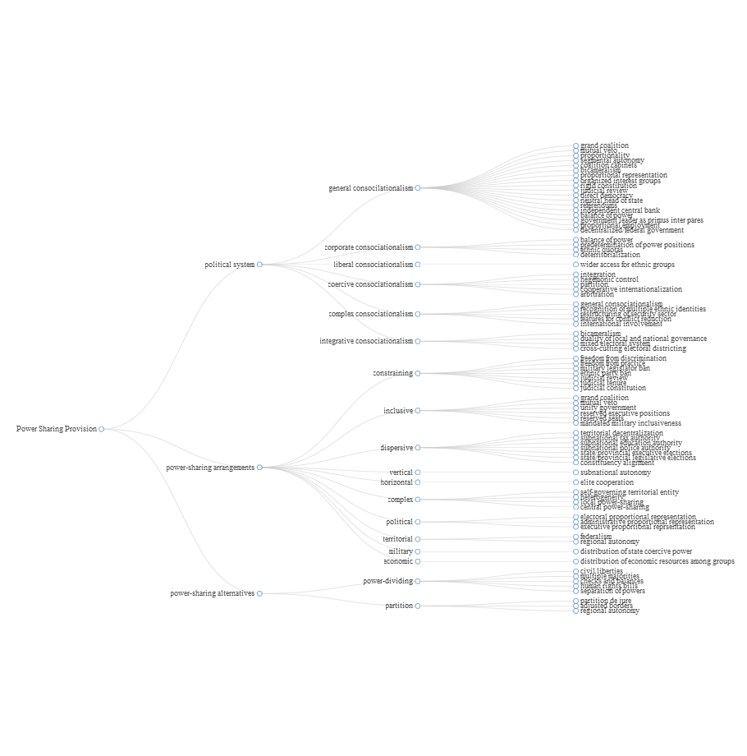 ### Note: This ontology is a work in progress.