tjbrailey_wrangle_data

POLI 191A/B

Thomas Brailey

13/09/2019

# Load Data

# set working directory.   
wd <- paste0(here::here(), '/data/')   
  
# parse out .xlsx worksheets   
files <- list.files(paste0(wd, 'PSED_agreement.xlsx'))  
files <- files[]  
  
read_excel_allsheets <- function(filename) {   
 sheets <- readxl::excel_sheets(filename)   
 x <- lapply(sheets, function(x) readxl::read_excel(filename, sheet = x))   
 names(x) <- sheets   
 x   
}   
  
out <- lapply(paste0(here::here(), '/data/PSED_agreement.xlsx'), read_excel_allsheets)  
basename(files)

## character(0)

# install datasets.  
# power-sharing-specific datasets.  
#psed_prom <- out[[1]]$PSED_agreement_promises  
#psed_prac <- out[[1]]$PSED_agreement_practices  
idc <- rio::import(paste0(wd, 'IDC_country-year_v1_0.RData'))  
#impact <- rio::import(paste0(wd,'c_656154-l_1-k_impact--version2.0.csv'))  
dtd <- rio::import(paste0(wd,'Democracy Timeseries Data January 2009 Excel2007.csv'))  
#epr <- rio::import(paste0(wd,'data-epr_countryyear.csv'))  
#cah_pshare_and_dem <- rio::import(paste0(wd,'pshare_and_democracy_for_world_politics_publication.dta'))  
#cah_craft_peace <- rio::import(paste0(wd,'book_project_49_cases_long_time_version_feb_2004.dta'))  
#bumba <- rio::import(paste0(wd,'Bumba(peaceduration).RData'))  
pax <- rio::import(paste0(wd,'pax_20_02_2018_1_CSV.csv'))  
#di <- rio::import(paste0(wd,'Diplomatic Interventions data.dta'))  
#dme <- rio::import(paste0(wd,'DME data.dta'))  
  
# general datasets (the y value).  
vdem <- rio::import(paste0(wd,"V-Dem-CY-Full+Others-v9.csv"))  
dpi <- rio::import(paste0(wd,'DPI2012.xls'))  
#qog_cs <- rio::import(paste0(wd,'qog_std_cs_jan19.csv'))  
qog_ts <- rio::import(paste0(wd,'qog_std_ts_jan19.csv'))  
polityiv <- rio::import(paste0(wd,'p4v2017.xls'))  
ucdp <- rio::import(paste0(wd,'ucdp-prio-acd-191.xlsx'))  
wvs <- rio::import(paste0(wd, "F00008390-WVS_Longitudinal_1981_2016_r_v20180912.rds"))  
wvs <- dplyr::as_tibble(wvs)  
  
# clean workspace.  
rm(out, files, read_excel_allsheets)

# Set Baseline Data

tb <- idc  
  
tb$country[tb$country == "Cent. Af. Rep."] <- "Central African Republic"  
tb$country[tb$country == "Dom. Rep."] <- "Dominican Republic"  
tb$country[tb$country == "GDR"] <- "German Democratic Republic"  
tb$country[tb$country == "PRC"] <- "China"  
tb$country[tb$country == "ROK"] <- "South Korea"  
tb$country[tb$country == "S. Africa"] <- "South Africa"  
tb$country[tb$country == "Serbia and Montenegro"] <- "Montenegro"  
  
tb <- tb[!is.na(tb$country) & !is.na(tb$ifs),]  
  
tb$cowc <- countrycode::countrycode(tb$country, 'country.name', 'cowc')

## Warning in countrycode::countrycode(tb$country, "country.name", "cowc"): Some values were not matched unambiguously: Serbia

tb$cown <- countrycode::countrycode(tb$country, 'country.name', 'cown')

## Warning in countrycode::countrycode(tb$country, "country.name", "cown"): Some values were not matched unambiguously: Serbia

# Some values were not matched unambiguously: Serbia  
  
tb <- tb %>%  
 dplyr::select(country,   
 cowc,   
 cown,   
 year,   
 gwno,   
 ifs,   
 mveto,  
 gcman,  
 gcimp,  
 auton,  
 jrevman,  
 relconstd,  
 relconstp,  
 milleg,  
 partynoethnic,  
 jtenure,  
 jconst,  
 gcseats1,  
 gcseats2,  
 gcseats3,  
 unity,  
 resman,  
 resseats,  
 resseats2,  
 resseatsimp,  
 miman,  
 subtax,  
 subed,  
 subpolice,  
 state,  
 muni  
 )

## DTD (Norris, 2008)

dtd_psp_sub <- dtd %>%  
 dplyr::select(Nation,  
 Year,  
 Natcode,  
 NatWVS,  
 Natmap,  
 Natabrv,  
 Coalition,  
 coalition2,  
 coalitiongov,  
 VANstand,  
 Admin,  
 mixed,  
 proportional,  
 roseprop,  
 xrcomp  
 ) %>%  
 dplyr::rename(country = Nation,  
 year = Year)  
  
# Some values were not matched unambiguously:  
  
dtd_psp_sub$country <- countrycode::countrycode(dtd_psp_sub$country, 'country.name', 'country.name')

## Warning in countrycode::countrycode(dtd_psp_sub$country, "country.name", : Some values were not matched unambiguously:

dtd_psp_sub$cowc <- countrycode::countrycode(dtd_psp_sub$country, 'country.name', 'cowc')  
dtd_psp_sub$cown <- countrycode::countrycode(dtd_psp_sub$country, 'country.name', 'cown')   
  
dtd_psp_sub <- dtd_psp_sub %>%  
 dplyr::select(-country)

## PAX (Bell, C. and Badanjak, S., 2019)

pax_psp_sub <- pax %>%  
 dplyr::select(Con,  
 Dat,  
 Agt,  
 PpsAut,  
 TpsAut,  
 PpsEx,  
 CenBan,  
 PpsOro,  
 PpsOthPr,  
 StRef  
 ) %>%  
 dplyr::rename(country = Con,  
 year = Dat) %>%  
 dplyr::mutate(year = as.numeric(stringr::str_sub(year, start= -4))) %>%  
 dplyr::group_by(PpsAut,  
 TpsAut,  
 PpsEx,  
 CenBan,  
 PpsOro,  
 PpsOthPr,  
 StRef,   
 country, year) %>%  
 dplyr::summarise(Agt = paste(Agt, collapse=", ")) %>%   
 dplyr::ungroup() %>%  
 dplyr::mutate(country = sub("\\/.*", "", country)) %>%  
 dplyr::select(-Agt)  
  
# Some values were not matched unambiguously: Kurds-Kurdistan, United Nations  
# Some values were not matched unambiguously: Palestinian Territories, Serbia  
# Some values were not matched unambiguously: Palestinian Territories, Serbia  
  
pax_psp_sub$country <- countrycode::countrycode(pax_psp_sub$country, 'country.name', 'country.name')

## Warning in countrycode::countrycode(pax_psp_sub$country, "country.name", : Some values were not matched unambiguously: Kurds-Kurdistan, United Nations

pax_psp_sub$cown <- countrycode::countrycode(pax_psp_sub$country, 'country.name', 'cown')

## Warning in countrycode::countrycode(pax_psp_sub$country, "country.name", : Some values were not matched unambiguously: Palestinian Territories, Serbia

pax_psp_sub$cowc <- countrycode::countrycode(pax_psp_sub$country, 'country.name', 'cowc')

## Warning in countrycode::countrycode(pax_psp_sub$country, "country.name", : Some values were not matched unambiguously: Palestinian Territories, Serbia

pax_psp_sub <- pax_psp_sub %>%  
 dplyr::select(-country)

## V-Dem

vdem_psp_sub <- vdem %>%  
 dplyr::select(country_name, country_id, country_text_id, year, e_miinterc, e_civil_war) %>%   
 dplyr::rename(country = country_name)  
vdem_psp_sub$country <- countrycode::countrycode(vdem_psp_sub$country, 'country.name', 'country.name')

## Warning in countrycode::countrycode(vdem_psp_sub$country, "country.name", : Some values were not matched unambiguously: Republic of Vietnam, WÃ¼rtemberg

vdem_psp_sub$cown <- countrycode::countrycode(vdem_psp_sub$country, 'country.name', 'cown')

## Warning in countrycode::countrycode(vdem_psp_sub$country, "country.name", : Some values were not matched unambiguously: Brunswick, Hamburg, Hesse-Darmstadt, Hesse-Kassel, Hong Kong SAR China, Nassau, Oldenburg, Palestinian Territories, Piedmont-Sardinia, Saxe-Weimar-Eisenach, Serbia

vdem_psp_sub$cowc <- countrycode::countrycode(vdem_psp_sub$country, 'country.name', 'cowc')

## Warning in countrycode::countrycode(vdem_psp_sub$country, "country.name", : Some values were not matched unambiguously: Brunswick, Hamburg, Hesse-Darmstadt, Hesse-Kassel, Hong Kong SAR China, Nassau, Oldenburg, Palestinian Territories, Piedmont-Sardinia, Saxe-Weimar-Eisenach, Serbia

vdem_psp_sub <- vdem_psp_sub %>%  
 dplyr::select(-country)

## QoG

qog_ts_psp_sub <- qog_ts %>%  
 dplyr::select(ccode,   
 cname,   
 year,   
 fe_etfra,  
 iaep_ebbp,  
 gle_gdp,  
 bti_ci,  
 cspf_sfi,  
 gtm_unit,  
 ccp_hr,  
 ffp_hr,  
 iiag_phr,  
 dpi_housesys,  
 dpi_sensys,  
 jw_bicameral,  
 bti_ig,  
 vdem_partipdem,  
 iaep_nr,  
 bti_sop,  
 gol_est,  
 gol_mt,  
 iaep_es,  
 no_ef,  
 no_ce,  
 iaep_eccdt,  
 iaep_ecdl,  
 iaep_eml,  
 iaep_epmf,  
 iaep_evp,  
 iaep_lcre,  
 iaep_lego,  
 iaep_lrit,  
 wbgi_pve  
 ) %>%  
 dplyr::rename(country = cname)  
qog_ts_psp_sub$country[qog_ts_psp_sub$country == "Micronesia"] <- "Federated States of Micronesia"  
qog_ts_psp_sub$country[qog_ts_psp_sub$country == "Serbia and Montenegro"] <- "Montenegro"  
qog_ts_psp_sub$country <- countrycode::countrycode(qog_ts_psp_sub$country, 'country.name', 'country.name')

## Warning in countrycode::countrycode(qog_ts_psp_sub$country, "country.name", : Some values were not matched unambiguously: Tibet

qog_ts_psp_sub$cown <- countrycode::countrycode(qog_ts_psp_sub$country, 'country.name', 'cown')

## Warning in countrycode::countrycode(qog_ts_psp_sub$country, "country.name", : Some values were not matched unambiguously: Serbia

qog_ts_psp_sub$cowc <- countrycode::countrycode(qog_ts_psp_sub$country, 'country.name', 'cowc')

## Warning in countrycode::countrycode(qog_ts_psp_sub$country, "country.name", : Some values were not matched unambiguously: Serbia

qog_ts_psp_sub <- qog_ts_psp_sub %>%  
 dplyr::select(-country)

## DPI

dpi_psp_sub <- dpi %>%  
 dplyr::select(countryname,   
 year,  
 system,  
 pr,  
 sensys,  
 eiec  
 ) %>%  
 dplyr::rename(country = countryname) %>%  
 dplyr::mutate(year = as.numeric(year))  
dpi_psp_sub$country[dpi_psp_sub$country == "Cent. Af. Rep."] <- "Central African Republic"  
dpi_psp_sub$country[dpi_psp_sub$country == "Dom. Rep."] <- "Dominican Republic"  
dpi_psp_sub$country[dpi_psp_sub$country == "GDR"] <- "German Democratic Republic"  
dpi_psp_sub$country[dpi_psp_sub$country == "PRC"] <- "China"  
dpi_psp_sub$country[dpi_psp_sub$country == "PRK"] <- "North Korea"  
dpi_psp_sub$country[dpi_psp_sub$country == "ROK"] <- "South Korea"  
dpi_psp_sub$country[dpi_psp_sub$country == "S. Africa"] <- "South Africa"  
dpi_psp_sub$country <- countrycode::countrycode(dpi_psp_sub$country, 'country.name', 'country.name')  
dpi_psp_sub$cowc <- countrycode::countrycode(dpi_psp_sub$country, 'country.name', 'cowc')  
dpi_psp_sub$cown <- countrycode::countrycode(dpi_psp_sub$country, 'country.name', 'cown')  
  
dpi_psp_sub <- dpi_psp_sub %>%  
 dplyr::select(-country)

## World Value Survery

wvs_psp_sub <- wvs %>%   
 dplyr::select(S003, S020,  
 A035,  
   
 A124_01, A124_02,A124_03,A124_04,A124_05,A124_06,A124_07,A124_08,A124_09,A124_10,A124_11,A124_12,A124_13,A124_14,A124_15,A124_16,A124_17,A124_18,A124_19,A124_20,A124_21,A124_22,A124_23,A124_24,A124_25,A124_27,A124_28,A124_29,A124_30,A124_31,A124_32,A124_33,A124_34,A124_35,A124_36,A124_37,A124_38,A124_42,A124_43,A124_45,A124_46,A124_47,A124_48,A124_49,A124_50,A124_51,A124_52,A124_53,A124_54,A124_55,A124_56,A124_57,A124_58,A124_59,A124_60,A124_61,  
   
E069_11, E069_12,  
  
E114, E115, E116, E117,  
  
E124)  
  
wvs_psp_sub[wvs_psp_sub == -4] <- NA  
  
wvs_psp_sub$country <- countrycode::countrycode(wvs$S003, "iso3n", "country.name", nomatch = "unknown")  
wvs_psp_sub$cowc <- countrycode::countrycode(wvs$S003, "iso3n", "cowc")

## Warning in countrycode::countrycode(wvs$S003, "iso3n", "cowc"): Some values were not matched unambiguously: 101, 275, 344, 630, 688, 914

wvs_psp_sub$cown <- countrycode::countrycode(wvs$S003, "iso3n", "cown")

## Warning in countrycode::countrycode(wvs$S003, "iso3n", "cown"): Some values were not matched unambiguously: 101, 275, 344, 630, 688, 914

wvs_psp_sub <- wvs_psp_sub %>%  
 dplyr::select(-country)  
  
  
wvs_n_per_year <- wvs_psp_sub %>%  
 dplyr::group_by(S020) %>%  
 dplyr::summarize(obs=n())

## Warning: Calling `n()` without importing or prefixing it is deprecated, use `dplyr::n()`.  
## This warning is displayed once per session.

wvs_n_by_country <- wvs_psp_sub %>%  
 dplyr::group_by(S020, cowc) %>%  
 dplyr::summarize(states = n())

# Join Data

tb_1 <- dplyr::left_join(tb, dtd_psp_sub, by = c("cown", "cowc", "year"))  
tb_2 <- dplyr::left_join(tb_1, qog_ts_psp_sub, by = c("cown", "cowc", "year"))  
tb_3 <- dplyr::left_join(tb_2, pax_psp_sub, by = c("cown", "cowc", "year"))  
tb_4 <- dplyr::left_join(tb_3, dpi_psp_sub, by = c("cown", "cowc", "year"))  
tb_5 <- dplyr::left_join(tb_4, vdem_psp_sub, by = c("cown", "cowc", "year"))  
  
# Collapse duplicate country/years whie retaining values.  
tb_6 <- tb_5 %>%   
 dplyr::group_by(country, year) %>%  
 dplyr::summarise_all(dplyr::funs(dplyr::first(na.omit(.))))

## Warning: funs() is soft deprecated as of dplyr 0.8.0  
## Please use a list of either functions or lambdas:   
##   
## # Simple named list:   
## list(mean = mean, median = median)  
##   
## # Auto named with `tibble::lst()`:   
## tibble::lst(mean, median)  
##   
## # Using lambdas  
## list(~ mean(., trim = .2), ~ median(., na.rm = TRUE))  
## This warning is displayed once per session.

saveRDS(tb_6, paste0(here::here(), '/data/tjbrailey_psp.rds'))  
  
rm(tb_1, tb_2, tb_3, tb_4, tb_5)

# Visualize Data

DataExplorer::plot_missing(tb_6)

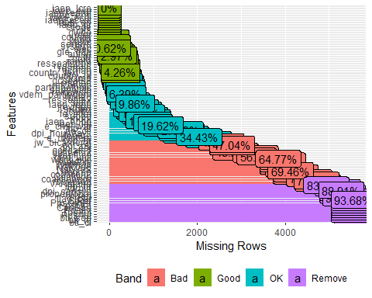

DataExplorer::plot_histogram(tb_6)

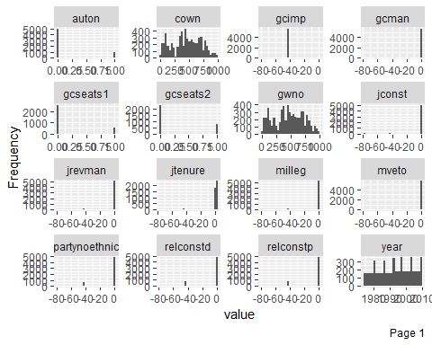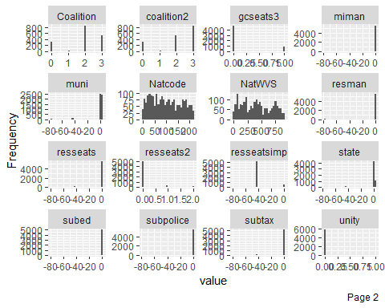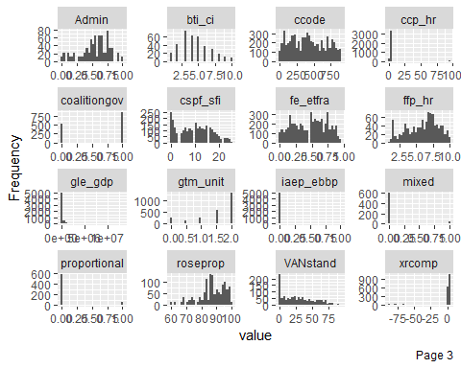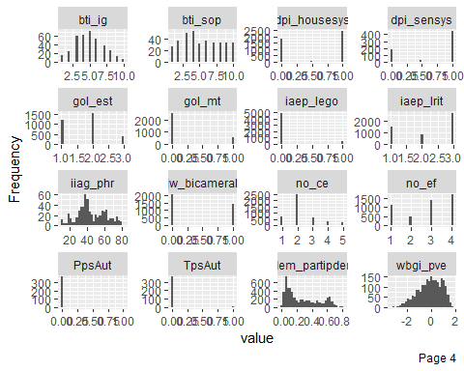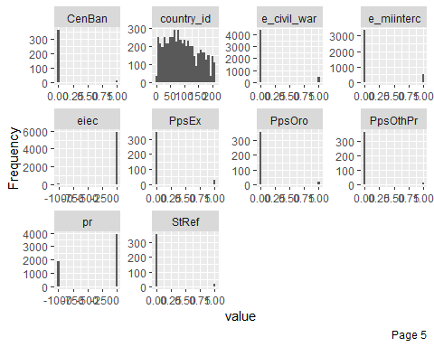

png(file = paste0(here::here(), '/vis/tjbrailey_psp_datexp.png'),  
 width = 2000,  
 height = 1000)  
DataExplorer::plot_missing(tb_6)  
dev.off()

## png   
## 2

Amelia::missmap(tb_6)

## Warning in if (class(obj) == "amelia") {: the condition has length > 1 and  
## only the first element will be used

## Warning: Unknown or uninitialised column: 'arguments'.  
  
## Warning: Unknown or uninitialised column: 'arguments'.

## Warning: Unknown or uninitialised column: 'imputations'.

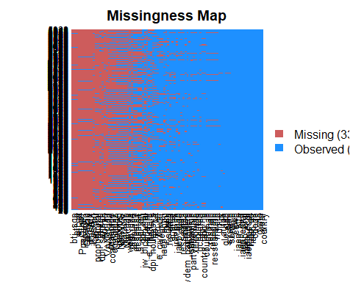

png(file = paste0(here::here(), "/vis/tjbrailey_psp_missingness.png"),  
 width = 2000,   
 height = 1000)  
Amelia::missmap(tb_6)

## Warning in if (class(obj) == "amelia") {: the condition has length > 1 and  
## only the first element will be used

## Warning: Unknown or uninitialised column: 'arguments'.  
  
## Warning: Unknown or uninitialised column: 'arguments'.

## Warning: Unknown or uninitialised column: 'imputations'.

dev.off()

## png   
## 2