CIS 2987 — Capstone Project Weekly Update
AI-Powered Storytelling Tool for Nonprofits

Student: Thomas Brett | Week: 1 — Foundation
Course: CIS 2987 — CIS Capstone | Report Date: March 23, 2026
PM Tool: ClickUp | Due Date: March 22, 2026

1. Detailed Task Breakdown (30-Minute Increments)
All tasks below are from the ClickUp list "Week 1 - Foundation" in the CIS Capstone space. Time estimates and actual time are pulled directly from ClickUp’s time tracking fields.
# | Task | Status | Est. Time | Actual Time | Variance
1 | Install Ollama and pull the LLaMA 3 model | Complete | 0:30 | 0:30 | On target
2 | Build a basic Flask web app skeleton | Complete | 0:45 | 0:45 | On target
3 | Build Step 1 screen — goal selection dropdown | Complete | 0:45 | 0:45 | On target
3a | ↳ Subtask: Create 'goals.py' | Complete | — | — | —
4 | Build Step 2 screen — audience selection dropdown | Complete | — | 0:45 | —
4a | ↳ Subtask: Create 'audiences.py' | Complete | — | — | —
5 | Store goal/audience as full config objects | Complete | — | — | —
 | Week 1 Total |  | 2:00+ | 2:45
Note: Subtask time is included within parent task totals. Tasks without explicit estimates were scoped during execution as part of parent tasks. All time tracked via ClickUp.

2. Weekly Reflections
What went well:
The initial tasks were not difficult and I have experience with both Ollama and Python.

Challenges encountered:
The “framework” or planning for the project structure was more difficult than expected. I needed to be deliberate with how I structured it to create a solid baseline for the future.

Noteworthy items:
Using Claude to generate these reports from ClickUp works really well.

3. Updated Project Timeline
The table below shows the planned vs. actual schedule for Week 1 tasks. All Week 1 tasks were completed on schedule (March 23, 2026).
Task | Planned Due | Actual Completion | Status
Install Ollama & pull LLaMA 3 | 03/23/2026 | 03/23/2026 | ✓ Complete
Build Flask web app skeleton | 03/23/2026 | 03/23/2026 | ✓ Complete
Step 1 — goal selection dropdown | 03/23/2026 | 03/23/2026 | ✓ Complete
Step 2 — audience selection dropdown | 03/23/2026 | 03/23/2026 | ✓ Complete
Store goal/audience as config objects | 03/23/2026 | 03/23/2026 | ✓ Complete
Timeline Revision Notes: No revisions needed. Week 1 completed on schedule. Remaining project phases (Weeks 2–6) remain as originally planned.

4. Proof of Completed Tasks
The following screenshots document task completion and are also stored as attachments on their respective ClickUp tasks.
Task 1: Install Ollama and pull the LLaMA 3 model
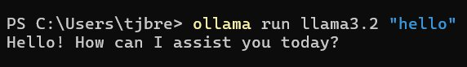
Task 2: Build a basic Flask web app skeleton
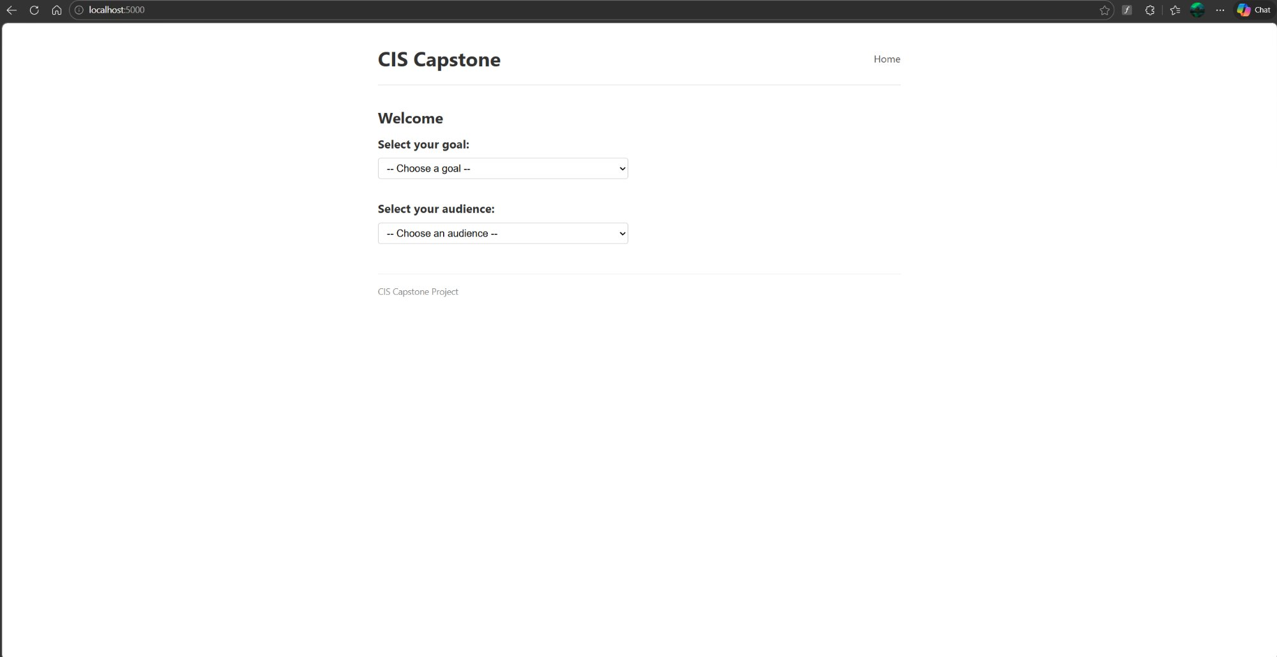

Task 3: Build Step 1 screen — goal selection dropdown
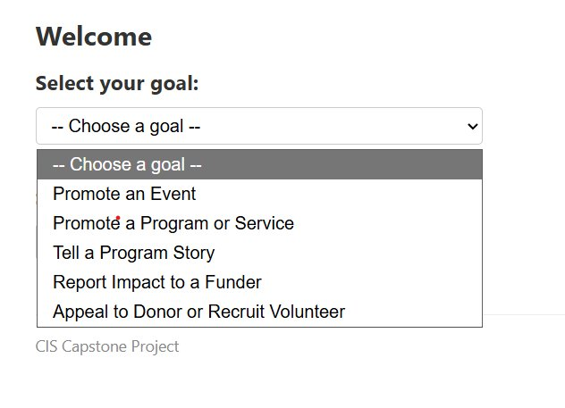
Task 4: Build Step 2 screen — audience selection dropdown
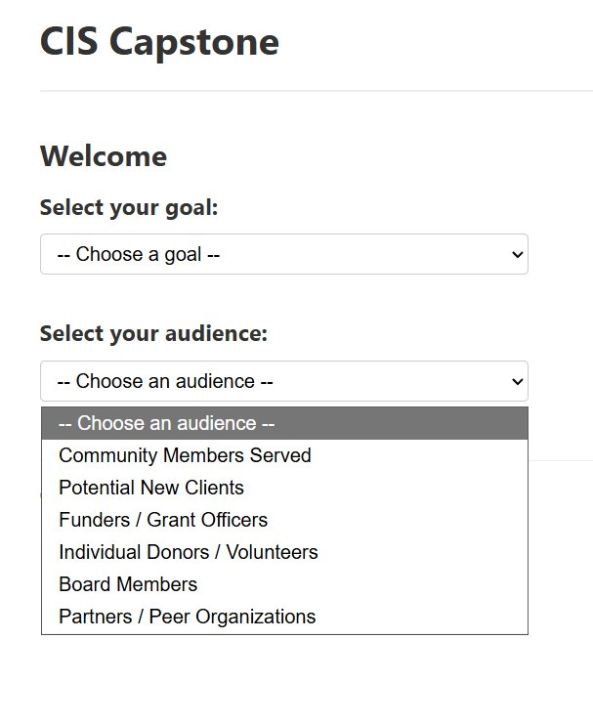
Full-resolution screenshots are also accessible via the linked ClickUp tasks. Project management data sourced from ClickUp (Space: CIS Capstone, List: Week 1 - Foundation).

5. Time Summary
Category | Hours This Week | Cumulative Hours
Development Tasks | 2:45 | 2:45
Project Management / Reporting | 0:30 | 0:30
Week 1 Total | 3:15 | 3:15
Project management/reporting time (0:30) includes updating ClickUp tasks, logging time, and preparing this weekly report, per capstone requirements.

Generated from ClickUp project management data — CIS Capstone Space, Week 1 - Foundation list. Thomas Brett | Lake Superior College | CIS 2987

