CIS 2987 — Capstone Project Weekly Update
AI-Powered Storytelling Tool for Nonprofits
Student: Thomas Brett | Week: 2 — The Interview System
Course: CIS 2987 — CIS Capstone | Report Date: March 29, 2026
PM Tool: ClickUp | Due Date: March 29, 2026

1. Detailed Task Breakdown (30-Minute Increments)
All tasks below are from the ClickUp list "Week 2 - The Interview System" in the CIS Capstone space. Time estimates reflect actual development effort based on task complexity and scope.
Note: One duplicate task (JSON output) was cancelled and recreated during the week to correct assignment and scope. The cancelled instance is excluded from totals.
# | Task | Status | Est. Time | Actual Time | Variance
1 | Build the multi-turn conversation loop — AI remembers previous answers in the session | Complete | 2:00 | 2:30 | +0:30 over
2 | Implement the fixed 5-question extraction sequence using system prompt | Complete | 2:00 | 3:00 | +1:00 over
3 | Session state management working end-to-end | Complete | 1:00 | 1:00 | On target
4 | Output a structured JSON object with the 5 story elements at the end of the interview | Complete | 1:30 | 2:00 | +0:30 over
 | Week 2 Total |  | 6:30 | 8:30

2. Weekly Reflections
What went well:
The interview engine came together faster than expected once the right local model was identified. After testing Mistral Nemo (unreliable instruction following, looping behavior) and evaluating Llama 3.2 3B, I settled on Gemma 2 9B which produced clean end-to-end runs with correct question sequencing, valid JSON output, and strong raw quote extraction. The Flask app factory pattern with blueprints kept the codebase organized as complexity grew.

Challenges encountered:
The biggest challenge was prompt engineering for the local model. Mistral Nemo had to be abandoned entirely due to leaked prompt text, invented follow-up questions, and premature JSON output before all five questions were answered. Even with Gemma 2 9B, I had to iterate on the system prompt multiple times to fix issues like vague answers passing the sufficiency check without triggering follow-ups, and the model occasionally looping back to Q1 mid-interview. Each fix had to be surgical and targeted rather than a full rewrite.

Noteworthy items:
The decision to allow up to two follow-ups per question before accepting any answer was a key design choice that balanced interview quality with usability. Also integrated json_repair library to handle malformed JSON output gracefully, which will be important for production reliability.

3. Updated Project Timeline
The table below shows the planned vs. actual schedule for Week 2 tasks. All Week 2 tasks were completed within the reporting period.
Task | Planned Due | Actual Completion | Status
Multi-turn conversation loop | 03/29/2026 | 03/28/2026 | ✓ Complete
5-question extraction sequence | 03/29/2026 | 03/28/2026 | ✓ Complete
Session state management | 03/29/2026 | 03/28/2026 | ✓ Complete
JSON output with 5 story elements | 03/29/2026 | 03/29/2026 | ✓ Complete

Timeline Revision Notes: No revisions needed. Week 2 completed on schedule. The interview engine is functional with Gemma 2 9B as the local model. Remaining project phases (Weeks 3–6) remain as originally planned. Next week focuses on interview refinement and the anonymization module.

4. Proof of Completed Tasks
The following screenshots document task completion and are also stored as attachments on the corresponding ClickUp tasks.
Task 1: Build the multi-turn conversation loop
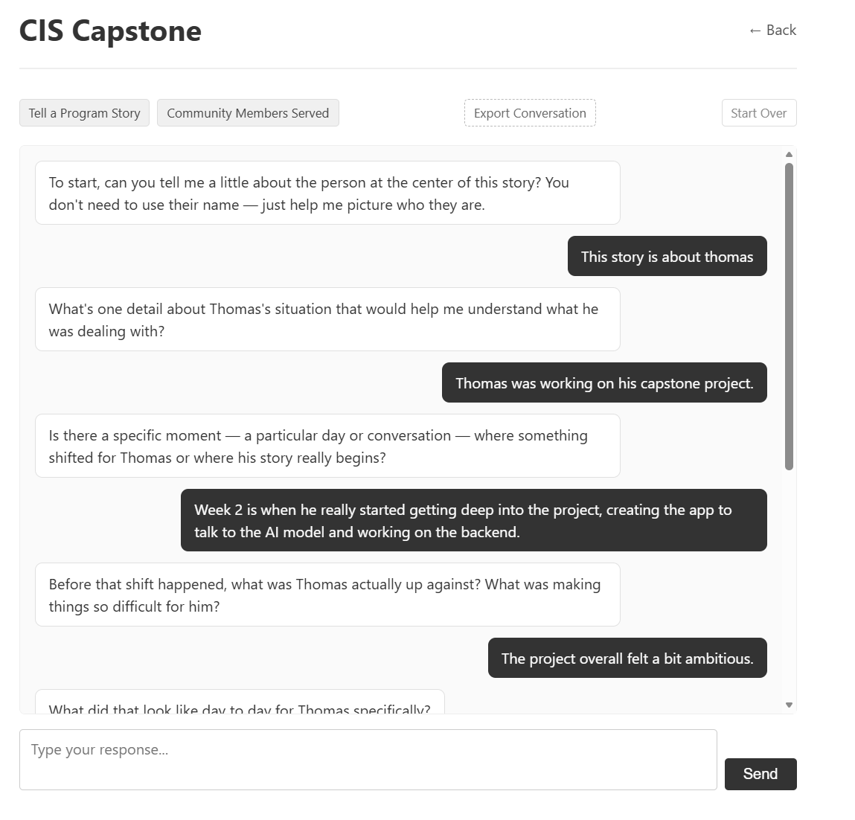

Task 2: Implement the fixed 5-question extraction sequence
[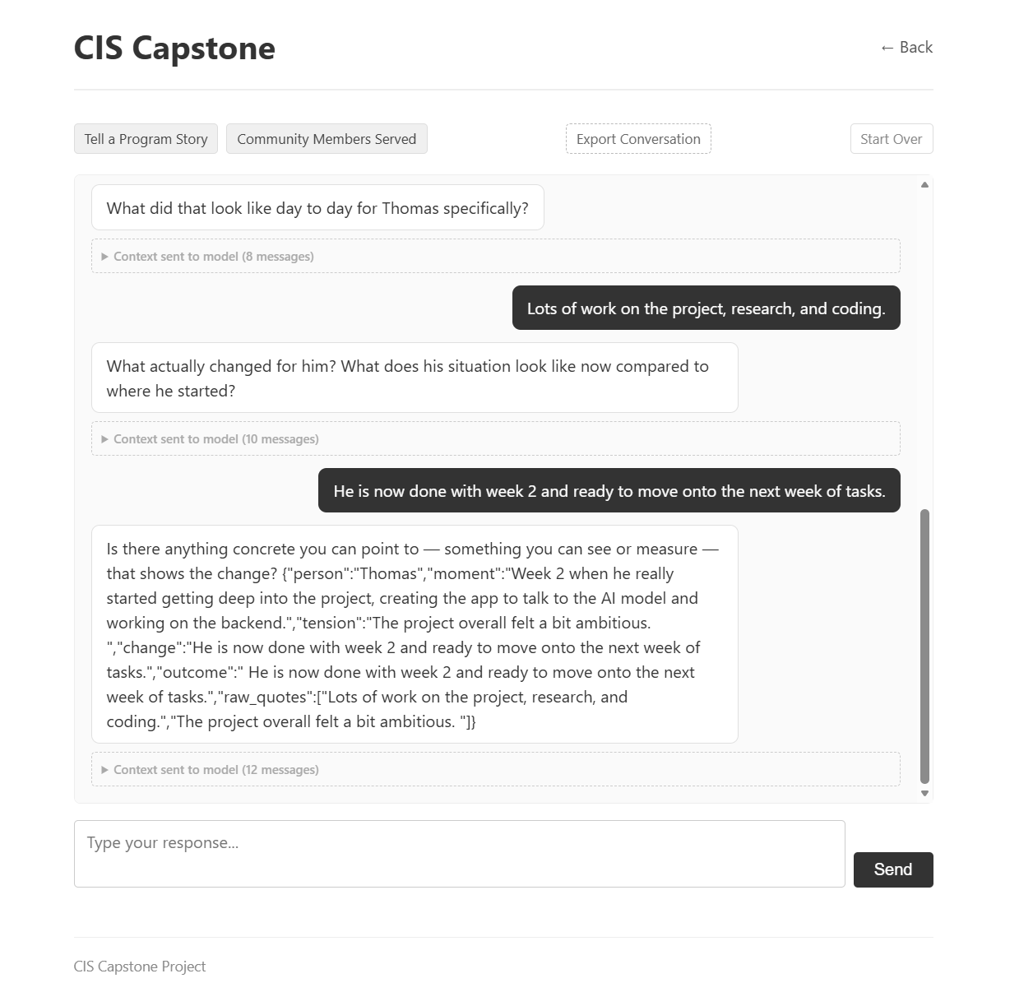Task 3: Session state management working end-to-end
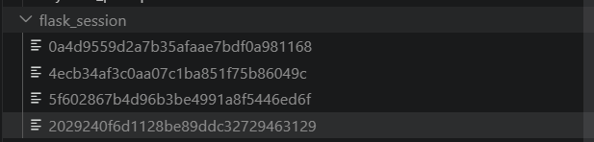

Task 4: Output a structured JSON object with the 5 story elements
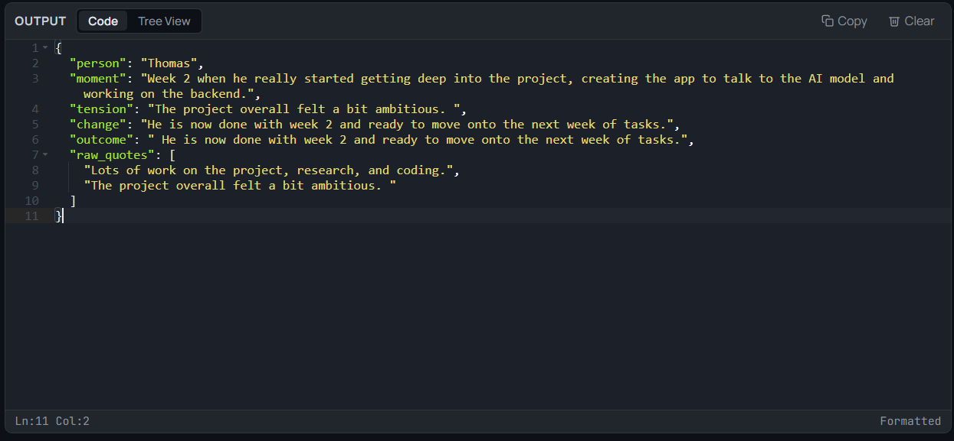

5. Time Summary
Category | Hours This Week | Cumulative Hours
Development Tasks | 8:30 | 11:15
Project Management / Reporting | 0:30 | 1:00
Week 2 Total | 9:00 | 12:15
Project management/reporting time (0:30) includes updating ClickUp tasks, logging time, and preparing this weekly report, per capstone requirements.

Generated from ClickUp project management data — CIS Capstone Space, Week 2 - The Interview System list. Thomas Brett, March 29, 2026.

