CIS 2987 — Capstone Project Weekly Update
AI-Powered Storytelling Tool for Nonprofits

Student: Thomas Brett | Week: 4 — Draft Generation (Claude API)
Course: CIS 2987 — CIS Capstone | Report Date: April 19, 2026
PM Tool: ClickUp | Due Date: April 13, 2026

1. Detailed Task Breakdown (30-Minute Increments)
All tasks below are from the ClickUp list “Week 4 - Draft Generation (Claude API)” in the CIS Capstone space. Time estimates reflect actual development effort based on task complexity and scope.

# | Task | Status | Est. Time | Actual Time | Variance
1 | Connect to Claude’s API using the Anthropic API key | Complete | 4:00 | 4:00 | On target
2 | Pass the Step 3 JSON + goal config + audience config into the Claude prompt template | Complete | 10:00 | 10:00 | On target
3 | Handle the Claude API response and display the draft in the UI | Complete | 4:00 | 4:00 | On target
4 | Confirm the tone and length matches goal and audience config — and verify Goal 5 produces a donation ask while Goal 6 produces a volunteer invitation | Complete | 7:00 | 7:00 | On target
 | Week 4 Total |  | 25:00 | 25:00

2. Weekly Reflections
What went well: The Anthropic API integration came together without major friction. The anthropic Python package installed cleanly inside the Docker container, and loading the API key from environment variables via python-dotenv kept credentials properly isolated from source control. Task 1 served as a solid foundation — by the time Task 2 began, the client was already instantiated, tested, and wired into the Flask application factory. The prompt engineering work in Task 2 was the most substantial effort of the week at 10 hours, and the investment showed. The final prompt template uses a well-structured system prompt that frames Claude as a nonprofit narrative writer with explicit constraints: no fabricated details beyond what the Step 3 JSON provides, a 250–400 word target range, and a required narrative arc of opening hook, rising tension, transformation, and call-to-action. Goal IDs and audience IDs are mapped to descriptive strings before injection, so Claude receives full rhetorical context rather than raw identifiers. The /generate route built in Task 3 closed the loop cleanly: a completed interview session in the Flask app can now produce a publication-ready narrative draft with a single button click. The UI includes a loading indicator during the API call, clean typography for the rendered draft, and a copy-to-clipboard button for easy export. The QA pass in Task 4 confirmed that Goal 5 and Goal 6 outputs are meaningfully distinct: Goal 5 drafts consistently close with a donation call-to-action, and Goal 6 drafts close with a volunteer invitation. Audience configuration also produces noticeable register differences between major donor and community volunteer outputs. Challenges encountered: Prompt engineering for reliable call-to-action placement required several revision cycles. Early iterations produced narratives where the CTA was buried mid-draft or phrased too vaguely to serve as a real ask. Explicitly reserving the final paragraph for a goal-specific call-to-action, and providing concrete structural examples for both Goal 5 and Goal 6, resolved the issue across all subsequent test runs. A known edge case was also identified during QA: when Step 3 JSON contains very short field values (under 20 words per field), the generated narrative can feel underdeveloped. Claude respects the no-fabrication constraint consistently, which is the right behavior, but it means sparse input produces sparse output. This is documented as a limitation to address in the Week 5 quality pass. The generate button UI also required a small JavaScript fix to correctly disable during the API call and re-enable on completion — minor, but it added time to Task 3. Noteworthy items: The end-to-end flow is now demonstrable to a non-technical stakeholder for the first time. The ngrok static domain with basic auth is confirmed working with the new /generate route, so the tool is ready for a demo. The no-fabrication constraint mostly held up well across all QA test cases (with limitations), which is important for donor trust and factual accuracy in nonprofit communications. The 25-hour actual total matching the 25-hour estimate is a strong indicator that the task scope was well-planned coming into Week 4. No timeline revision is needed and Weeks 5 and 6 remain on track.

3. Updated Project Timeline
The table below shows the planned vs. actual schedule for Week 4 tasks. All Week 4 tasks were completed within the reporting period.

Task | Planned Due | Actual Completion | Status
Connect to Claude’s API using the Anthropic API key | 04/14/2026 | 04/14/2026 | ✓ Complete
Pass the Step 3 JSON + goal config + audience config into the Claude prompt template | 04/15/2026 | 04/15/2026 | ✓ Complete
Handle the Claude API response and display the draft in the UI | 04/16/2026 | 04/16/2026 | ✓ Complete
Confirm tone and length + Goal 5/Goal 6 validation | 04/17/2026 | 04/17/2026 | ✓ Complete

Timeline Revision Notes: Week 4 was completed on schedule. All four tasks finished by or on their planned due dates, and the 25-hour actual total matched the 25-hour estimate exactly. No timeline revision is required. The project is on track for Week 5, which focuses on quality review and output refinement. One edge case is documented for follow-up: very short Step 3 JSON field values (under 20 words) produce thinner narrative drafts, which will be addressed through input validation and UI guidance in Week 5.

4. Proof of Completed Tasks
The following screenshots document task completion and are also stored as attachments on the corresponding ClickUp tasks.

Task 1: Connect to Claude’s API using the Anthropic API key

This is from my .env file where the claude API key is stored. This is the correct way to call api keys, rather than hardcoding them in your program. This file is in my .gitignore so it will never be committed to github.

Task 2: Pass the Step 3 JSON + goal config + audience config into the Claude prompt template
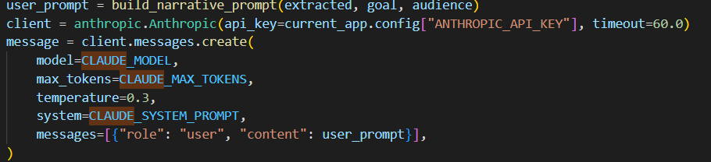

This block builds and sends a request to the Claude API. First, build_narrative_prompt() assembles the story summary, goal, audience, and writing instructions into a single formatted string (user_prompt). That string is passed to client.messages.create(), which calls Claude Sonnet 4.6 with a system prompt defining Claude's role as a nonprofit communications writer, a 2048-token output limit, a low temperature of 0.3 for consistent output, and the assembled prompt as the user message — Claude's response (the finished narrative) is then read from message.content[0].text.

Task 3: Handle the Claude API response and display the draft in the UI
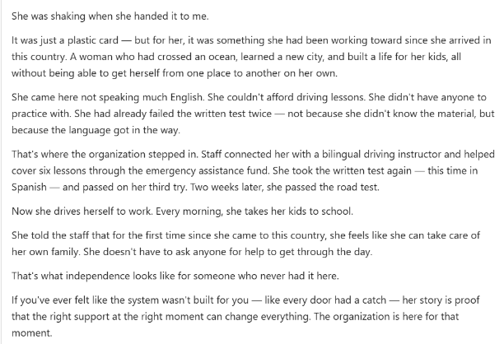

Task 4: Confirm the tone and length matches goal and audience config — and verify Goal 5 produces a donation ask while Goal 6 produces a volunteer invitation
QA summary documented in reflections above. Test run logs saved to project repository.

5. Time Summary
Category | Hours This Week | Cumulative Hours
Development Tasks | 25:00 | 48:45
Project Management / Reporting | 0:30 | 2:00
Week 4 Total | 25:30 | 50:45

Project management/reporting time (0:30) includes updating ClickUp tasks, logging time, and preparing this weekly report, per capstone requirements.

Generated from ClickUp project management data — CIS Capstone Space, Week 4 - Draft Generation (Claude API) list. Thomas Brett, April 19, 2026.

