CIS 2987 — Capstone Project Weekly Update
AI-Powered Storytelling Tool for Nonprofits

Student: Thomas Brett | Week: 5 — Quality Check + Output
Course: CIS 2987 — CIS Capstone | Report Date: April 26, 2026
PM Tool: ClickUp | Due Date: April 20, 2026

1. Detailed Task Breakdown (30-Minute Increments)
All tasks below are from the ClickUp list “Week 5 - Quality Check + Output” in the CIS Capstone space.

# | Task | Status | Est. Time | Actual Time | Variance
1 | Connect Steps 5 and 6 into the full pipeline | Complete | 6:00 | 6:00 | On target
2 | Build the clean output screen — copy-paste ready narrative | Complete | 4:00 | 4:00 | On target
3 | Build the Flesch readability score on the final draft | Complete | 2:00 | 2:00 | On target
4 | Build PII detection — flag names, locations, and identifying details in the draft | Complete | 3:00 | 3:00 | On target
 | Week 5 Total |  | 15:00 | 15:00

2. Weekly Reflections
What went well: The application reached a fully integrated, demonstrable state this week. Step 4 output now flows automatically through the Flesch scorer (Step 5) into the clean output screen (Step 6) with no manual steps between them. The Flesch scorer wraps textstat’s flesch_reading_ease() and maps the raw score to one of seven grade bands (4th–5th grade at 90+ down to college graduate below 30). It then parses the audience’s target grade range from the config string and compares the two using overlap logic, returning one of three match states — too_simple, too_complex, or matches — with a plain-language summary the staff member can act on without interpreting a raw number. The PII scanner uses a hybrid approach — Presidio for names, locations, and contact info, plus six custom regex layers covering relationship-name patterns, facility keywords, court and case references, medication and diagnosis language, immigration and legal-status phrases, and date-plus-event combinations at the sentence level. Each finding includes a category label, a plain-English reason, and a suggested replacement; overlapping flags deduplicate with more specific categories winning. The scanner deliberately errs toward over-flagging, since a false positive takes seconds to dismiss while a missed disclosure causes real harm. Challenges encountered: Managing Flask session state across the pipeline routes required care — the draft and readability score are stored in session after generation so downstream routes stay idempotent. On the PII scanner, short all-caps tokens were being misclassified as LOCATION entities by Presidio; these are now reclassified as potential initials or nicknames. A pronoun blacklist prevents common sentence-start words from being captured as names by the relationship-name regex. The Presidio engine is loaded at app boot via a warmup() call to avoid a delay on the first scan request. Noteworthy items: The full flow works end-to-end in Docker and is accessible via the ngrok static domain. The tool is demo-ready ahead of Week 6, which will focus on testing, documentation, and the final capstone write-up.

3. Updated Project Timeline
The table below shows the planned vs. actual schedule for Week 5 tasks. All tasks were completed within the reporting period.

Task | Planned Due | Actual Completion | Status
Connect Steps 5 and 6 into the full pipeline | 04/21/2026 | 04/20/2026 | ✓ Complete
Build the clean output screen — copy-paste ready narrative | 04/22/2026 | 04/21/2026 | ✓ Complete
Build the Flesch readability score on the final draft | 04/23/2026 | 04/22/2026 | ✓ Complete
Build PII detection — flag names, locations, and identifying details in the draft | 04/24/2026 | 04/23/2026 | ✓ Complete

Timeline Revision Notes: Week 5 was completed on schedule with all four tasks finishing one day ahead of their planned due dates. The project is on track for Week 6, which covers testing, documentation, and the final capstone write-up. No timeline revision is required.

4. Proof of Completed Tasks
The following screenshots document task completion and are stored as attachments on the corresponding ClickUp tasks.

Task 1: Build the Flesch readability score on the final draft
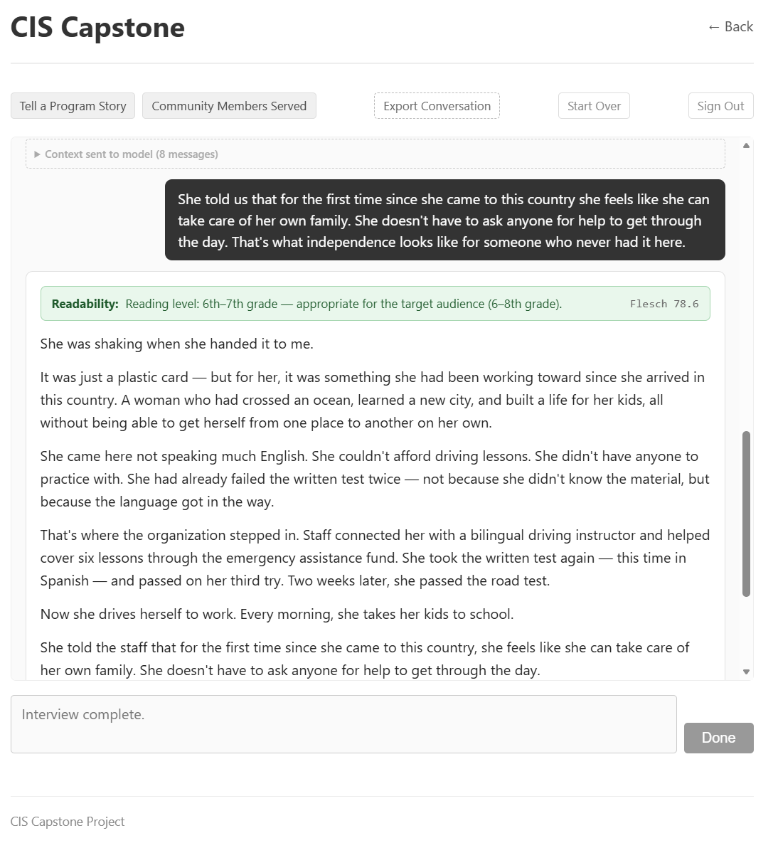

Task 2: Build PII detection — flag names, locations, and identifying details in the draft
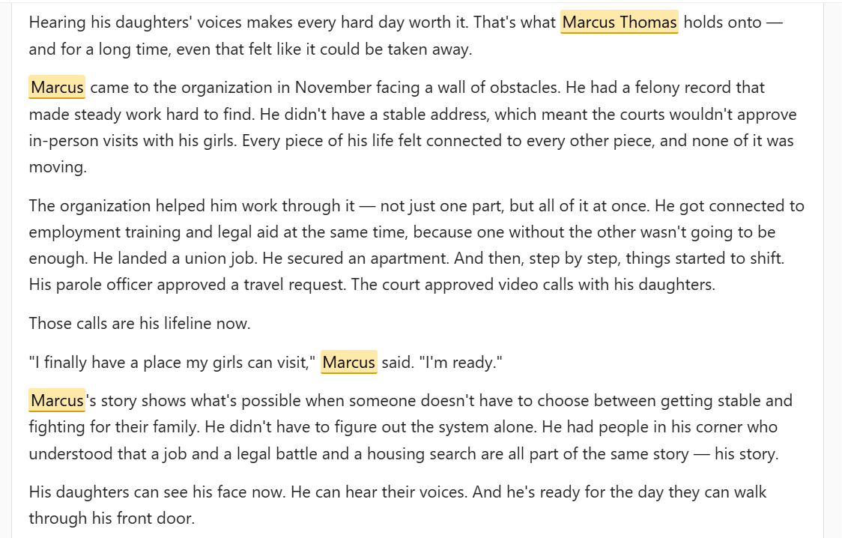
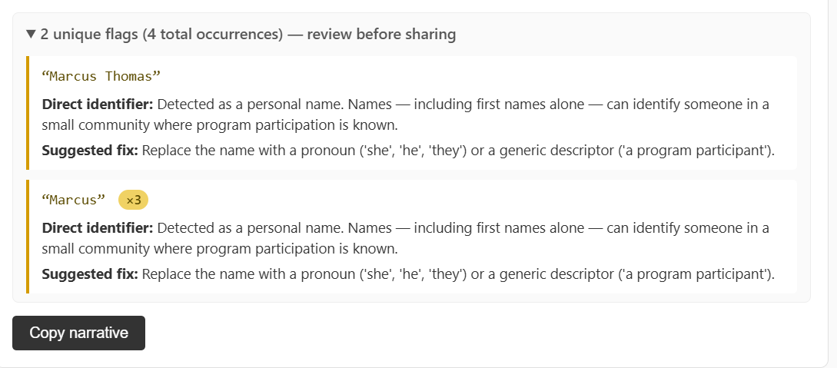

Task 3: Build the clean output screen — copy-paste ready narrative
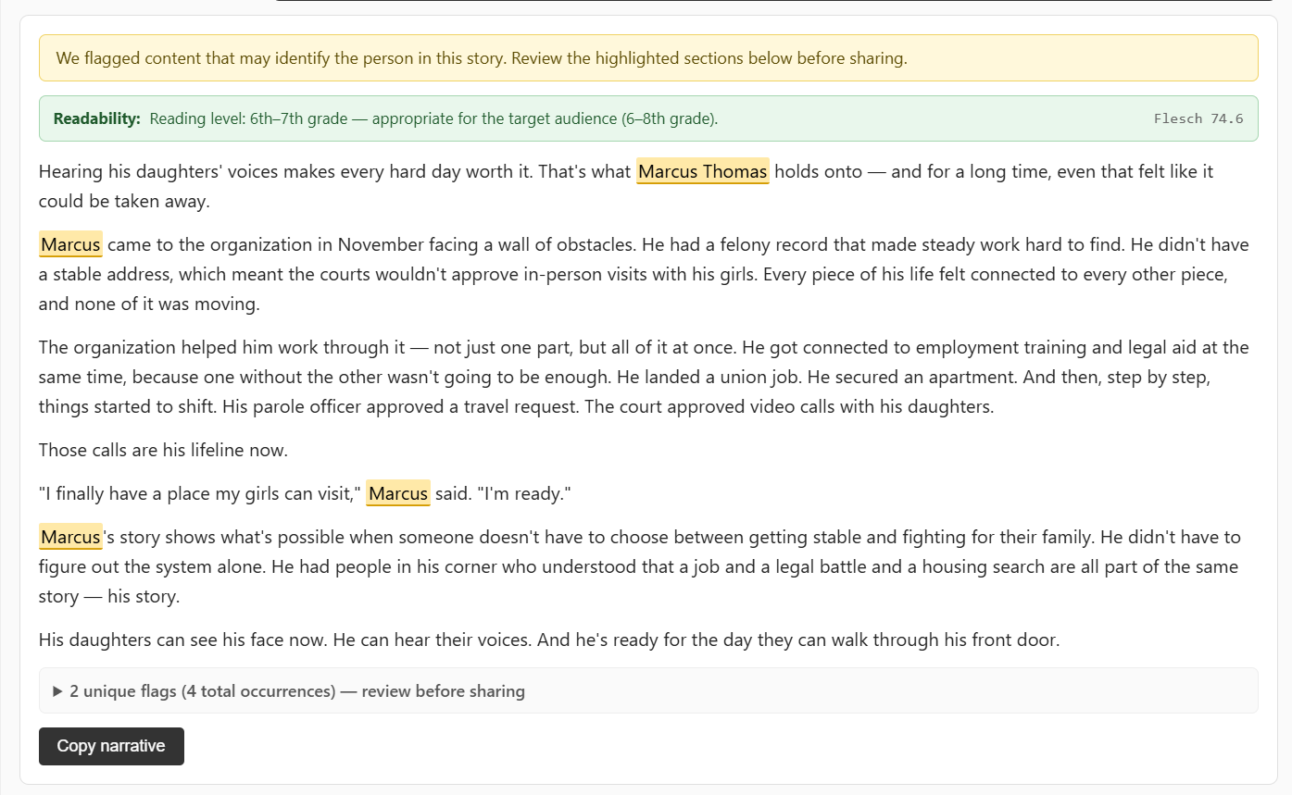

Task 4: Connect Steps 5 and 6 into the full pipeline
See above

5. Time Summary
Category | Hours This Week | Cumulative Hours
Development Tasks | 15:00 | 63:45
Project Management / Reporting | 0:30 | 2:30
Week 5 Total | 15:30 | 66:15

Project management/reporting time (0:30) includes updating ClickUp tasks, logging time, and preparing this weekly report, per capstone requirements.

Generated from ClickUp project management data — CIS Capstone Space, Week 5 - Quality Check + Output list. Thomas Brett, April 26, 2026.

