**Communications Management Plan**

**Online Hotel Management System**

**SUMMER2016 HOTEL**

**ROXAS BOULEVARD**

**Pasay City, Metro Manila**

**April 18, 2016**

**Table of Contents**

Introduction 2

Communications Management Approach 2

Communications Management Constraints 2

Stakeholder Communication Requirements 3

Roles 3

Project Team Directory 6

Communication Methods and Technologies 6

Communications Matrix 8

Communication Flowchart 9

Guidelines for Meetings 9

Communication Standards 10

Communication Escalation Process 13

Glossary of Communication Terminology 14

# Introduction

This Communications Management Plan sets the communications framework for this project. It will serve as a guide for communications throughout the life of the project and will be updated as communication needs change. This plan identifies and defines the roles of persons involved in this project. It also includes a communications matrix which maps the communication requirements of this project. An in-depth guide for conducting meetings details both the communications rules and how the meetings will be conducted, ensuring successful meetings. A project team directory is included to provide contact information for all stakeholders directly involved in the project.

# 

# Communications Management Approach

The Project Manager will take a proactive role in ensuring effective communications on this project. The communications requirements are documented in the Communications Matrix presented in this document. The Communications Matrix will be used as the guide for what information to communicate, who is to do the communicating, when to communicate it and to whom to communicate.

As with most project plans, updates or changes may be required as the project progresses or changes are approved. Changes or updates may be required due to changes in personnel, scope, budget, or other reasons. Additionally, updates may be required as the project matures and additional requirements are needed. The project manager is responsible for managing all proposed and approved changes to the communications management plan. Once the change is approved, the project manager will update the plan and supporting documentation and will distribute the updates to the project team and all stakeholders. This methodology is consistent with the project’s Change Management Plan and ensures that all project stakeholders remain aware and informed of any changes to communications management.

# 

# Communications Management Constraints

All project communication activities will occur within the project’s approved budget, schedule, and resource allocations. The project manager is responsible for ensuring that communication activities are performed by the project team and without external resources which will result in exceeding the authorized budget. Communication activities will occur in accordance with the frequencies detailed in the Communication Matrix in order to ensure the project adheres to schedule constraints. Any deviation of these timelines may result in excessive costs or schedule delays and must be approved by the project sponsor.

Summer2016 Hotel organizational policy states that where applicable, standardized formats and templates must be used for all formal project communications. The details of these policy requirements are provided in the section titled “Standardization of Communication” in this document.

Summer2016 Hotel organizational policy also states that only a Finance and Administrative Officer or higher level employee may authorize the distribution of confidential information. The project manager is responsible for ensuring that approval is requested and obtained prior to the distribution of any confidential information regarding this project.

# 

# Stakeholder Communication Requirements

As part of identifying all project stakeholders, the project manager will communicate with each stakeholder in order to determine their preferred frequency and method of communication. This feedback will be maintained by the project manager in the project’s Stakeholder Register. Standard project communications will occur in accordance with the Communication Matrix; however, depending on the identified stakeholder communication requirements, individual communication is acceptable and within the constraints outlined for this project.

In addition to identifying communication preferences, stakeholder communication requirements must identify the project’s communication channels and ensure that stakeholders have access to these channels. If project information is communicated via secure means or through internal company resources, all stakeholders, internal and external, must have the necessary access to receive project communications.

Once all stakeholders have been identified and communication requirements are established, the project team will maintain this information in the project’s Stakeholder Register and use this, along with the project communication matrix as the basis for all communications.

# Roles

**Project Sponsor**

The project sponsor is the champion of the project and has authorized the project by signing the project charter. This person is responsible for the funding of the project and is ultimately responsible for its success. Since the Project Sponsor is at the executive level communications should be presented in summary format unless the Project Sponsor requests more detailed communications.

* Jose Bautista – Finance and Admin Officer

**Key Stakeholders**

Normally Stakeholders includes all individuals and organizations who are impacted by the project. For this project we are defining a subset of the stakeholders as Key Stakeholders. These are the stakeholders with whom we need to communicate with and are not included in the other roles defined in this section. The Key Stakeholders includes executive management with an interest in the project and key users identified for participation in the project.

* Dr. Lorena Rabago as the President/CEO of the Summer2016 Hotel and all Stakeholders

**Change Control Board**

The Change Control Board is a designated group which is reviews technical specifications and authorizes changes within the organizations infrastructure. Technical design documents, user impact analysis and implementation strategies are typical of the types of communication this group requires.

|  |  |  |
| --- | --- | --- |
| **Name** | **Position** | **CCB Role** |
| Jose Bautista | Project Sponsor | CCB Chair |
| Benedicto Balilo Jr | Project Manager | CCB Co-Chair |
| Adomar Ilao | Deputy Project Manager | CCB Member |
| Zhella Anne Nisperos | Quality Assurance Chief | CCB Member |

# 

# Change Control Process

The Change Control Process for the IS Project will follow the organizational standard change process for all projects. The project manager has overall responsibility for executing the change management process for each change request.

1. Identify the need for a change (Stakeholders) – Change requestor will submit a completed change request form to the project manager.
2. Log change in the change request register (Project Manager) – The project manager will keep a log of all submitted change requests throughout the project’s lifecycle.
3. Evaluate the change (Project Manager, Team, Requestor) – The project manager will conduct a preliminary analysis on the impact of the change to risk, cost, schedule, and scope and seek clarification from team members and the change requestor.
4. Submit change request to CCB (Project Manager) – The project manager will submit the change request, as well as the preliminary analysis, to the CCB for review.
5. Obtain Decision on change request (CCB) – The CCB will discuss the proposed change and decide whether or not it will be approved based on all submitted information.
6. Implement change (Project Manager) – If a change is approved by the CCB, the project manager will update and re-baseline project documentation as necessary.

**Project Manager**

The Project Manager has overall responsibility for the execution of the project. The Project Manager manages day to day resources, provides project guidance and monitors and reports on the projects metrics as defined in the Project Management Plan. As the person responsible for the execution of the project, the Project Manager is the primary communicator for the project distributing information according to this Communications Management Plan. The PM is also responsible for approving that work activities meet established acceptability criteria and fall within acceptable variances. The PM will evaluate the performance of all project team members and communicate their performance to functional managers.

* Benedicto Balilo Jr – Project Manager

**Assistant Project Manager (APM**) or Deputy Project Manager, assists and prepares the project management plan and revision(s) thereto. Participate in and manages project planning activities, manages, reviews, and prioritizes the project work plans with objective to stay on time and on budget. Provides status and progress reviews to Sponsor and receives directions. Manages and supervises project team. Brings issues to the Sponsor as needed and makes recommendations. Identifies required project team members and forms project team. Motivates and coaches project team members. Monitors contract compliance. Manages change orders. Conducts risk management analysis. Meets facility and resource requirements. Reviews deliverables. Supervises the activities of the project team

* Adomar Ilao – Assistant Project manager

**Project Team**

The Project Team is comprised of all persons who have a role performing work on the project. The project team needs to have a clear understanding of the work to be completed and the framework in which the project is to be executed. Since the Project Team is responsible for completing the work for the project they played a key role in creating the Project Plan including defining its schedule and work packages. The Project Team requires a detailed level of communications which is achieved through day to day interactions with the Project Manager and other team members along with weekly team meetings based on Figure 1.0.



**Figure 1.0 IT Department Structure Channel of Communication**

**Steering Committee**

The Steering Committee includes management representing the departments which make up the organization. The Steering Committee provides strategic oversight for changes which impact the overall organization. The purpose of the Steering Committee is to ensure that changes within the organization are effected in such a way that it benefits the organization as a whole. The Steering Committee requires communication on matters which will change the scope of the project and its deliverables.

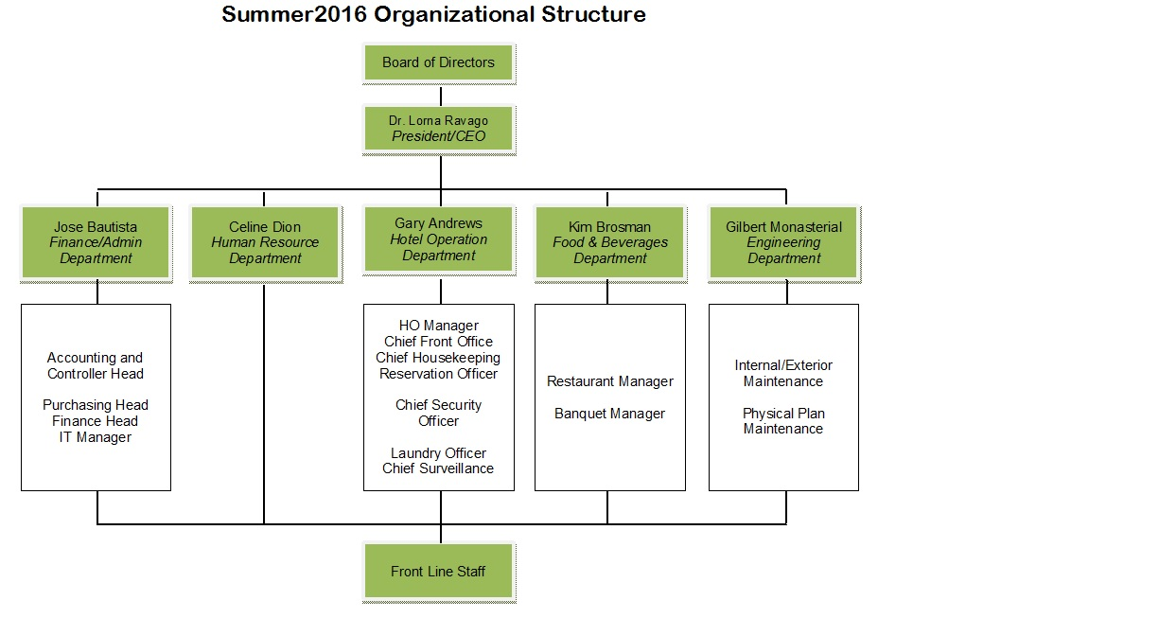



**Technical Lead**

The Technical Lead is a person on the Project Team who is designated to be responsible for ensuring that all technical aspects of the project are addressed and that the project is implemented in a technically sound manner. The Technical Lead is responsible for all technical designs, overseeing the implementation of the designs and developing as-build documentation. The Technical Lead requires close communications with the Project Manager and the Project Team.

* Sheena Sapuay - Documentation
* Joseph Lorilla – Project Technical
* Adomar Ilao – Project Management Chief
* Zhella Anne Nisperos – Quality Assurance Chief

**Customer**

The customer for this project are selected through the records from the database of the OHMS. As the customer who will be accepting the final deliverable of this project they will be informed of the project status including potential impacts to the schedule for the final deliverable or the product itself.

**Tabular Representation of Stakeholders’ Roles in Communication Process**

|  |  |  |
| --- | --- | --- |
| **Stakeholder** | **Roles** | **Communication Output** |
| President/ CEO | * Issue Memos * Approves Requests for meetings and training-workshop of stakeholders * Meeting Chair Person * Approves Budget | * Memorandum |
| Project Sponsor | * Appropriates Budget for Procurement of Hardware and Software needed for the project | * Purchase Request form * Approved Budget |
| Change Control Board | * Evaluate and decide Change Requests | * Approved change request form |
| Program Manager/ Project Manager | * Requests for meetings and training-workshop of stakeholders * Oversees the overall execution of the project * Implement CCB approved changes in the project * Meeting Chair Person * Presents project’s milestones to stakeholders | * Communication Letters * Change request log * Project Status and Reports |
| Assistant PM | * assists and prepares the project management plan and revisions * manages project planning activities, manages, reviews, and prioritizes the project work plans with objective to stay on time and on budget. * Provides status and progress reviews to Sponsor and receives directions. * Manages and supervises project team * Conducts risk management analysis. | * Project work plans * Status and progress reviews * Risk Management Analysis |
| Project Team | * Responsible for the planning and completing the work in the project | * Project Plan * Deliverables * Project Status Reports |
| Technical Lead | * Facilitator of Meetings * Serve as Note Taker and time keeper in every meetings * Ensuring all activities in the Project are well Documented | * Minutes of the Meeting * All project deliverables * Communication Letters |
| Steering Committee | * Request for Change in the Project * Give Feedback on the implementation of OHMS | * Change Requests form * Feedback |
| Customer | * Give Feedback on the implementation of OHMS | * Surveys * Feedback |

# Project Team Directory

The following table presents contact information for all persons identified in this communications management plan. The email addresses and phone numbers in this table will be used to communicate with these people.

|  |  |  |  |  |  |
| --- | --- | --- | --- | --- | --- |
| **Role** | **Name** | **Title** | **Organization/ Department** | **Email** | **Phone** |
| **Project Sponsor** | Jose Bautista | Finance and Administrative Officer | Finance and Admin Dept | [j.bautista@summerhotel.com](mailto:j.bautista@summerhotel.com) | (02) 632-22-12  0917-223-12-12 |
| **Project Management** | Benedicto Balilo Jr | Project Manager | IT Department | [j.balilo@summerhotel.com](mailto:j.balilo@summerhotel.com) | (02) 632-51-01 |
| **Asst. Project Manager** | Adomar Ilao | Asst. Project Manager | IT Department | [a.ilao@summerhotel.com](mailto:a.ilao@summer.com) | (02) 632-36-11 |
| **Project Stakeholders** | See Stakeholder Register | See Stakeholder Register | See Stakeholder Register | See Stakeholder Register | See Stakeholder Register |
| **Customer** | See Customer List | See Customer List | See Customer List | See Customer List | See Customer List |
| **Project Management Team** | Adomar Ilao | Deputy Project Manager | IT Department | [a.ilao@summerhotel.com](mailto:a.ilao@summer.com) | (02) 632-36-11 |
| **System Analyst** | Godfrey Dulla | System Analyst | IT Department | [g.dulla@summerhotel.com](mailto:g.dulla@summer.com) | (02)632-43-09 |
| **Technical Team** | Joseph Lorilla | Project Technical Chief | IT Department | [j.lorilla@summerhotel.com](mailto:j.lorilla@summer.com) | (02)632-88-56 |
| **Configuration Team** | Magielyn Racacho | Configuration Officer | IT Department | [m.racacho@summerhotel.com](mailto:m.racacho@summerhotel.com) | (02)632-11-21 |
| **Business Team** | Marvee Cheska Natividad | Business Analyst | IT Department | [m.natividad@summerhotel.com](mailto:m.natividad@summerhotel.com) | (02) 632-55-39 |

# Communication Methods and Technologies

The project team will determine, in accordance with Summer2016 Hotel organizational policy, the communication methods and technologies based on several factors to include: stakeholder communication requirements, available technologies (internal and external), and organizational policies and standards.

Summer2016 Hotel maintains a Mail server of OHMS platform within the PMO which all projects use to provide updates, archive various reports, and conduct project communications. This platform enables senior management, as well as stakeholders with compatible technology, to access project data and communications at any point in time. Mail server of OHMS also provides the ability for stakeholders and project team members to collaborate on project work and communication.

For stakeholders who do not have the ability to access the mail server of the website, they will be given a text message or a call about the meeting and other concern ahead of time.

All project teams are responsible for developing, maintaining, and communicating schedules. PERT Charts are the preferred format for communicating schedules to stakeholders. The project schedule will be maintained on both the Mail server of OHMS platform and the project website.

All project communication and documentation, in addition to being maintained on the Mail server of OHMS platform and project website, will be archived on the internal Summer2016 Hotel shared drive which resides in the PMO program directory. Organizational naming conventions for files and folder will be applied to all archived work.

# Communications Matrix

The following table identifies the communications requirements for this project.

|  |  |  |  |  |  |  |  |
| --- | --- | --- | --- | --- | --- | --- | --- |
| **Communication Type** | **Objective of Communication** | **Medium** | **Frequency** | **Audience** | **Owner** | **Deliverable** | **Format** |
| **Memorandum/ Circular Orders** | | | | | | | |
| * Request for a meeting * Call for Meetings * Call for Training-Workshops | * Conduct a meeting to be participated by all Stakeholders * Calling the active participation of all Stakeholders of the Company | * Request Letter * Memorandum Letters * E-mail | As needed  Daily | * Project Sponsor * Project Team * Stakeholders | * President * Project Manager | * Memorandum Letters * Request Letters * Meeting Summaries * News Letters | * Hardcopy of a formal letter * Soft copy archived on project Mail server of OHMS site and project web site |
| **Meetings** | | | | | | | |
| Kickoff Meeting | Introduce the project team and the project. Review project objectives and management approach. | * Face to Face | Once | * Project Sponsor * Project Team * Stakeholders | Project Manager | * Agenda * Meeting Minutes | * Soft copy archived on project Mail server of OHMS site and project web site |
| Project Team Meetings | Review status of the project with the team. | * Face to Face * Conference Call | Daily/As Needed | * Project Team | Project Manager | * Agenda * Meeting Minutes * Project schedule | * Soft copy archived on project Mail server of OHMS site and project web site |
| Technical Design Meetings | Discuss and develop technical design solutions for the project. | * Face to Face | As Needed | * Project Technical Staff | Technical Lead | * Agenda * Meeting Minutes | * Soft copy archived on project Mail server of OHMS site and project web site |
| Monthly Project Status Meetings | Report on the status of the project to management. | * Face to Face * Conference Call | Weekly  /As Needed | * PMO | Project Manager | * Slide updates * Project schedule | * Soft copy archived on project Mail server of OHMS site and project web site |
| Project Status Reports | Report the status of the project including activities, progress, costs and issues. | * Email | Daily | * Project Sponsor * Project Team * Stakeholders * PMO | Project Manager | * Project Status Report * Project schedule | * Soft copy archived on project Mail server of OHMS site and project web site |
| **Change Requests** | | | | | | | |
| * Request for changes in the project * Decision for change requests | * Request for any possible changes in the project * Approved or Disapproved change requests | * Change Request Letters * Face to Face | As needed | * Change Control Board | * Stakeholder | * Change Request Letters * Decision Letter of CCB | * Hardcopy of change request letters and forms and Soft copy archived on project Mail server of OHMS site and project web site |
| **Deliverables Update** | | | | | | | |
| Submission of deliverable output/ reports | Update the status of the project | * Face to face * E-Mail | Weekly and/or  As needed | * Project Sponsor * Project Team | * Project Manager * Project Team | * Draft or Final Project Status Report | * Hardcopy of deliverables and Soft copy archived on project Mail server of OHMS site and project web site |
| **Conference** | | | | | | | |
| Presentation of the Summer2016 Online Hotel Management System | Gather feedback from the stakeholder and to the selected customer | * Face to Face | Every other two weeks  /As Needed | * President/ CEO * Project Sponsor * Project Team * Stakeholders * Customer | * President/ CEO * Project Sponsor * Project Team | * Surveys * Feedback Summaries | * Formal presentation |

# Communication Flowchart

The communication flowchart below was created to aid in project communication. This flowchart provides a framework for the project team to follow for this project. However, there may be occasions or situations which fall outside of the communication flowchart where additional clarification is necessary. In these situations the Project Manager is responsible for discussing the communication with the Project Sponsor and making a determination on how to proceed.

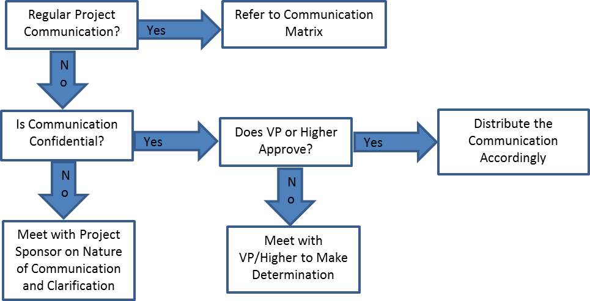

Does Finance & Admin Officer or Higher Approve?

Meet with Finance & Admin Officer or Higher to make Determination

# 

# Guidelines for Meetings

**Meeting Agenda**

Meeting Agenda will be distributed 5 business days in advance of the meeting. The Agenda should identify the presenter for each topic along with a time limit for that topic. The first item in the agenda should be a review of action items from the previous meeting.

**Meeting Minutes**

Meeting minutes will be distributed within 2 business days following the meeting. Meeting minutes will include the status of all items from the agenda along with new action items and the Parking Lot list.

**Action Items**

Action Items are recorded in both the meeting agenda and minutes. Action items will include both the action item along with the owner of the action item. Meetings will start with a review of the status of all action items from previous meetings and end with a review of all new action items resulting from the meeting. The review of the new action items will include identifying the owner for each action item.

**Meeting Chair Person**

The Chair Person is responsible for distributing the meeting agenda, facilitating the meeting and distributing the meeting minutes. The Chair Person will ensure that the meeting starts and ends on time and that all presenters adhere to their allocated time frames.

**Note Taker**

The Note Taker is responsible for documenting the status of all meeting items, maintaining a Parking Lot item list and taking notes of anything else of importance during the meeting. The Note Taker will give a copy of their notes to the Chair Person at the end of the meeting as the Chair Person will use the notes to create the Meeting Minutes.

**Time Keeper**

The Time Keeper is responsible for helping the facilitator adhere to the time limits set in the meeting agenda. The Time Keeper will let the presenter know when they are approaching the end of their allocated time. Typically a quick hand signal to the presenter indicating how many minutes remain for the topic is sufficient.

**Parking Lot**

The Parking Lot is a tool used by the facilitator to record and defer items which aren’t on the meeting agenda; however, merit further discussion at a later time or through another forum.

A parking lot record should identify an owner for the item as that person will be responsible for ensuring follow-up. The Parking Lot list is to be included in the meeting minutes.

**Memorandum/ Circular Orders**

The Project Manager will notify the President for the different meetings to be conducted from the very beginning of the project up to the end in a request letter form. The President/ CEO give memorandum to stakeholders to inform them for the upcoming meeting or events in a form of Memorandum letters or through emails of stakeholders.

**Deliverable Updates**

The Assistant Project Manager is incharge to update the status and progress of the project weekly or as needed. He monitors each project team members through face to face conversation with a log form for any comments and requires submission of draft or final deliverables from the team. He will submit the gathered report to the Project Manager for recommendations.

**Conference**

This will be done before the implementation of the Online Hotel Management System to inform the stakeholders on its processes then the feedback from them will be gathered to improve the system. This conference will be participated by all stakeholders of the company, from the top management up to the end – users and to the selected customers of the Hotel as well.

# Communication Standards

For this project, Summer2016 Hotel will utilize standard organizational formats and templates for all formal project communications. Formal project communications are detailed in the project’s communication matrix and include:

Kickoff Meeting – project team will utilize Summer2016 Hotel standard templates for meeting agenda and meeting minutes. Additionally, any slides presented will use the Summer2016 Hotel standard slideshow template.

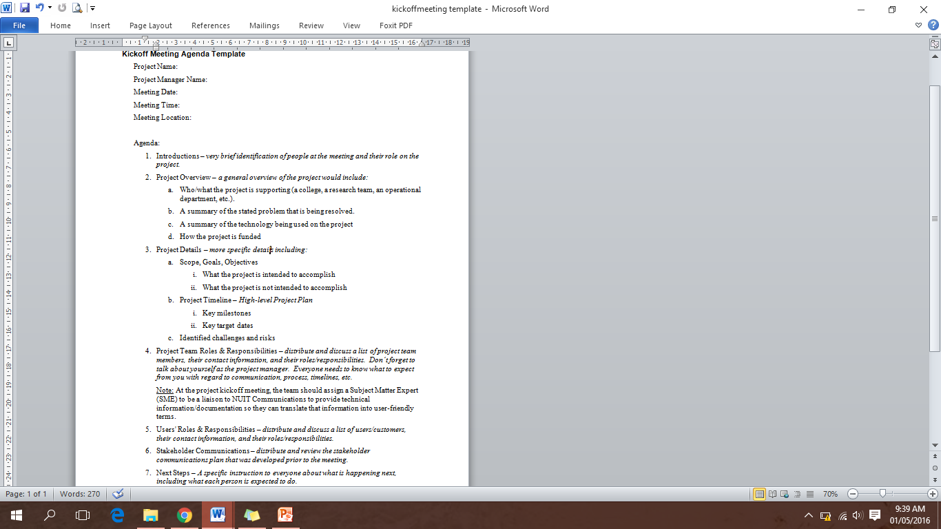

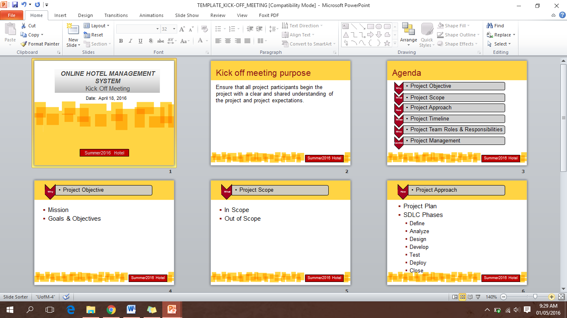

Project Team Meetings – project team will utilize Summer2016 Hotel standard templates for meeting agenda and meeting minutes. Additionally, any slides presented will use the Summer2016 Hotel standard slideshow template.

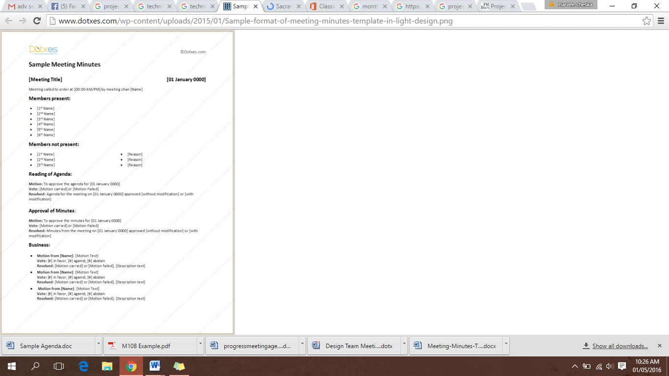

Technical Design Meetings - project team will utilize Summer2016 Hotel standard templates for meeting agenda and meeting minutes. Additionally, any slides presented will use the Summer2016 Hotel standard slideshow template.

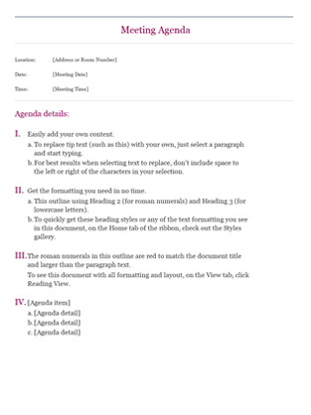

Monthly Project Status Meetings - project team will utilize Summer2016 Hotel standard templates for meeting agenda and meeting minutes. Additionally, any slides presented will use the Summer2016 Hotel standard slideshow template.

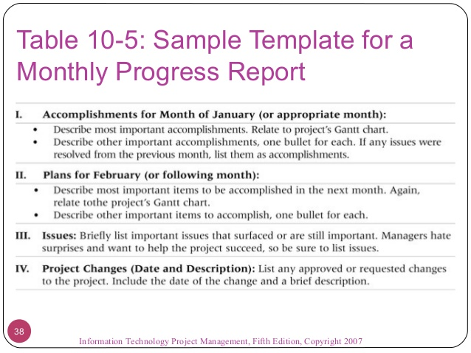

Project Status Reports – project team will utilize Summer2016 Hotel standard templates for meeting agenda and meeting minutes. Additionally the standard project status report document, available on the share drive, will be used to provide project status.

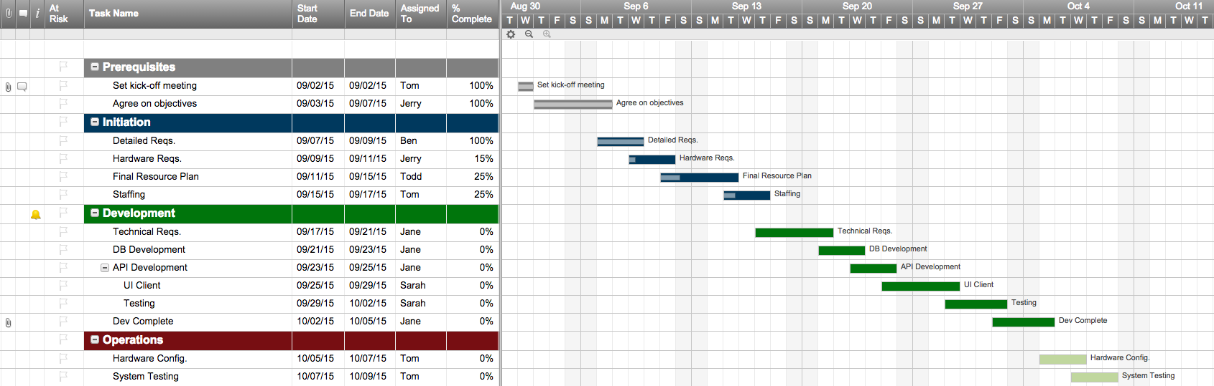

Informal project communications should be professional and effective but there is no standard template or format that must be used.

# Communication Escalation Process

Efficient and timely communication is the key to successful project completion. As such, it is imperative that any disputes, conflicts, or discrepancies regarding project communications are resolved in a way that is conducive to maintaining the project schedule, ensuring the correct communications are distributed, and preventing any ongoing difficulties. In order to ensure projects stay on schedule and issues are resolved, Summer2016 Hotel will use its standard escalation model to provide a framework for escalating communication issues. The table below defines the priority levels, decision authorities, and timeframes for resolution.

|  |  |  |  |
| --- | --- | --- | --- |
| **Priority** | **Definition** | **Decision Authority** | **Timeframe for Resolution** |
| Priority 1 | Major impact to project or business operations. If not resolved quickly there will be a significant adverse impact to revenue and/or schedule. | Vice President or higher | Within 4 hours |
| Priority 2 | Medium impact to project or business operations which may result in some adverse impact to revenue and/or schedule. | Project Sponsor | Within one business day |
| Priority 3 | Slight impact which may cause some minor scheduling difficulties with the project but no impact to business operations or revenue. | Project Manager | Within two business days |
| Priority 4 | Insignificant impact to project but there may be a better solution. | Project Manager | Work continues and any recommendations are submitted via the project change control process |

** NOTE: Any communication including sensitive and/or confidential information will require escalation to VP level or higher for approval prior to external distribution.

The different issues that need to be addressed for this communication escalation process are stated in the Risk Management Plan.

# Glossary of Communication Terminology

|  |  |
| --- | --- |
| Term | Definition |
| Communication | The effective sending and receiving of information. Ideally, the information received should match the information sent. It is the responsibility of the sender to ensure this takes place. |
| Stakeholder | Individuals or groups involved in the project or whose interests may be affected by the project’s execution or outcome. |
| Communications Management Plan | Portion of the overall Project Management Plan which details how project communications will be conducted, who will participate in communications, frequency of communications, and methods of communications. |
| Escalation | The process which details how conflicts and issues will be passed up the management chain for resolution as well as the timeframe to achieve resolution. |

Sponsor Acceptance

Approved by the Project Sponsor:

**JOSE BAUTISTA Date: _____________**

Finance and Administrative Officer